reference:- https://devopscube.com/kubernetes-cluster-vagrant/

Kubernetes-Kubeadm Vagrant Github Repository
The Kubeadm Vagrantfile and scripts are hosted on Github repository.
Clone the repository to follow along with the guide.
git clone https://github.com/scriptcamp/vagrant-kubeadm-kubernetes

Setup Kubernetes Cluster on Vagrant
Note: You need a minimum of 16 Gig RAM workstation to run this setup without any issues.
Follow the steps given below to spin up the Kubernetes cluster and validate all the cluster configurations.
Step 1: To create the cluster, first cd in to the cloned directory.
cd vagrant-kubeadm-kubernetes
Step 2: Execute the vagrant command. It will spin up three nodes. One master and two worker nodes. Kubernetes installation and configuration happens through the shell script present in the scripts folder.
vagrant up
Note: If you are running it for the first time, Vagrant will first download the ubuntu box mentioned in the Vagrantfile. This is a one-time download.
Step 3: Login to the master node to verify the cluster configurations.
vagrant ssh master
Step 4: List all the cluster nodes to ensure the worker nodes are connected to the master and in a ready state.
kubectl top nodes
You should see the output as shown below.
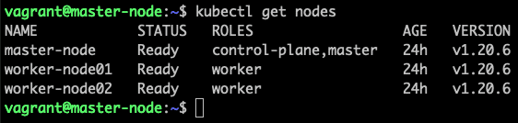
Step 5: List all the pods in kube-system namespace and ensure it is in running state.
kubectl get po -n kube-system
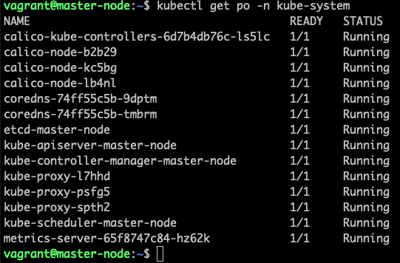
Step 6: Deploy a sample nginx app and see if you can access it over the nodePort.
kubectl apply -f https://raw.githubusercontent.com/scriptcamp/kubeadm-scripts/main/manifests/sample-app.yaml
You should be able to access Nginx on any of the node’s IPs on port 32000. For example, http://10.0.0.11:32000
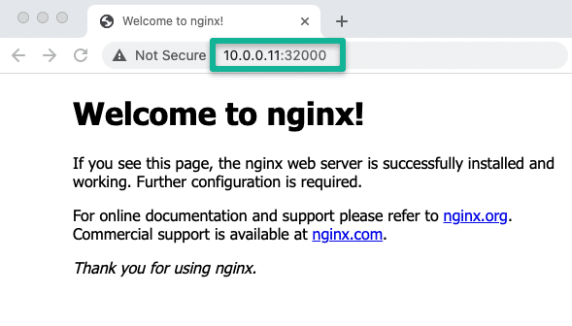
Thats it! You can start deploying and testing other applications.
To shutdown the Kubernetes VMs, execute the halt command.
vagrant halt
Whenever you need the cluster, just execute,
vagrant up
To destroy the VMs,
vagrant destroy
Note: If you want applications to persist data on each cluster or pod restart, make sure you use the persistent volume type “local” attached to a nodeSelector.

