reference:- https://www.youtube.com/watch?v=JBa-l5_9Nys&t=1s

used to template configuration and developing reports.

suppose we

-want to add a block of line to remote machine.
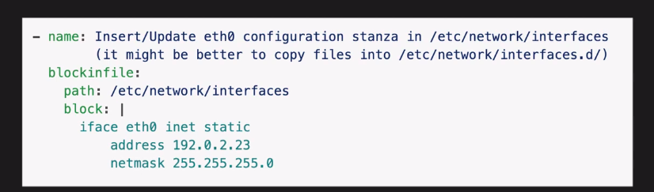

but what if we need to replace remote specify string/var in about string block like

eth0 may not be interface for this host may be eth1. so we need some kind of templating mechanism.

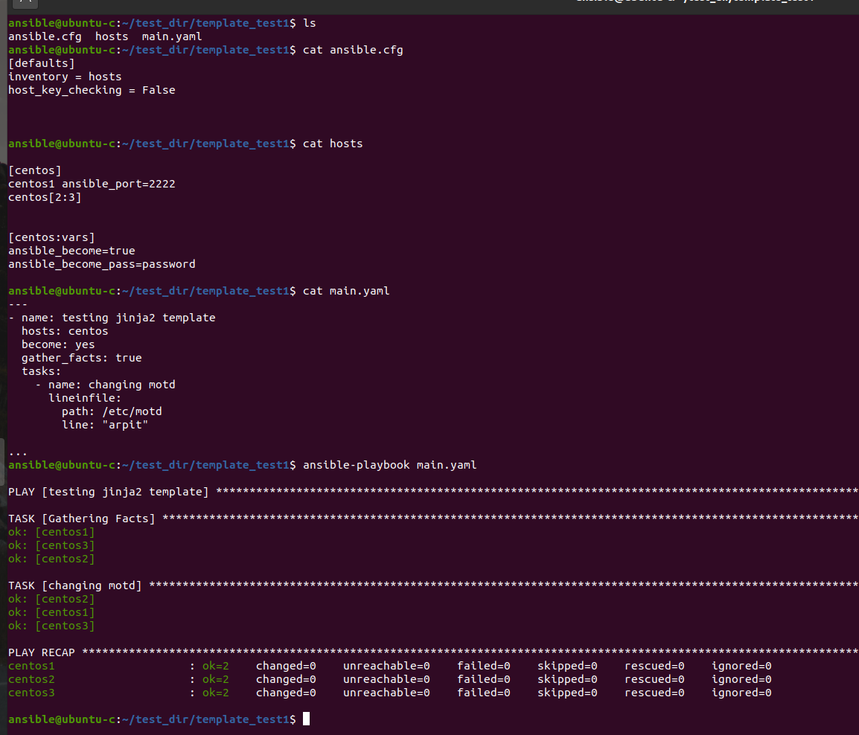

let try to print hostname/ip address in motd for all centos hosts.

let a create a file motd.j2 we can use any name and extension
also j2 is extension for jinja2 template.

welome to {{ ansible_facts.hostname }}
ip address {{ ansible_facts.default_ipv4.address }}
this motd message is configured by ansible
------------------------------------------------------------------------------

here original json contain ansible_default_ipv4_address and ansible_hostname but we use only default_ipv4_address and hostname.

above is basic jinja2 template. we can also include loop and if condition which we will see later.

now we will use this motd.j2 file in our playbook

here we are going to use new module called "template" in our ansible playbook.

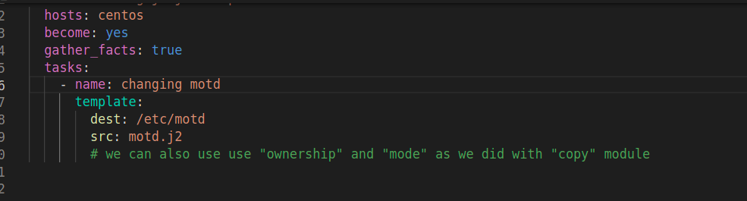

so this will push these template with variable values on target machine.

now run this playbook

ap is alias for ansible-playbook

