Facts:-



we can try to gather subset of facts.

pwd :- /home/ansible/diveintoansible/Ansible Playbooks, Introduction/Ansible Playbooks, Facts/01

lets suppose we need all the facts related to network for an host. it means we need subset form all gather_fact set that contain network information with other information

$ ansible all -m setup -a 'gather_subset=network'

$ ansible centos -m setup -a 'gather_subset=network' | wc -l ==> to count line

==> 350+ line

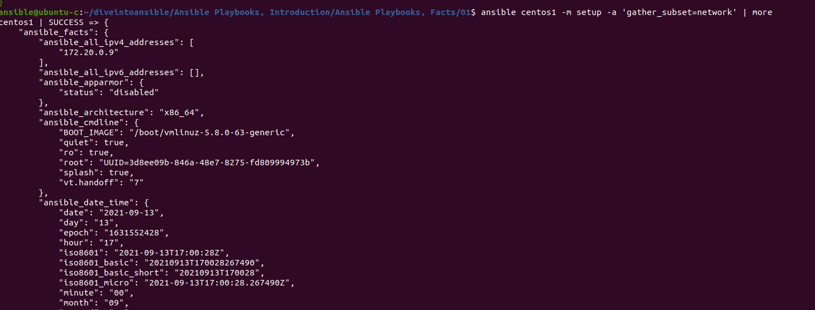

but this is still lot of information.

If we want only network information

ansible centos1 -m setup -a 'gather_subset=!all,!min,network' | wc -l

==> 208 line

this "!all,!min" => this means not to include this information.

Filter:-

Other alternation and effective approaches is to us filter option. this option is like fetching value like dictionary key and value.

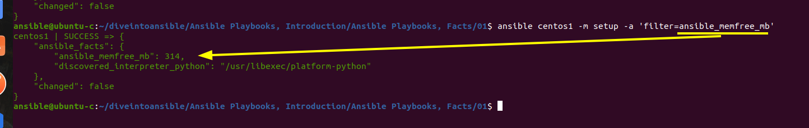

we can also use wildcard in filter to acts this like grep.

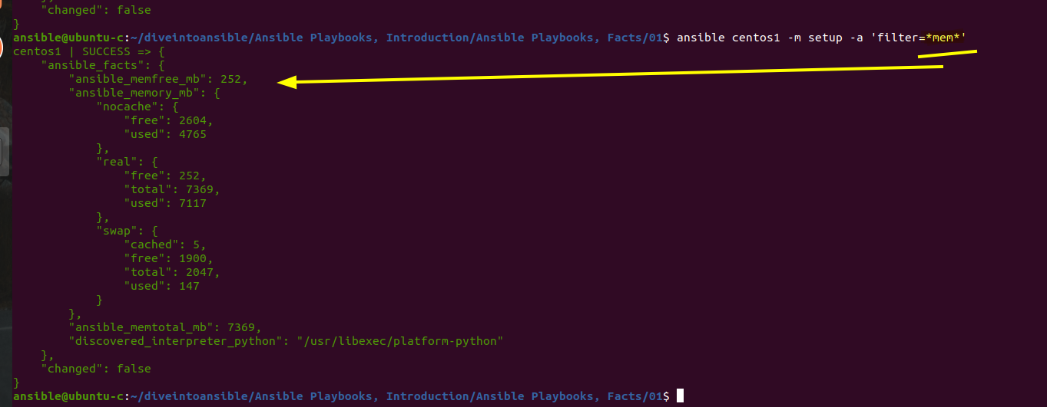

in above pic we can see the root key is ansible_facts for setup's module json.

but we don not need to specify ansible_facts while accessing these value in playbook.

like

