Jinja2 template:-

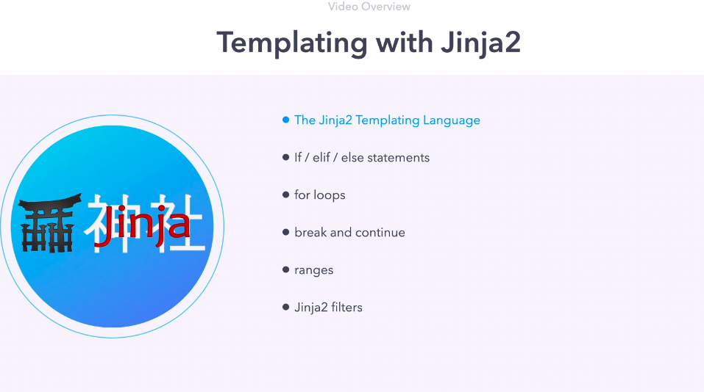

we already see jinja 2 template as mustache bracket {{ }}.
this is brief topic with many resource/book to this subject alone.

good article for jinja2 template:- https://medium.com/@hasiniwitharana/jinja2-templating-9ffc5e2c0fd6

- Delimiters
There are different kinds of delimiters that are defined in Jinja2.
{% ... %} for conditions, expressions that will be evaluated
{{ ... }} for values to print to the template output
{# ... #} for comments not included in the template output
# ... ## for line statements

2. IF Condition
First, we will look at how to write an “if” condition.

{% if <condition> %}
condition is satisfied
{% else %}
condition is not satisfied
{% endif %}

There are several conditions we can use with “if”. In all the below examples you need to replace <variable> with your particular variable.

The more effective you are in jinja2, the more effective you will be for ansible.

The templating language is most commonly used in two ways:-
- a syntactical language within the playbook
- As a template agent for files eg configuration files.

we will use jinja2 for if else and elif statement, for loops, break, continue, range.

Revision 1

pwd:-
/home/ansible/diveintoansible/Ansible Playbooks, Introduction/Templating with Jinja2/01

here we can see "setup" module shows as "ansible_hostname"

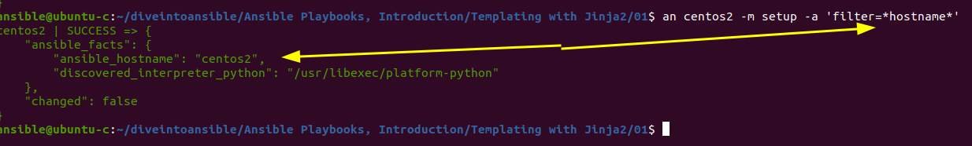

cd "/home/ansible/diveintoansible/Ansible Playbooks, Introduction/Templating with Jinja2/01
"

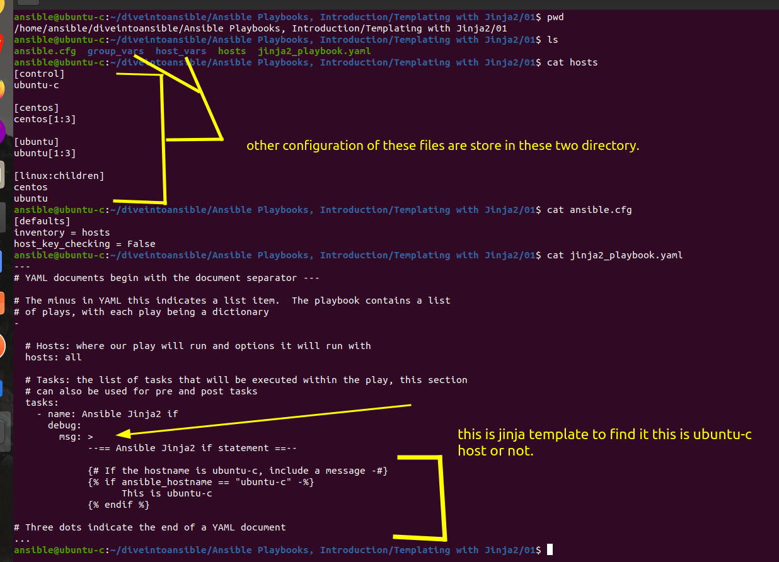

in above example we are experimenting with the if statement
so we are checking whether we are hostname is ubuntu-c if yes we can print this is ubuntu-c

Here in our playbook we have use "debug" module to print result.

{# #} this is for comment in console which is usually comment on output message as well.

{% %} ==> this is used for conditional operator.

{% -%} ==> '-' this minus symbol we will use to remove empty carrige return (Enter, may be to avoide new line).

let give this a try.

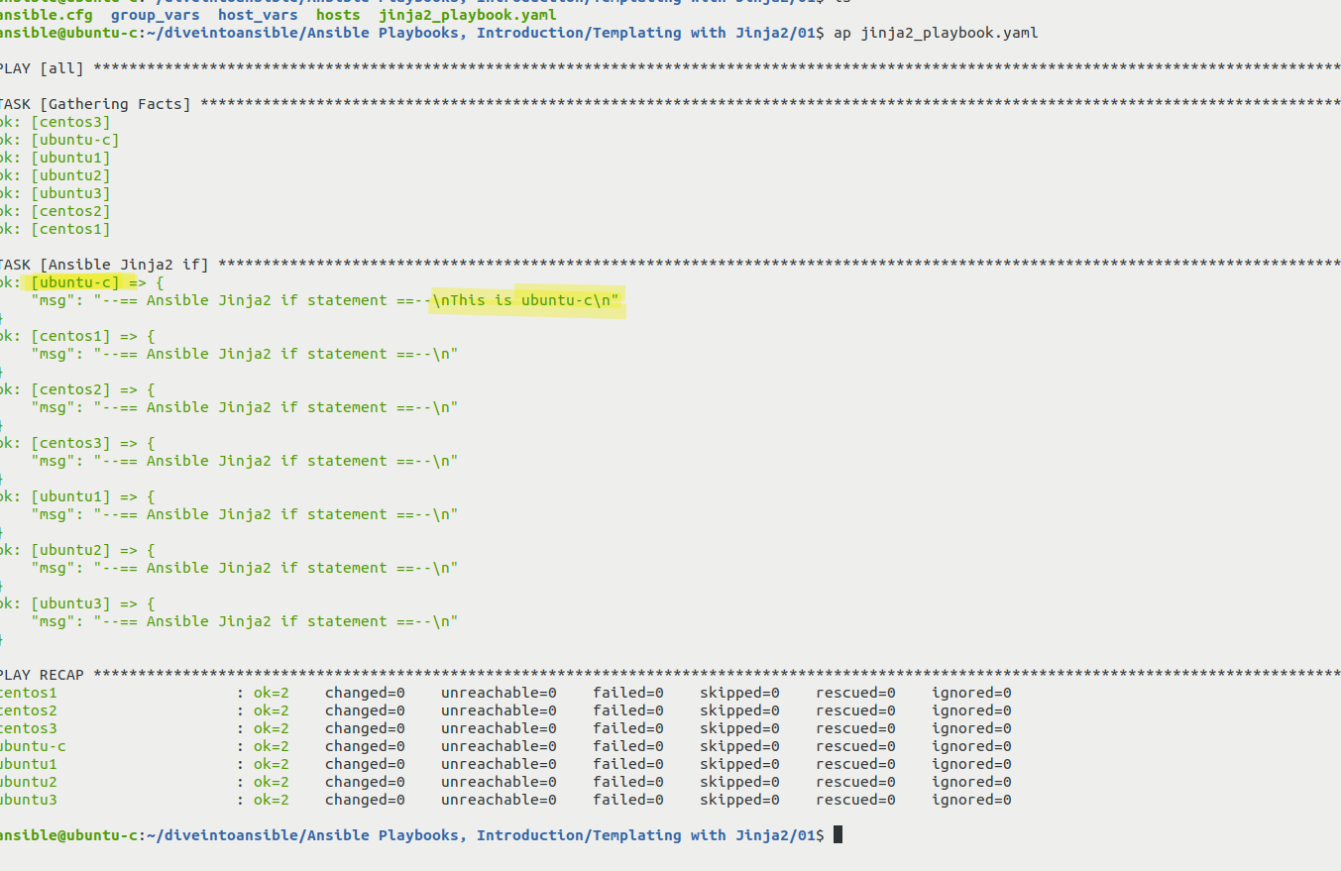

Revision 2

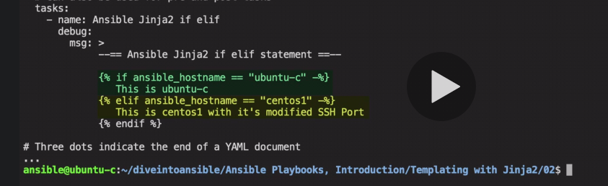

we introduce "elif" statement to enhance possibility for centos1 as well.

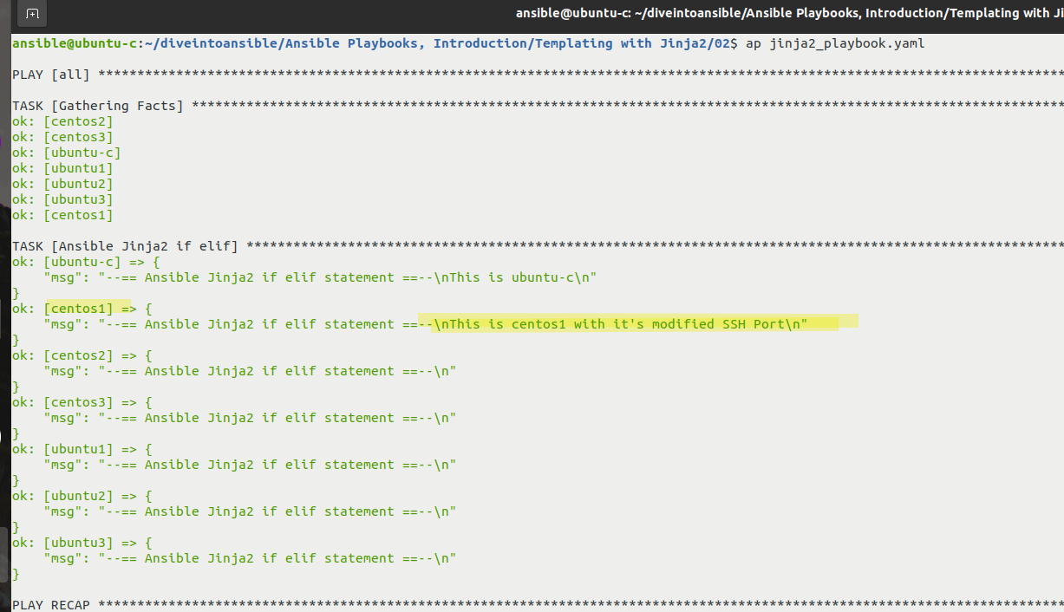

Revision 3

we have added "else" condition to check all cases.

