Ansible :-

some linux ssh command like :-

$ adduser <username> to create a user
$passwd <usernname>

$ visudo => add a user here to give sudo privilegede. So user can use “sudo”
Always use visudo to edit the /etc/sudoers file.
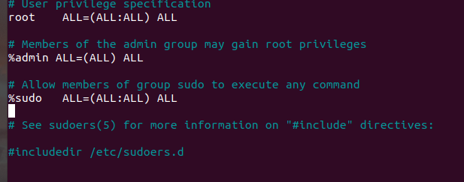

Add this line at last to give sudo permission:-
<username> ALL=(ALL) NOPASSWD:ALL

Allow the user to run only specific commands via sudo:-
<username> ALL=(ALL) NOPASSWD:/bin/mkdir,/bin/rmdir

----------------------------------------------------------------------------------------------------------------------

Ansible command:-

