Create EC2 instance using amazon linux image, in security group allow port 8080 as jenkins run on port 8080.

Now ssh to ec2 instance

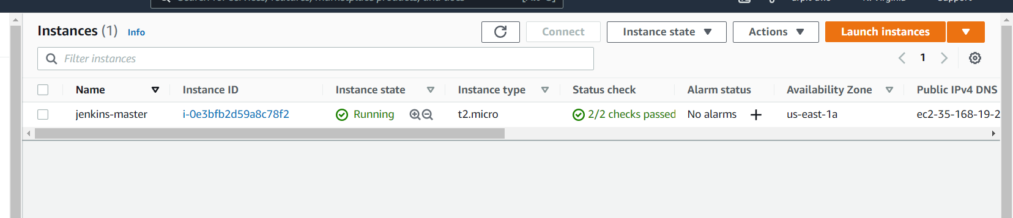

Now follow this article we are going to use exact same steps:-

https://learn.sandipdas.in/2021/06/03/build-docker-image-using-jenkins-pipeline/

Step 1 :- installing jenkins

Step 2 :- Install Docker

Step 3:- add “jenkins” user into “docker” group

$ sudo usermod -a -G docker jenkins

Step 4:- Install Jenkins plugins for Docker

--> go to browser --> jenkins --> manage jenkins --> manage plugin --> available plugin

Search for docker and docker pipeline plugin

- Docker plug-in
- Docker pipeline plug-in

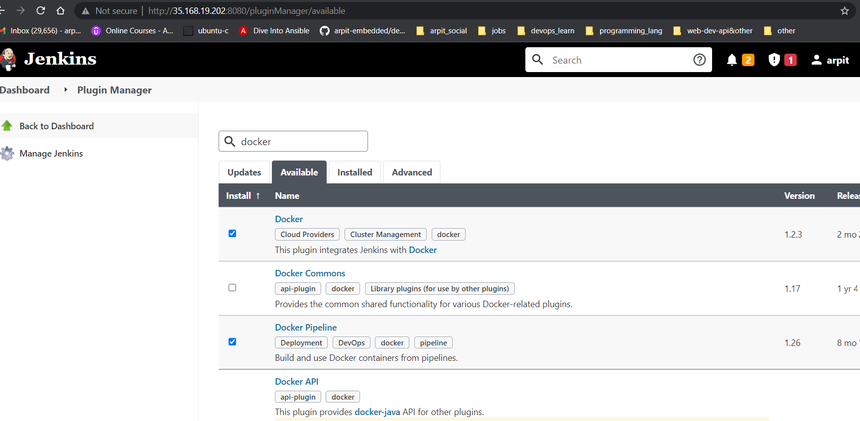

Click on install without restart.

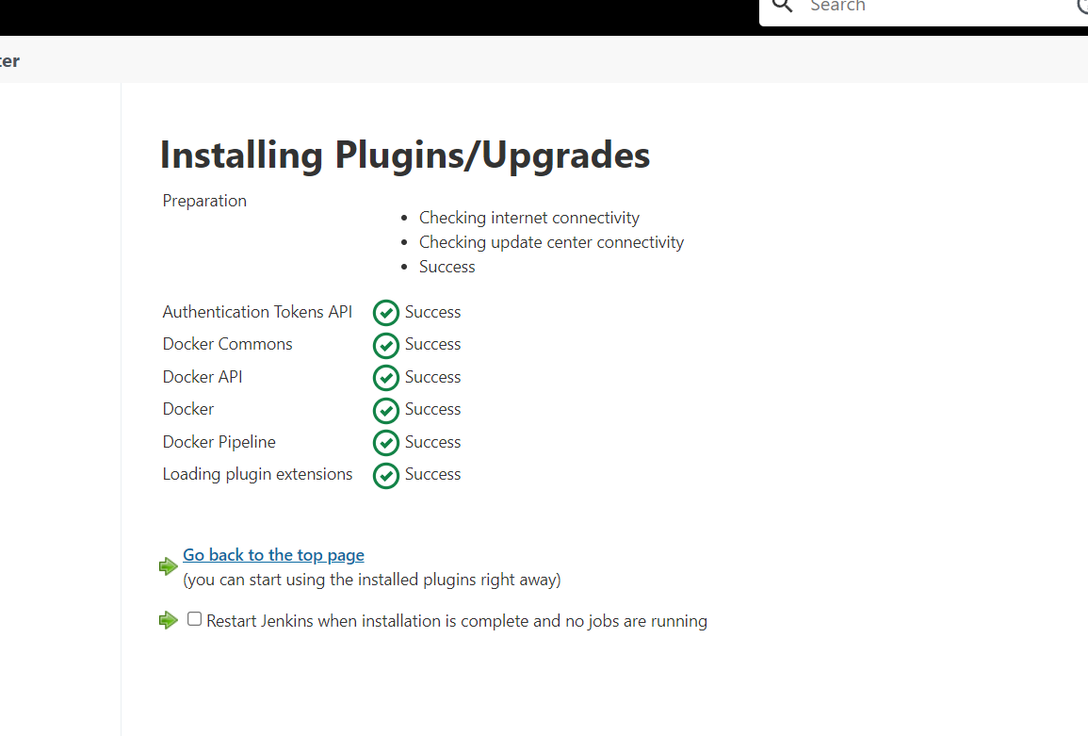

Step 5:- install git

Step 6 :- lets create a ECR repo

--> go to aws console --> ECR service ---> create a repo and give good uri.

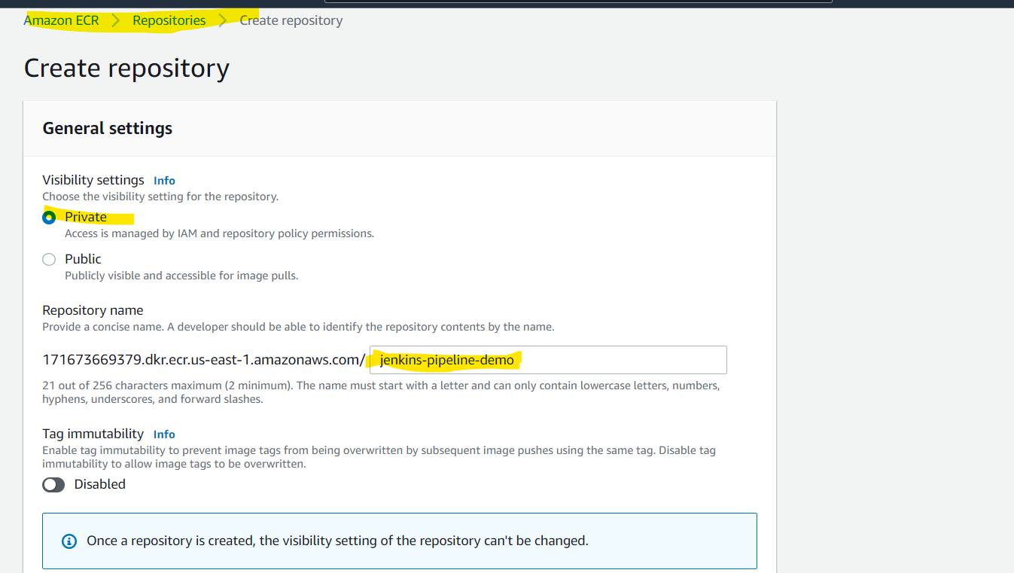

That are all required push command to this repo

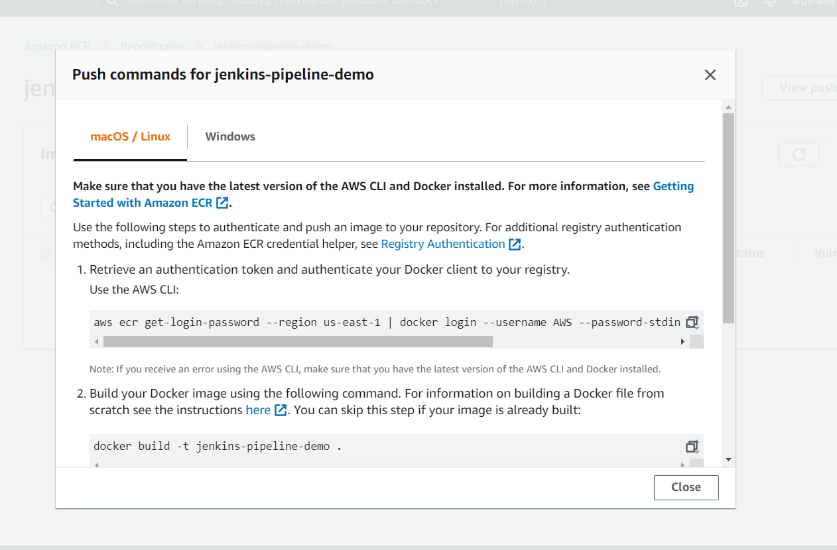

So we can build image and push it to ECR.

Step 7:- now Create IAM role and With AmazonEC2ContainerRegistryFullAccess policy and attach with the Jenkins EC2 Instance.

IAM --> EC2 --> set permission--> AmazonEC2ContainerRegistryFullAccess

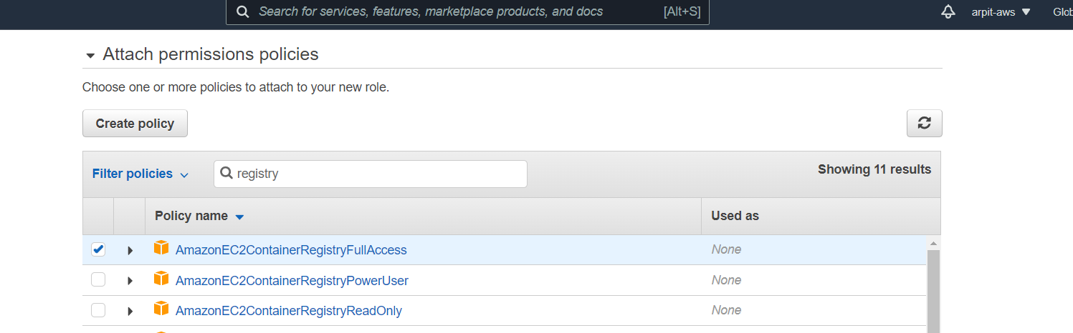

Create role

Attach that to EC2

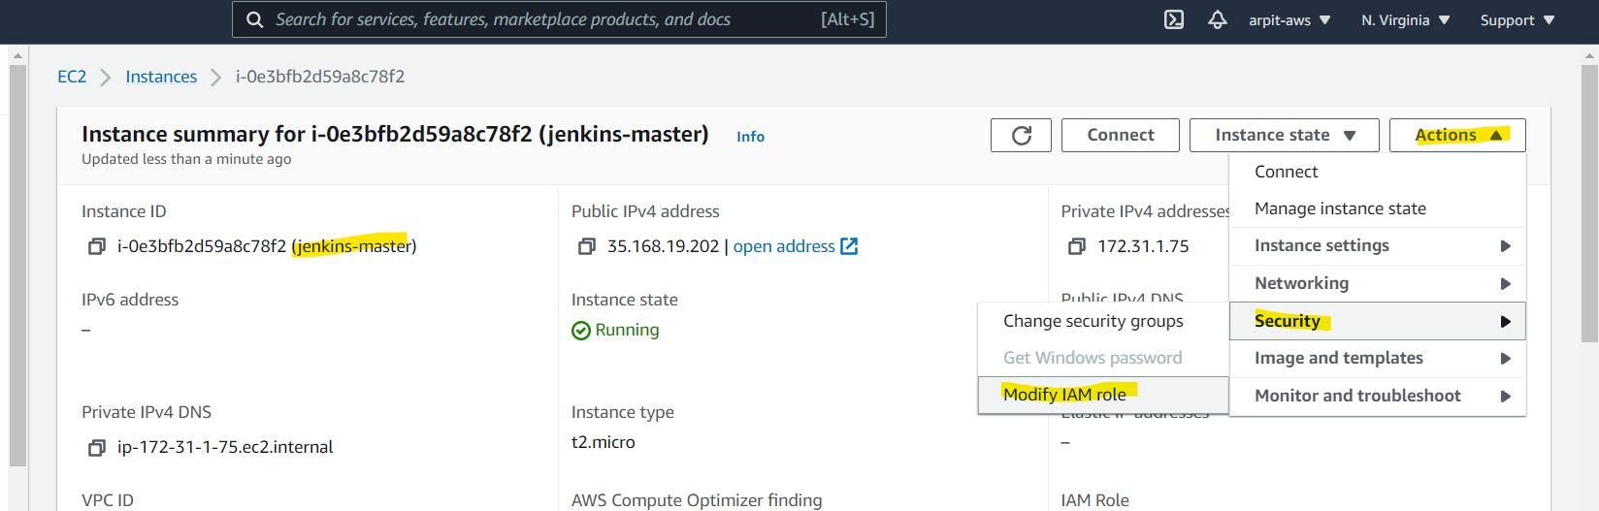

After attach IAM roles go to EC2 bash, and run login command that we got from ECR registry

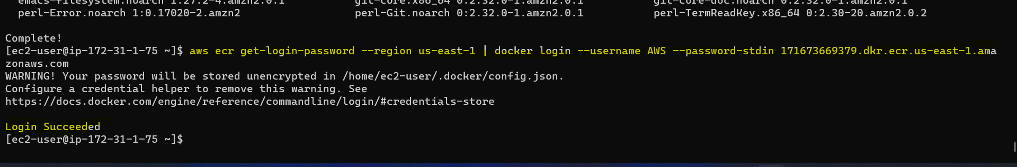

Here we are login successfully.

Step 7 :- create jenkins Pipeline
Jenkins --> new item

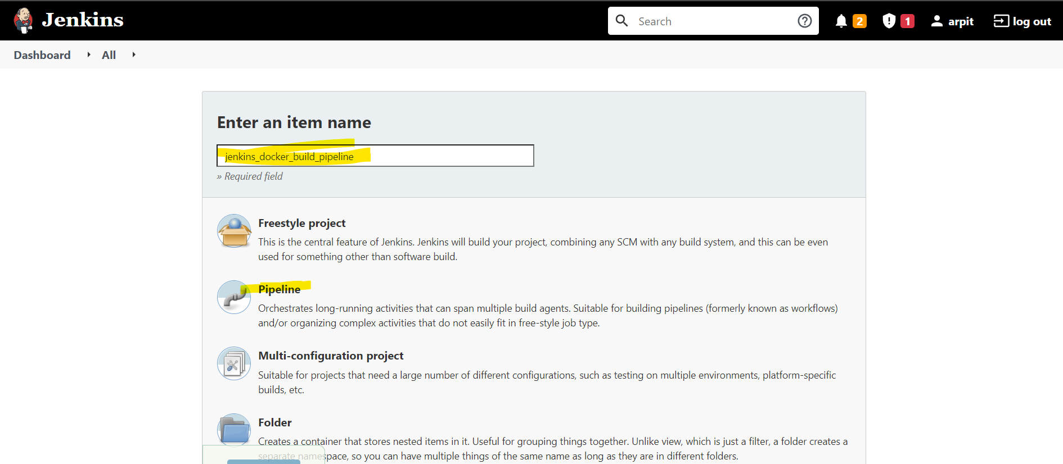

Choose github project

Use this https://github.com/sd031/aws_codebuild_codedeploy_nodeJs_demo.git

For this demo purpose

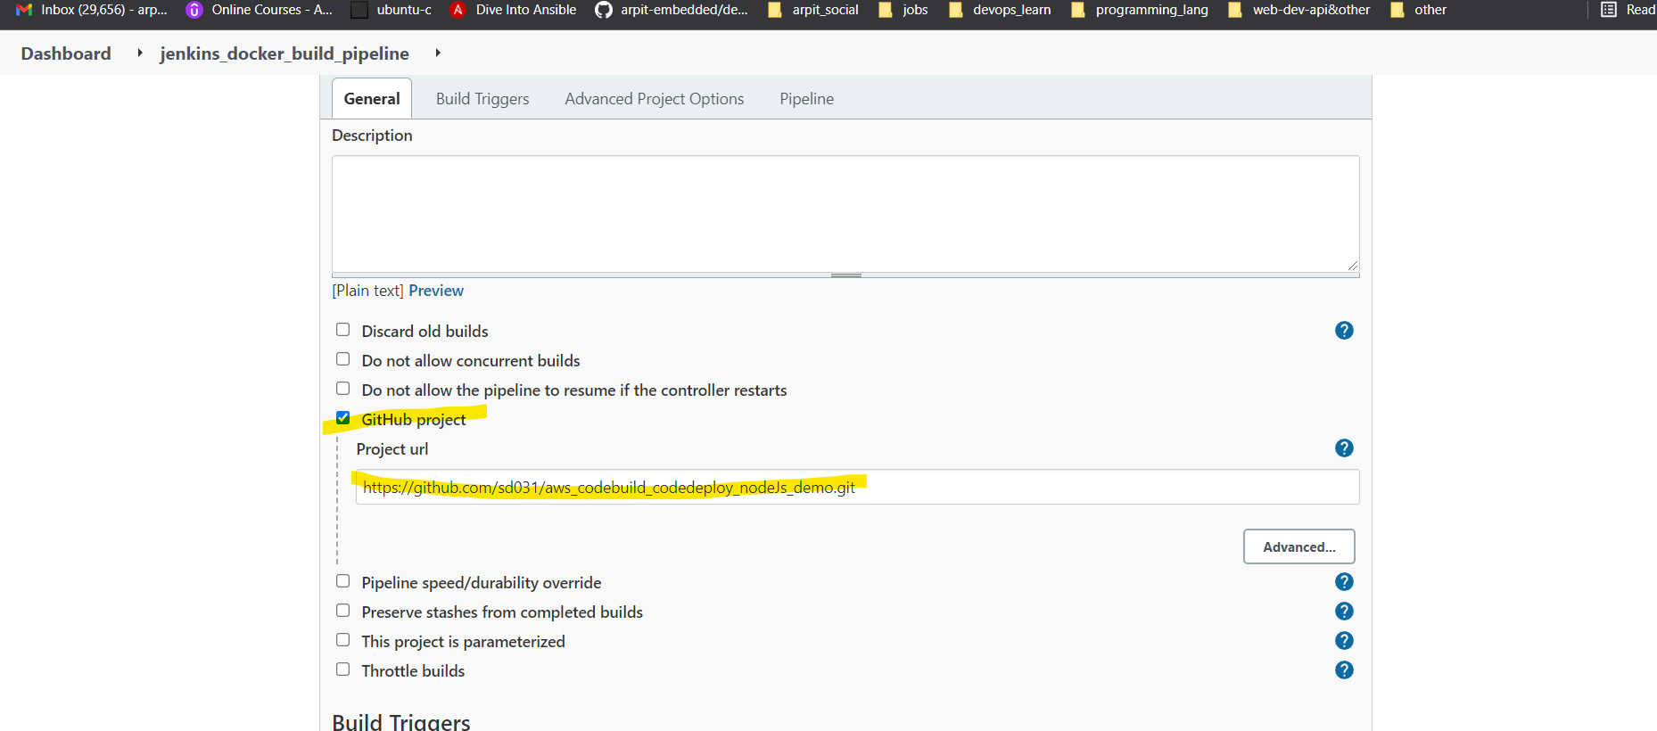

Now select build trigger whether it is webhook or Poll SCM

And write this jenkings scripts

YOUR_ACCOUNT_ID_HERE --> go to registry pull command you can find account ID 1716736*****
CREATED_AWS_ECR_CONTAINER_REPO_REGION ==> give region
ECR_REPO_NAME ==>
IMAGE_TAG ==>

environment {} ==> by this way we can create environment variable and we can use it in later in our declarative syntax.

pipeline {
agent any
environment {
AWS_ACCOUNT_ID="YOUR_ACCOUNT_ID_HERE"
AWS_DEFAULT_REGION="CREATED_AWS_ECR_CONTAINER_REPO_REGION"
IMAGE_REPO_NAME="ECR_REPO_NAME"
IMAGE_TAG="IMAGE_TAG"
REPOSITORY_URI = "${AWS_ACCOUNT_ID}.dkr.ecr.${AWS_DEFAULT_REGION}.amazonaws.com/${IMAGE_REPO_NAME}"
}

stages {

stage('Logging into AWS ECR') {
steps {
script {
sh "aws ecr get-login-password --region ${AWS_DEFAULT_REGION} | docker login --username AWS --password-stdin ${AWS_ACCOUNT_ID}.dkr.ecr.${AWS_DEFAULT_REGION}.amazonaws.com"
}

}
}

stage('Cloning Git') {
steps {
checkout([$class: 'GitSCM', branches: [[name: '*/master']], doGenerateSubmoduleConfigurations: false, extensions: [], submoduleCfg: [], userRemoteConfigs: [[credentialsId: '', url: 'https://github.com/sd031/aws_codebuild_codedeploy_nodeJs_demo.git']]])
}
}

// Building Docker images
stage('Building image') {
steps{
script {
dockerImage = docker.build "${IMAGE_REPO_NAME}:${IMAGE_TAG}"
}
}
}

// Uploading Docker images into AWS ECR
stage('Pushing to ECR') {
steps{
script {
sh "docker tag ${IMAGE_REPO_NAME}:${IMAGE_TAG} ${REPOSITORY_URI}:$IMAGE_TAG"
sh "docker push ${AWS_ACCOUNT_ID}.dkr.ecr.${AWS_DEFAULT_REGION}.amazonaws.com/${IMAGE_REPO_NAME}:${IMAGE_TAG}"
}
}
}
}
}

Because of public github repo we don’t need to give username and password.
In general we have to give username and password.

dockerImage = docker.build "${IMAGE_REPO_NAME}:${IMAGE_TAG}"

This docker.build comes from plugin.

Now we are tagging and pushing to ECR

Now click on APPLY and then SAVE

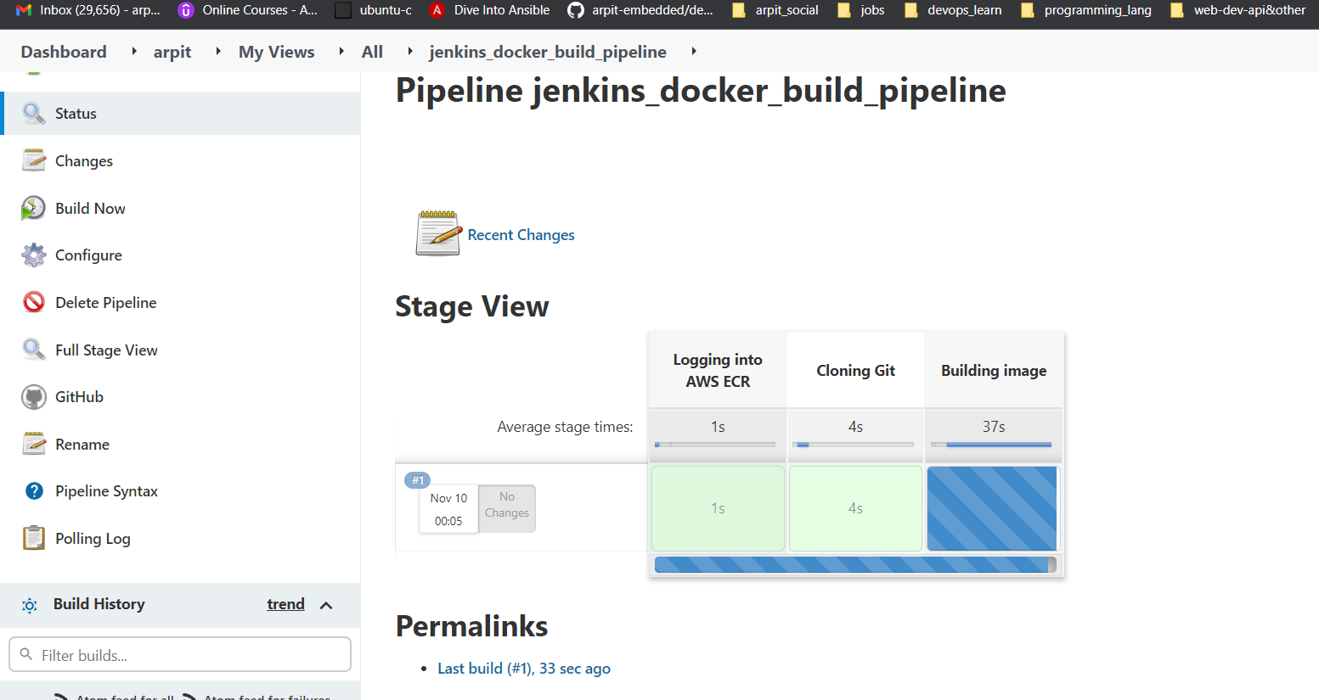

Now our docker image is present in our ECR registry.

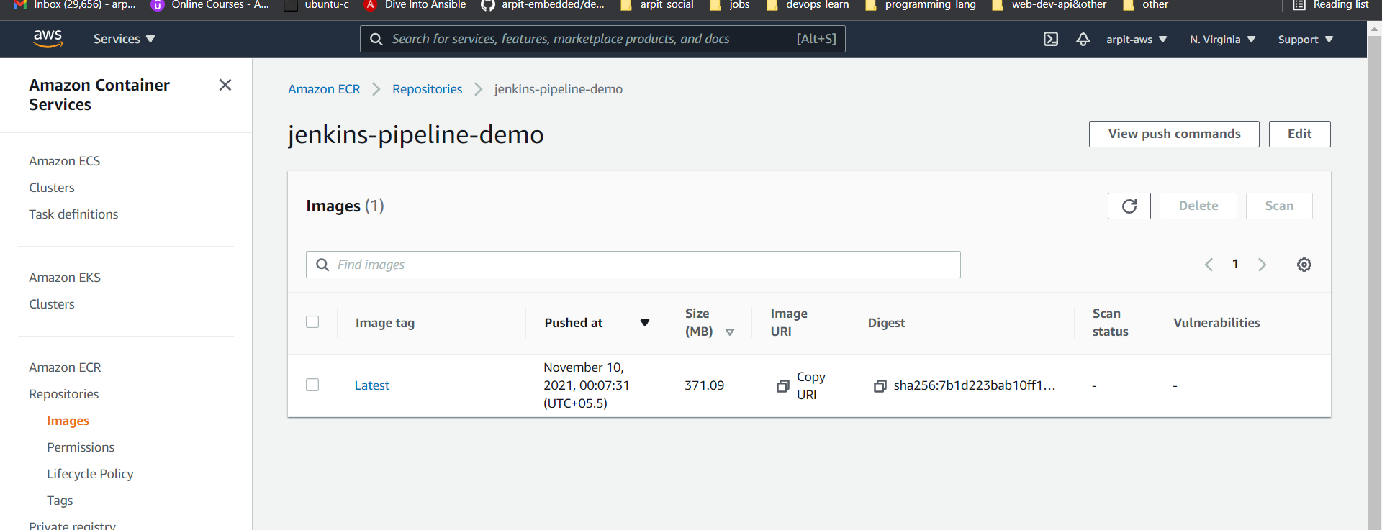

Click on console output and you can see what basically happens behind the scene

