S3 - security and encryption

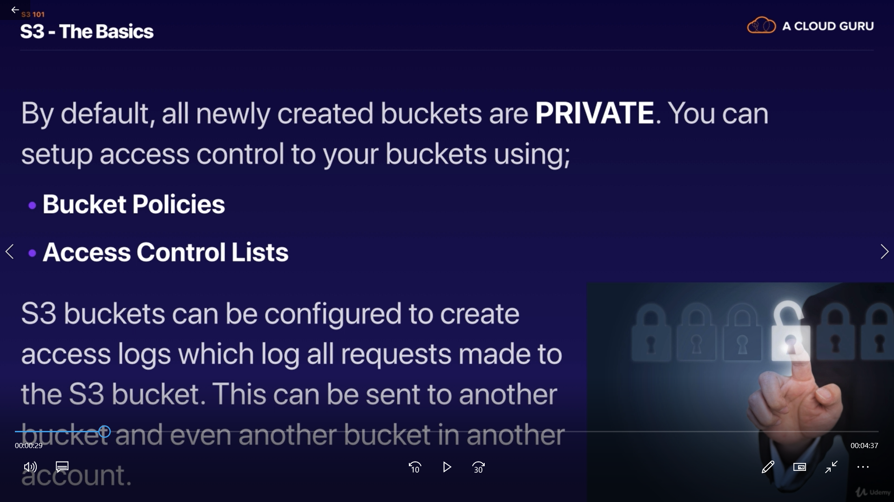

Bucket Policy :- this policy work on bucket only.
Access Control List :- this will work on individual object inside bucket.

For Encryption can be done on time :-
- at transit time (when data is in transferring or on network) -> by SSL/TSL
- At rest (on server side /client side) -> means like encryption as on hard disk.
If encryption at rest done at server side then AWS Encryption may work for you
lets look at pics to get better idea.

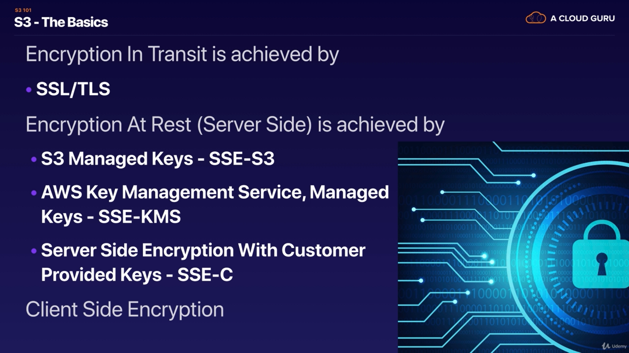

note:- "key" is just a medium to encryption and decryption it. just like we use "key for the lock"

- there is S3 manage key -> for this AWS manage key for us. where is called as SSE (server side encryption)
- there is amazon key management service where we and amazon manage all keys together. (SSE-KMS)
- SSE-C => server side encryption side encryption with costumer provided keys.

Client side encryption => you have file in your local machine and you encrypted and uploaded on AWS.

now lets try some practical stuff:-

just go to you "object(file)" inside bucket and enable encryption with SSE-S3

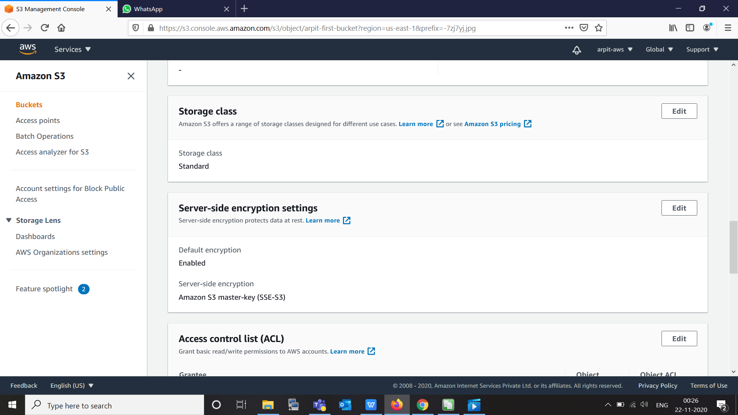

Now our file is encrypted with amazon key now if someone stolen AWS hard-drive where our file is store, he found our file as encrypted.

