Here we are going to create an more complex application that going to store number of visit to page in redis database.
Redis is basically an in-memory database for fast execution.

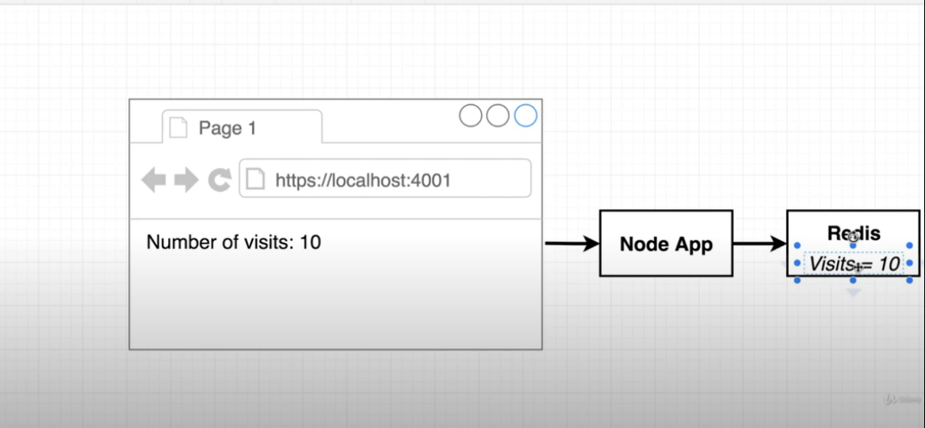
Yes we can also store no of visit in node application, but to make it more complex we are going to use redis application.

There are certain ways of doing that like:-

1. Putting redis and node app under single container, but it has some drawbacks like:-
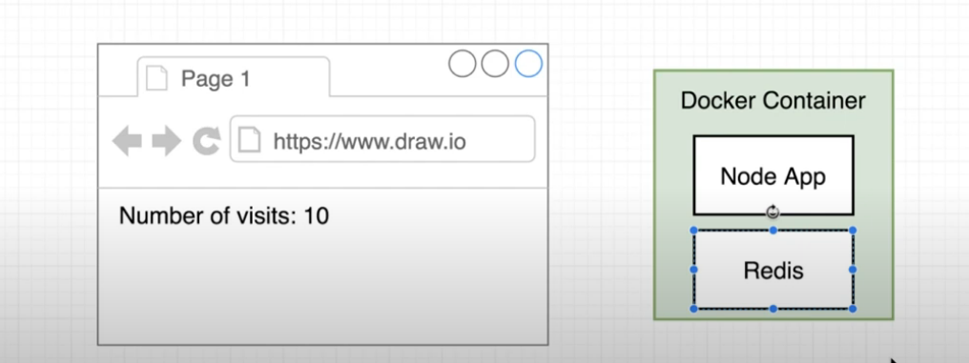
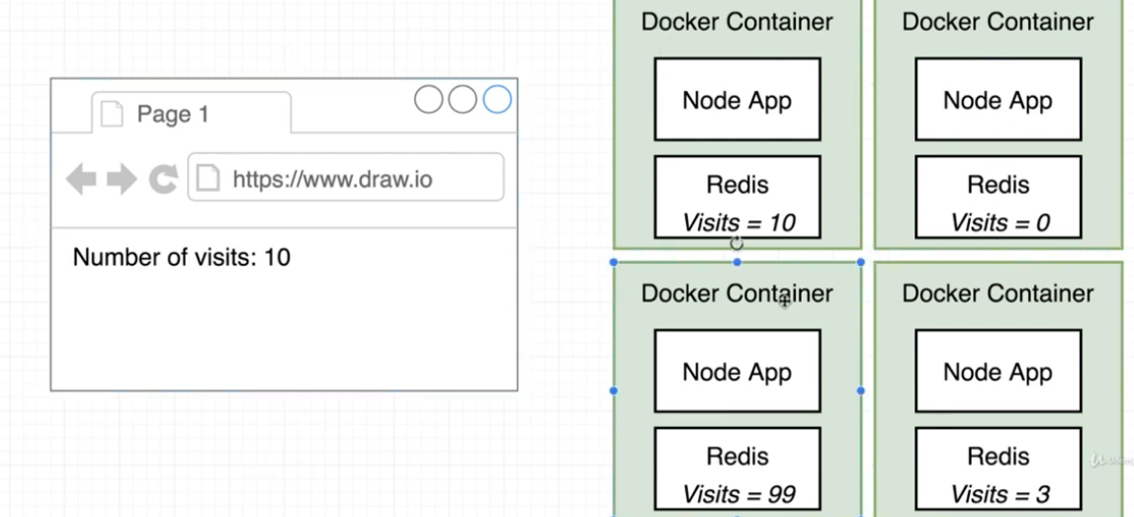
the problem might be every container would be disconnected to each other.

This will leads to every redis server has its own counter when it is called.

More robust way for doing this is like:-

2. many node conatiner that connect to a single redis container. Like:-
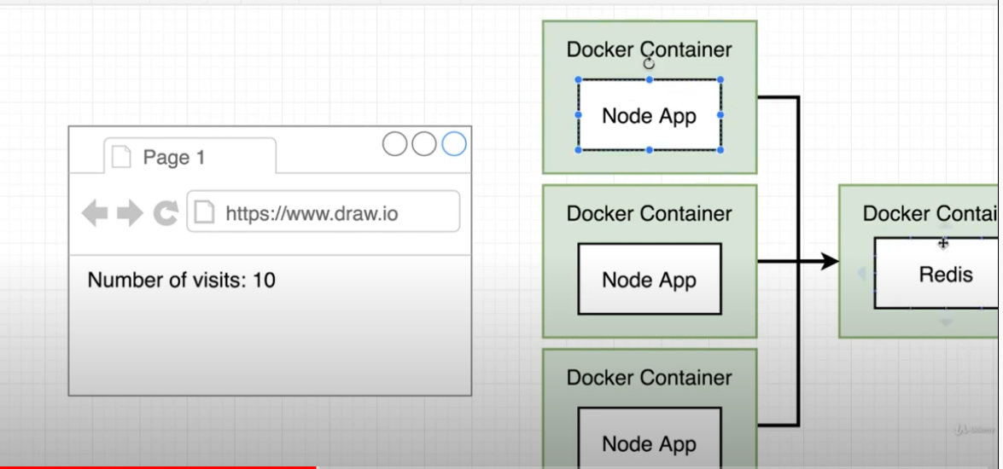
but for our current example we are going to use one docker container and one redis server.

Now we are going to write some nodejs code for our node application.

Lets create an folder called “visits”
and we will do all the stuff there.

You will find this directory inisde this repo ../practical/nodejs/visits

