$ ansible --version

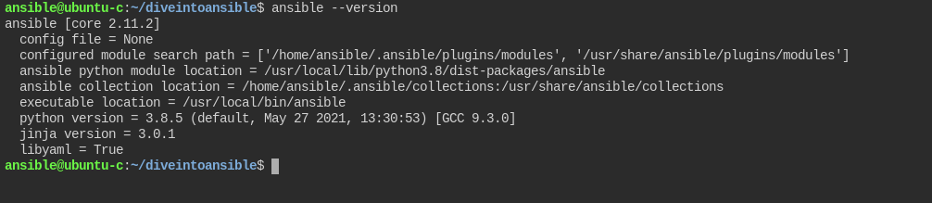

here we can see lot of infromation.

things to notices:-

config file = None ---> currently we don't have any configuration file to which ansible is making reference to. we can use environment varibale and manually giving file location.

- the lowest priority configuration file is /etc/ansible/ansible.cfg

like if you do --> apt install ansible ==> this file will be present.

lets see this directory.
currently this directory not present in our ansible server.
now we have to switch to root and lets create this directory.

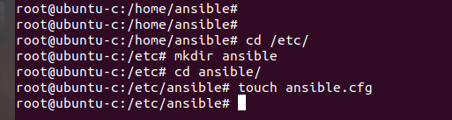

now run $ansible --version

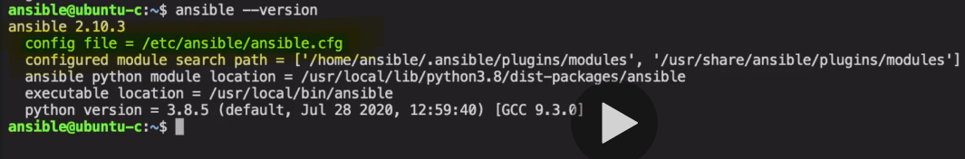

here we can see config file are now getting marked.

the above file is least priority,

Let see this :-
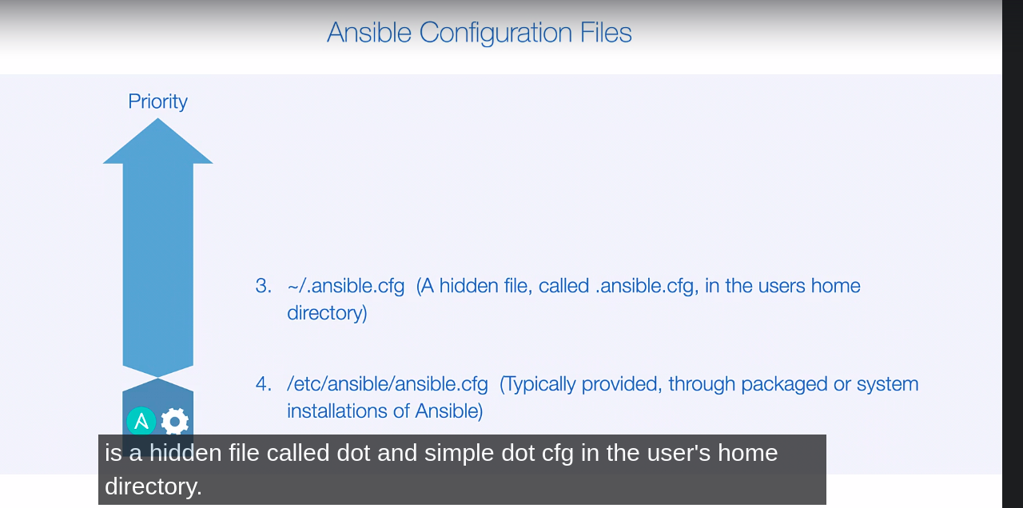

- here we see that in if we have .ansible.cfg this is hidden file, in user's home directory, which basically have higher priority than /etc/ansible/ansible.cfg.

let create this file in user home directory and check $ ansible --version.

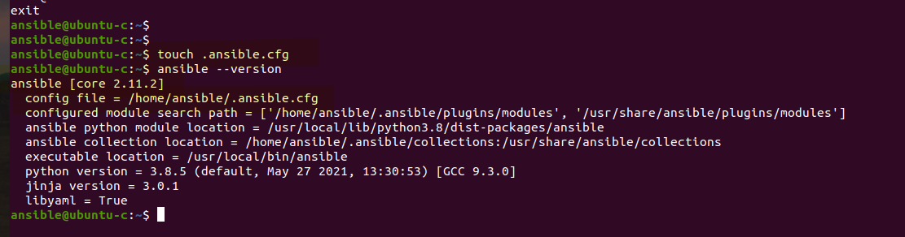

so config file has reference to this new file as it have higher priority.

- now more priority config file is ./ansible.cfg in current working directory.
this is not an hidden file.

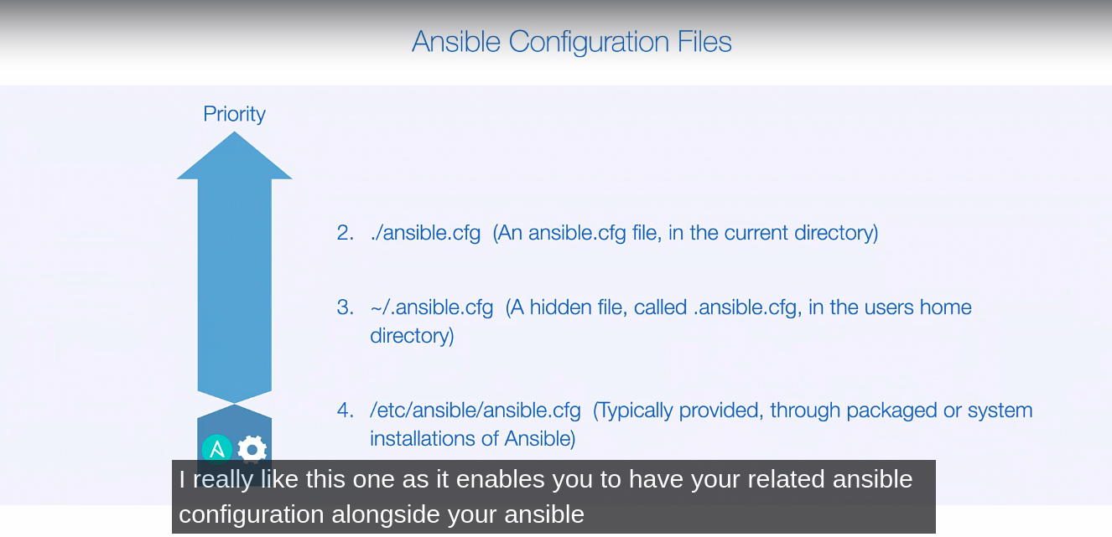

let create this file in some directory and check.

this local directory ansible.cfg is very helpfull as it keep configuration closer to our directory.

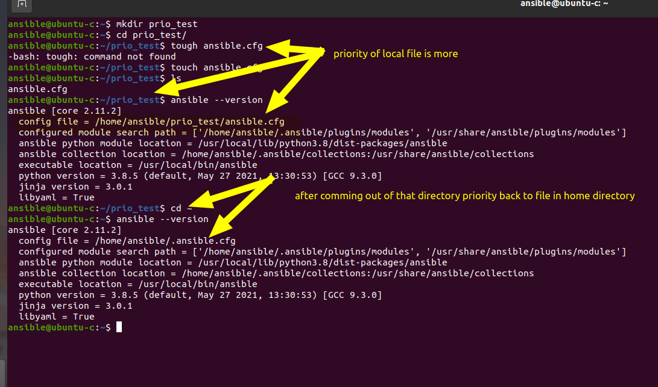

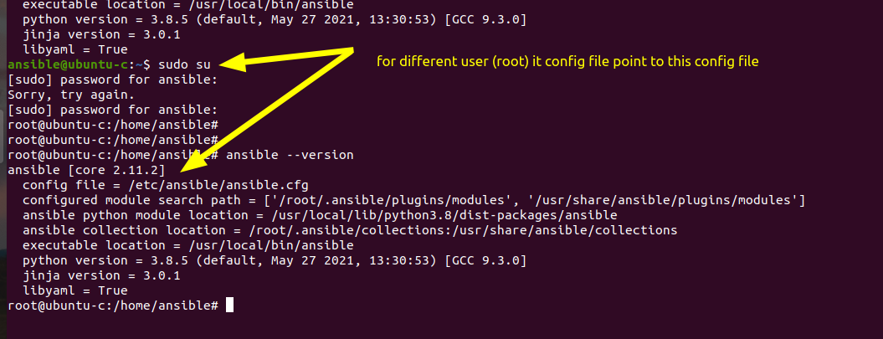

- highest priority is given to ANSIBLE_CONFIG environment variable.

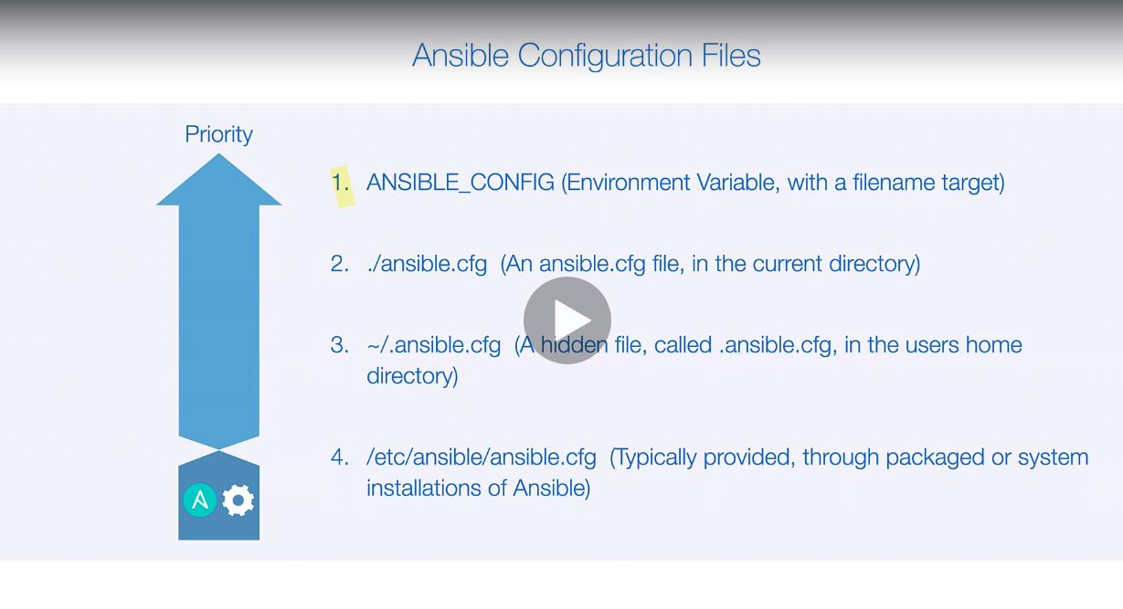
We can even give customise name for config file. lets try this

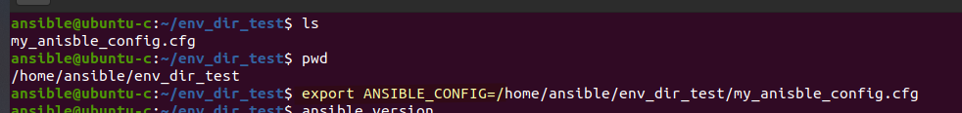

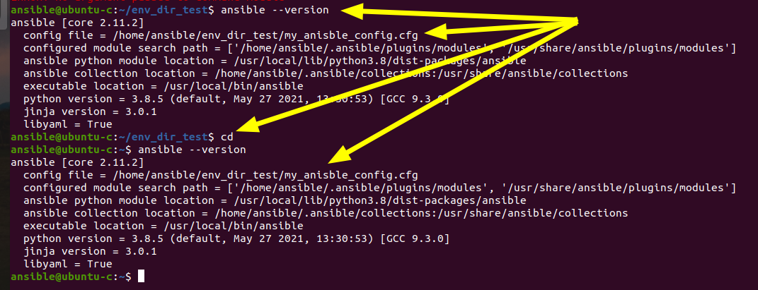

so this env varibale has highest priority.

