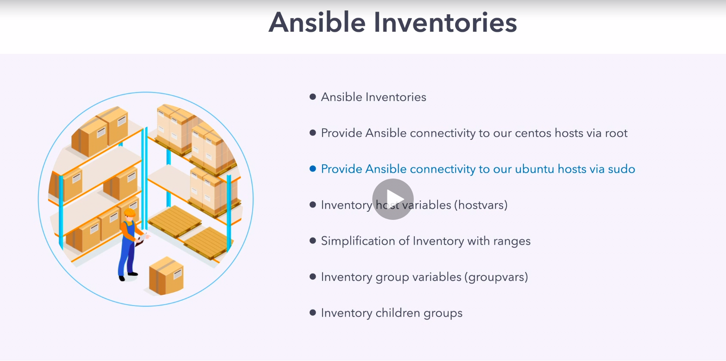

In this course they have created this git repo in this way like lecture numbering like 01, 02, 03 follow this.

from now we will start using author's repo for doing things.

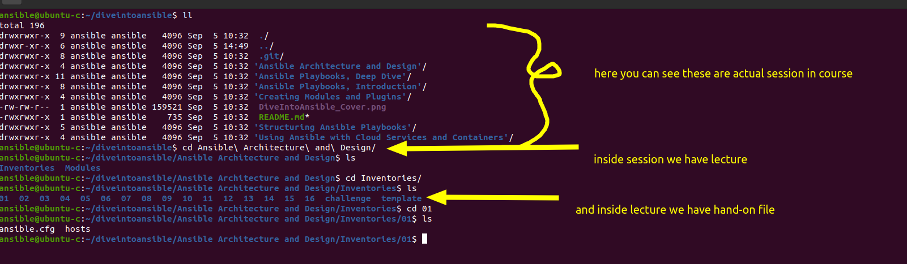

this is important hierarchal structure to understand this will help in doing hand-on.

