Terraform --- Dynamic Group

refer :- https://www.youtube.com/watch?v=IkykgsOC3so&t=507s

we can put dynamic block into resource block, data blocks.

==> when you want to repeat multiples of same block types.

this is not like loop for a resources, it is for single block inside a resource.

may be block means :- {}

why ?-
Here is database table:-

called as first form.
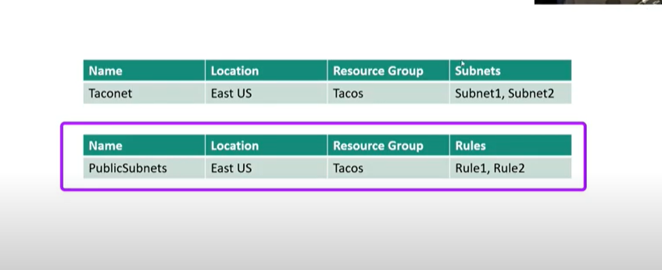

you can not have multiple entries in one column like here in subnets and rules.

to solve this we need to have some relation ship table which tells about two different table regards to subnet like:-

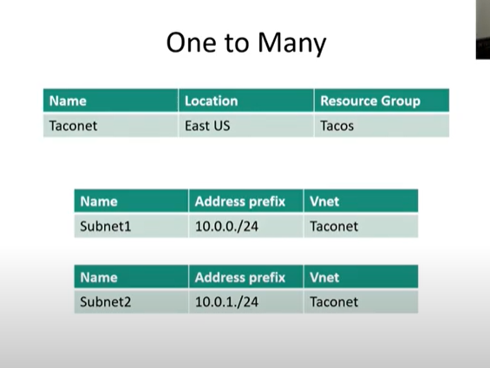

==> The idea of Dynamic block violates this first form. so in single resource we are creating multiple of things like, in one virtual server we have multiple of ports. and we are establishing relationship between those ports in one resource like multiple entries in one column.

Syntax :-

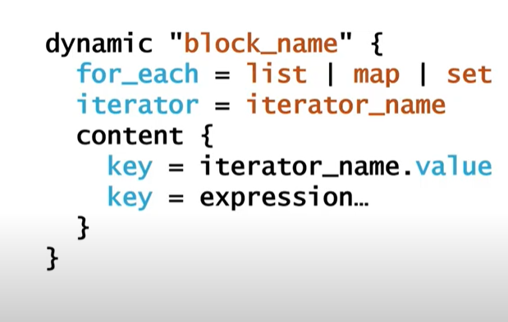

This is syntax of dynamic block which is nested inside resource block.

- block_name ==> lets say "ports". this will repeate and create multiple ports.
- for_each ===> this will define what particular element in list, map, set you are going to iterate. like "list of ports", so it will pick one port at a time.
- iterator ====> optional entry, its a reference (just a name for iteration), so you can point which iteration is that. instead you can also use "block name" as well.
- content ===> this is actual entry in block, in key value things.

lets take two Azure example:-
Example one :-

- create subnet with "dynamic block" name "subnet" :-

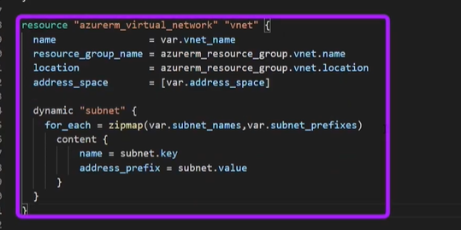

  - here for_each we have (here we are preparing map (dictionary) by two list using zigmap )

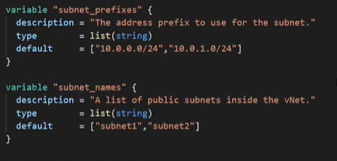

so above two have same number of element in two list (name prefix and name) and we are going to have club then into map using zigmap function.

1.2 here we didn't put any iterator so it means dynamic group name ie subnet is our iterator by default.

1.3 now we have content block here we have to define value to be fetch from for_each
here "name" is key I.e. subnet_name
and "address_prefix" is value I.e. prefix

notice that we call every portion in iterator as iterator_name.key like subnet.key

there name and address_prefix are the attribute in side resource I.e. part of resource.
------------------------------
Example two

- now we have to put security rule,

  - so this we have dynamic block

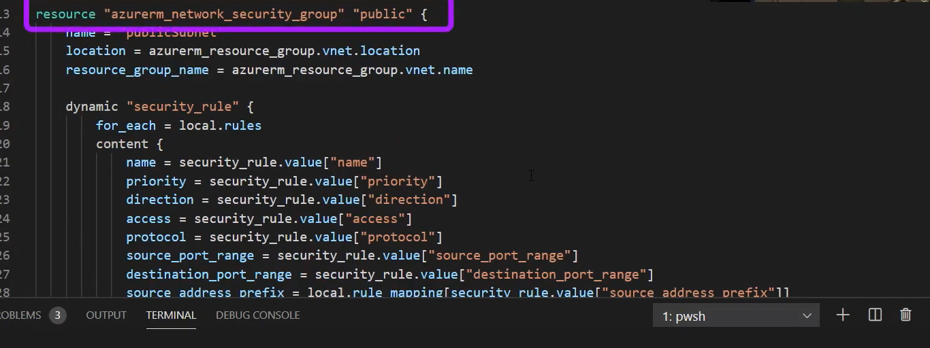

2.2 here we are configuring security groups, and we are parsing json to fetch.

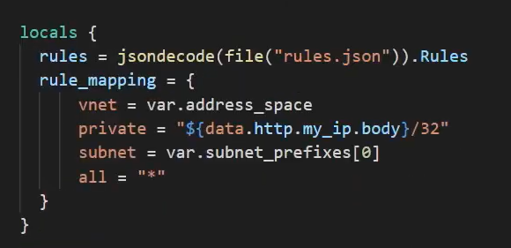

there we have local value on which we are using jsondecode to open a file and which is name as rules.json
and here our primary key is Rules , you can see this last word of jsondecode (.Rules)

In content block we are extracting our content.

2.3 see this square bracket

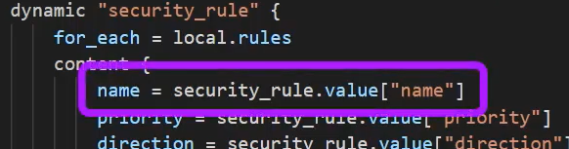

this square bracket contain default iterator name ie security_rule for this block to fetch vaule.

2.4 here is somethings interesting I got like :-

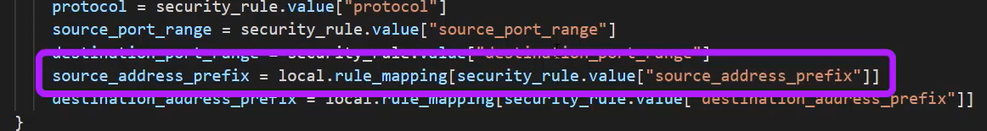

here our requirement is may be I need to apply that piece of rule only on private subnet
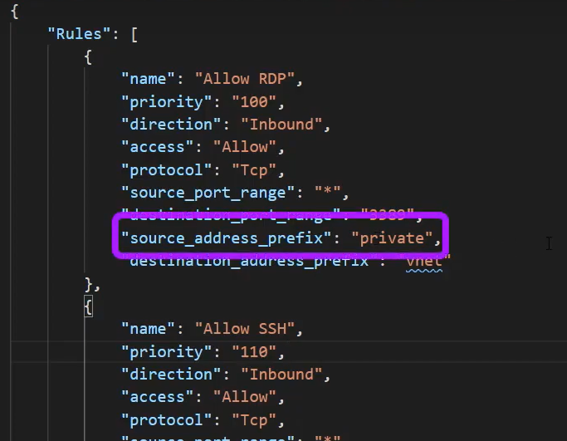
so above highlighted block is only meant for private connection in security group.
so we need to dynamically figure it out

here comes the logic:-
where this rule_mapping came and it is also local value so here it comes like:-

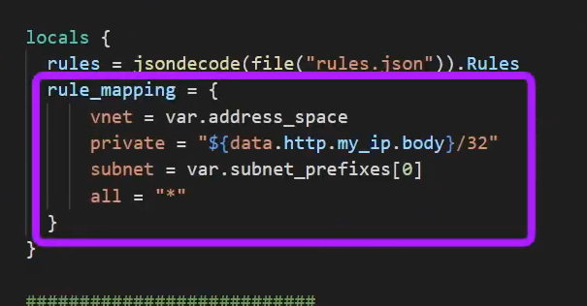

Now how we can call value for different data structure like:-

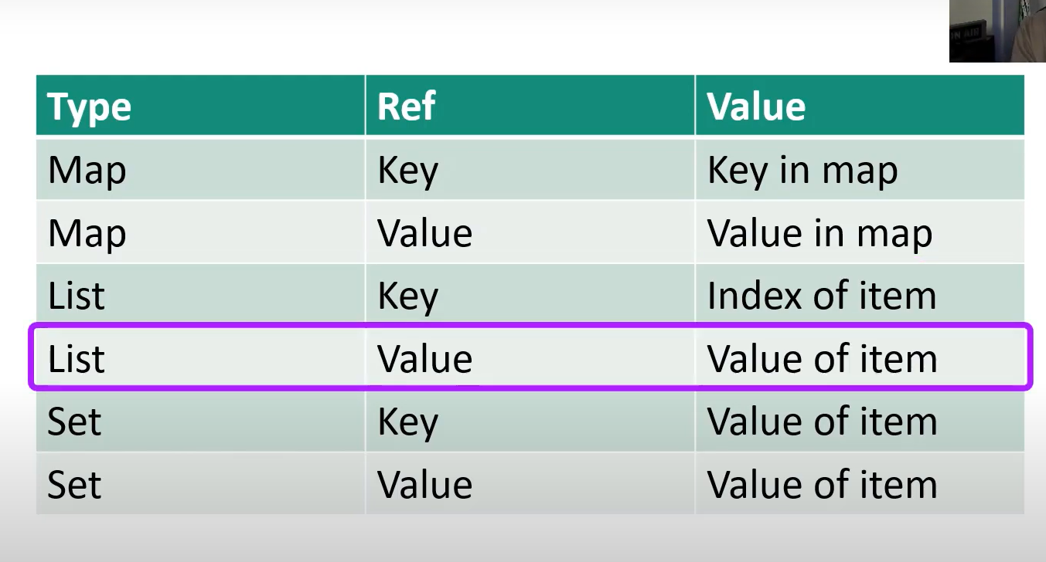

Important:-

for map :- so for first iteration only index 1 (loop 1) key, value will get iterated.
for list :- key is index and value is value at that index for each iteration
for set :- so set is unordered data structure so its key and value both refer to value of item.

Now lets say

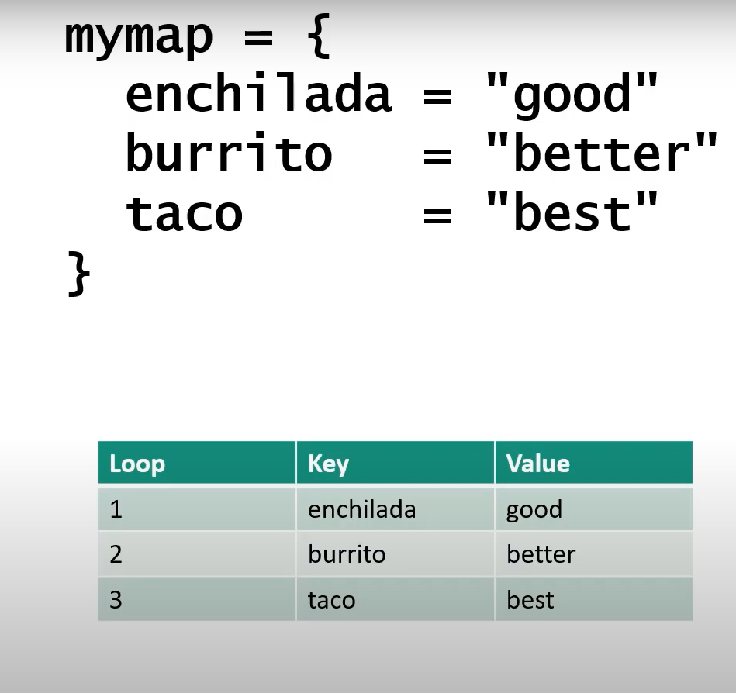

Important:-

for map :- so for first iteration only index 1 (loop 1) key, value will get iterated.

for list :- key is index and value is value at that index for each iteration
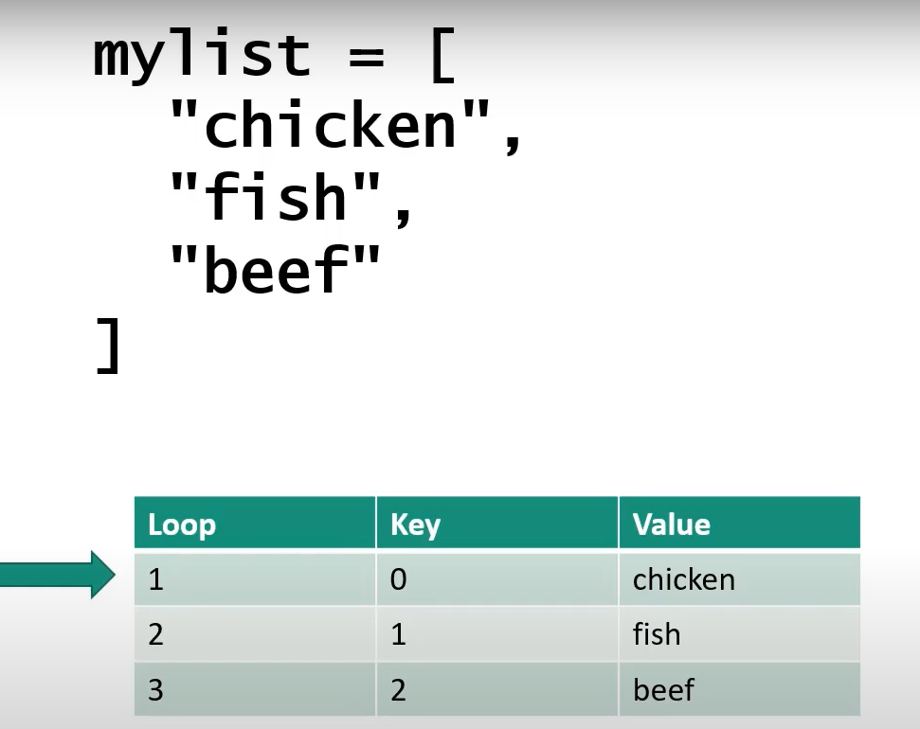

for set :- so set is unordered data structure so its key and value both refer to value of item.

we use toset function here.

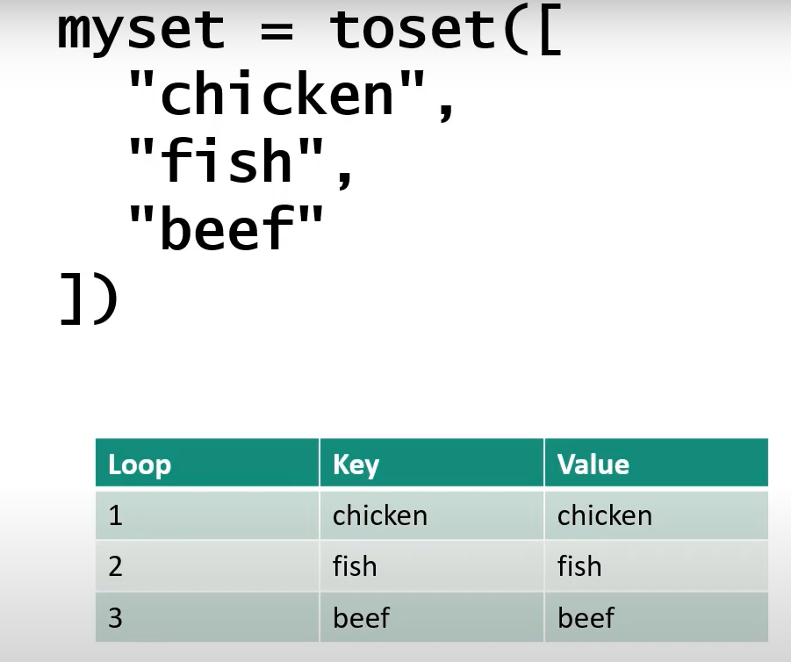

so you don’t know what order these value are going to be iterate.

Alternate way for dynamic group I.e doing same stuff with another way:-

- for subnet, we are using different resource azurerm_subnet , unlike dynamic block we have different resource here, in dynamic block we created an block in resource in azure_virtual_network.

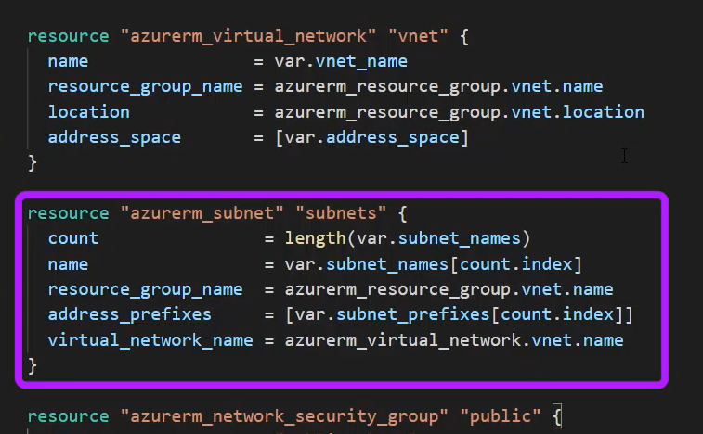

here we are using count so count will run through the list of name and using that count.index we can perform substitution.

- for network security group:-

here also we have different resource and we use for_each to parse json

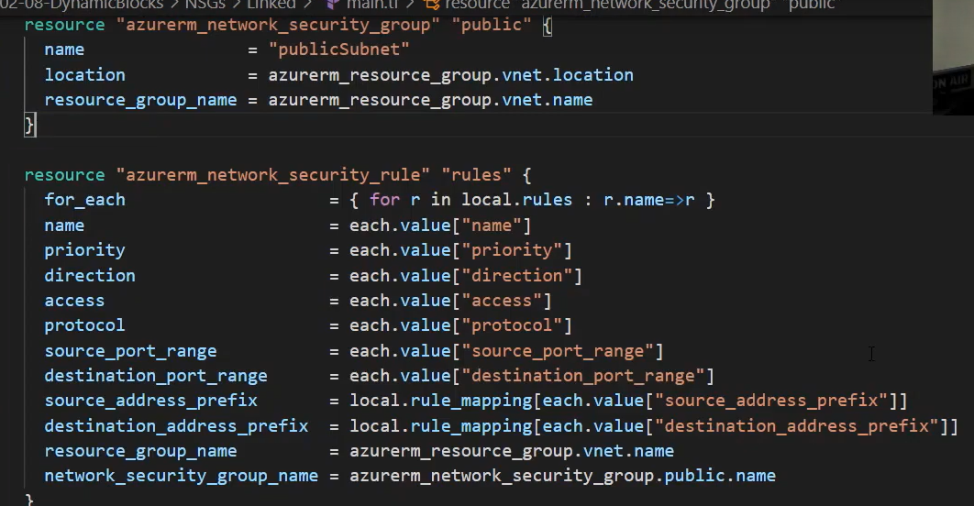

here we use for_each and it is parsing json from it

