Local value in terraform

Every things in terraform is module, the main file called as root modules and other than root file all other are called as child module.

reference:- https://www.youtube.com/watch?v=Yo06KIsKKN8&t=12s

variable are like parameter that is use to put value in template at before run-time. so we define we are going to use that much of data variable.

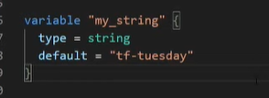

this is definition of variable in terraform. we can define varible like number(int), string, bool, collection like list, map, set. also we can create complex variable like list of map, of map of list.

locals
are those value which are created in run-time using other paramter in terraform

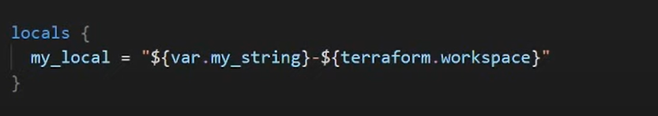

Inside this locals block, we can define one or more local value. that we will going to use further.

so this local value "my_local" we can use as replacement for this expression in our whole configuration file. so if we want to change this expression we have to do that in that single place and it will reflect everywhere.

variables defination in .tfvars file is like :-
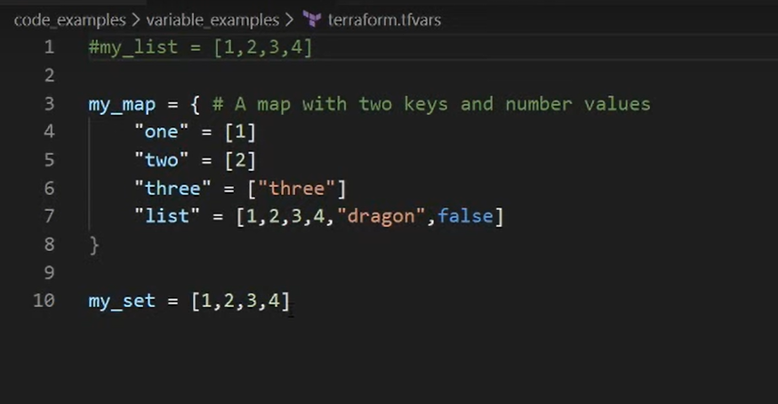

different type of value define in main.tf file as :-
1. list

# variable value1 {
# type = list(string)
# default = ["one", "two", "three"]
# description = "description"
# }

variable value1 {
type = list
default = [1, "two", false]
description = "description"
}
output value1print {
value = var.value1
#description = "description"
#depends_on = []
}

- map :-

# variable value1 {
# type = map
# default = {
# "hii" = "hello"
# "1" = 1
# "tg" = "ds"
# }
# description = "description"
# }

variable images { // "image" is use in older version of terraform
type = map
default = {
us-east-1 = "image-1234"
us-west-2 = "image-4567"
}
}
output value1print {
value = var.images
#description = "description"
#depends_on = []
}

