Loops in terraform:-

Reference :- https://www.youtube.com/watch?v=EiGD9G0Wj3A&t=112s
https://jhooq.com/terraform-for-and-for-each-loop/

we want to iterate collections like list, map, set.

- List ==> this is how we can store value

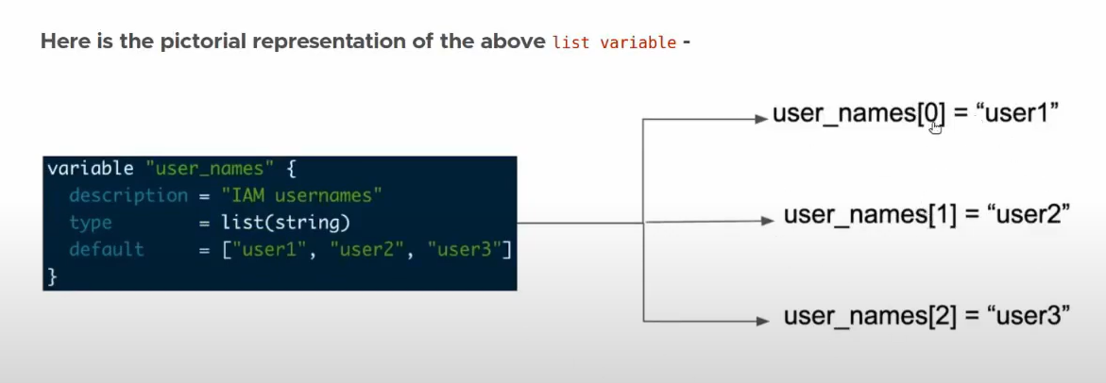

Note :- The "count" object can only be used in "module", "resource", and "data" blocks, and only when the "count" argument is set.

