Beamstalk:-



like BeamStalk :- it grows by its own.

Elastic Beamstalk is design for those user which have no idea about important aws services like IAM, EC2, s3, EBS and etc.

lets suppose your intention is only to spon a wordpress site only without going to much detail.
this will autoscale it self to meet the traffic demand.

Compute ----> Elastic Beamstalk

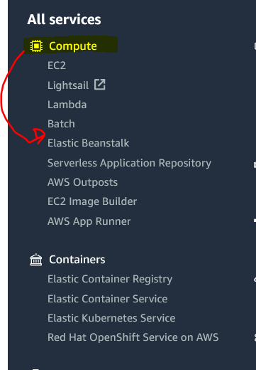

check all compute services.

so with Elastic Beamstalk, you don’t need to know about aws, just go there and upload your code.

Give your application name and platform
we will use PHP. as our wp is php application.

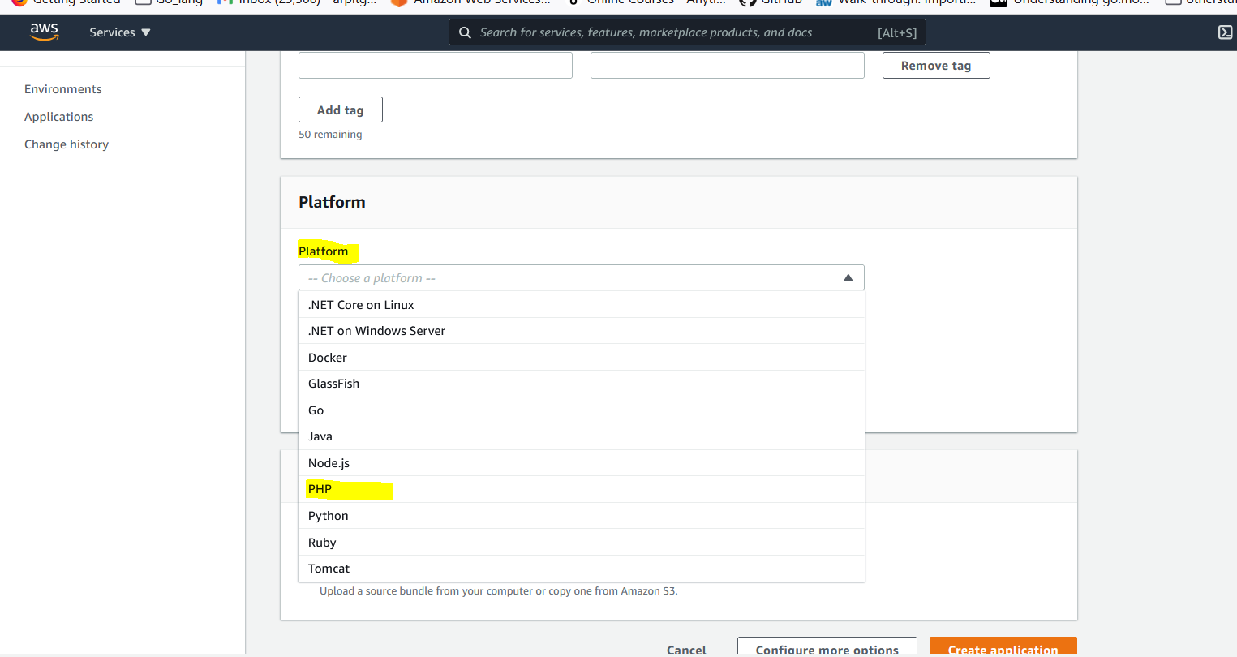

then choose:-


there sample application already have some code, it is not from stratch.

hit on "create application".

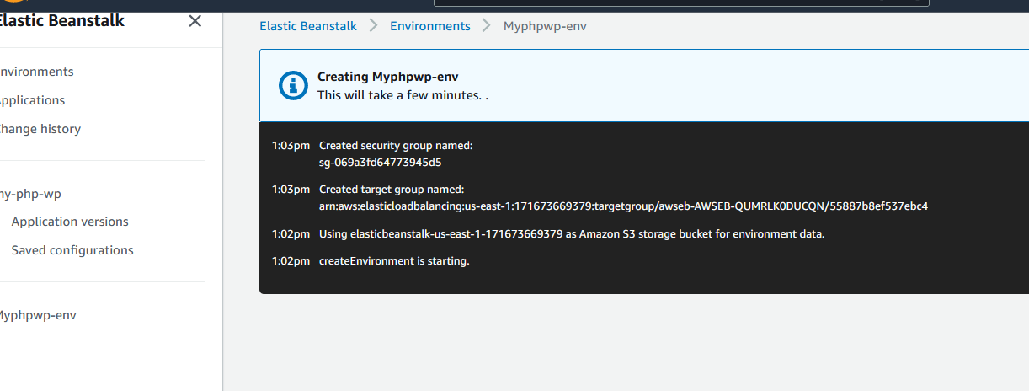

so you can see this automatically create SG, TG, S3, and you env.

Now you just need to upload your code and leave rest on aws.

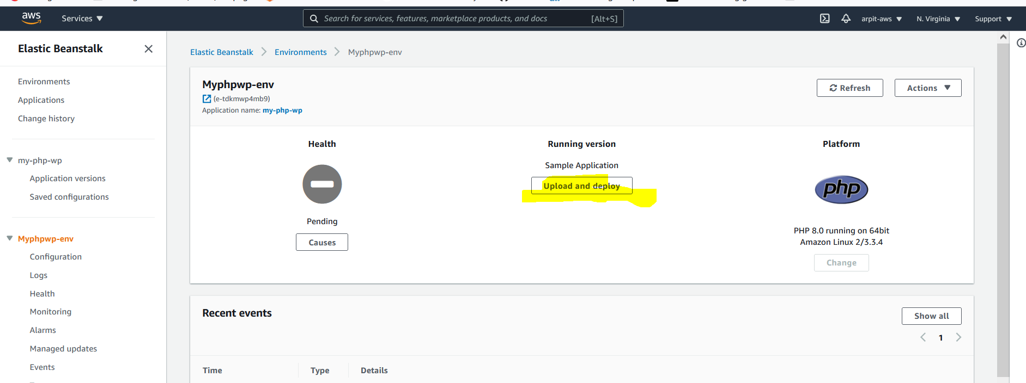

that it.

go to action ---> delete application to delete .

Exam tips:-

