Now here we are going to introduce more resilience to our wordpress site.

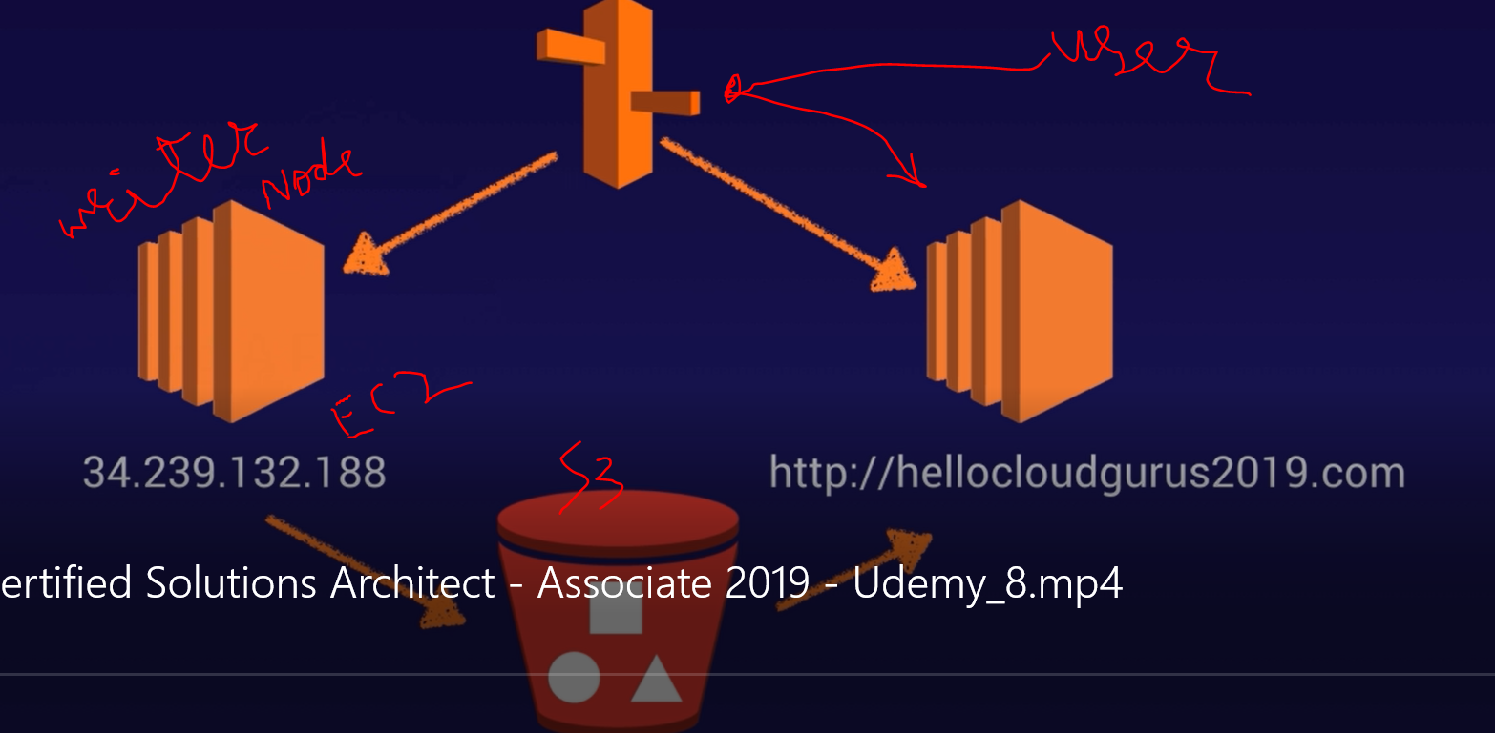

This IP address for our current EC2 instance, this is also a writer node to S3, so suppose when marketing team want to edit something/ write some blog post for wordpress site so it can can navigate directly to S3 bucket from this EC2 write node instance using aws s3 sync in crontab. This EC2 instance are going to use push anythings to S3 bucket.

Now then we also have bunch of EC2 instance which is mange by auto-scaling group so when we have new code pushed to S3 so these EC2 instance keep on pulling code from S3 bucket. say Read nodes

so when user hit URL it route53 will redirect it to auto-scaled group's EC2 instance.

Step 1:-
create golden image (AMI) for ec2 instances under auto-scaling group. says Read node.
Now goto /etc directory and do vim crontab

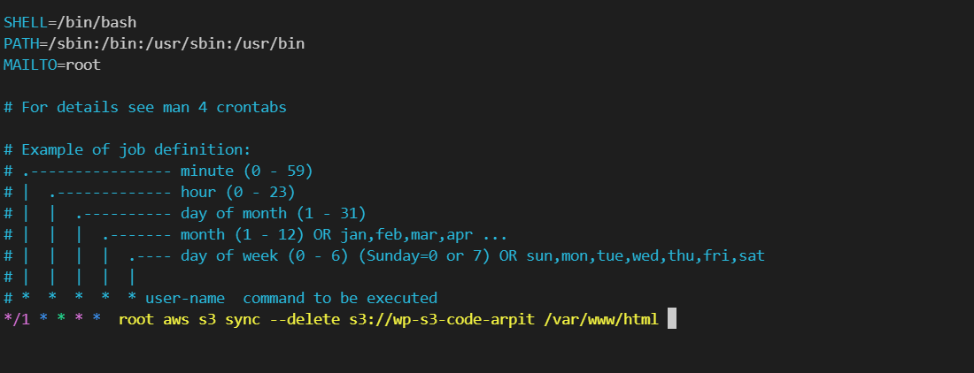

So it means every minute EC2 under auto-scaling group will check any change in S3 bucket, if change happen then it will pull those changes, so over server always works on latest changes.
lets say EC2 instance of these images as Read node

--delete option is used because if we delete anything in S3 it will also got delete from EC2 instances. to make perfect copy.

Save crontab and Optionally you can start crond service.

$ service crond restart
$ service crond status

Testing :- Now upload any file in S3 and check whether it is present in EC2 or not.

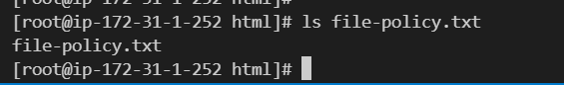

now lets create image of it, select EC2 instance --> action --> create image ---> go to ami section.

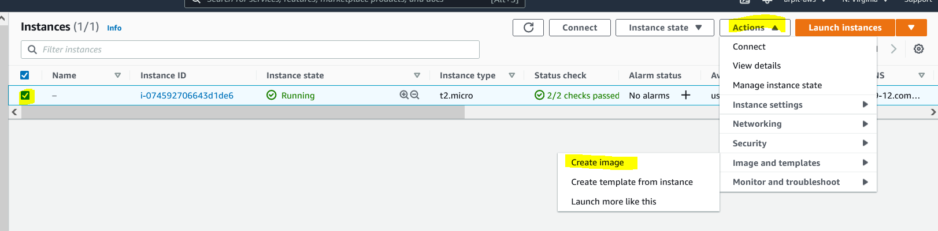

Step2:- Now prepare base image for writer node.

go to vim /etc/crontab, and edit like this.

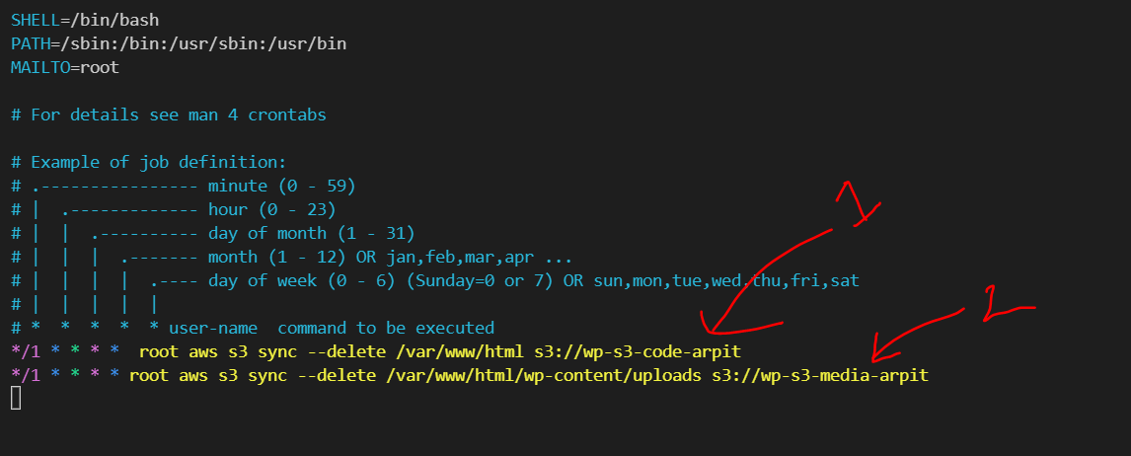

- code will be send to code s3 bucket.
- media will be send to S3 media bucket so that it will then serve as cloud-front.

we don’t want our write node to be public ally access-able.

we can also create ami as we did for reader nodes 's golden image.

now test this writer node :-
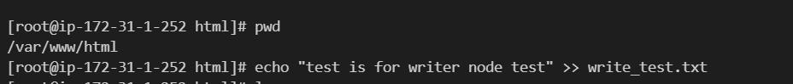

now go to s3 bucket and see whether changes are reflected or not.

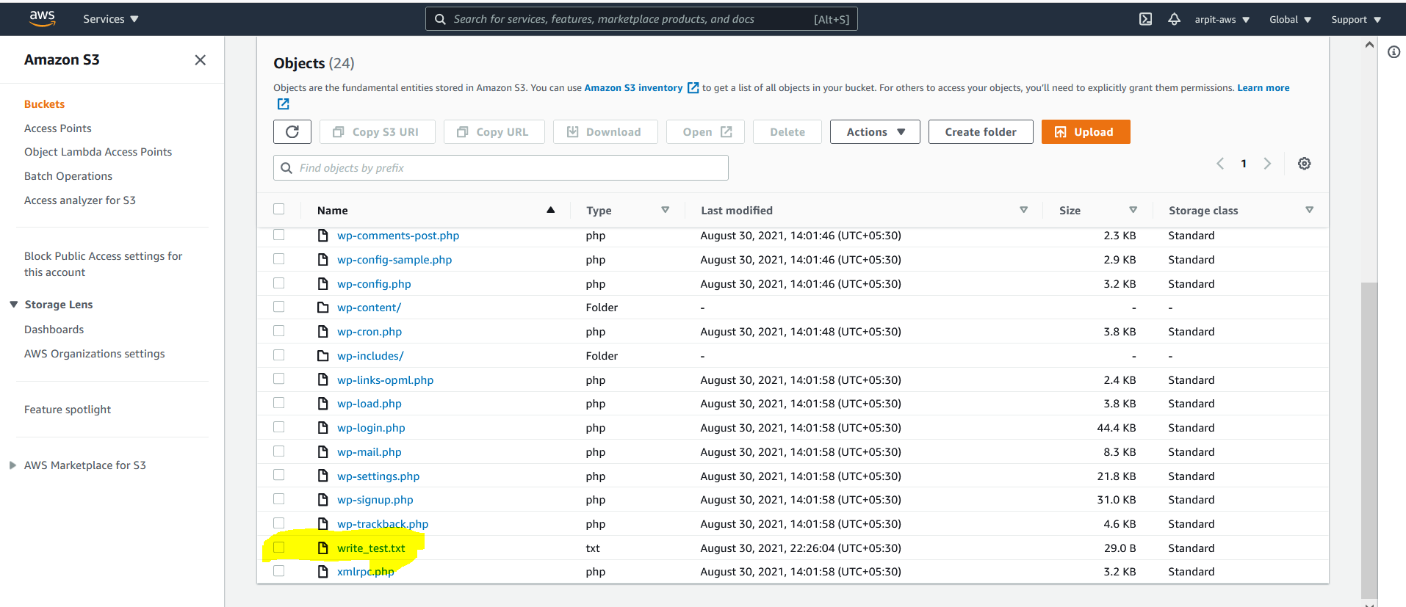

Okay this is there.

Step 3:- test writer to reader node flow via S3 and cloudfront.

now lets create an auto-scaling group for those Ec2 instance which are create with reader node's golden image and and try to change content using writer node.

step 3.1 :- create launch template

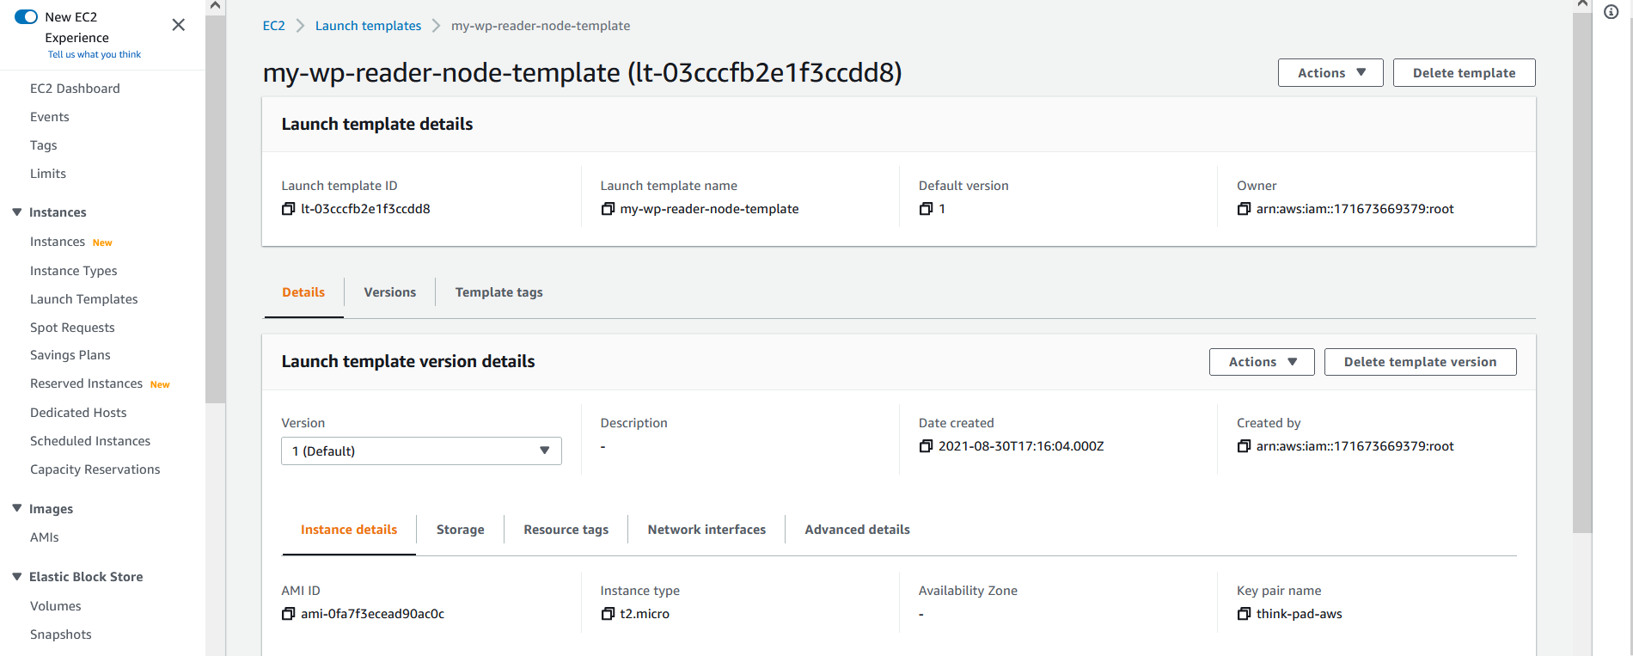

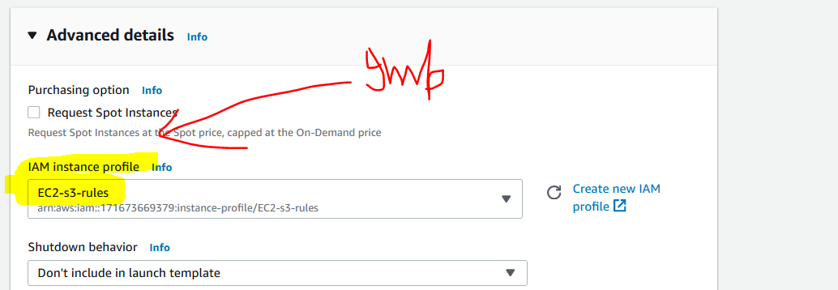

select public ip allocation and security group

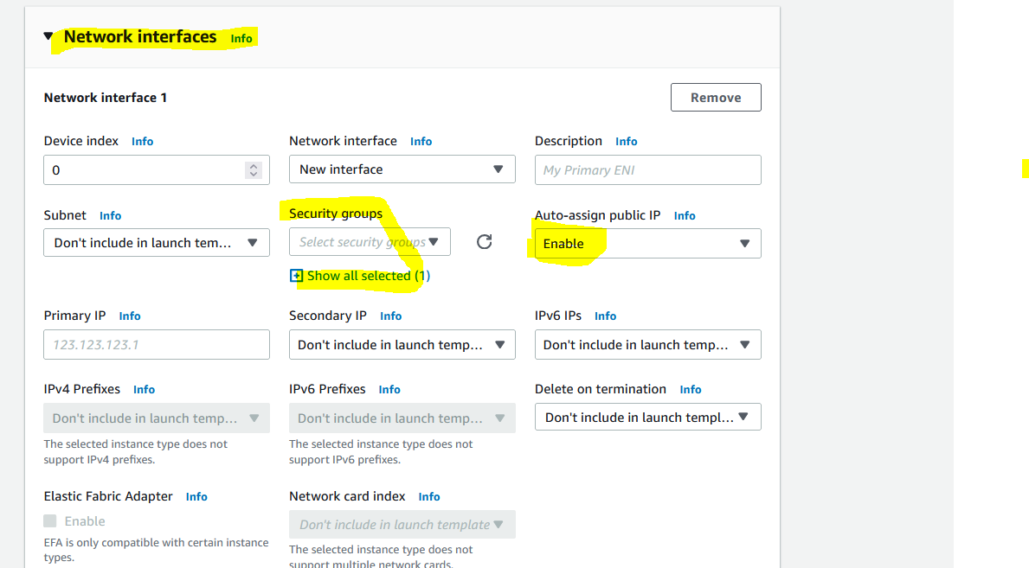

use this bootstrap script :-
sudo yum update -y
aws s3 sync --delete s3://wp-s3-code-arpit /var/www/html

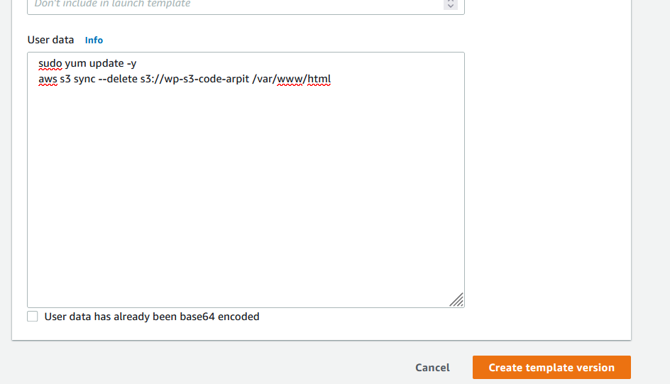

Step 3.2 :- create auto-scaling group.

select launch configuration template,

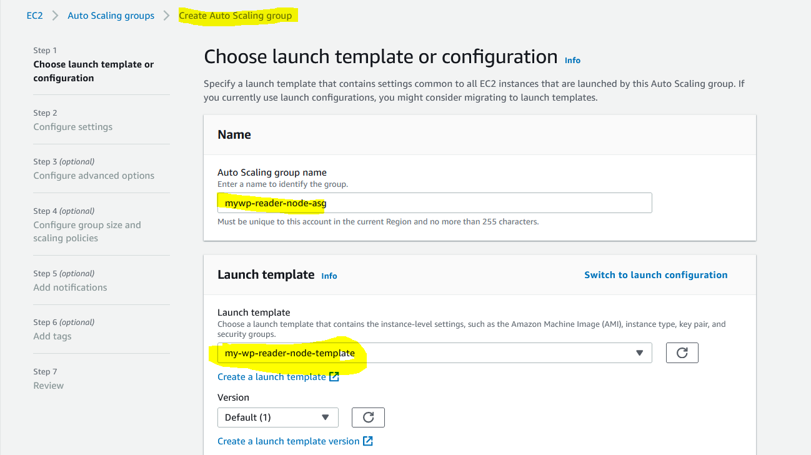

choose new load balancer and target group.

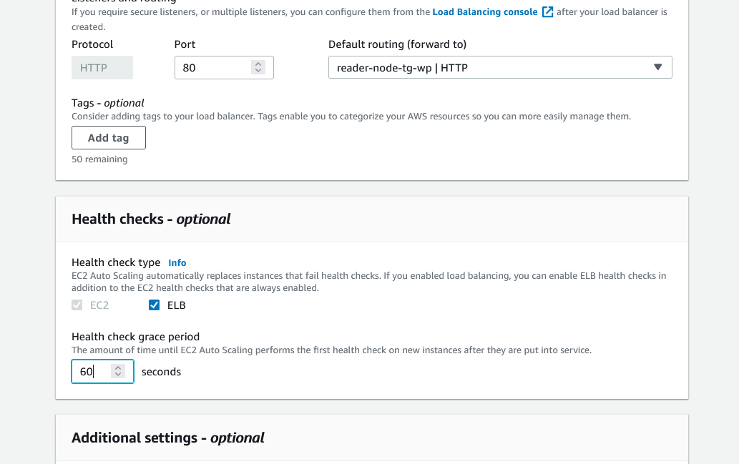

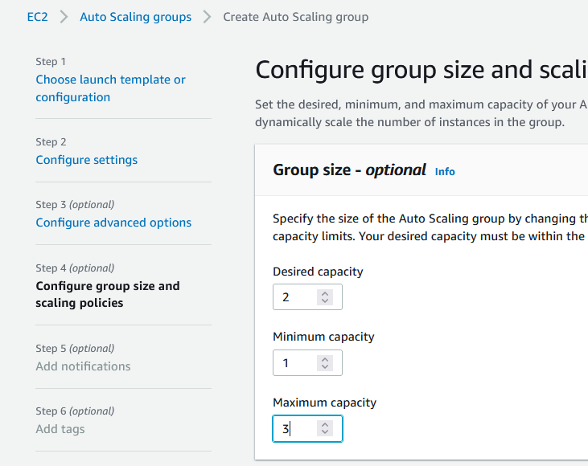

Now we can see we have reader and writer node available onto EC2 Dashboard.

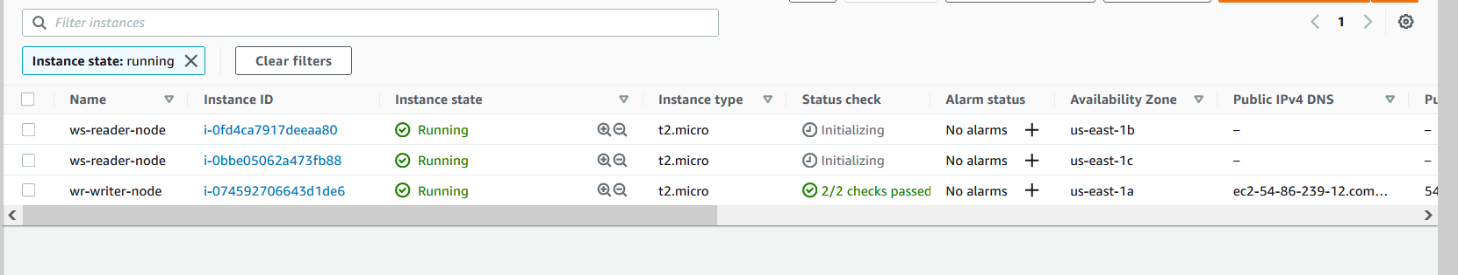

Also our target group says it is healthy.

