Auto-scaling intro:-
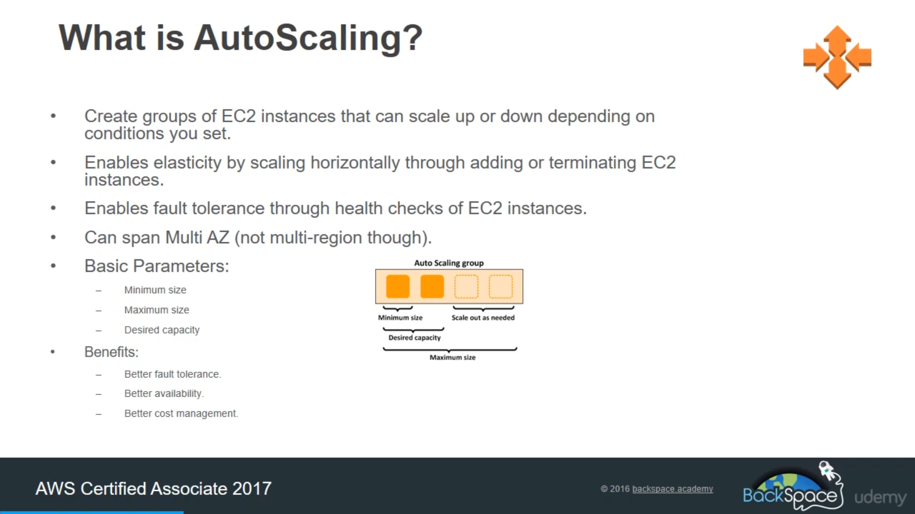

What are Launch Configuration :-
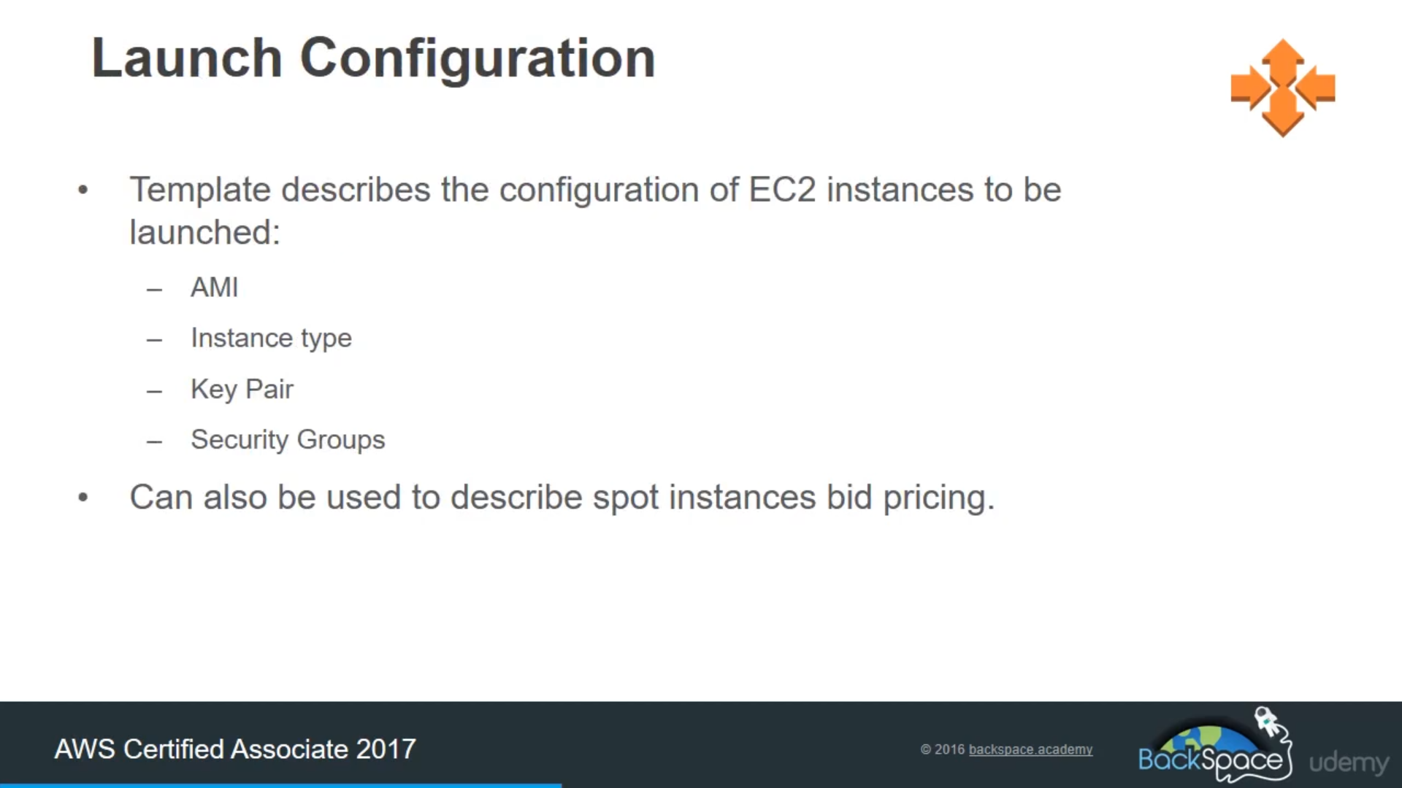

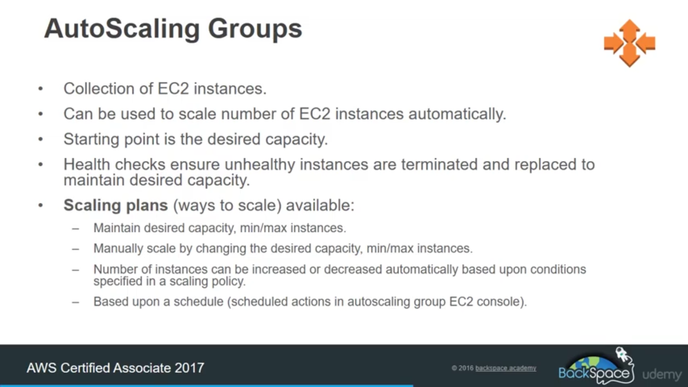

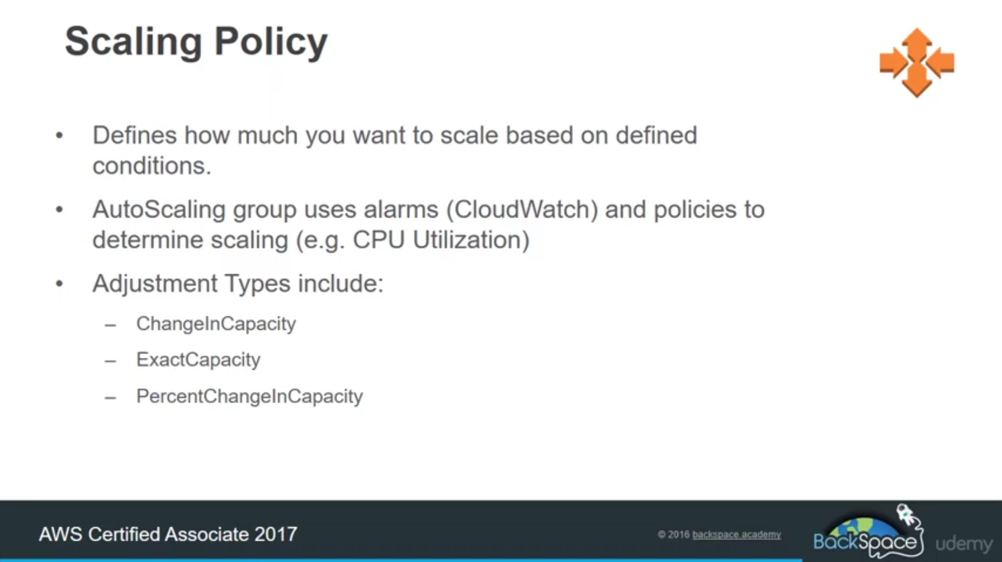

under auto-scaling you have two option:-

Go to auto-scaling group --> give name and create template.

there is no extra cost for auto-scaling-group only we have to pay for EC2 instance and cloud watch that we use.

Under Launch template:- This is set of instruction on how to create an EC2 instance, will use further in ASG, it is just configuration not exact EC2 instance.
Just fill this launch template form.

Some information about my Launch templates:-

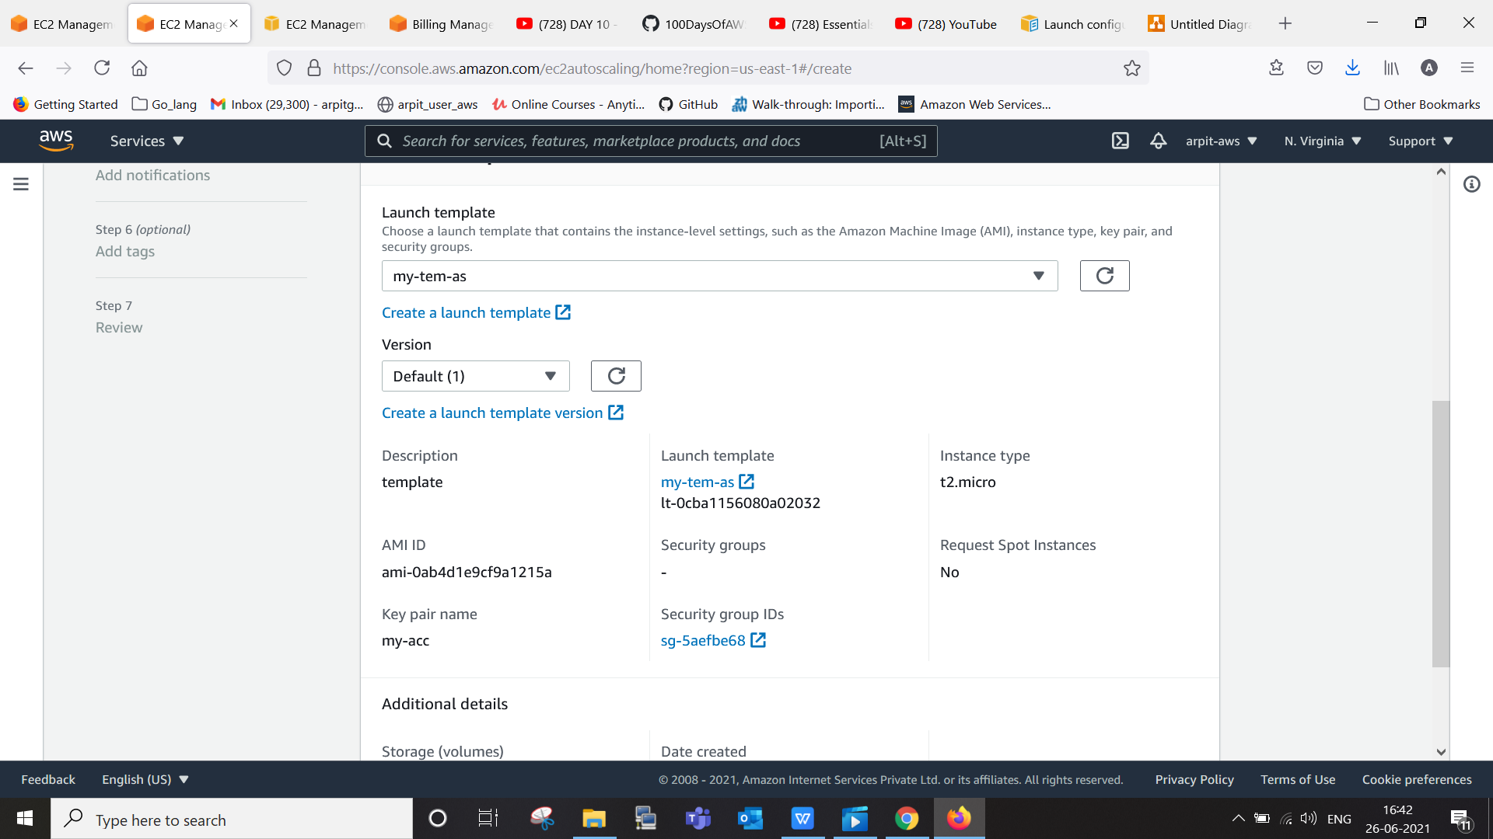

we put this script as well:-
#! /bin/bash
sudo yum update -y
sudo yum install httpd -y
sudo service httpd enable
sudo service httpd start
sudo echo "<html><head><b> arpit aws </b></head><body>this is ec2 ip = $(hostname -f) from ASG</body></html>" > /var/www/html/index.html

Now go to auto-scaling group and start creating one.

Choose this option for now and select vpc and multi subnet

PTO
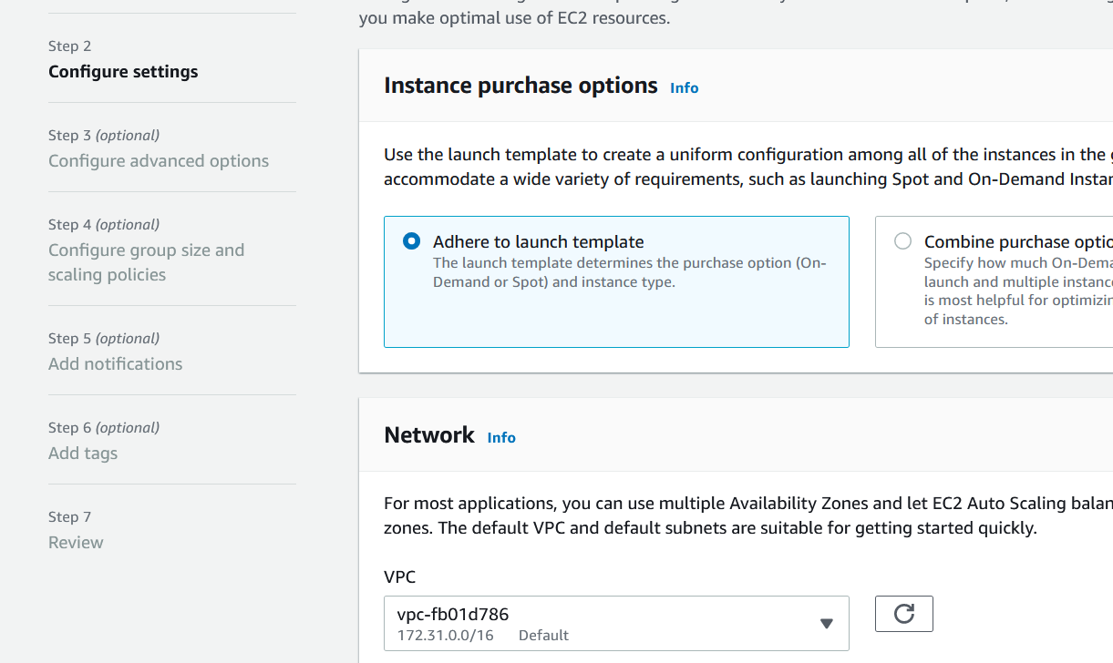

now select load balancer (optional)
1. for this case we will choose Application load balancer
  - we have to select it is internal or internet facing ==> we choose internal
  - choose subnet in which we want to expand our infra,
  - now create one target group.
  - make monitoring as 10 sec for EC2

Do next

- In advance setting
  - say min =1 max =3 desired =2 as capacity
  - for auto-scaling policy, put that to "none" for now we will add that later.

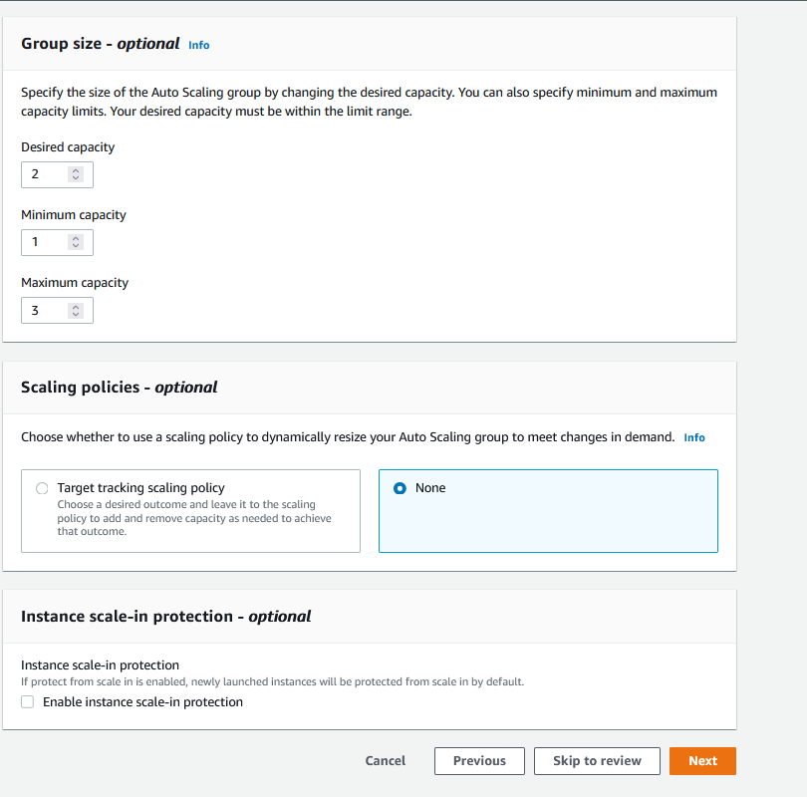

- skip notification for now and then go to review.

- Now if we click on created it will spon EC2 instance, load balance, target group and other things .

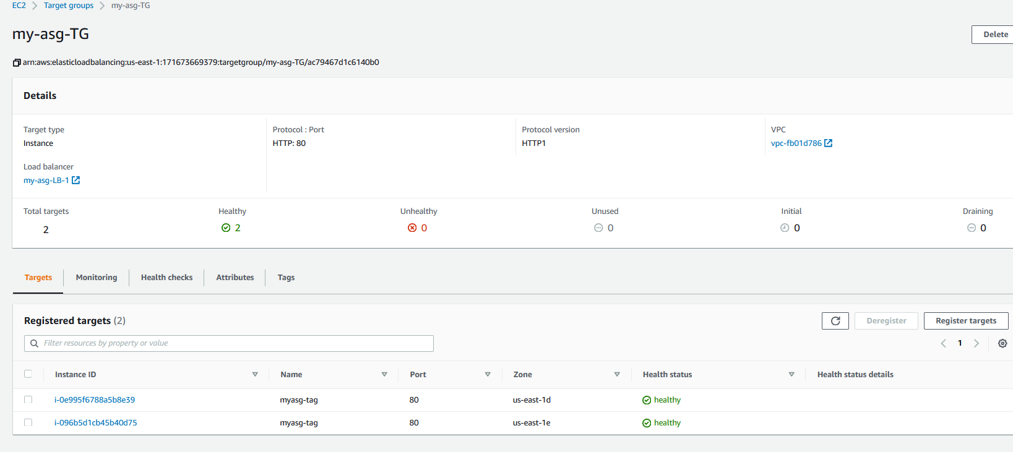

- for detail ---> ASG--> click on you asg ---> activity tab ---> shows list of activity.
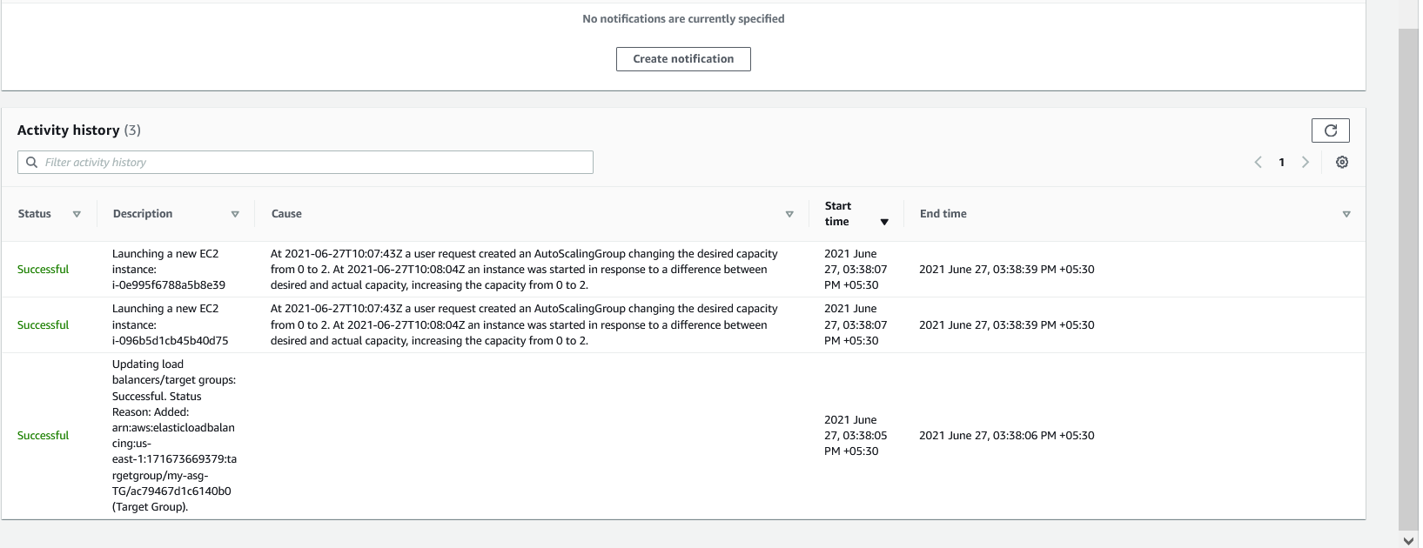

3.when we go to target group it automatically contain all EC2 instance created by asg.

then go to load balancer and copy dns name run that on browser.

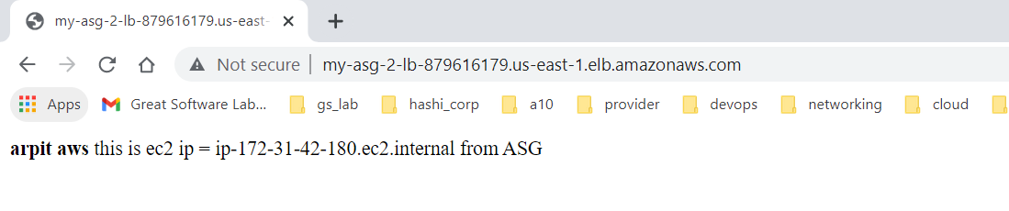
now lets go to auto-scaling group and change min number and go to activity tab , you will see change happen.

Now scaling policy

select dynamic group policy

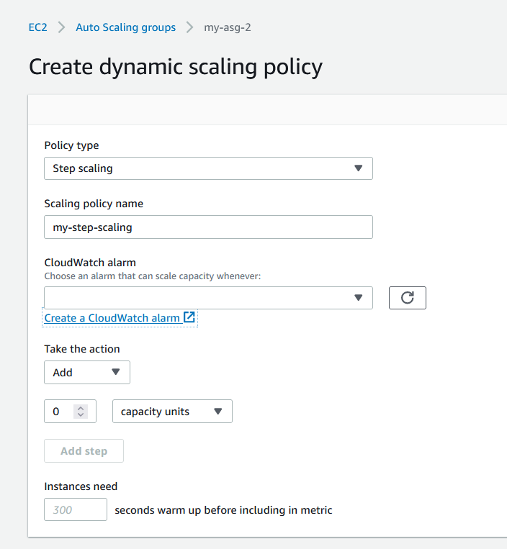

create cloud watch
for ec2 ---> asg--->cpu utilization.
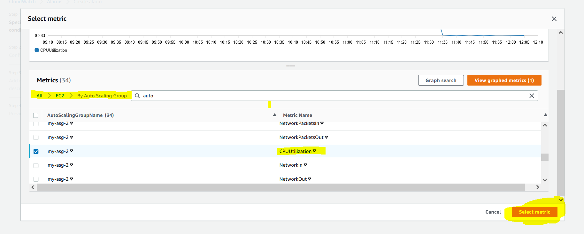

now select thrush hold value I select 30 (just for ease in testing)

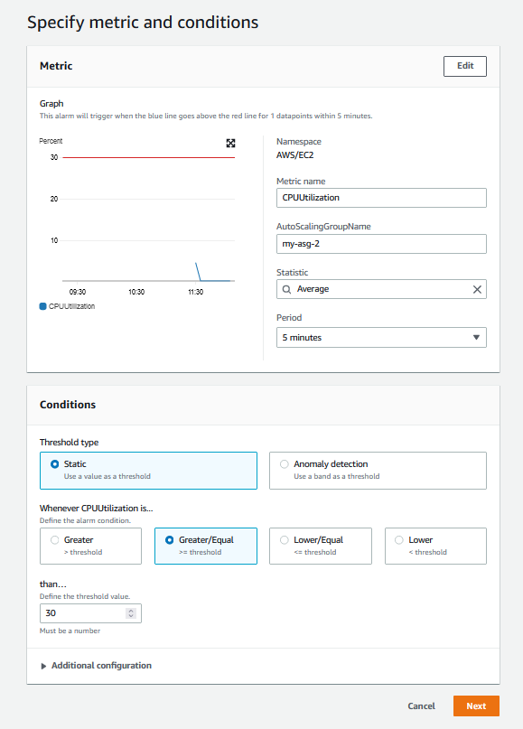

go to sns service and configure that.

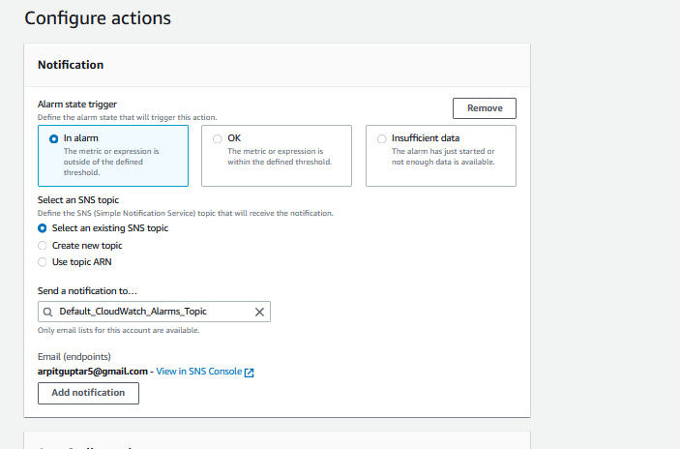

now cloud-watch is created and attach that cloud watch into asg.

so it say when cpu usage goes above 30% spon new instance

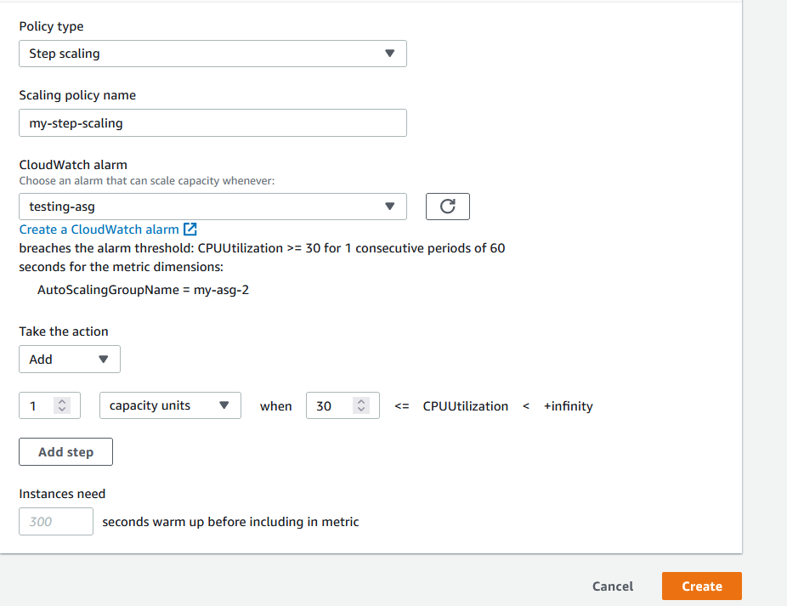

use this to install stress :-

Login into EC2 instance
You have to enable EPEL repo in Linux 2 AMI:

- sudo amazon-linux-extras install epel -y

Now, try to install stress:

2. sudo yum install stress -y

- sudo stress --cpu 8 --vm-bytes $(awk '/MemAvailable/{printf "%d\n", $2 * 0.9;}' < /proc/meminfo)k --vm-keep -m 1 ====>>> this will flow traffic

after few seconds :-
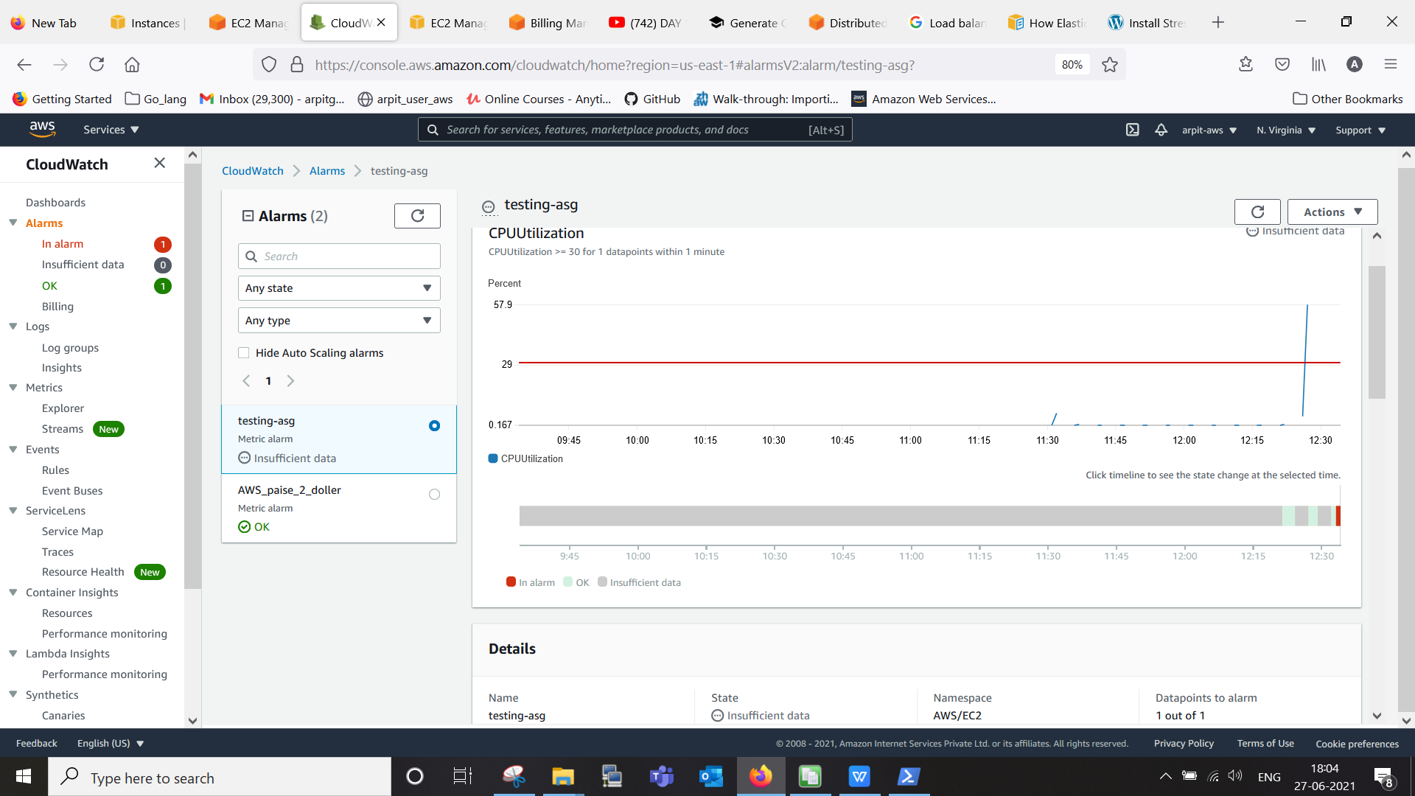

we can see here alarm trigger and I get notification on my mail regards to cpu.

also we have one another ec2 instance spin auto-automatically,

