Reference:- https://www.youtube.com/watch?v=T4Z7visMM4E

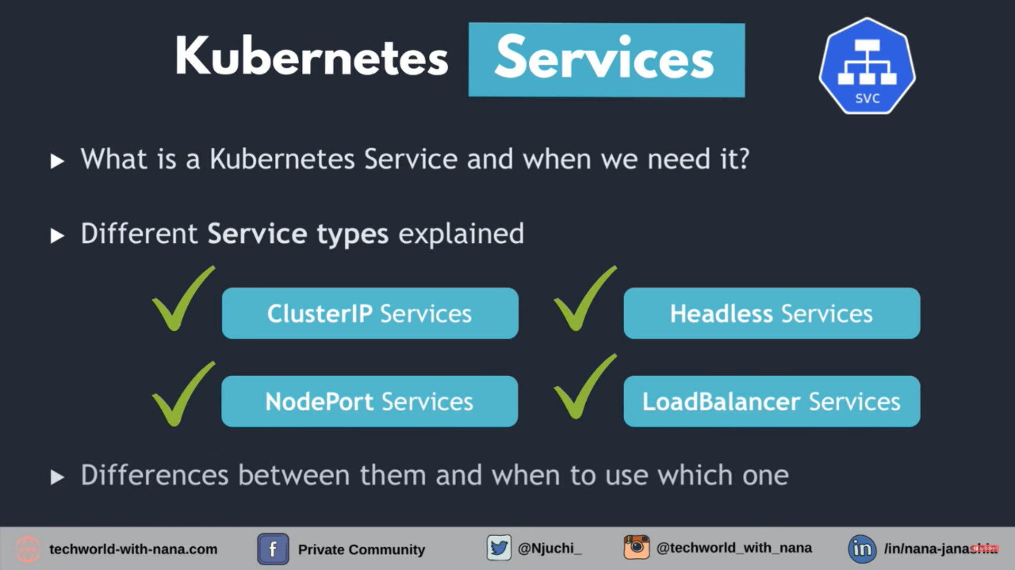

what is service:-

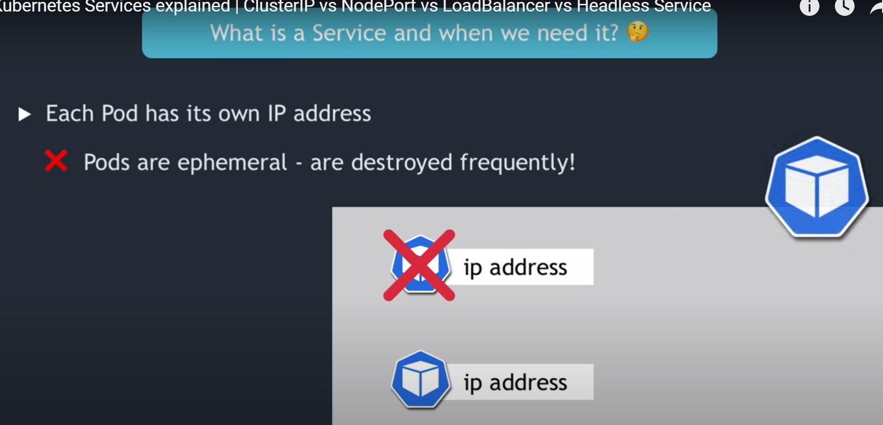

We know that each pod has its own IP, but these IP are ephemeral i.e. they may get destroy when pods destroy. and new pod has its own IP.
Therefore, it is not good idea to refer pods by its IP address, as in micro-services pods get recreated.

So Service provides solution like
- Stable IP:- Ip address which stays even when the pods Dies.

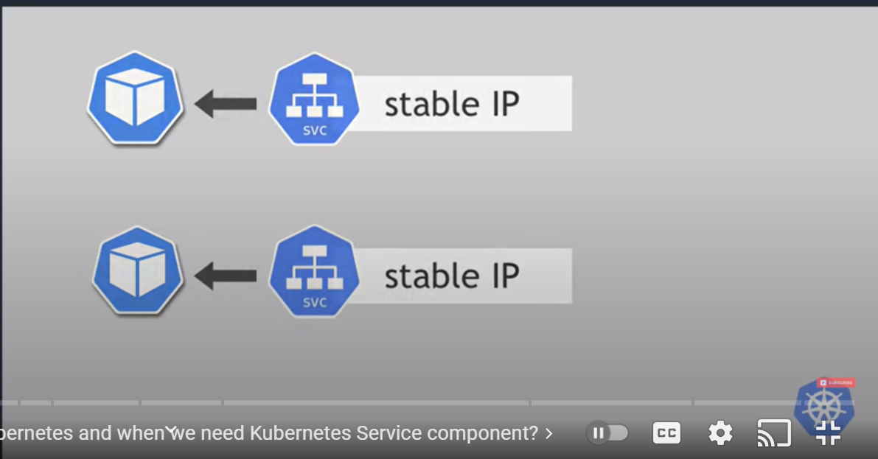

- Load Balancing:-
suppose you have pods replica (say mysql), and you need to distribute request coming from client.

So client can call single IP (LB ip) instead of calling replica individually.

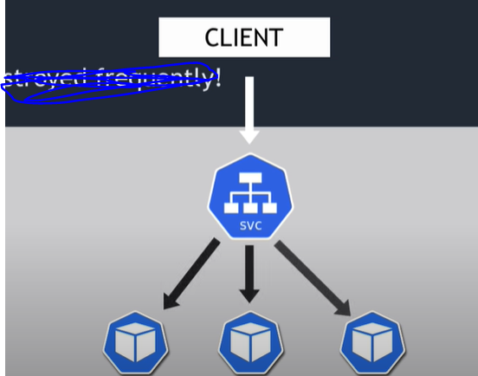

- Loose coupling :- communicating pods within cluster.
- Outside of cluster :- If request coming from outside browser.

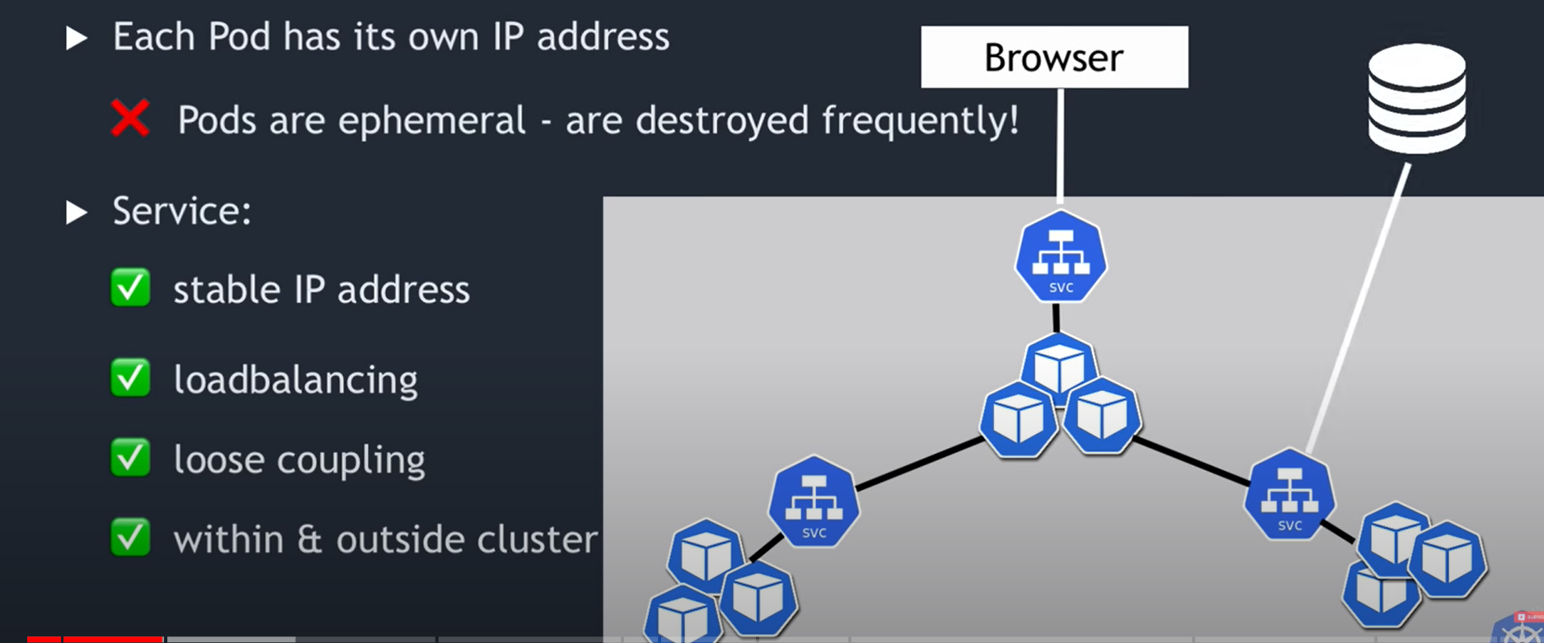

Types of service :-

- ClusterIp :- most common, this is default type, when you didn't specify any service in cluster then it is default.

How it works:-

