SQS:-

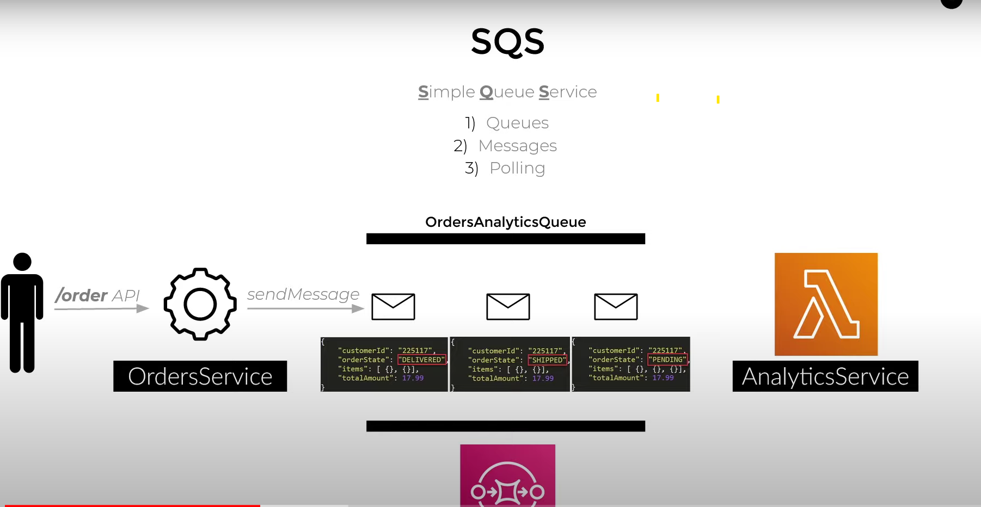

This order server send info to lambda for some analytic so it use queue, ie 1 to 1 mapping

DrawBack :- if want to send one to many so message send to first consumer delete that message so data missed for other consumer

Remember :- sender is not owner of queue, it receiver who is owner

SNS :- PUB SUB model

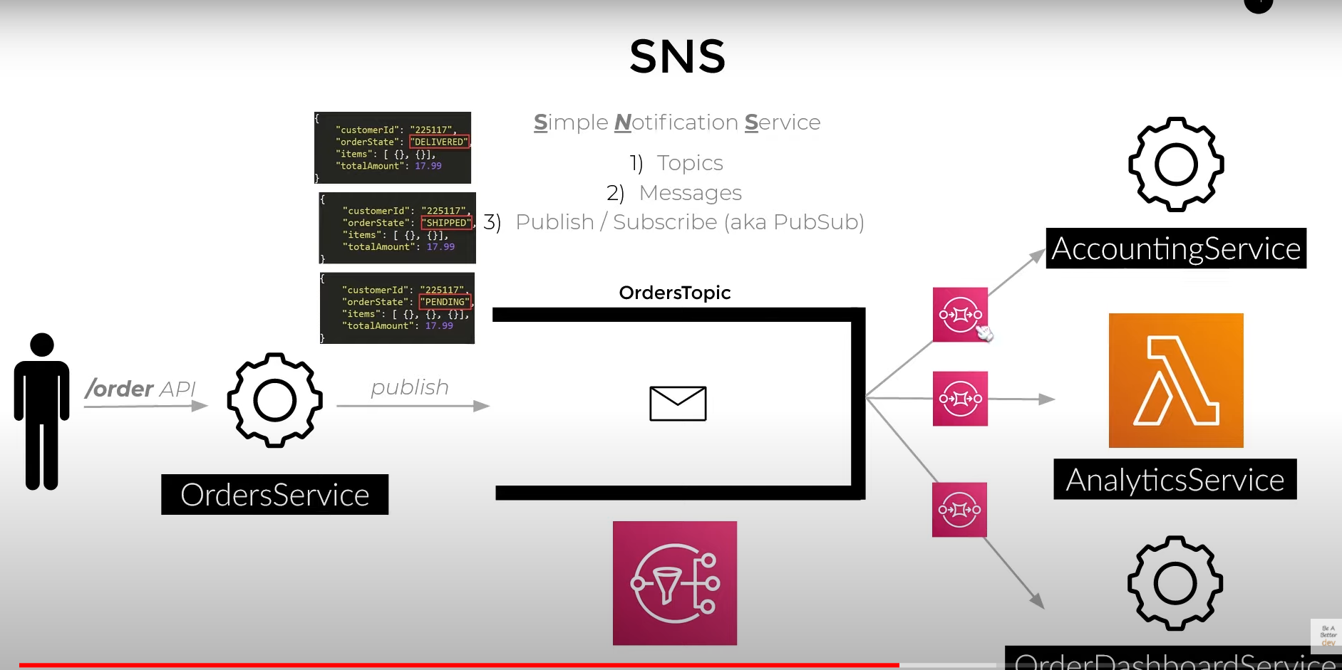

Publisher send message to Topic (kind of queue) which is copied to queue (SQS) and attached to respective subscriber.
Why SQS is used in SNS because suppose if one subscriber fail so message will not transmit to that subscriber, so message stay in Topic and it just full the Topic and no new message is fitted

