Source :- https://www.jenkins.io/

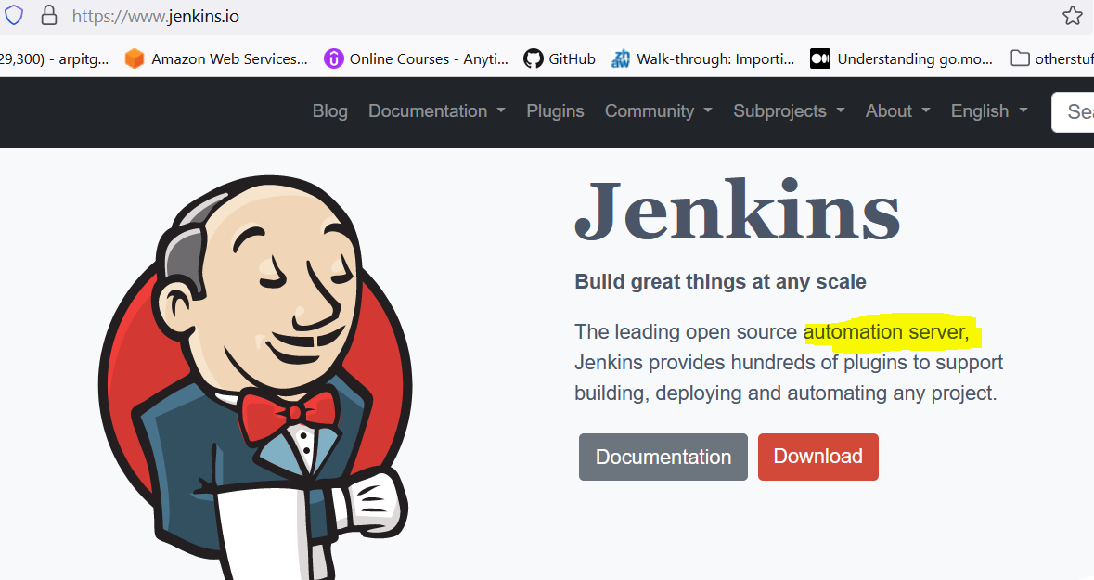

Jenkins Is purely an automation server.

so it help to achieve automation, but in current scenario it use heavily for CI/CD.

