Here we are going to build serverless website using API gateway and Lambda.

here is use-case that we need to use

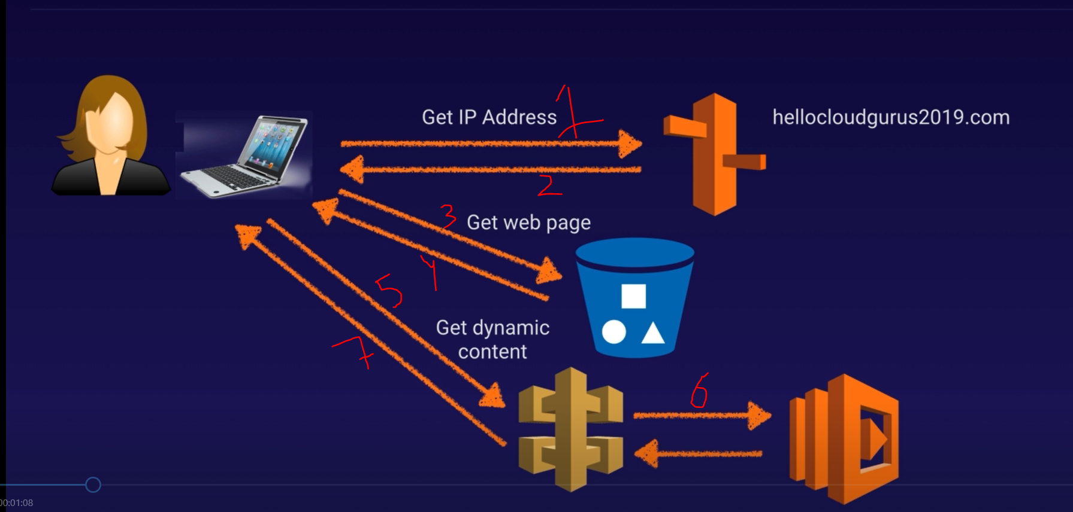

1 -> request came to URL
2 -> route53 send reference to S3 bucket which have static index.html file in it. suppose index.html file contain one button which can serve dynamic content.

3, 4 -> request and response for static page which have button for dynamic content.

5 -> for dynamic content api request send to API-Gateway.
6,7 -> this will then pass to aws Lambda , process it and get back response.

Now Hands-on :-

compute --> lambda --> create function

you will get something like this

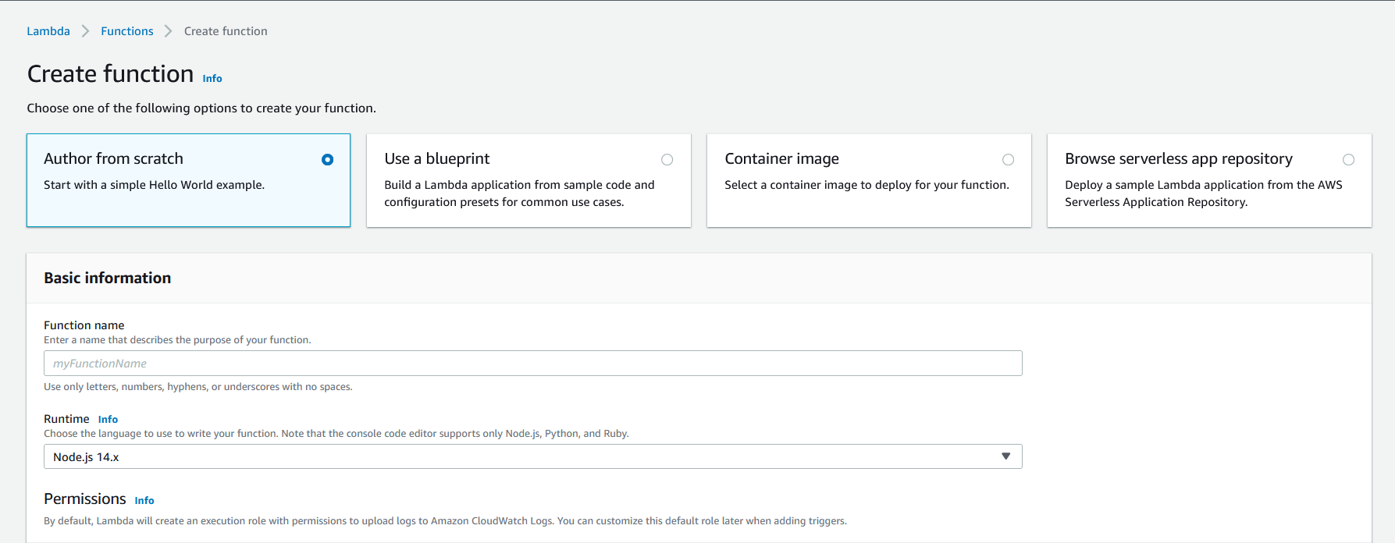

Author from scratch --> write from scratch
use a blueprint --> use case -> writing alexa application, you don't need to know code, these are simple blueprint.

browse from server less app repo --> these are pre build serverless app (very useful).

Step 1:- select author from scratch

- give name
- choose run time environment ---> I will choose python 3.6
- execution role --> first time so we will create new
- from role template we will choose simple microservice permission

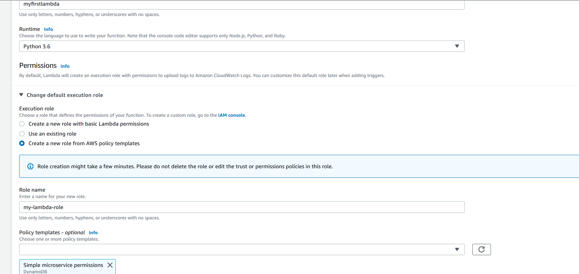

now click on "create function"

our function is created, it have primarily overview (function designer), code session, env-var, and other setting.

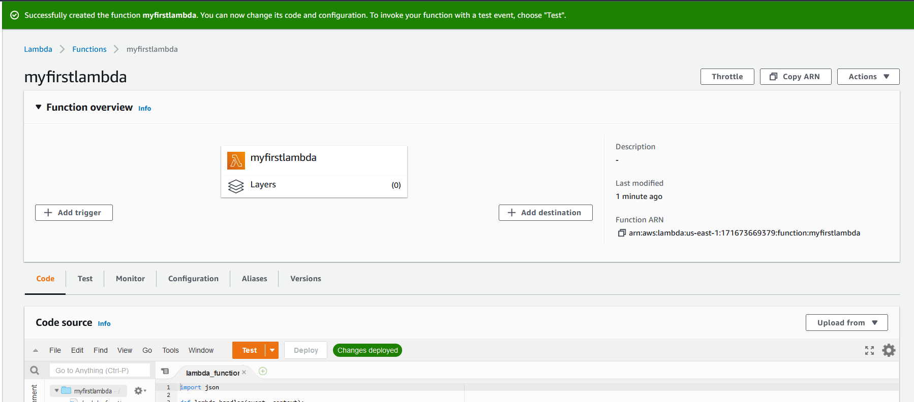

this is our IDE :-

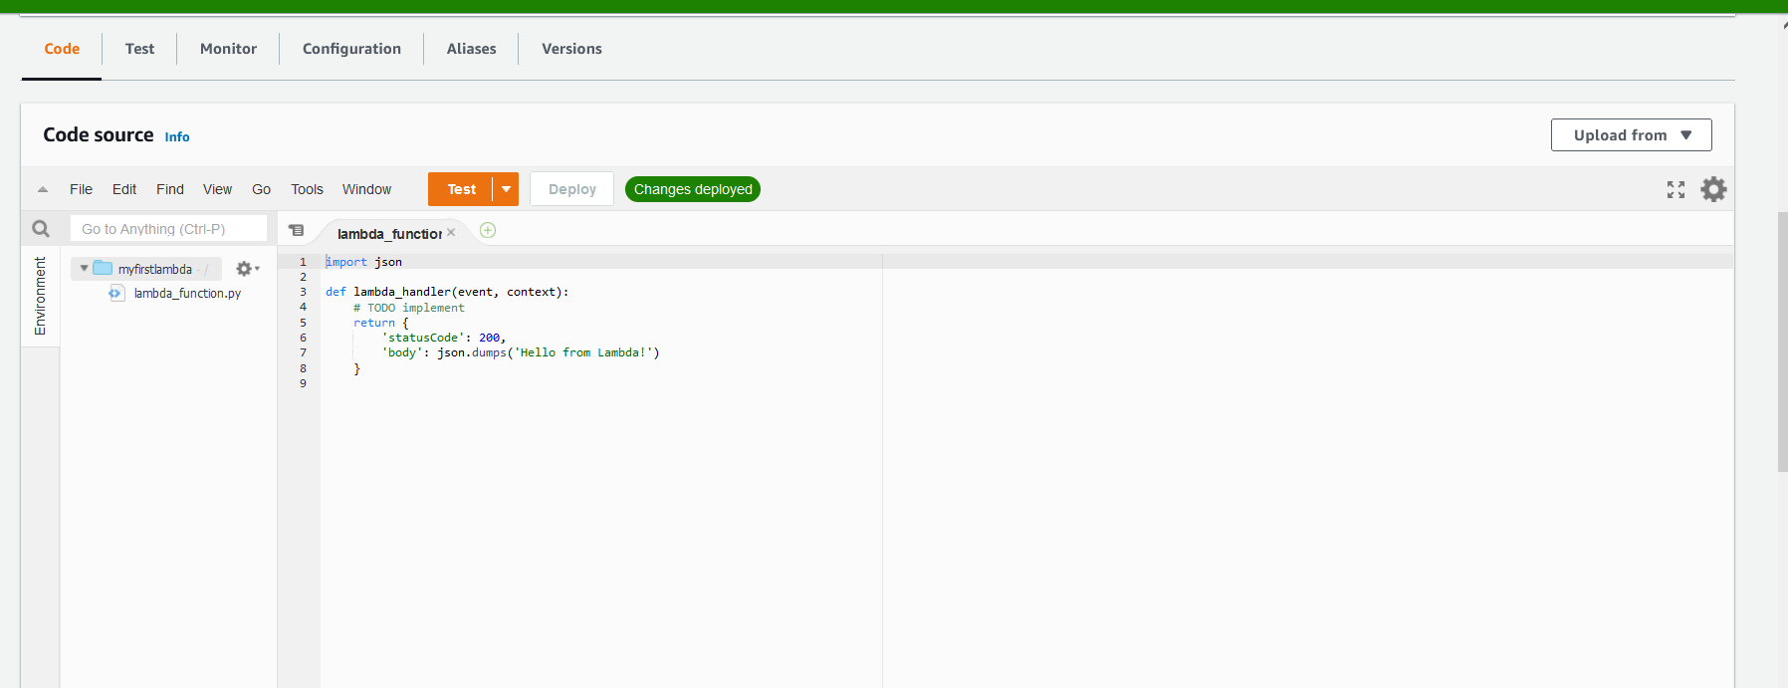

step 2 :- understanding this UI

- Add Trigger --> mention what triggers your lambda function

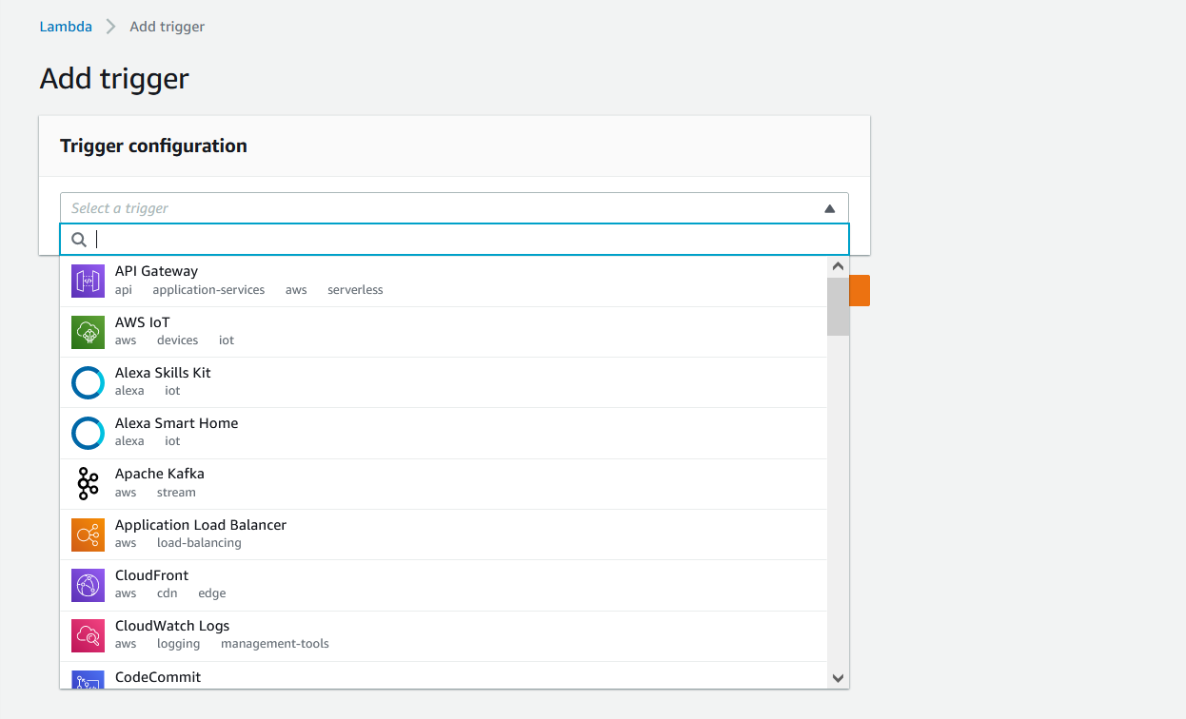

for our case it is API-Gateway, but for exam we need to understand others.
like aws-IOT, DynamoDB, cloudfront, codeCommit(devops - git), thirdparty like oneLogin
like RDS is not here

- we have IDE to write Python code.

Step 3:- writing code

so lambda is function, and function run only when it is called. so should be triggered.
here beamstalk is used to create application, but with Lambda our intention is to run backend code.

ec2 vs lambda => if you have sporadic task use lambda, and if you have all time running system use ec2.

use this sample code and don’t forget to save file

def lambda_handler(event, context):
print("In lambda handler")
resp = {
"statusCode": 200,
"headers": {
"Access-Control-Allow-Policy": "*"
},
"body": "arpit gupta"
}
return resp

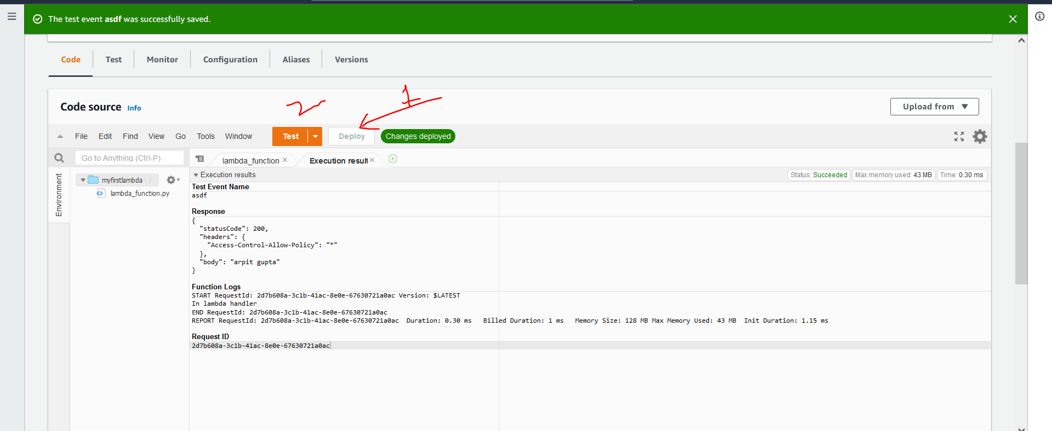

click on deploy.

Step4:- create API Gateway

- try with Http API

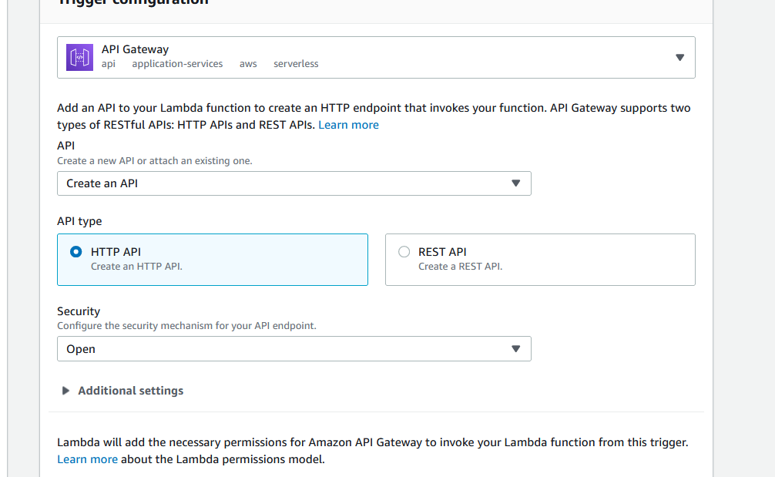

we make security as open, otherwise we can also use JWT token authentication.

click Add.

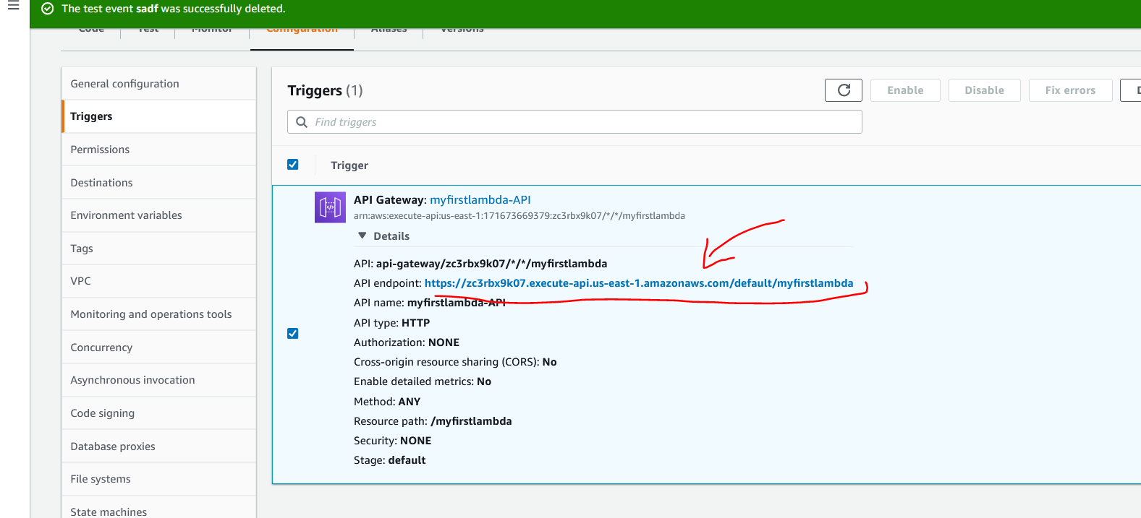

hit this API, we should get response :-

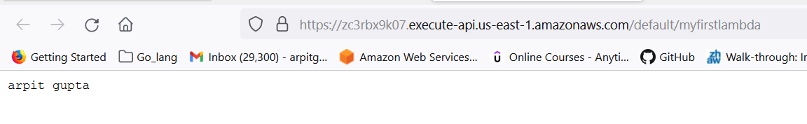

- try REST API:-

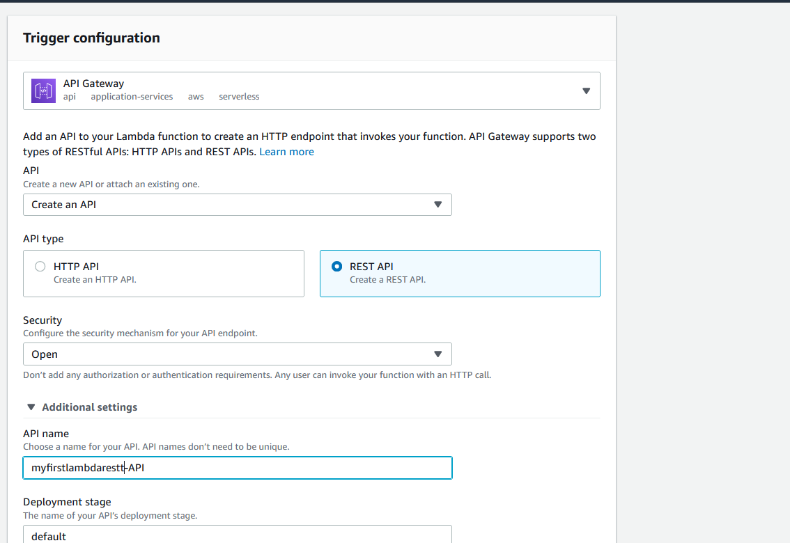

click on "Add"

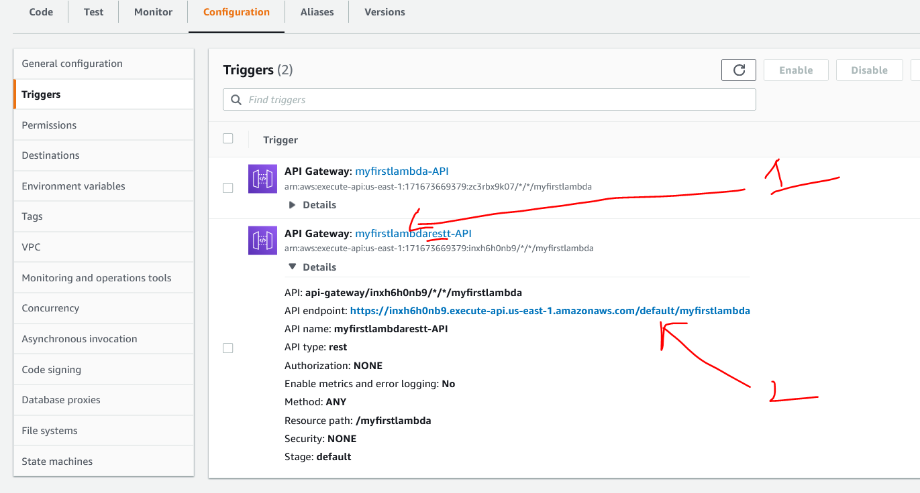

1 ->click here for nice UI that show functionality of lambda.

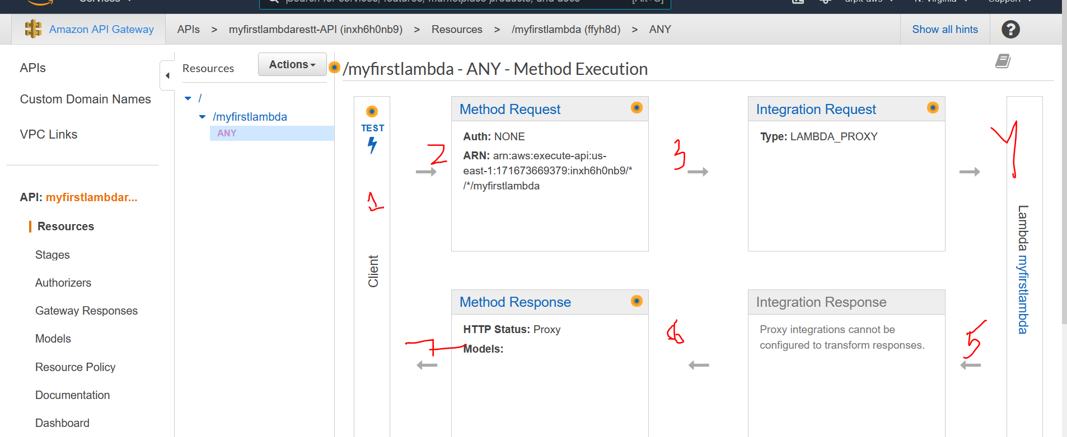

how this is self explanatory UI interface in terms of rest api.

1 --> you API client like postman
2 -->method request like POST, PUT, DELETE, GET
3 --> lambda proxy, behind it lambda reside.
4 --> your lambda function

now lets try to change method ANY to GET.

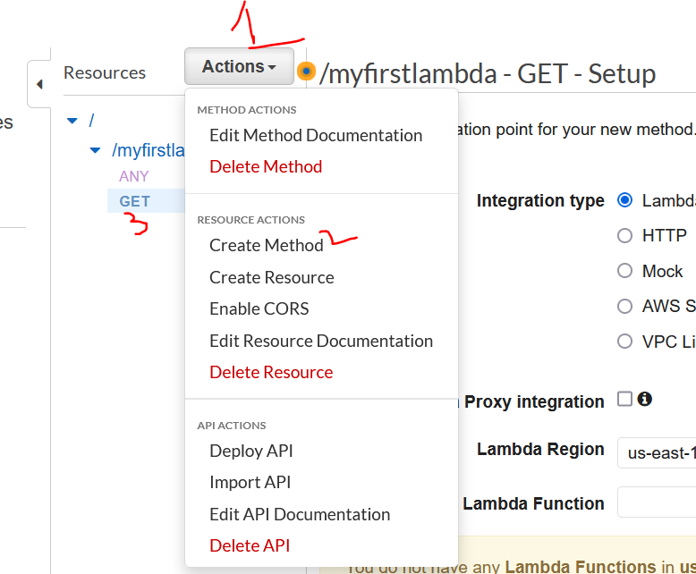

use lambda proxy integration --> yes

