Index
Search
udemy_lect_219 ----> The Path to Production
udemy_lect_223 ---> NodePort vs ClusterIP Services

udemy_lect_219 ----> The Path to Production

This is high level diagram overview of Architecture that we are going to use:-
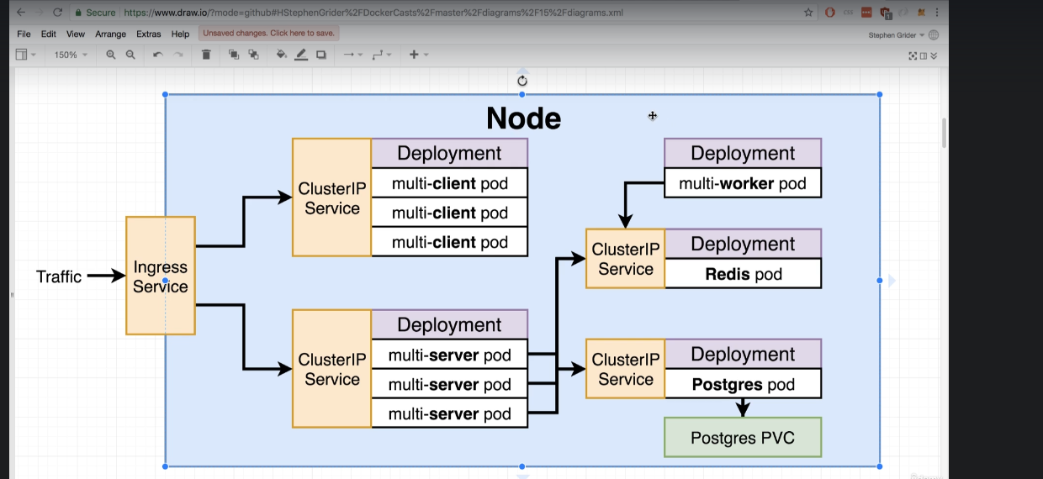
This is single node application deployment.
this application is to calculate fibonachhi number.

- here we are not using NodePort as service.
- Instead we are using Ingress and ClusterIP service.
- ClusterIP service seem to be attached with Deployment.
- Postgres Pod is clubbed with PVC (persistance Volume claim)

we first try to deploy it locally then we will go to some cloud platform like AWS to deploy this architecture in Multi-Node.

This is path for Production:-

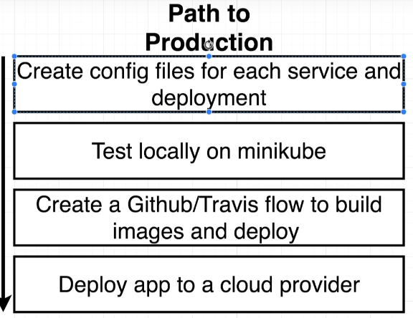

Step 1. we will create config file for every object you see in diagram, so we have config files for Ingress service, ClusterIP s, every Deployment, PVC. It might be 10-12 config file as per our requirement.

Step 2. test our application in development phase in minikube or local cluster.

Step 3. create CI/CD pipeline to build and deploy image.

lect 222 --> a quick checkpoint --> download zip for application we are going to deploy. we can also run docker-compose to test application.

copy this zip file extract it and delete some file like travis, docker-compose, nginx folder, Dockerrun
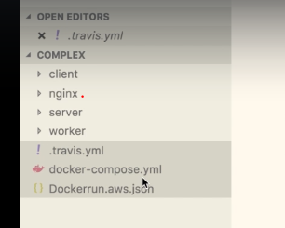

Now create a folder name k8s which will contains configuration for nginx, clusterIp, all deployments and PVC.
this is going to new directory structure

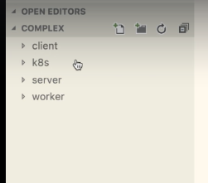

- client-deployment.yml
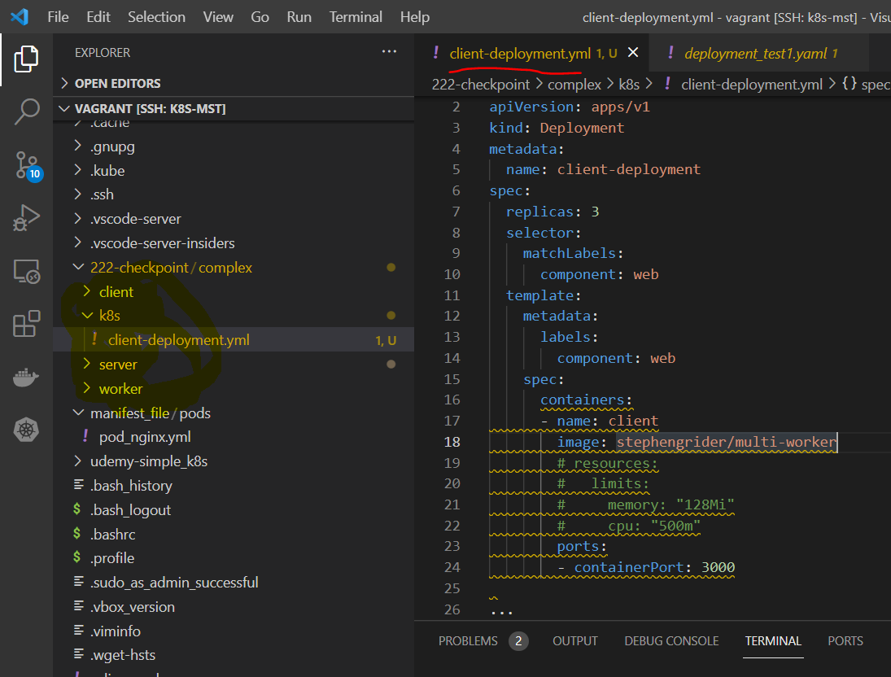

udemy_lect_223 ---> NodePort vs ClusterIP Services

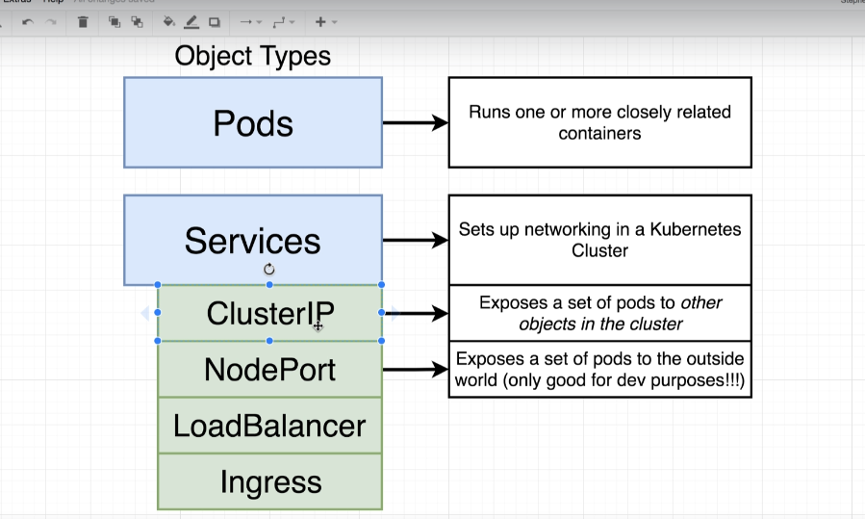

here NodePort expose set of pods to outside world using specific Port.

But ClusterIP is more restrict service, it can allow set of pods to other object in cluster, we can not access our pods from out-side worlds using ClusterIP.
In other word, ClusterIP allow object to access other object which is pointed by ClusterIP. But no body from outside world can connect to object.

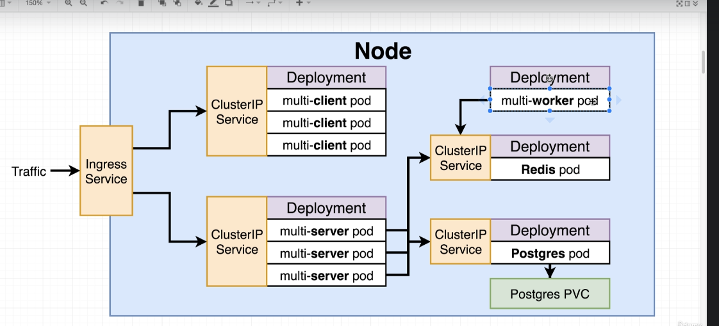

In Practical, ClusterIP attach to redis-pod eployment allow other object like multi-server deployment / multi-worker deployment to connect to redis-pod deployment.

we only need ClusterIP service attach to object (say deployment) only when we need to get traffic into deployment.
like worker-node pod deployment does not need any service because it no one want to reach inside worker-node, worker node can fetch information to other services.

if ClusterIP not attached to redis-pod then it will become isolated within cluster like:-

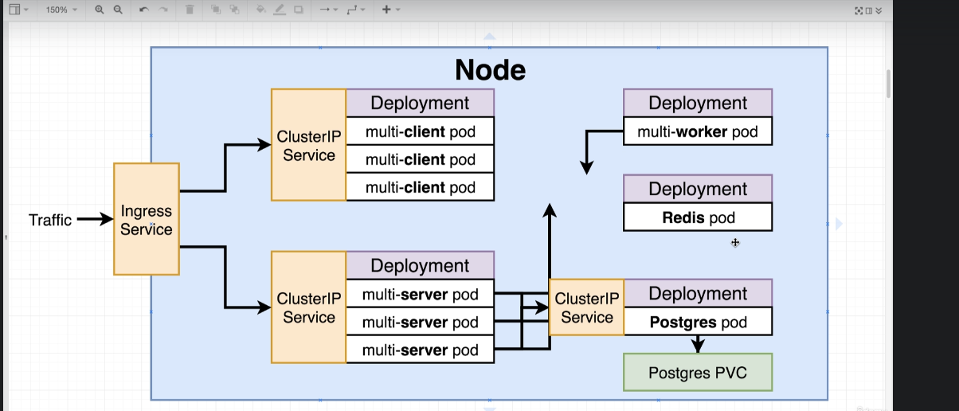

to connect to outside world we need to use Ingress service.

lets write a clusterIp config file which is going to expose our multi-client pod depoyment to other object inside cluster.
name :- client-ClusterIP-service.yml

The config file for NodePort and ClusterIP look almost same.

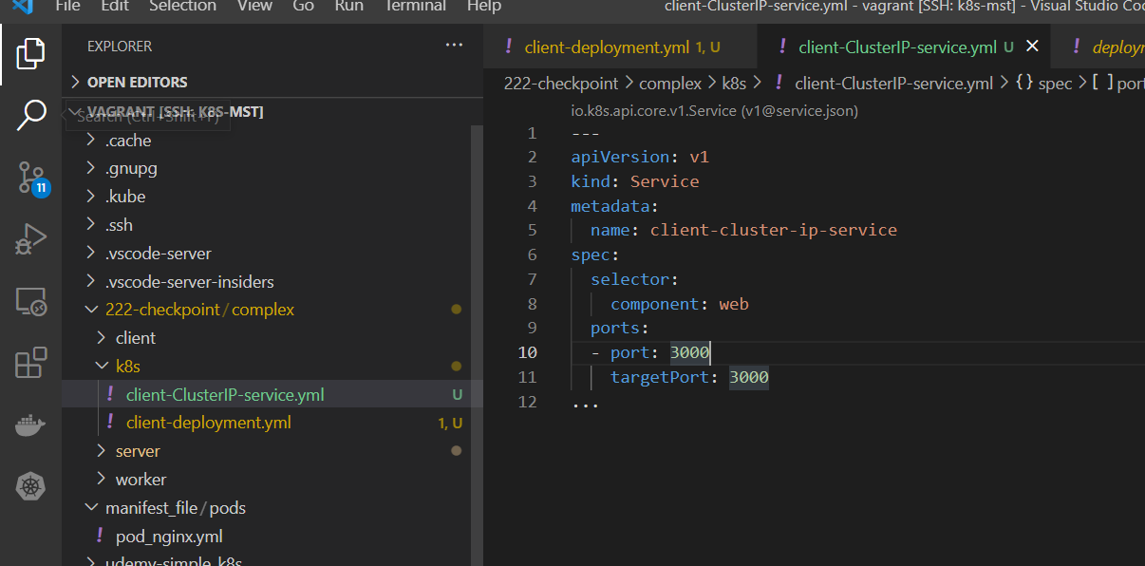

only nodePort is missing under ports as compare to NodePort service.

we have two config file in k8s folder.

we can "apply" multiple config file by applying to folder

$ kubectl apply -f k8s

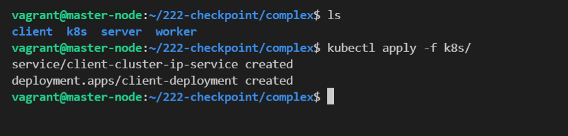

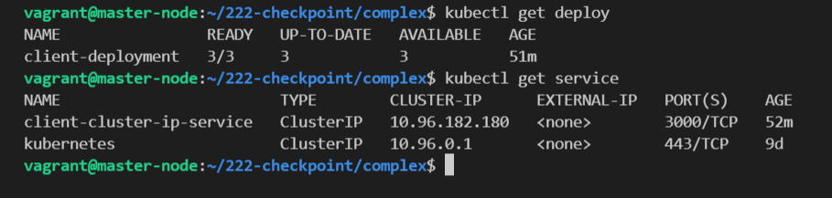

Okay Deployment done.

now lets go further to our multi-server which contain backend Express API, which we don’t want to export to outer world

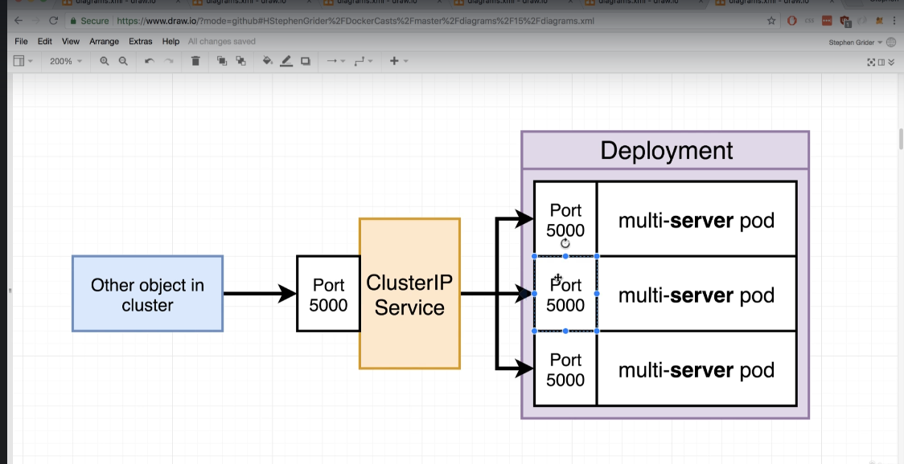

our Express API are expose to port 5000, and this multi-server pod is also need some environment variable to get access to database (postgress-sql) and redis.

lets create deployment configuration for multi-server

we can combine yml file using "---" as separator for different object
like

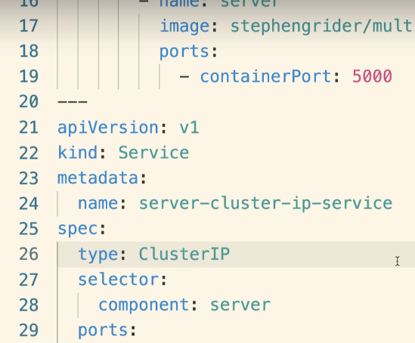

(OPTIONAL) create server_config.yml file which contain deployment + ClusterIP for multiserver.

we will keep every file separate. it make more sense with good naming convention.

Lets Put configuration for multi-worker pod

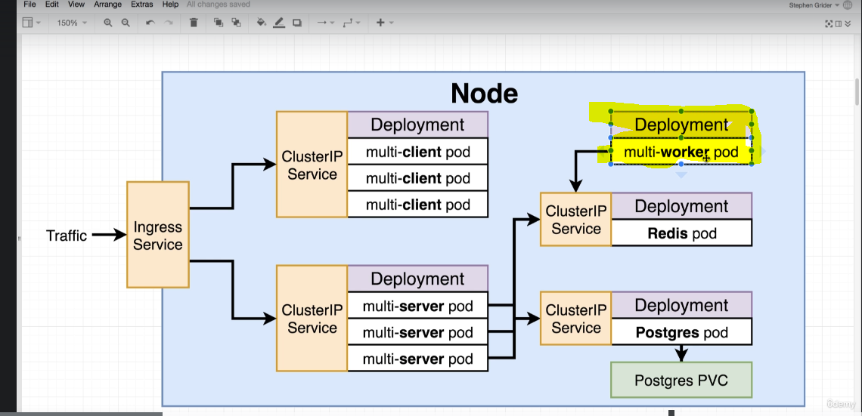

we don’t need to expose any port in worker pod because no one need to go inside worker node.
worker node can fetch information to other services.

so no need for service and no need to any port expose for worker pod.

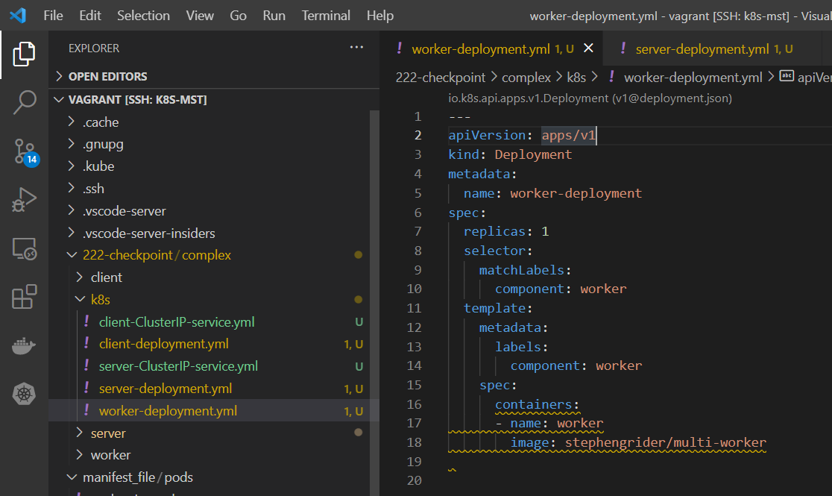

that its for this file.

