now make you media bucket to be public-ally access.

now we know S3 has two level of blockage :-
- account level --> for S3 account public access
- object level --> for individual object public access

account level:-
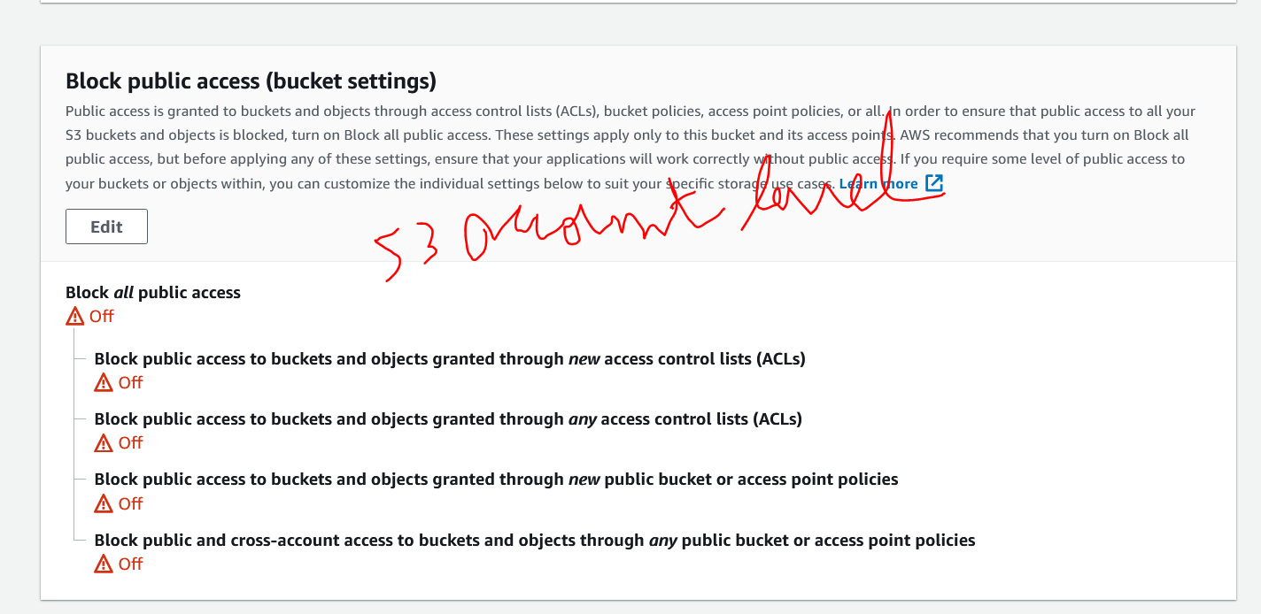

object level:-
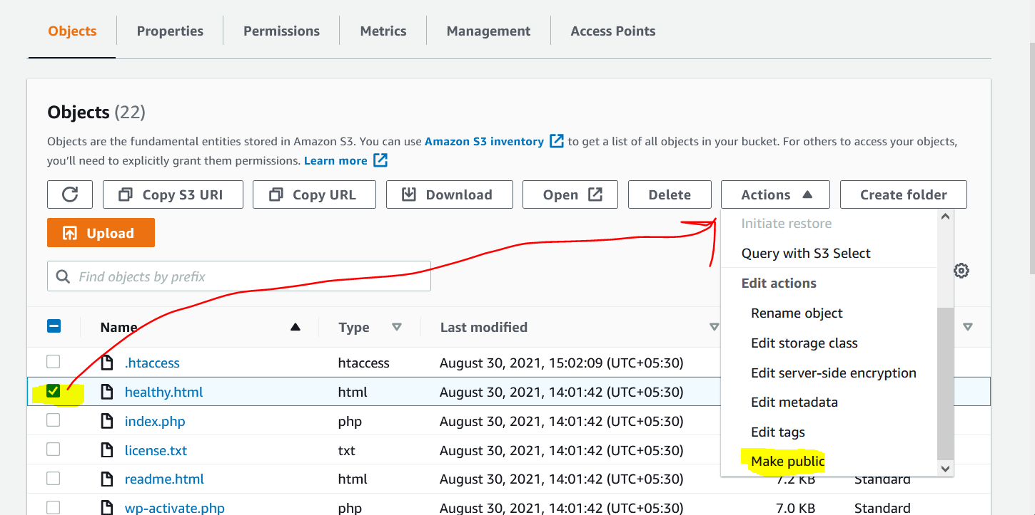

this object level is for individual user, but we have hunders of file we can not make public one by one.

so for we can create a policy of it. to make object available in single go like:-

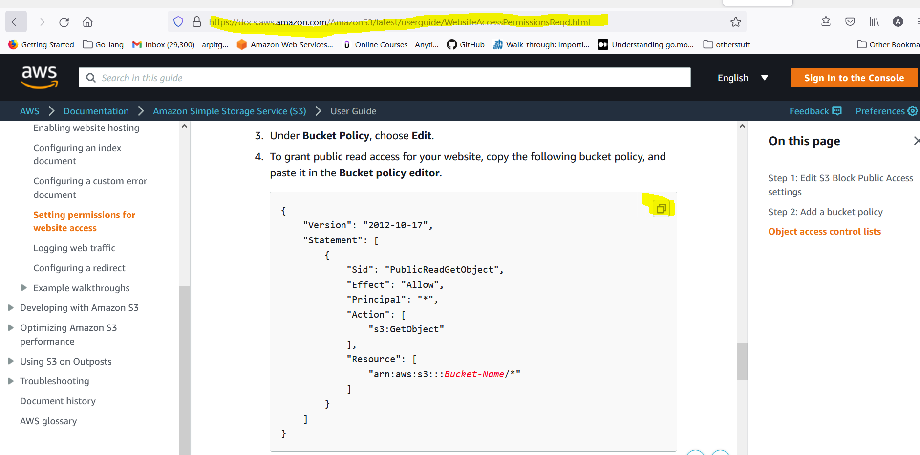

https://docs.aws.amazon.com/AmazonS3/latest/userguide/WebsiteAccessPermissionsReqd.html

{
"Version": "2012-10-17",
"Statement": [
{
"Sid": "PublicReadGetObject",
"Effect": "Allow",
"Principal": "*",
"Action": [
"s3:GetObject"
],
"Resource": [
"arn:aws:s3:::wp-s3-media-arpit/*"
]
}
]
}

this above policy will grant access to all object into bucket.

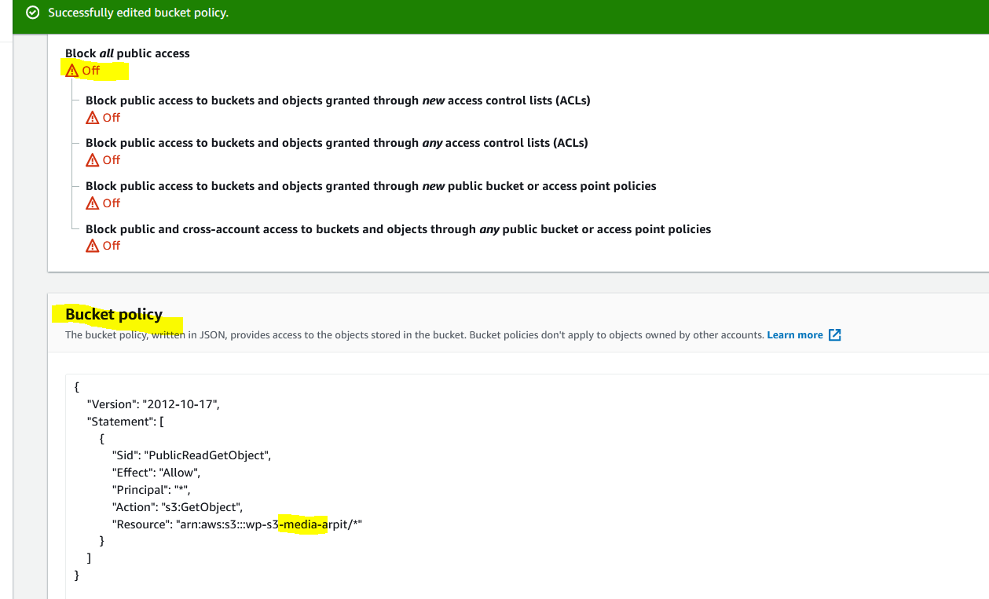

now bucket access if granted in both level.

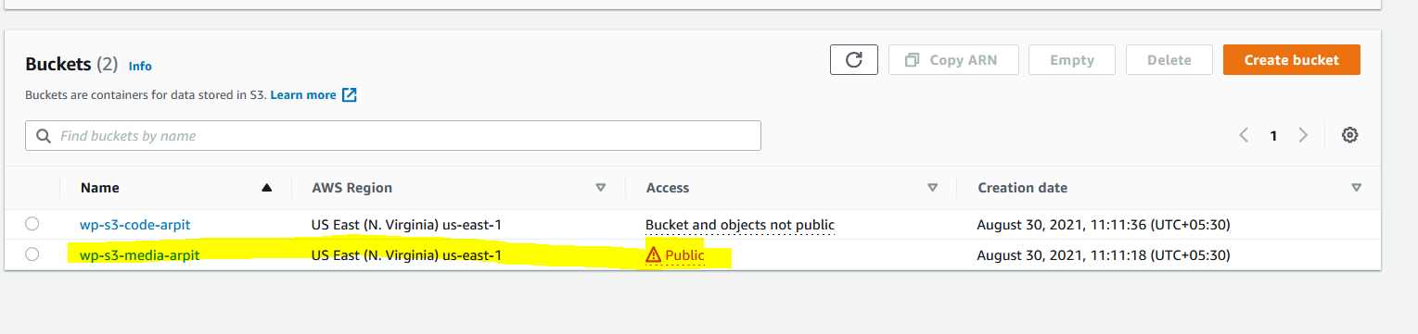

now UI is change and its says its public.

