By using wordpress we can create website ease as ease using facebook,
we can also create blog-post of our own.

here we dont need to worry about coding, web-development its just like drag and drop.

Now for linux for configuring wordpress we need to install LAMP stack.
LAMP stands for Linux, Apache, Mysql, PHP.

apt-get update -y

- Now configure Apache for wordpress

sudo apt-get install apache2 -y

If you want to install wordpress on nginx rather than apache use below link:-

https://www.youtube.com/watch?v=vZjAhjqLakU&t=0s

- install Mysql or maria db

sudo apt-get install mysql-server

for that i used docker image of mysql (just for experiment)
$ docker run --name ms -p 3306:3306 -e MYSQL_ROOT_PASSWORD=password mysql

we can also maria db as open source version for MySql

// apt-get install mariadb-server mariadb-client

- Start database and create a database name say "wordpress"

$ docker exec -it ms bash
$ mysql -u root -ppassword (no space between -p and password)
>create database wordpress;
>commit;

- now install PHP:-

sudo apt install php -y

- install word press

go to wordpress.org

then copy download link for there and come to terminal

wget https://wordpress.org/latest.zip

now do unzip like

$ unzip latest.zip

this will give wordpress folder.

- now copy every thing to /var/www/html/ like

$ cd wordpress
$ sudo cp -r ./* /var/www/html/

- now go to /var/www/html/ and remove index.html

$ cd /var/www/html/
$ sudo rm index.html

- install some more package to integrate php with mysql.

$ sudo apt install php-mysql php-cgi php-cli php-gd

///run this command to install
///sudo apt update
///sudo apt install wordpress php libapache2-mod-php mysql-server php-mysql

go to local host

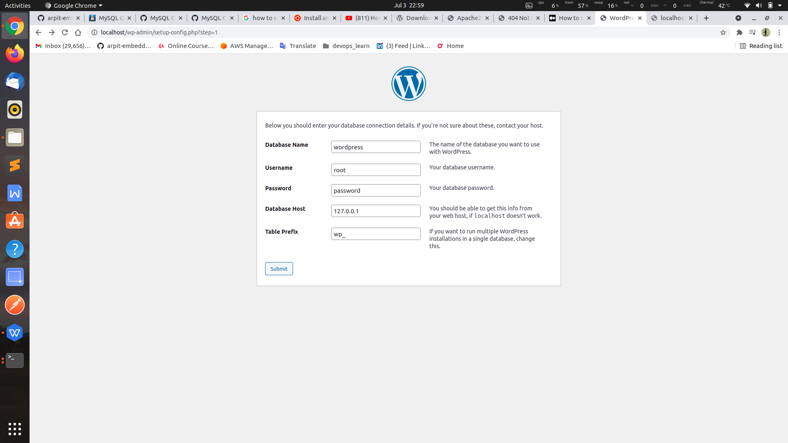

fill database entry.

this above page means we have set our apache and php page successfully.

by default apache run "www-data" user.
so we can also give
$ chown -R www-data:www-data /var/www

other wise you will face issue like :- Unable to write to wp-config.php file.

Now click on run the installation.

After installation you will see this kind of form

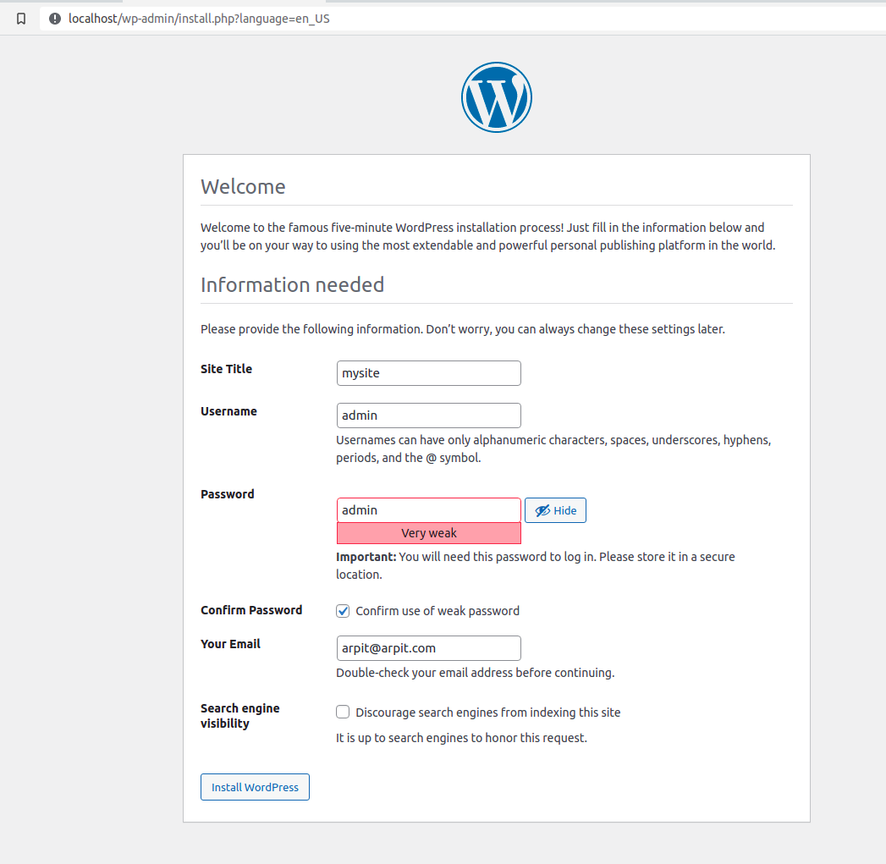

site name ==>

username and password ==> to access website later

search engine visibility ==> Don't click on this , it will stop google to recomend your website now click on install wordpress.

After login you will get this kind of interface

