log in to your ec2 instance and curl these to get bootstrap used script and ec2 metadata.



this 169.154.169.254 is an internal IP in aws for specific purpose this will not going to work from your own computer.

you don’t required any IAM Roles to be attached.

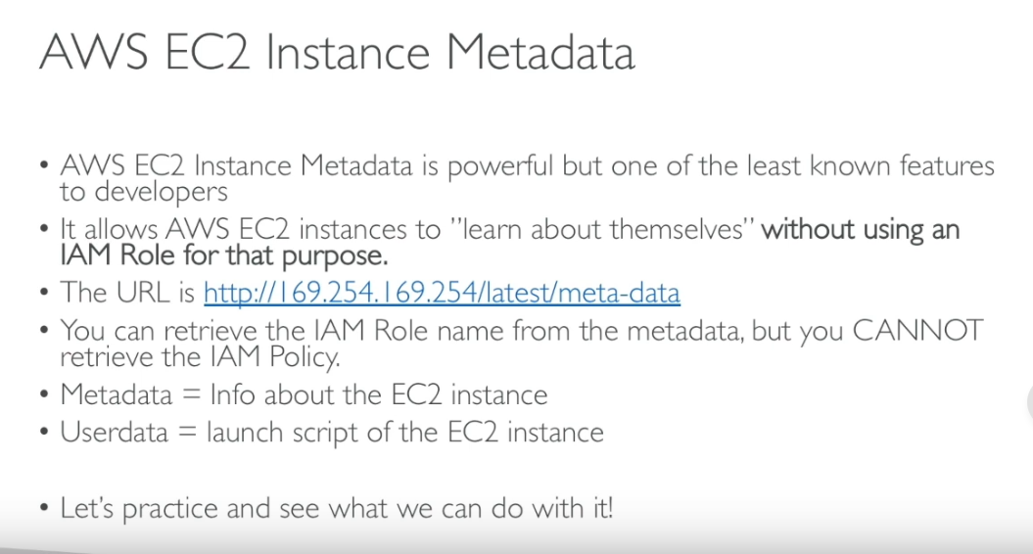

curl http://169.254.169.254/latest/meta-data/local-ipv4

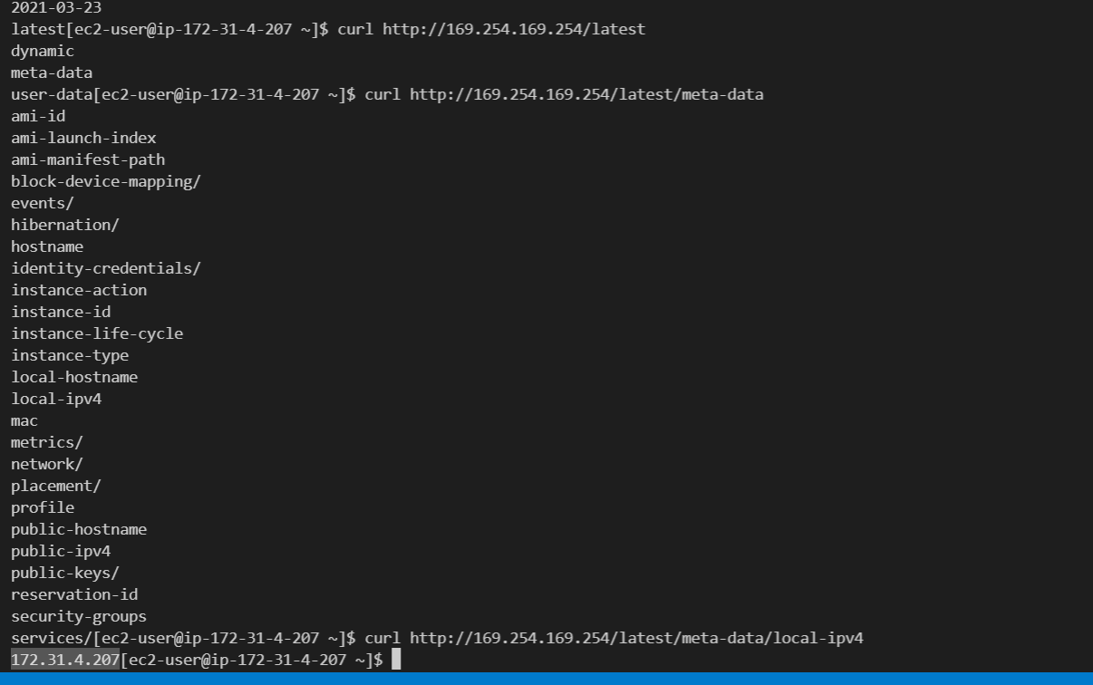

curl http://169.254.169.254/latest/meta-data/local-ipv4

