Here we are going to create first RDS instance:-

service ---> database ---> RDS ----> create Database -->

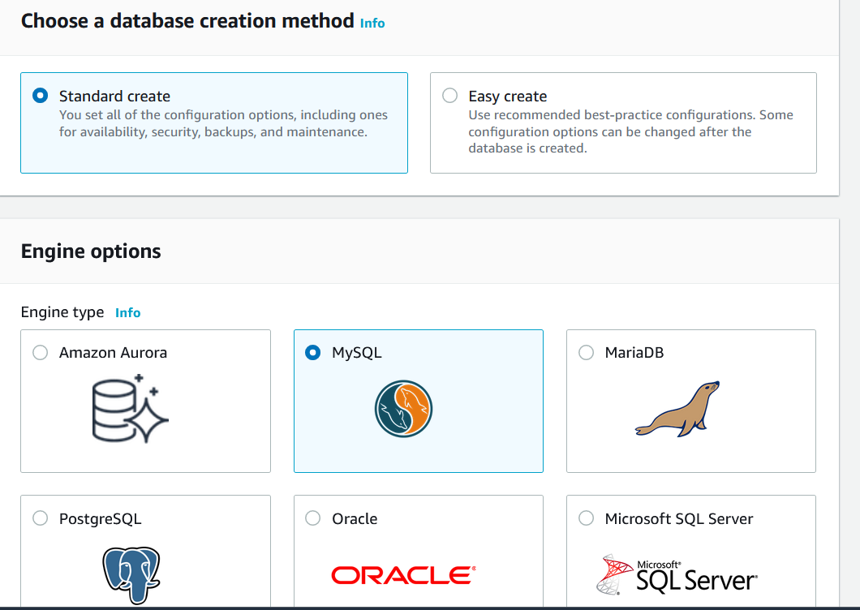

we can choose standard database or Easy create, there information about this is mention in there respective blocks.

Engine type:- there are 6 engine type as mention above,
In which Amazon Aurora is aws propitiatory RDS engine, this basically combination of MySQL and PostgreSQL.

we will use MySQL in our case.
As we know MySQL depend on server like t2 and other.
which AWS Aurora can be Serverless as well.

So once you select MySQL there will be other option came like free-tier choose that one.

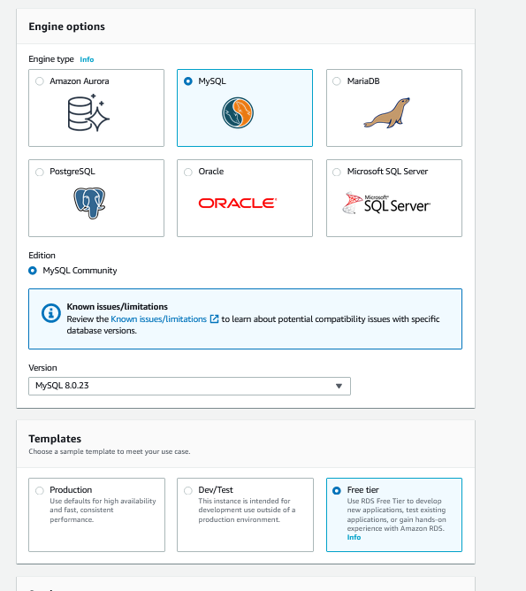

now you have to put database name, username, password

Now about if you choose "Production" what option is going to come

- we need to choose different instance class onto which our EC2 runs.
- then we need to configure harddisk and storage IOPS
- we can also create standby and storage auto-scaling (like if 80% of storage is used then increase storage) also we can Multi-AZ this will leads to read-replica.
- we can use VPC, subnet, whether we need to make our database public or not.
- there is also database authentication option which can done by simple username and password and also we can do that using IAM roles.
Also we need to create a database in our RDS, for that we need to go to advance setting and mention inital database say "wordpressdb"
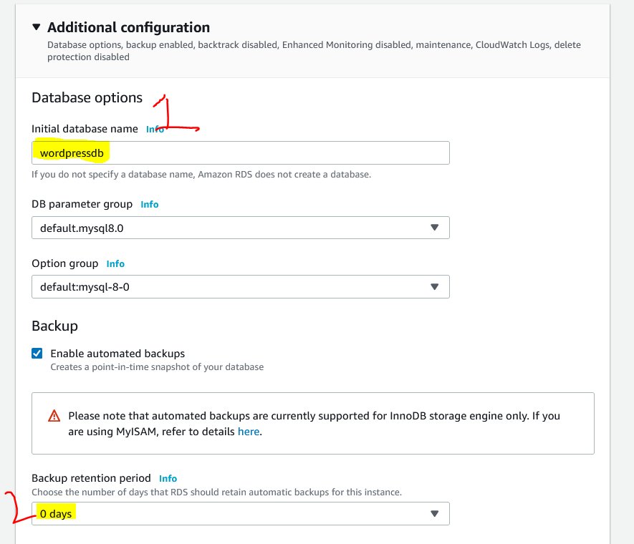

As we have different security group for RDS, but our EC2 security can not access this automatically.
So we need to create an inbound rule in RDS Security group.

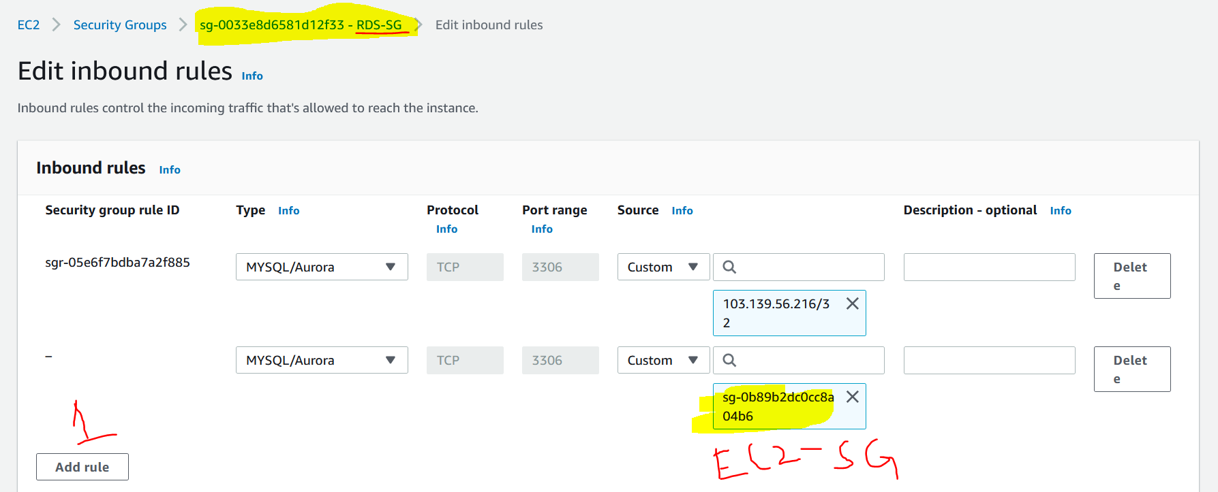

Now lets enable port no 3306 (sql port number sql/aurora) to be mention in security group to ec2 security group

now create RDS --> this will create something about 5 min.

now lets create an EC2 instance and run bootstrap script to install wordpress website.

#!/bin/bash
yum install httpd php-mysql -y
amazon-linux-extras install -y php7.3
cd /var/www/html
wget https://wordpress.org/latest.tar.gz
tar -xzf latest.tar.gz
cp -r wordpress/* /var/www/html/
rm -rf wordpress
rm -rf latest.tar.gz
chmod -R 755 wp-content
chown -R apache:apache wp-content
service httpd start
chkconfig httpd on

okay that done our wordpress server comes up

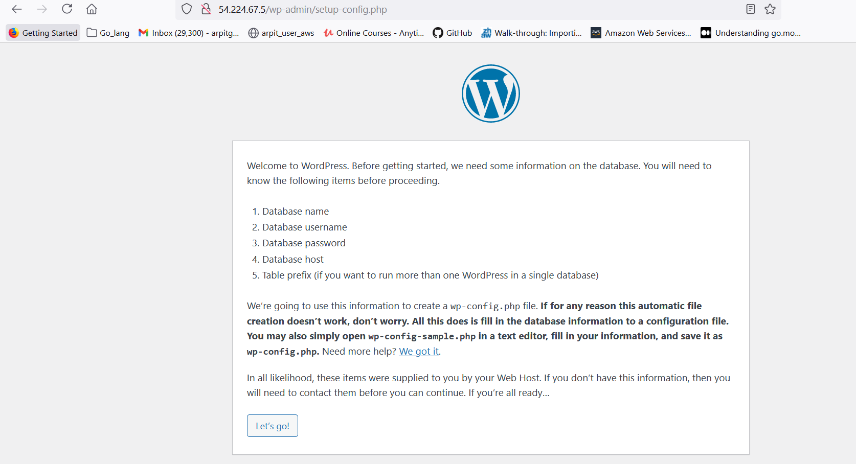

now configure this word press.

this endpoint is dns endpoint to access our RDS server

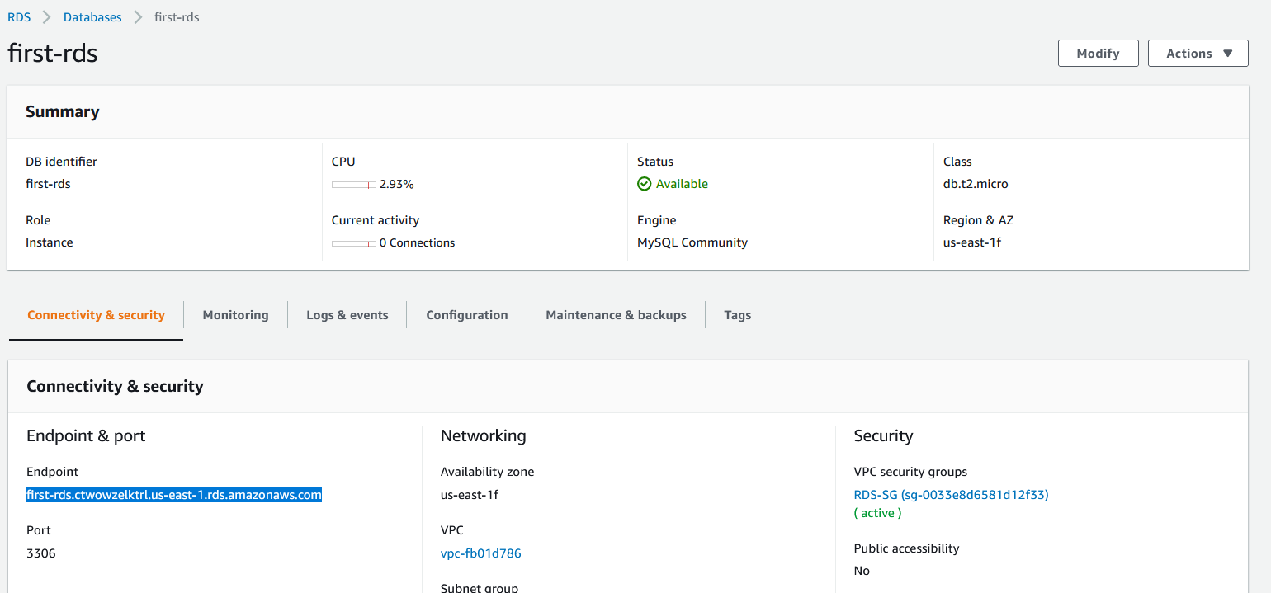

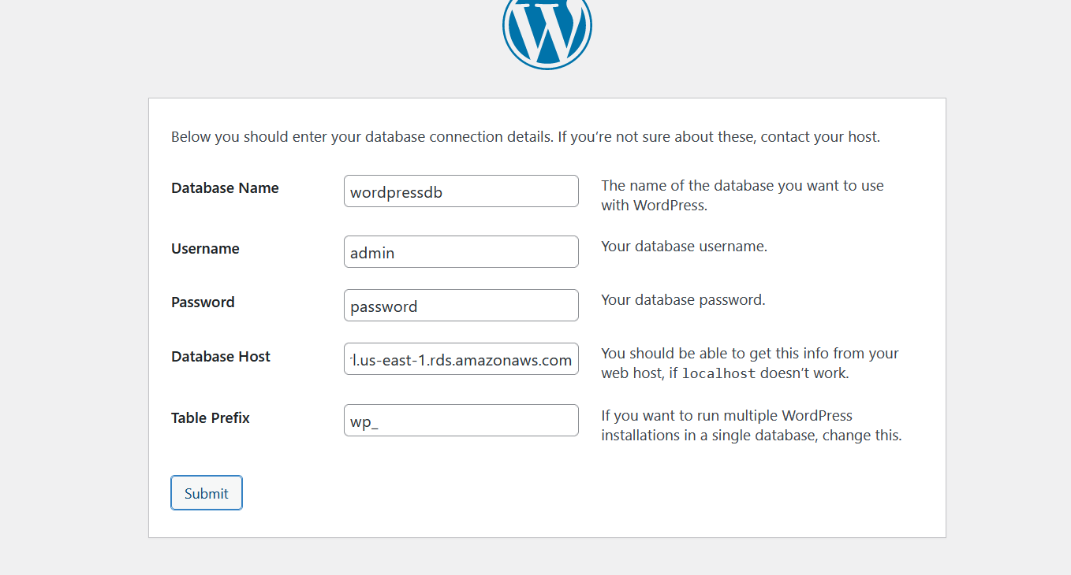

Now we have to SSH to our sever and we need to copy some of these line in a file /var/www/html/wp-config.php use sudo prev and paste this.

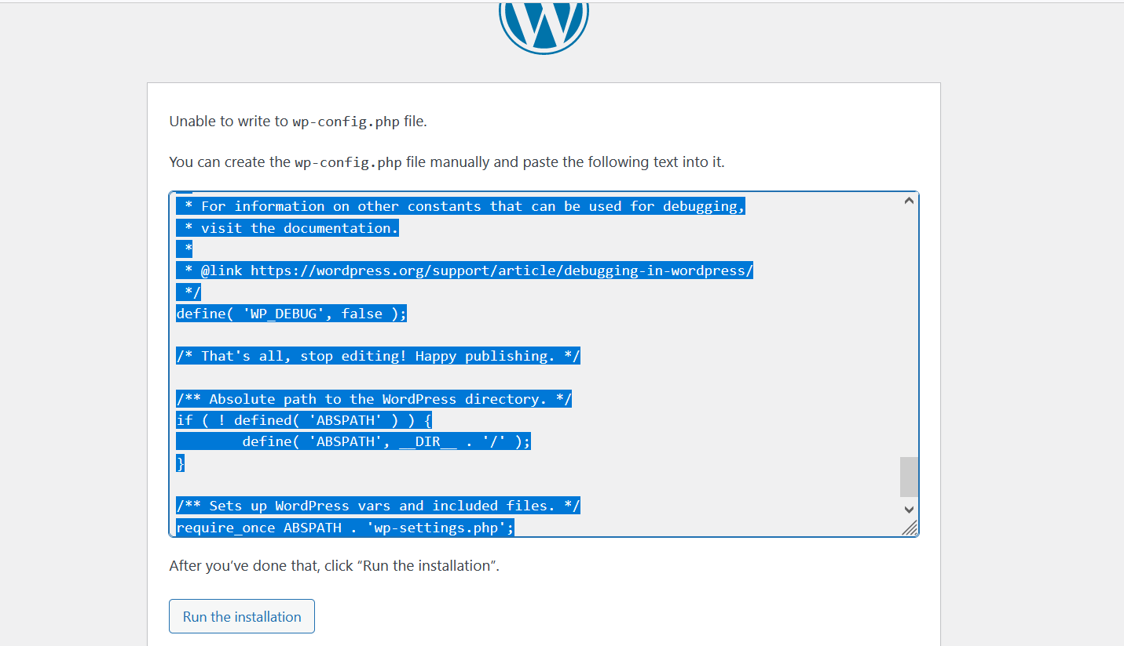

now click on Run the installation.

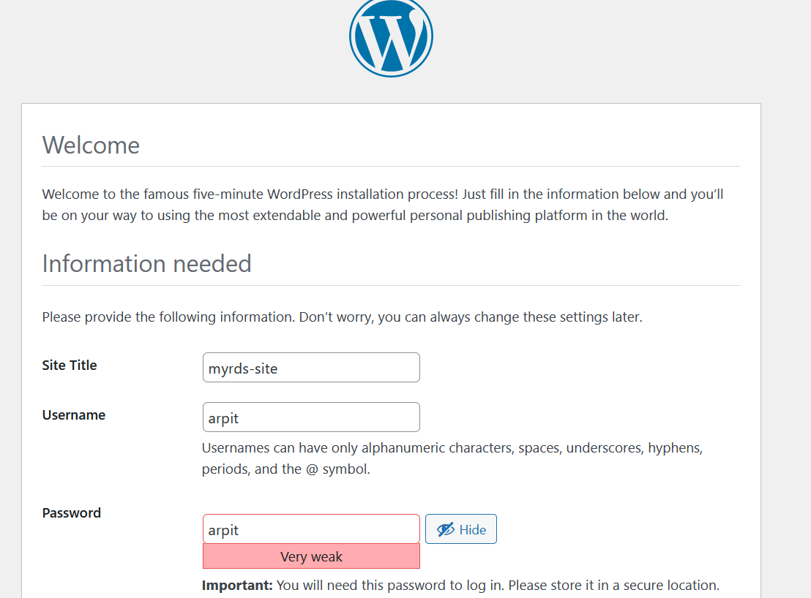

fill this form and you are good to go.

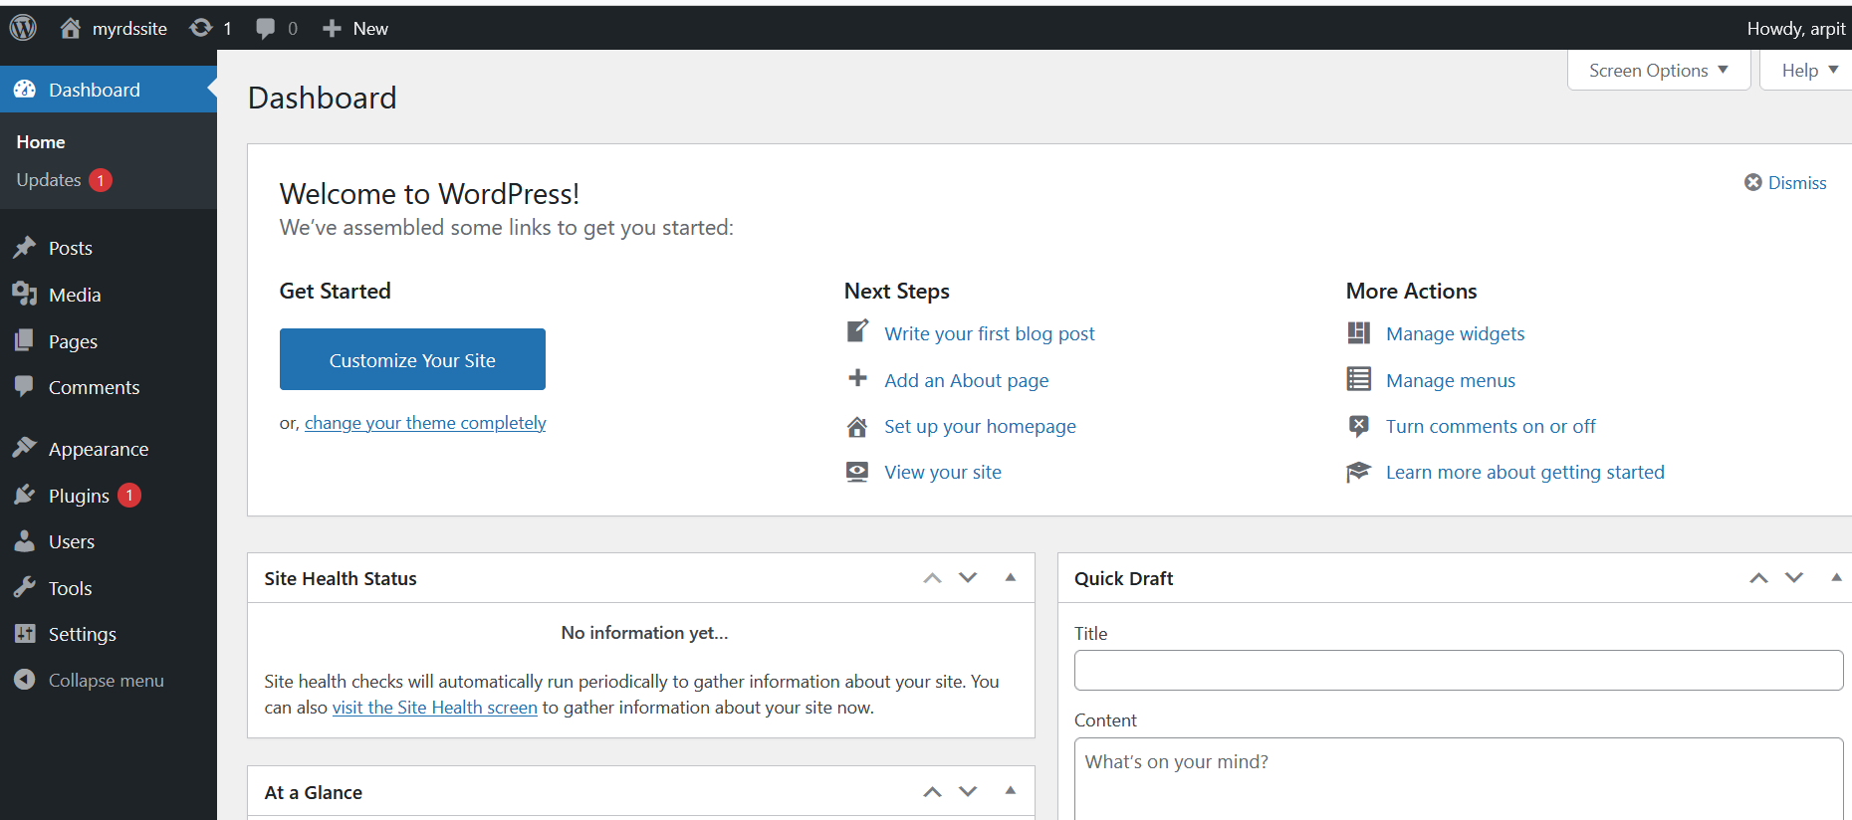

wordpress is working.

