Enabling Read replica:-

- To enable read replica you first need to enable backup (drop down menu in databse where we need to mention number of days)

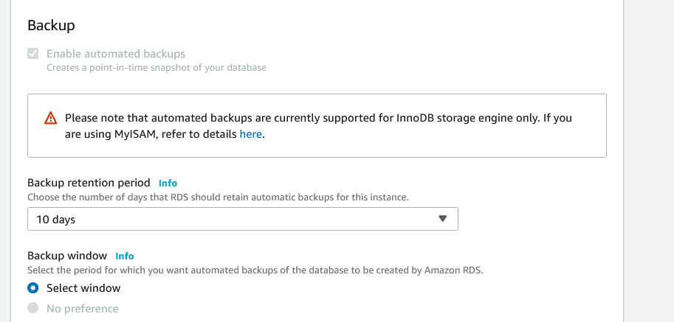

press continue --> then apply immediately

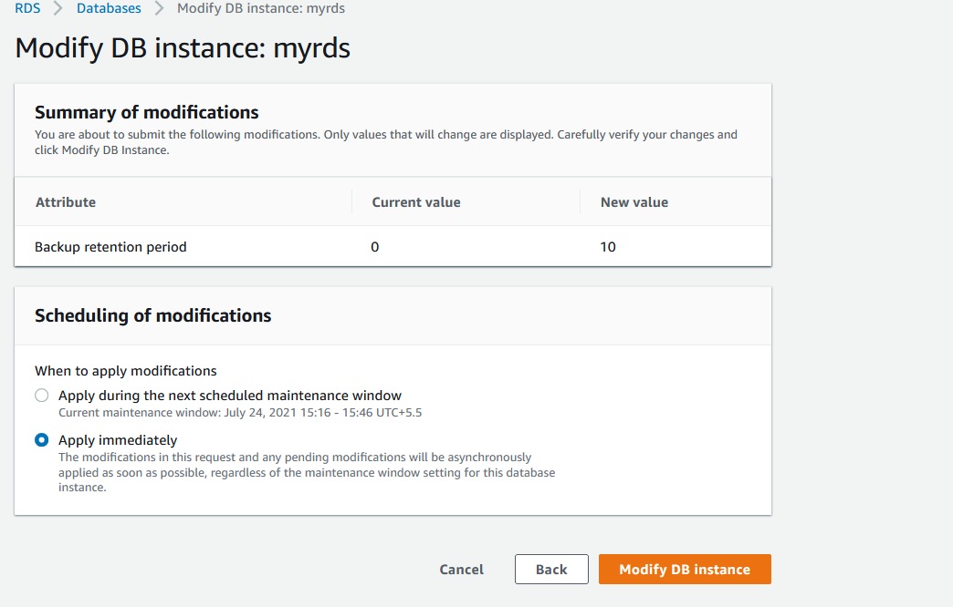

Now doing this immediately going to give you some downtime.
After modification

now go to "action" ---> then "create read-replica"
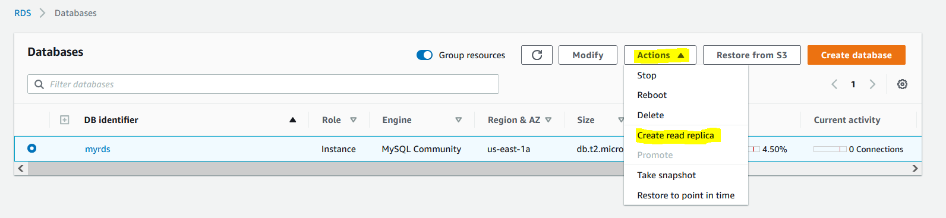

now fill that form like region, database name, SG, etc and hit "create"
lets wait for everything to come up
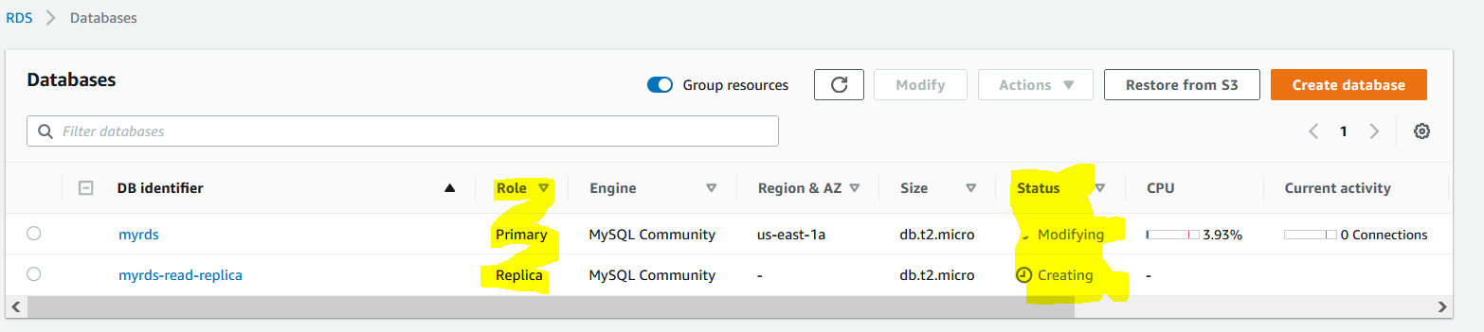

Now our read replica is created and it should have all content of primary db.

If you promote replica db as primary then it will stop replicate there previous primary and become a standalone db.

