HashiCorp Packer.io

Why do we need packer?
=> by using same configuration file we can create image for multiple platform.

This is used to create custom image between multiple of platform.

Mutable infrastructure (mutation) :- Infrastructure can be subject to change.

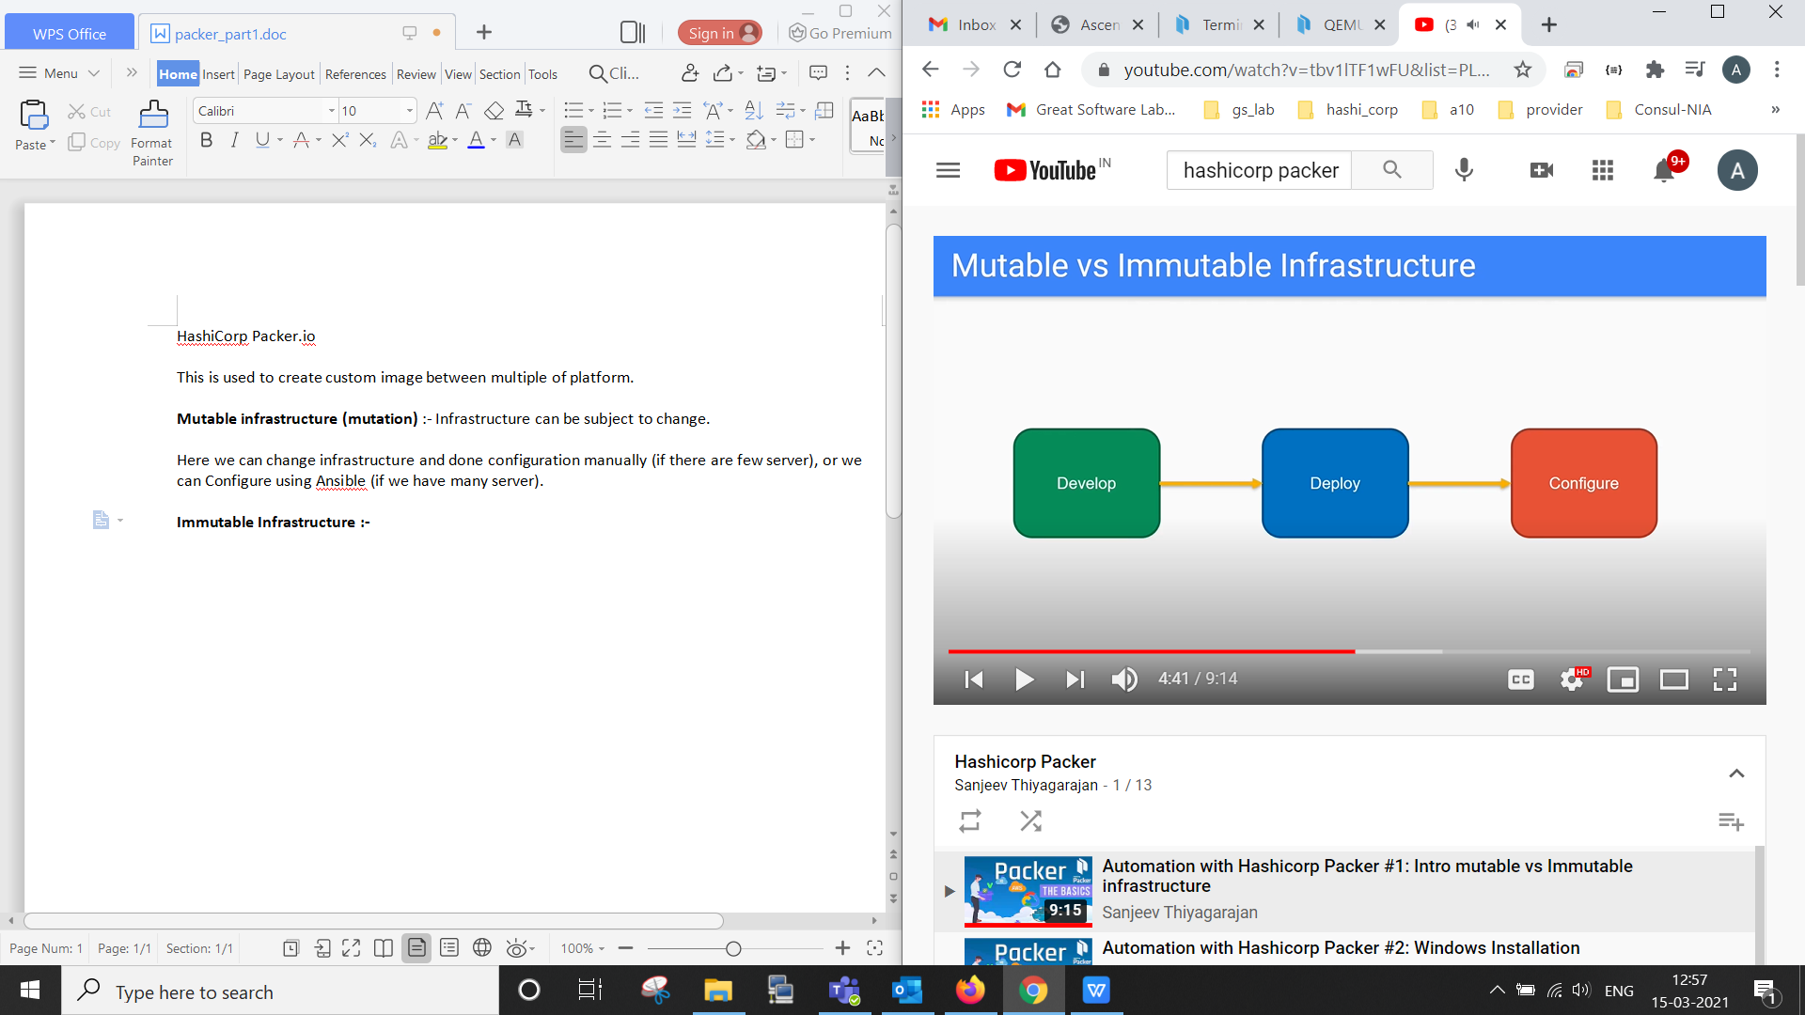

So here we first deploy an Infrastructure then we configure that manually or using Ansible.

Here we can change infrastructure and done configuration manually (if there are few server), or we can Configure using Ansible (if we have many server).

Immutable Infrastructure :-

Now if we want to do configuration before Deployment.

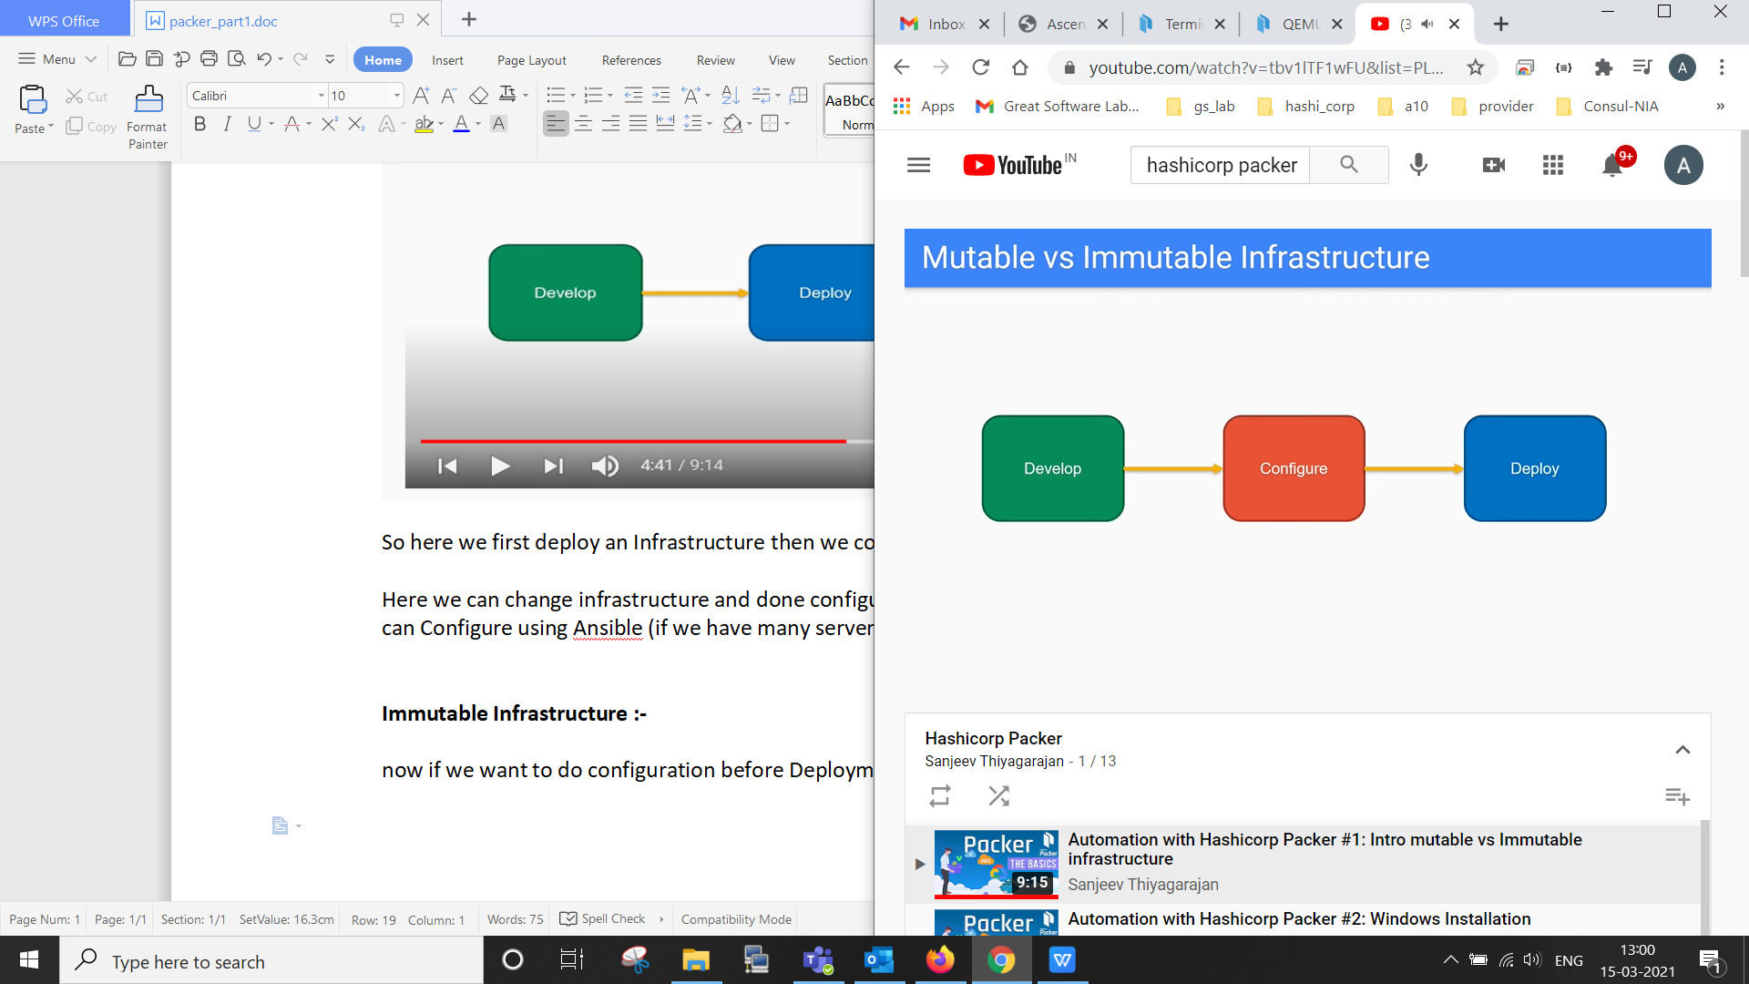

so once we deploy, all configuration and all done in one go.
Now this server is already production ready.
because all of that previously baked onto our image.

So when we deploy our image into server, now we don’t have to do any kind of mutation, that why it is called as immutable.
we can not change anything as it is immutable image, then how can we do necessary change if known further.

For that we can kill that server rebaked new image with necessary changes, but this will leads no availability of server as in term of downtime.

but we can overcome this using load balancer.

