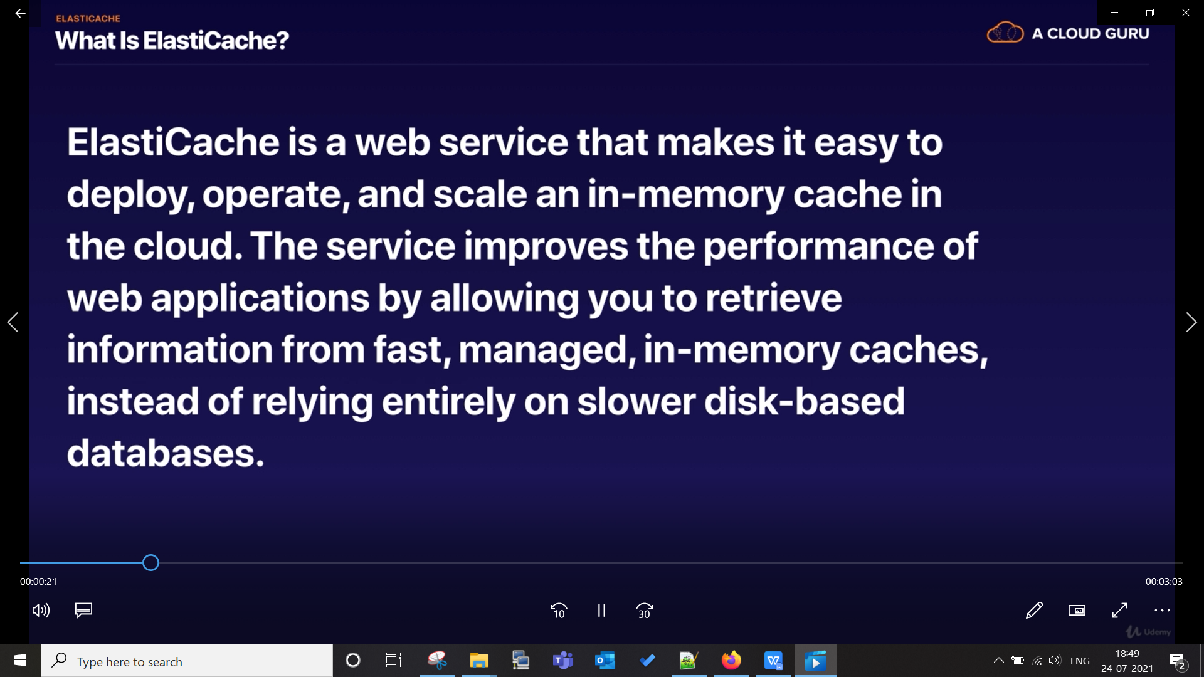

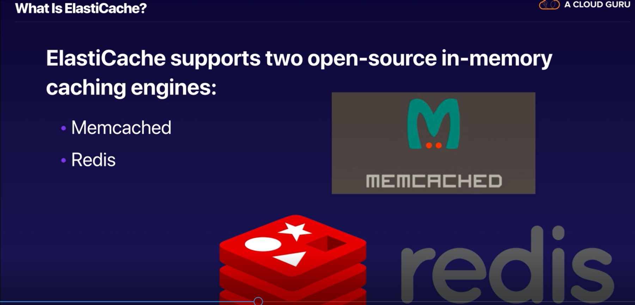

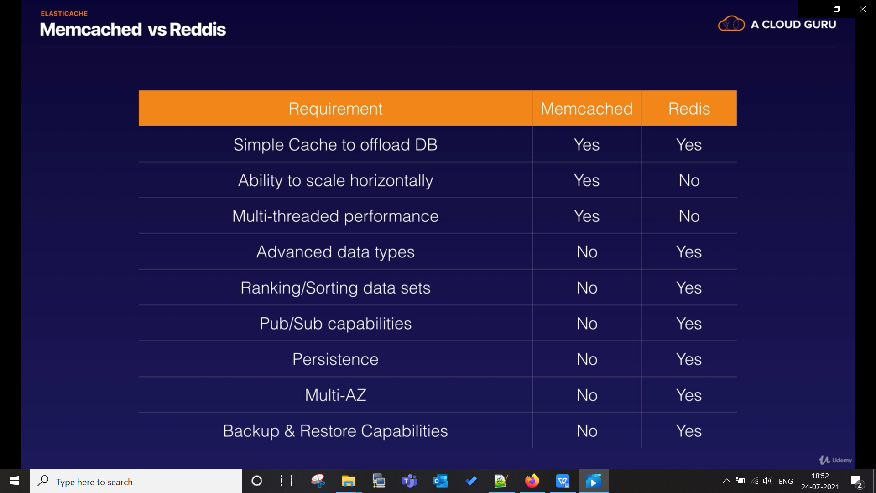

Ques :- your database is overloaded how will you deal with these solution ?

Ans:- there are two possible solution for that:-
- use read replica and direct traffic to different read replica
- use memcache

