Index:-
search

udemy_lect_206 ----> Deployment Configuration Files
udemy_lect209 ---> Why Use Services?

------------------------------------------------------------------------------------------------------------------

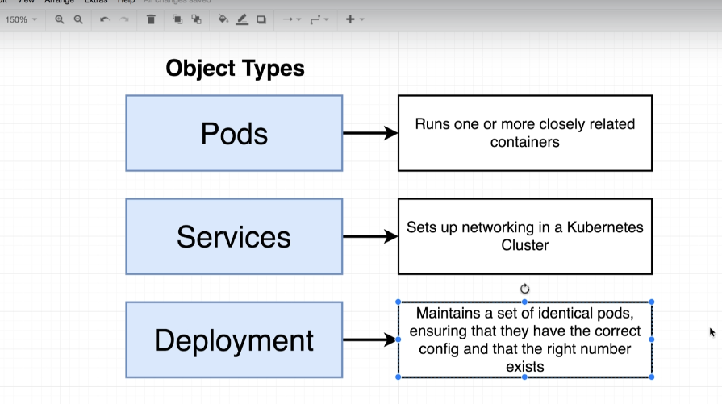

For any serious k8s working we will use Deployment instead of using pod

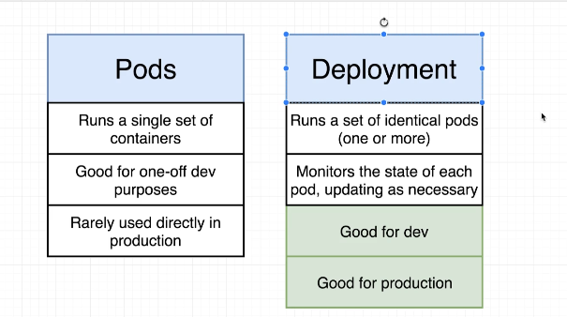

it is better to use deployment to pod creation rather that creating a single pod.

Suppose we want to upgrade our application ,
If we do that with replica-set then we have to first uninstall previous version and after that and create new version . this will consume time whether it was of microsecond.

- To achieve zero downtime , we introduce new concept -> deployment
There are also different statergies to achieve this in deployment, we will see them later

Other benefit of deployment is
- Suppose you during rollback we experiance some error , so we can also rollback to previous version
- We can also apply pause and play during upgradation .

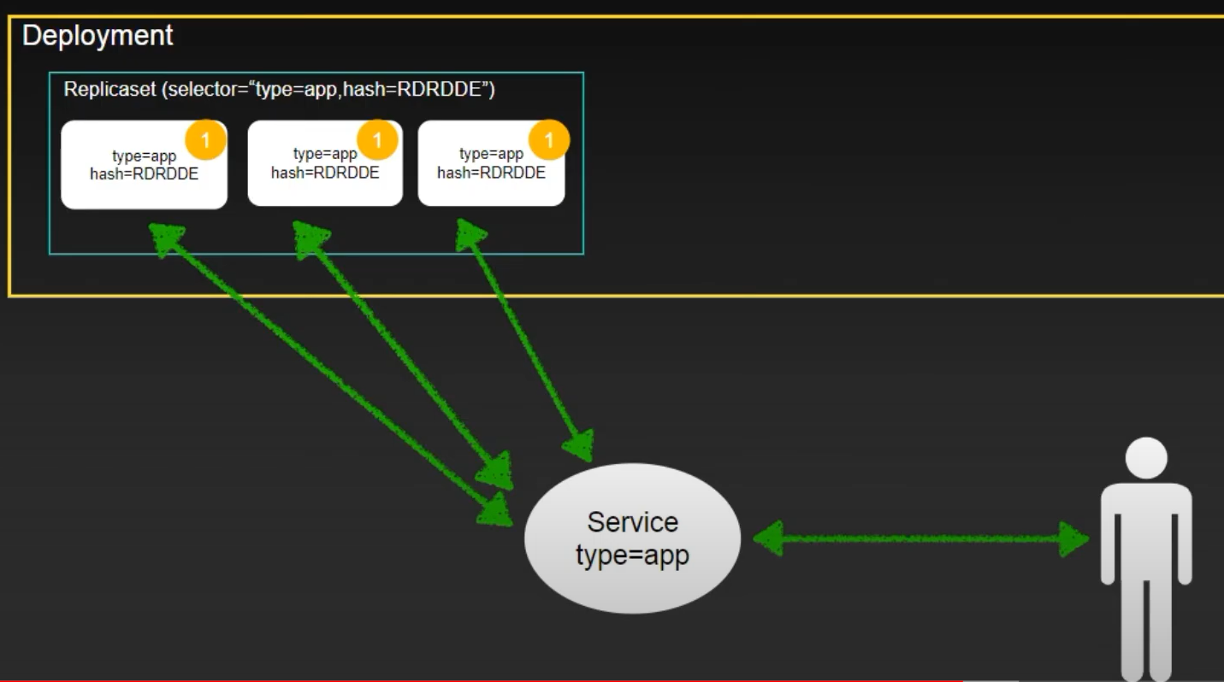

This is previous version 1 of our application and what deployment is doing is that it create replica-set and a hash (will discuss later ) for previous version .

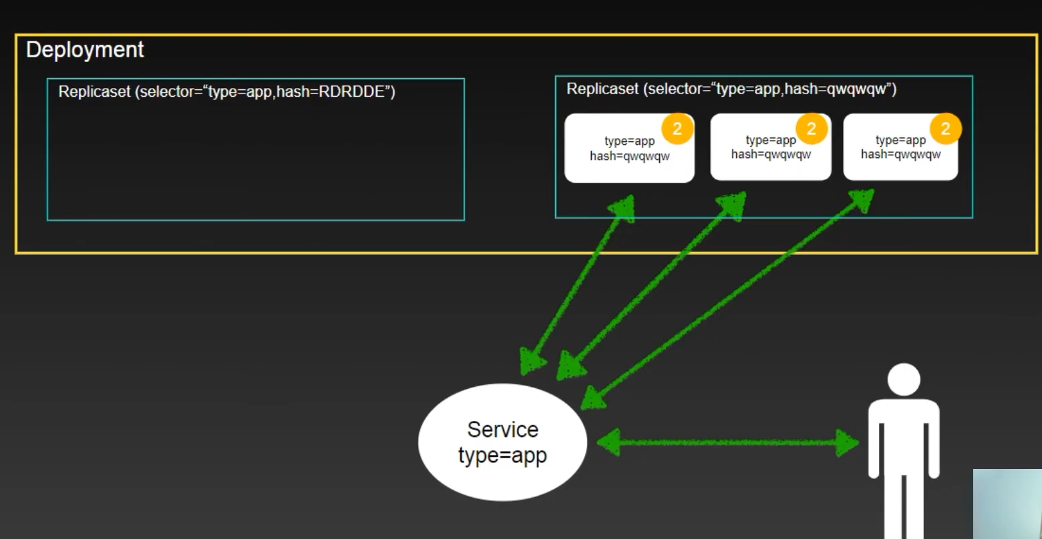

Here we can see that when we want to upgrade it create another replica set and previous replica-set is also not deleted -> which is required when we need rollback .

The above strategics are know as recreation strategics -> it contain some amount of downtime.

Lets move to those strategics which does not have downtime.

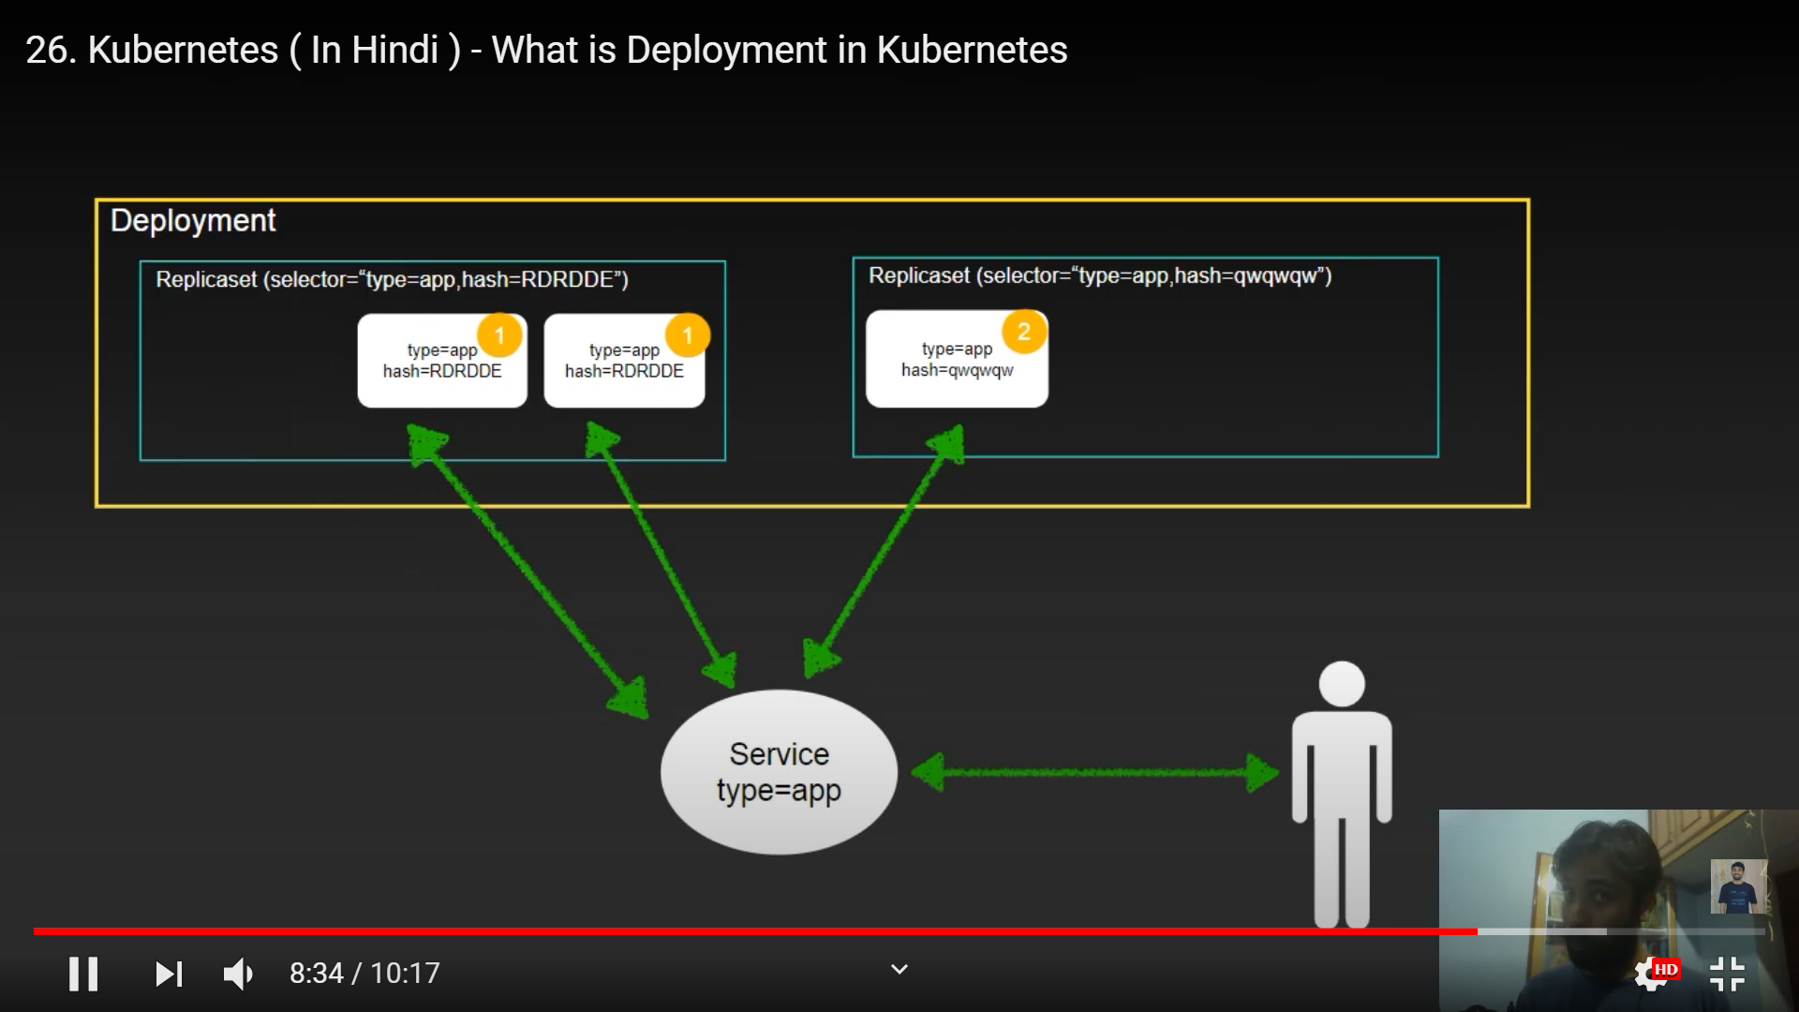

Here in this statergies we have see that when one pod is created then other pod will be created
This stargies are know as rolling update .

K8s deployment will give hash value because inside replica set is uniquely identified.

Deployment having pod template inside it.

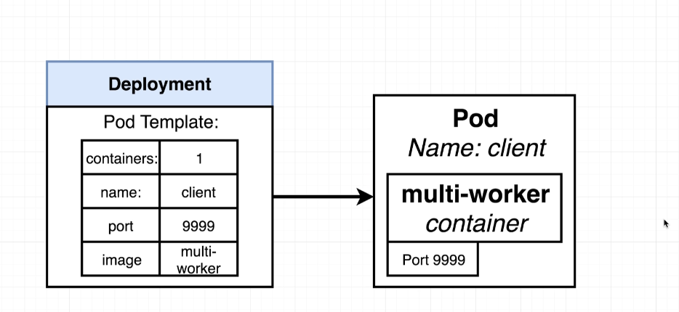

So when we want to make any upgradation to this pod template like changing port what it will do is , it will create a new pod with latest upgradation and kill previous one.

udemy instructor image :- stephengrider/multi-client

udemy_lect_206. Deployment Configuration Files

now we are going write an config file to create a object called deployment where we will create template for pod.

---
apiVersion: apps/v1
kind: Deployment
metadata:
name: client-deployment
spec:
replicas: 1
selector:
matchLabels:
component: web
template:
metadata:
labels:
component: web
spec:
containers:
- name: client
image: stephengrider/multi-client
resources:
limits:
memory: "128Mi"
cpu: "500m"
ports:
- containerPort: 3000

here "apiVersion: apps/v1" means we are going to create a object (deployment) which is under this apiVersion.

template field are pod specification under deployment.

As replicas = 1 so one pod is maintained by deployment. these pod are identical in nature.

Selector :- by this selector Deployment can manage pod created by it.

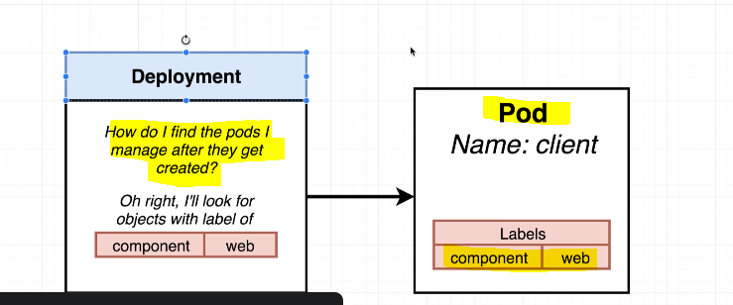

Now lets apply these deployment config file

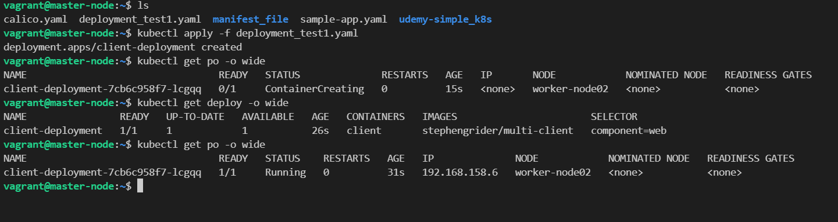

udemy_lect209 ---> Why Use Services?

create this NodePort service so that we can access our deployment from outer browser.

apiVersion: v1
kind: Service
metadata:
name: client-node-port
spec:
type: NodePort
ports:
- port: 3050
targetPort: 3000
nodePort: 31515
selector:
component: web

clusterip:31515

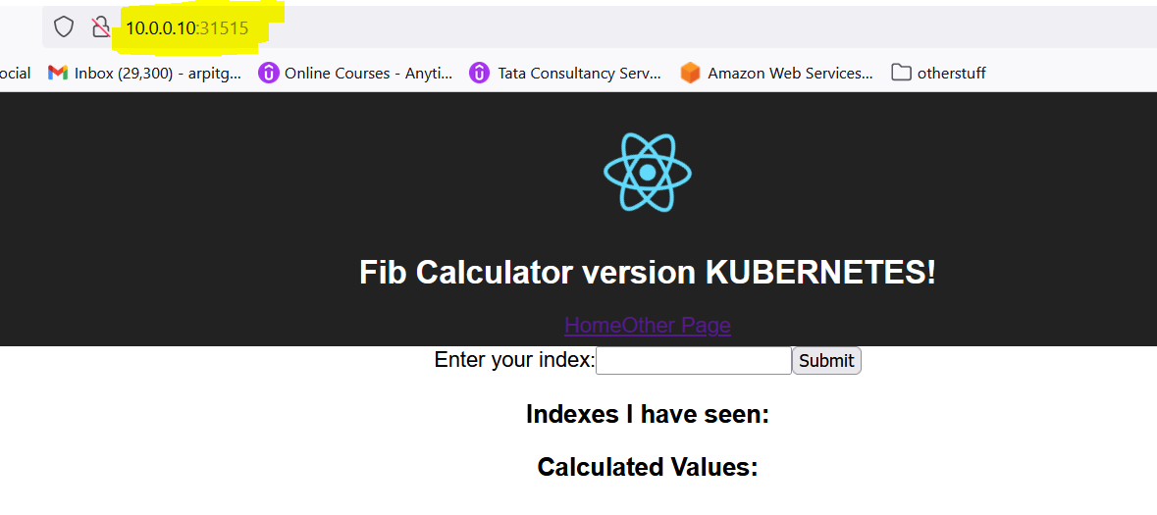
I have seen I can access this deployment application on any master or worker ip for that perticular port.

accessing from worker node IP

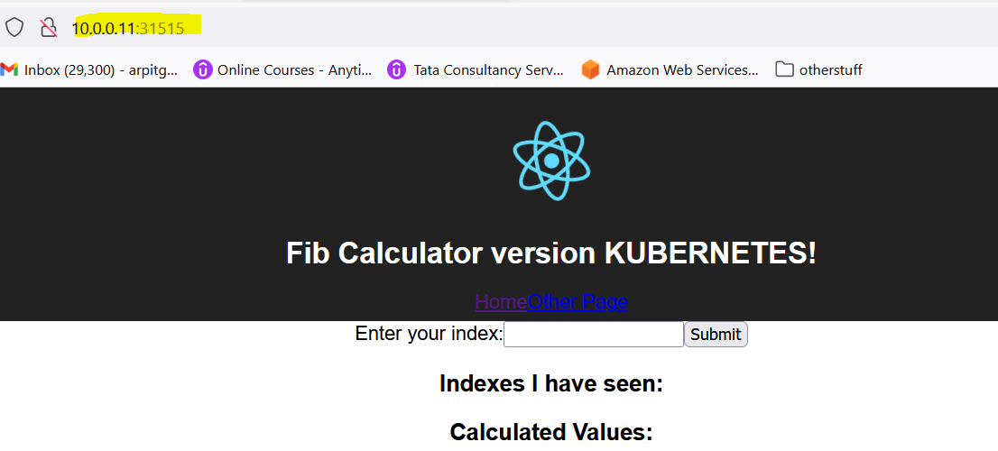

one reason k8s uses service to export not directly pod ip is pod is Ephemeral (I.e may be deleted, recreate with different IP).

but service have single IP that matches to its selector.

