what are attribute use in typical aws policy json

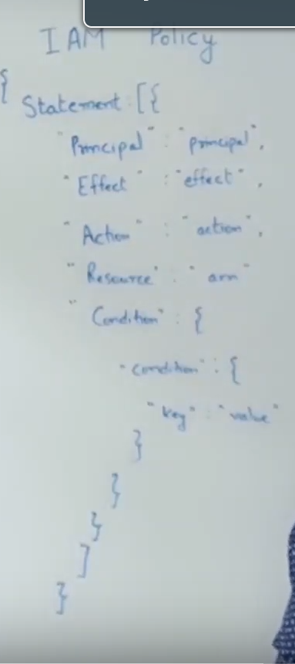

to learn element use acronym "RECAP"

R -> resource
E -> effect
C -> condition
A -> Action
P -> Principal

Principal is entity that is used for "allowed" or "denied" access. It can be for IAM use, IAM roles.

Most of time we can see principal is missing in IAM policy,

there is two kind of policy:-
- Identity based policy --> for IAM user, here Principal is optional
- Resource based policy ---> it attached to resource, here Principal is mandatory. eg :- s3, EBS

Effect this will tell what should policy do after it comes into effect. always required.

Action:- this will acts as rule to be allowed or denied, like "start EC2 instance" , "get S3 object"
we can also use like s3 allowed * this will give all permission for s3, this is know as wildcard.

Resource :- this is target resource on which the policy is going to be applied.
every resource has ARN mention that ARN here.

Condition:- it make policy to be effected on certain condition like apply this on certain region, certain subnet, tags and so on. here we can use lots of operator like "string like", "string equals", "booleans" etc.

