Create S3 bucket:-

service -> storage -> S3
you can notice here your region is change to "global".

S3 -> Create bucket -> <give unique name for bucket>
by default bucket is "private" Access-able but we can make that public.
we will try to upload my image as see is we are able to access it or not through web page.

note -> EFS -> elastic file storage.

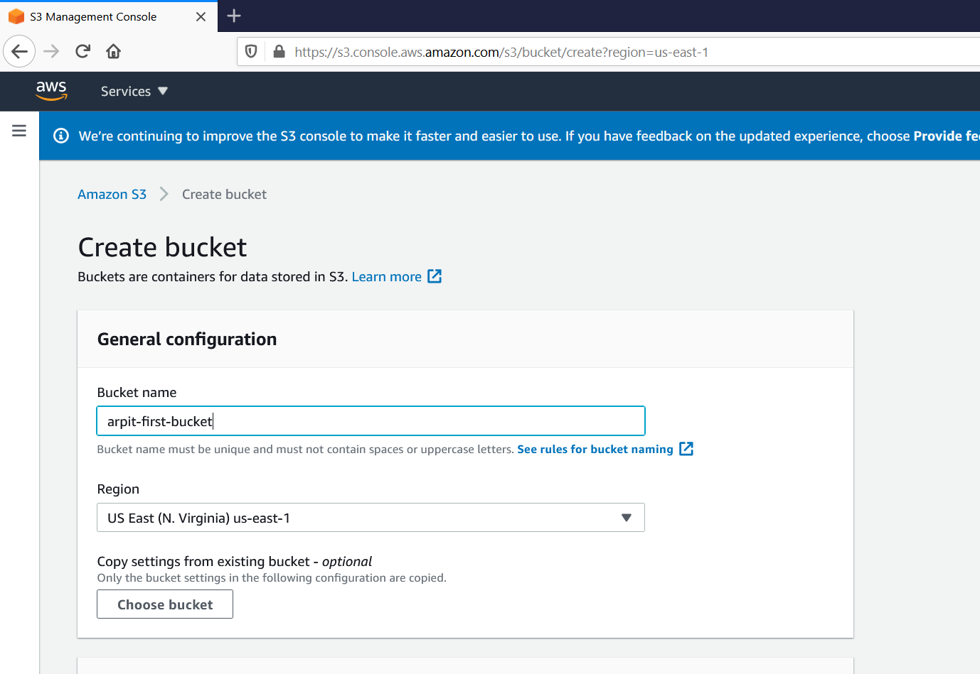

here we can put one unique bucket name.
also we need to give region.

there are other option as well like:-
- Bucket settings for Block Public Access => we will come to this option later as we want public access to this bucket.
- Bucket Versioning
- Tags(0) - optional
- Default encryption

we will leave all this option as it is for now .

now go and create bucket.

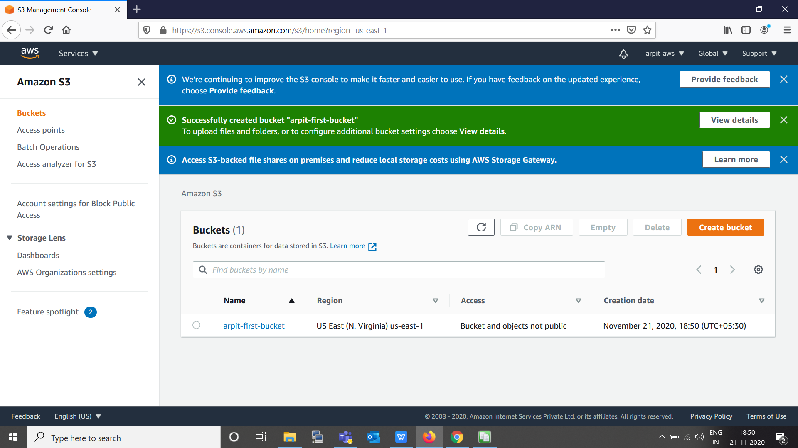

now we can see our bucket is created and we will see in Access tab => "Bucket and objects not public".

Now will go inside it and upload one picture.

here you can see ARN which is Amazon Resource Name.

now our image is successfully uploaded and we are able to see its console as well:-
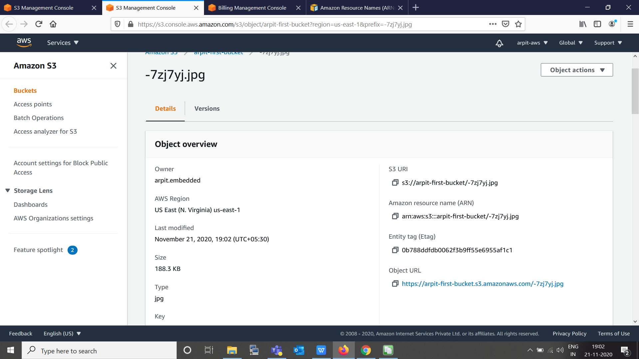

here we can see detail of our upload we can see object url, lets try to access that image by this url.

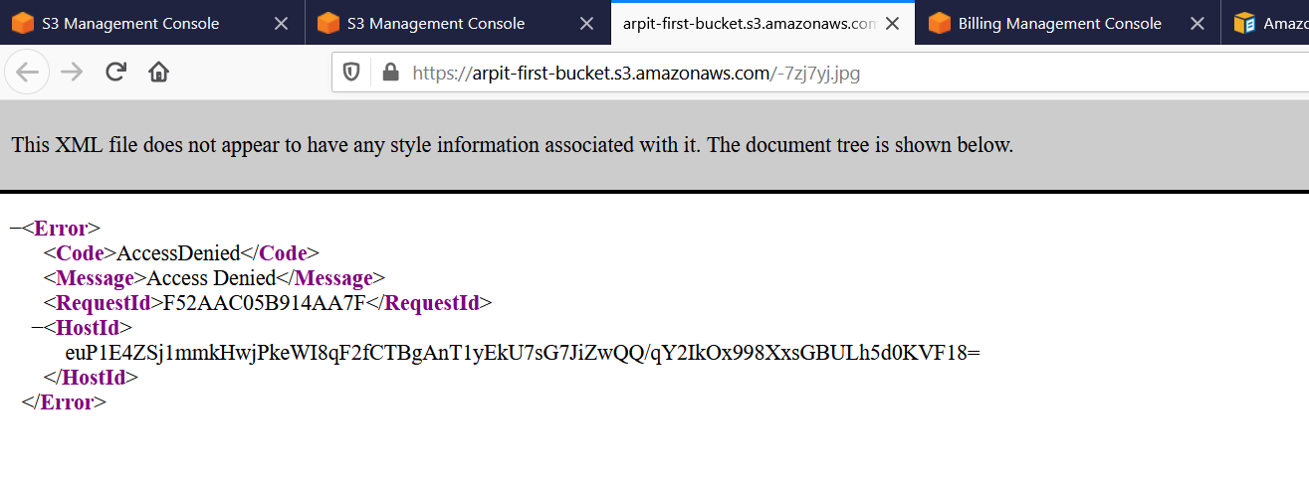

we are getting access denied, so to make this access-able we need to change some setting,
In action for this file we can see that "make public" option is disable, because our S3 bucket is set to private.
now we will make it to "public" then option for "make public" will come.

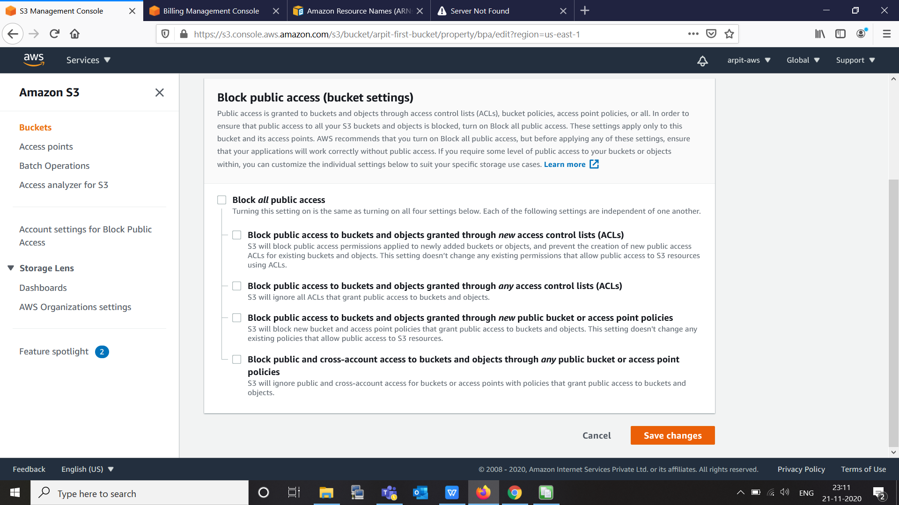

now all public access is unblock -> confirm and we see that
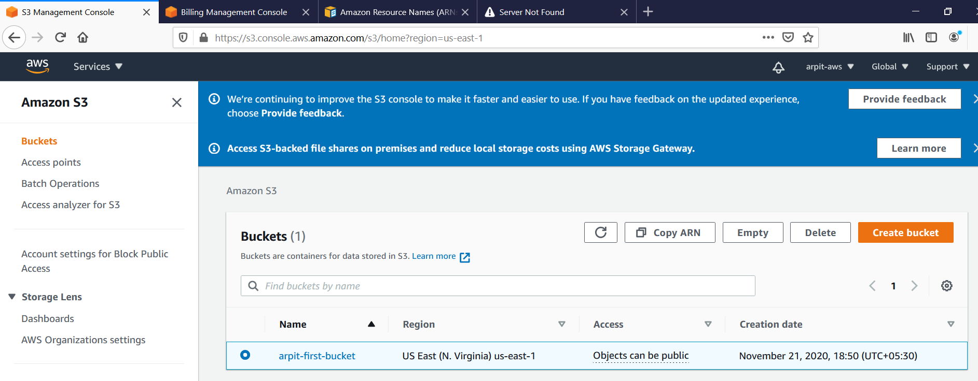

now we can see that object can be public.
now go to our object (image) and "make public"
and try to access.

