IAM :- Identity Access Management

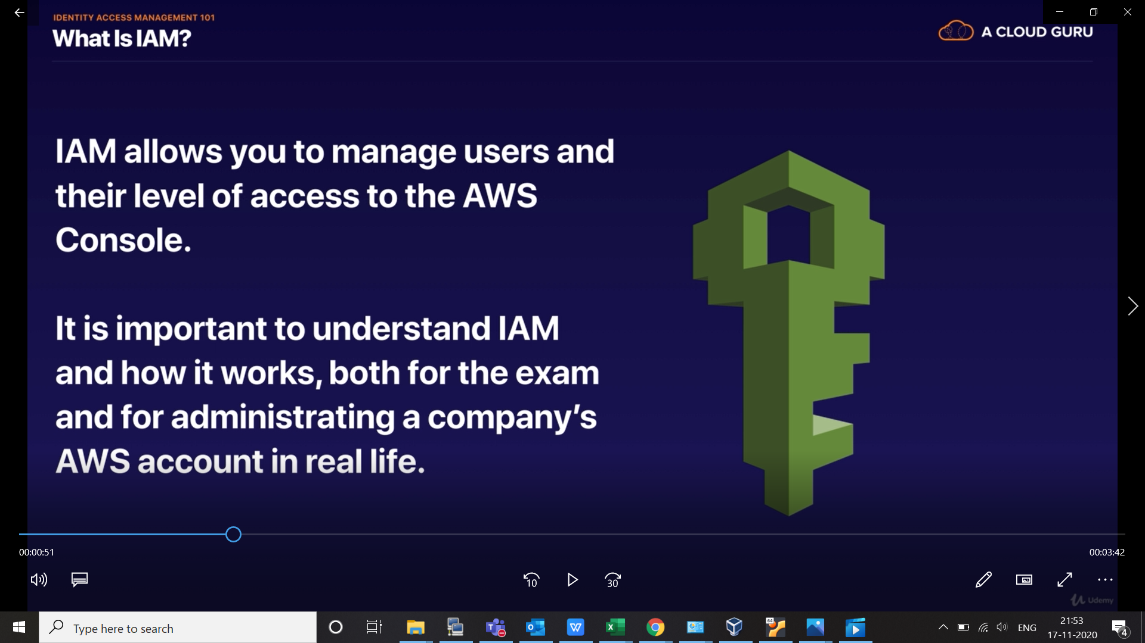

used to setup user, group , roles and permission.

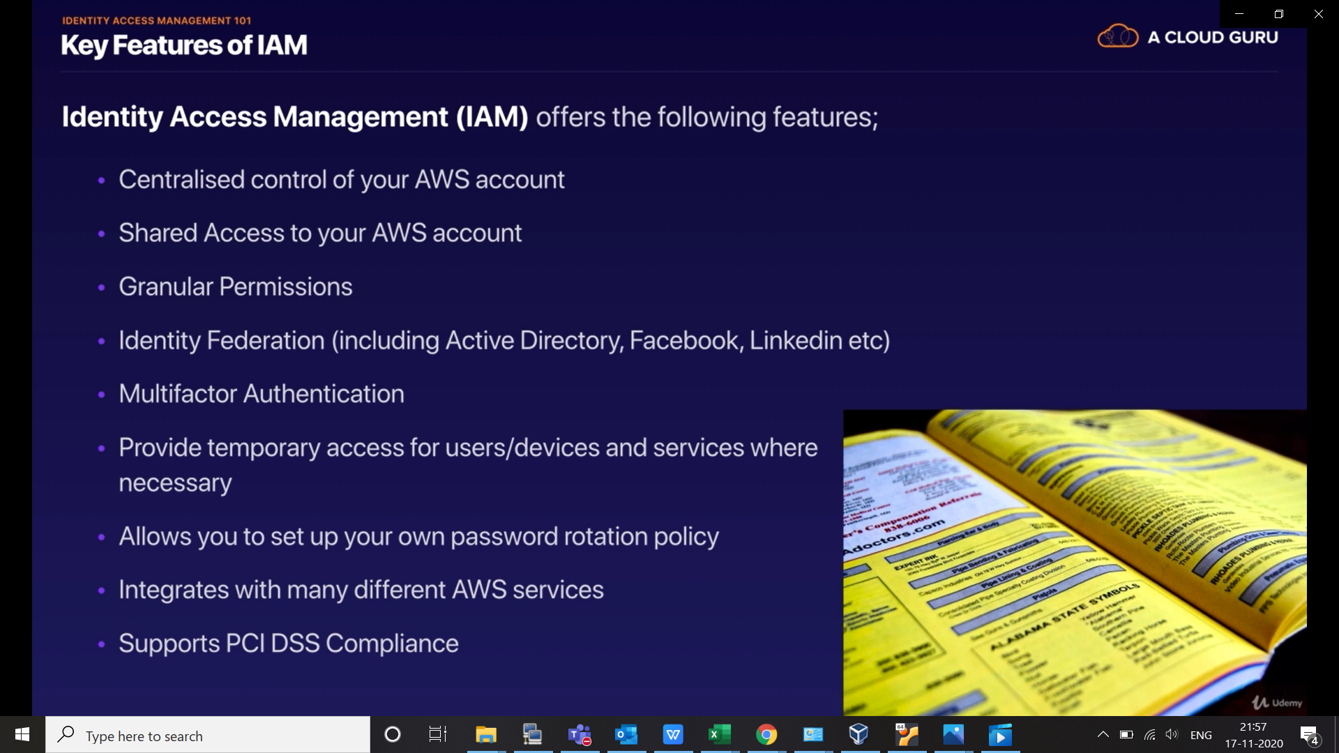

just we need to know about 4 types of IAM terminology listed here:-

