Cross region replication
Go to you S3 bucket --> Management ---> Replication.

So basically cross region replication required to enable versioning in S3 bucket.

here we can replicate on basis :-
- entire bucket
- bucket object prefixes or tags

also you can replicate bucket on :-
- your current account
- on another account

lets choose current account,
here we have to give another bucket name (which will be meant for replication)
and region onto which we have create this replicated bucket.

we can also change class of S3 bucker and its own ship if you want.

Now we have to create new IAM roles, Actually we don’t need to create that rule manually;
we just need to give IAM rule name, AWS will done that ruling for us.

now just review and hit save.

Now when you go to replicate bucket, you can not see you previous object and even its versioning is not present. because we need to upload new object into our original S3 bucket to be reflected in replica S3 bucket.

If you delete some thing form you original bucket it is not marked delete in replication bucket as this precautionary measure taken by AWS to stop accidentally delete something.

Also if you already have file in origin bucker (say v1) and you create Replica bucket, then
you upload file v2 in origin bucket, this v2 version is going to replicate into replication bucket.

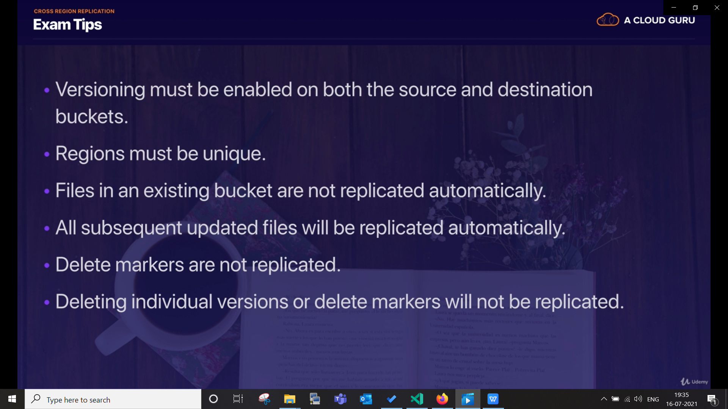

these were the replication rules:-
for my origin bucket
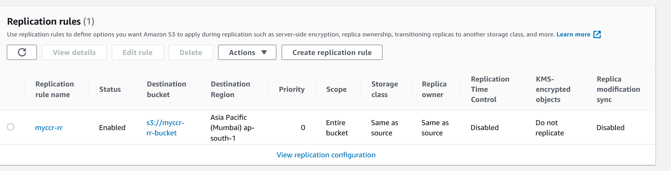

my origin bucket

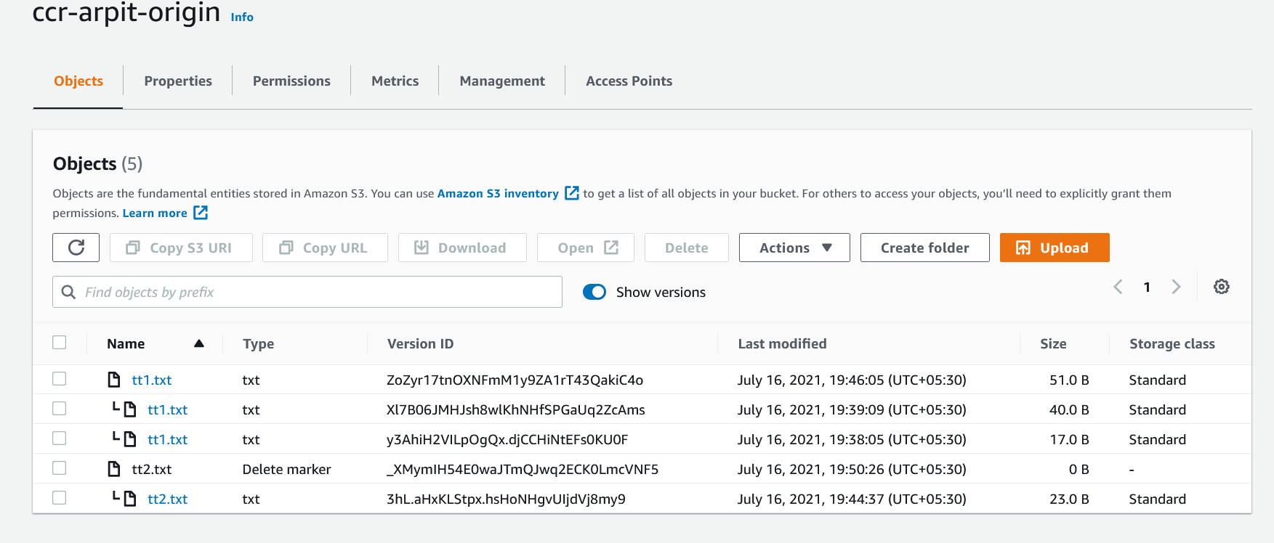

my replica bucket

