What is VPC flow logs ?

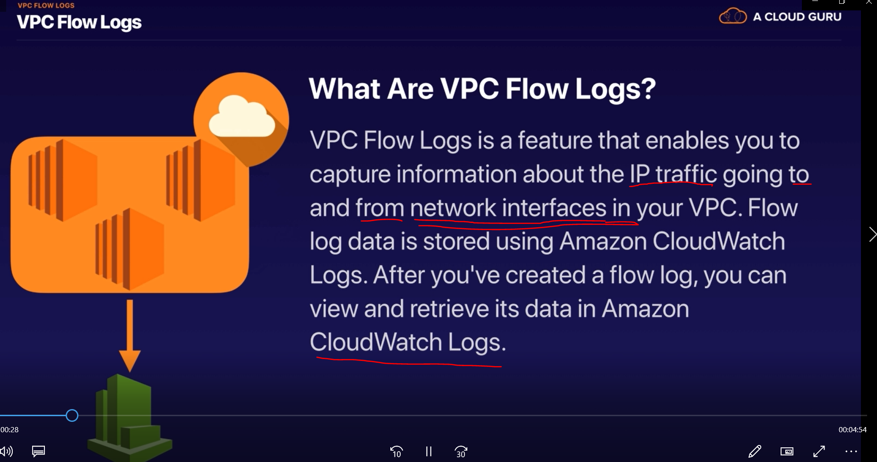

It store and retrive data from Amazon CloudWatch Logs.

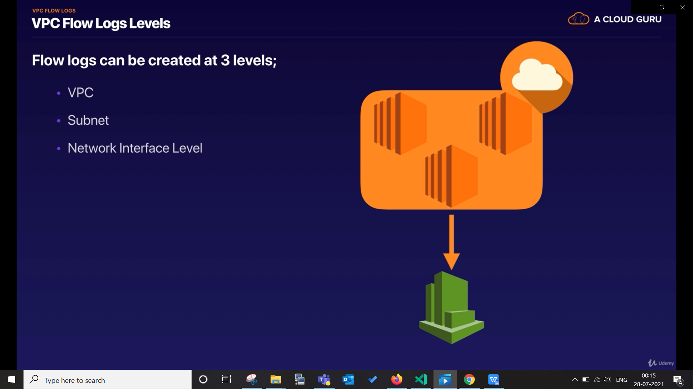

Go to VPC ---> select VPC ----> Action --> create flowlogs

create IAM roles (set up permission this will automatically create IAM roles for us), select cloud watch-log group.

Create an EC2 instance and generate traffic.

and then go to cloudwatch flow logs and you can get your logs there
