here will be the diagram that we are going to implement:-

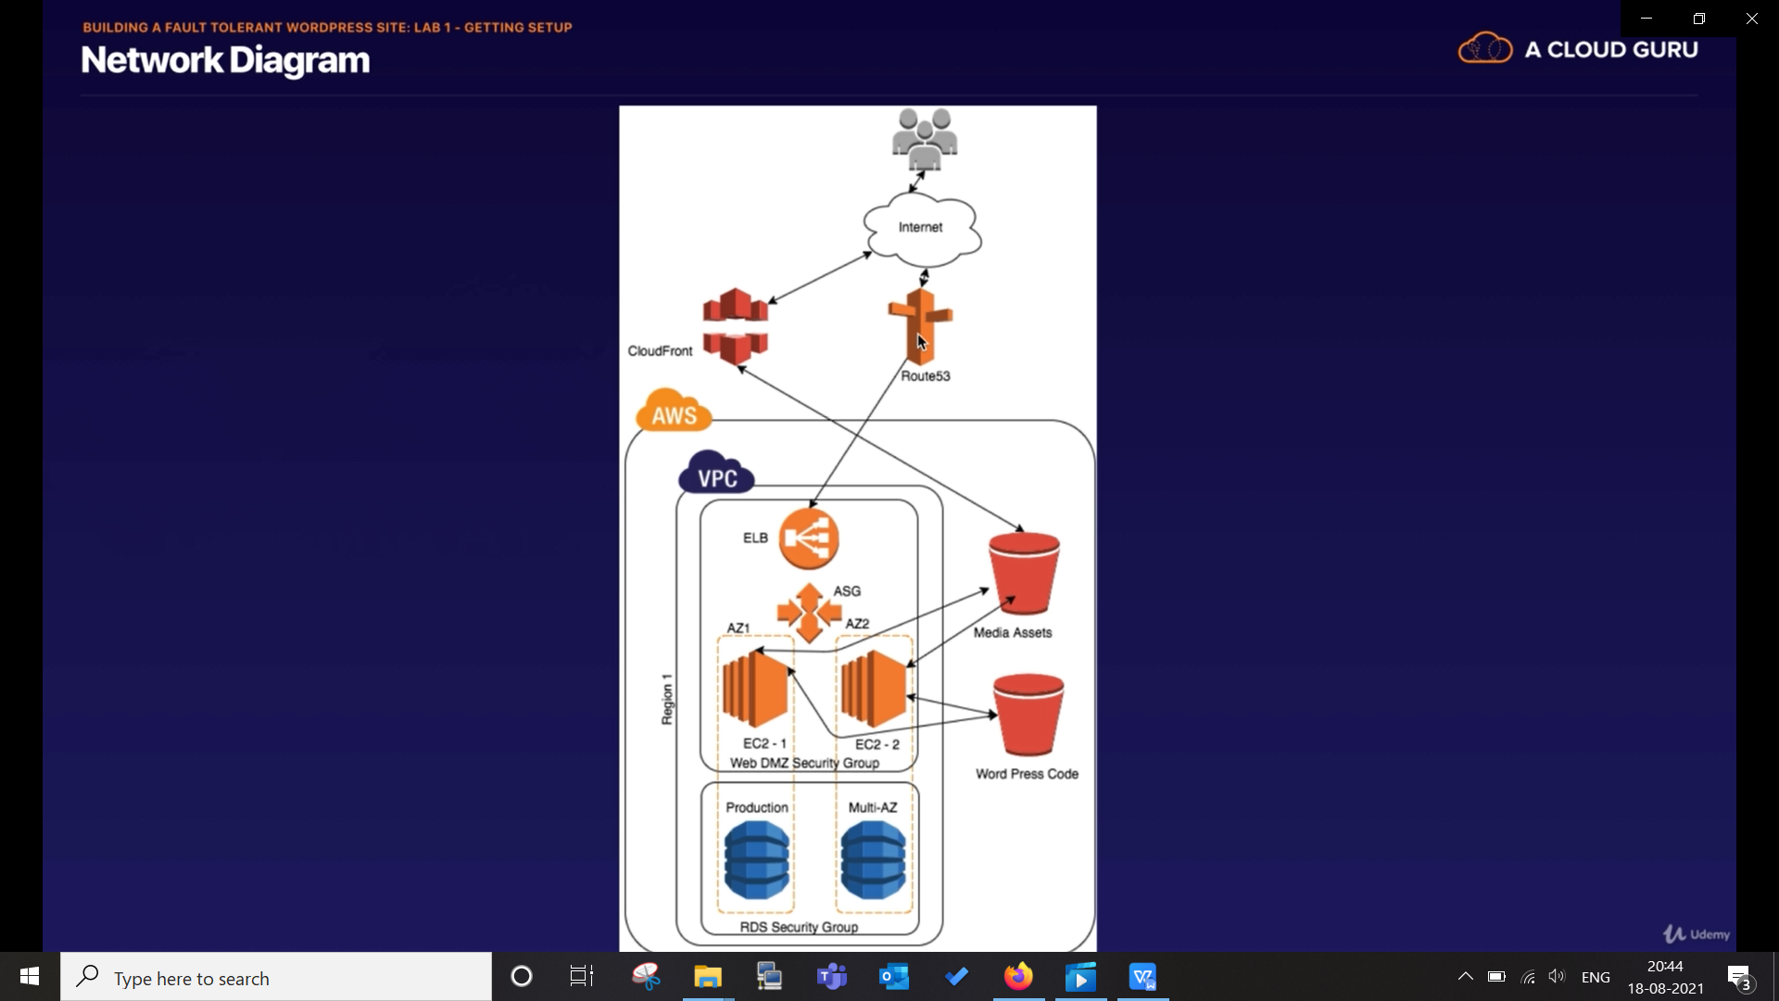

this route53 is optional, you can use Load balancer in that place as well.

there is two bucket:-
1. one might have media assets like pic, video etc
- other will contain all code regards to wordpress.

we will also serve our picture using cloud front.

once that infrastructure is done we will introduce failure in one EC2 and RDS so check fault tolerance.

Step1:- create two bucket for code and media

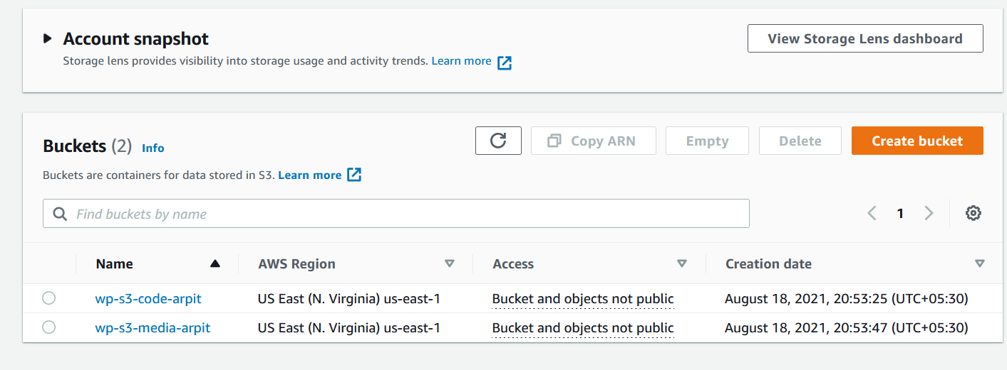

Step2:- create "cloudfront" distribution in "network and content delivery services (CDN service)"
create this as first as it will take time.

click on create cloud-front distribution

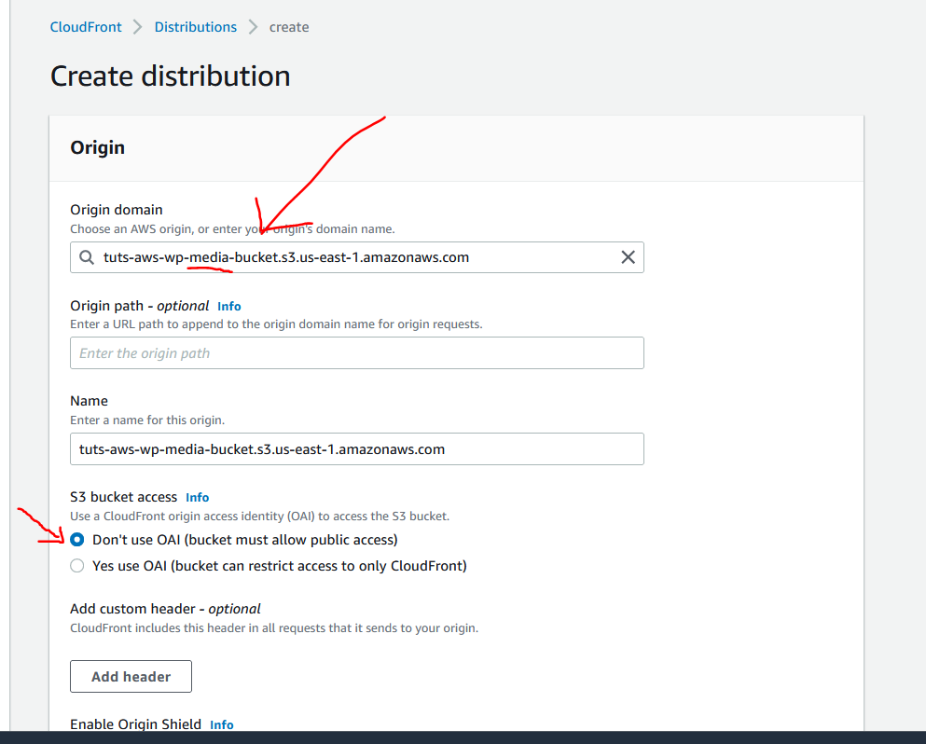

choose origin domain (means what it is going to server). and leave every this as it is.

Step3:- create RDS instance as it also takes time.
step 3.1:- create security group for rds having mysql/aurora

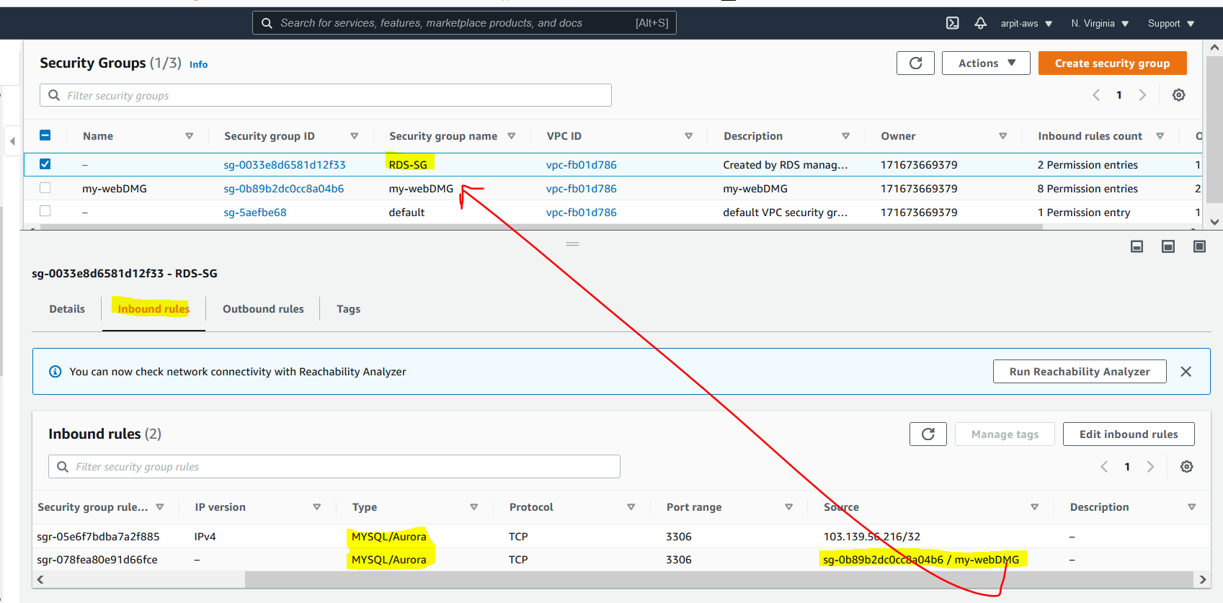

while create security group for RDS make source as ec2's security group onto which you are going to run http server.

step 3.2 :- now create MySql-RDS instance
we are not gonna make it public-ally access-able.
also create a database in our rds.
create subnet group which contain atleast 2 subnet in different availability-zone.

Step4 :- create IAM role for EC2 service which can access S3.
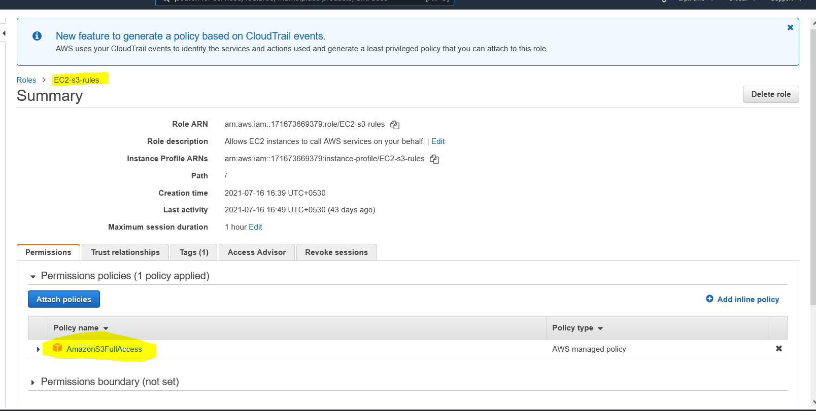

Step5 :- create EC2 instance with IAM roles as EC2-s3-rules, and use this bootstrap script to install wordpress.

#! /bin/bash
yum update -y
yum install httpd php php-mysql -y
cd /var/www/html
echo "healthy" > healthy.html # this if for health check
wget https://wordpress.org/wordpress-5.1.1.tar.gz
tar -xzf wordpress-5.1.1.tar.gz
cp -r wordpress/* /var/www/html/
rm -rf wordpress
rm -rf wordpress-5.1.1.tar.gz
chmod -R 755 wp-content
chown -R apache:apache wp-content
wget https://s3.amazonaws.com/bucketforwordpresslab-donotdelete/htaccess.txt # for cloud front
mv htaccess.txt .htaccess
chkconfig httpd on
service httpd start

------------------------------------------------------Part-2-------------------------------------------------------------------------Setting up wordpress site.

