Docker networking enables a user to link a Docker container to as many networks as he/she required.

so we can create multiple container running on same network (by default is bridge)

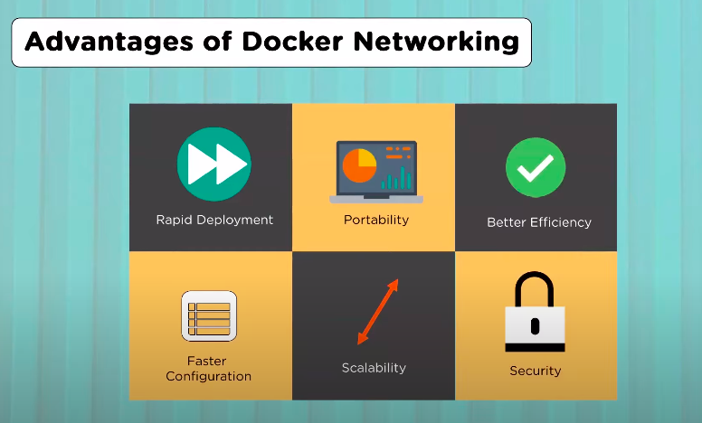

so every network has its own attribute like CIDR, GATEWAY, Routes etc.

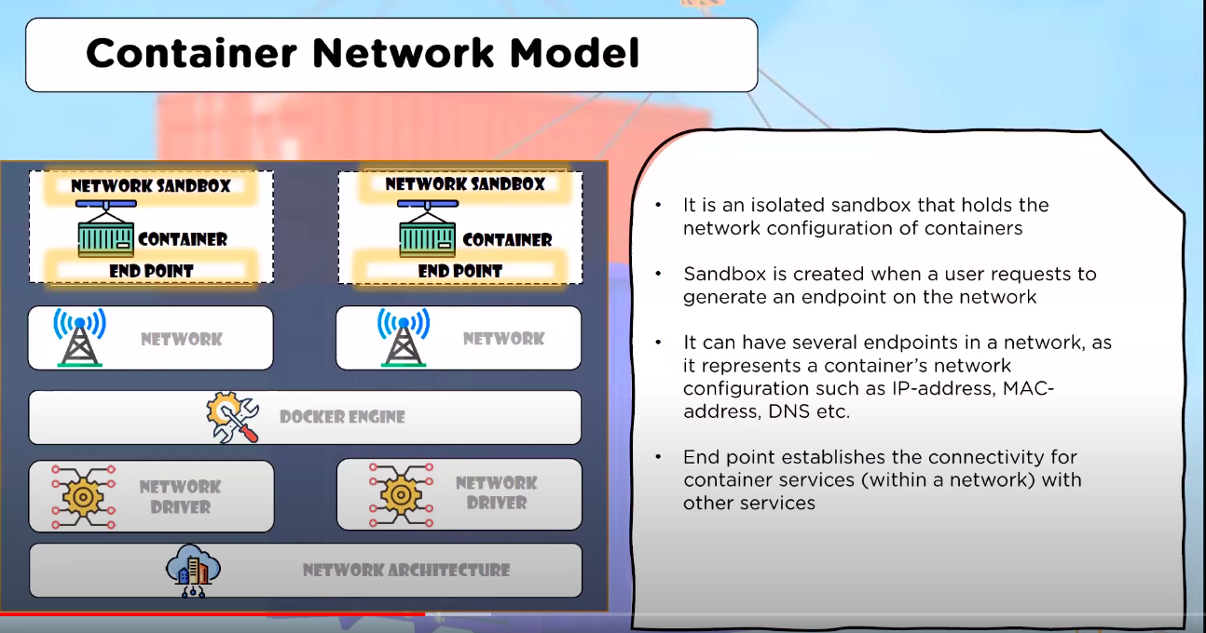

there were 5 types of network driver are available in docker like:-

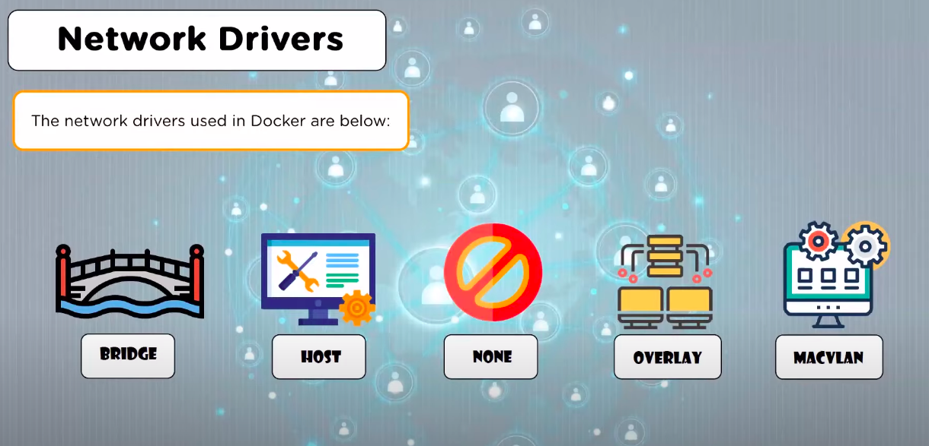

Bridge:- its a private default network driver created by the host when you create a network.
Containers linked to this network have an internal IP address through which they communicate with each other.
Container can interact with each other but you dont have connectivity outside.

decker0 :- this is default network interface available which is bridge.

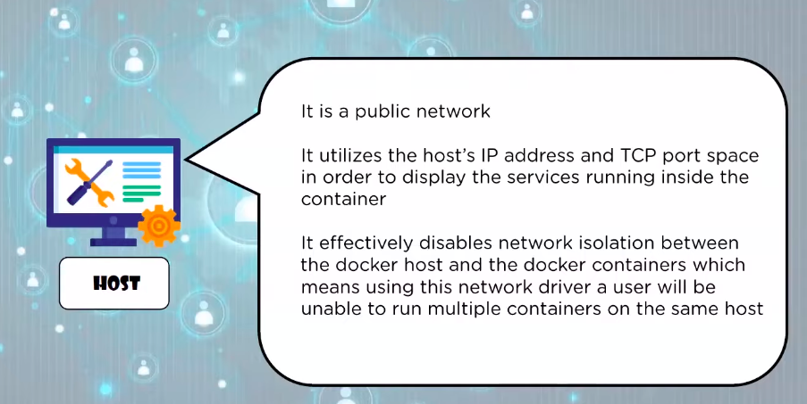

for HOST here configuration is IP address and port and by this we can interact with outside word.

Overlay to communicate between different nodes in docker swam like k8s nodes communication.

so it is helpfull in case of cluster.

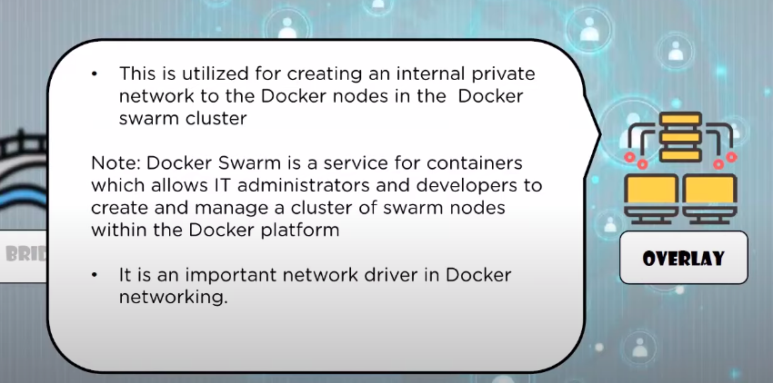

MACVLAN

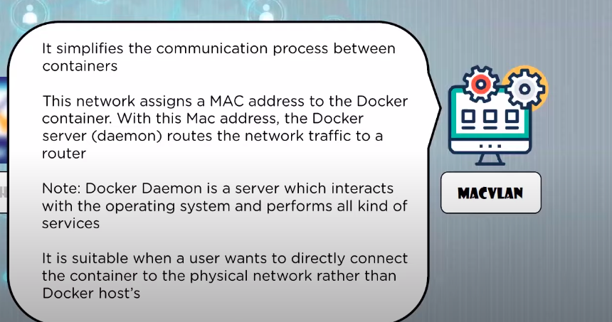

this will assign MAC address to container and instead of IP address we use MAC address to communicate.

so help full when we have only physical connection between conatainer.

Demo PART about bridge:-

$ docker network ls ==> to see all network driver present

$ docker network inspect <network name> ==> this will give network driver and conatianer attach to this host information.

Now create some contianer and create network bridge to connect

to create bridge network use
$ sudo docker network create my-net-bridge

this will be bridge network

to create container in this bridge we need to run like:-

$ sudo docker run -itd --name img5 --net my-net-bridge alpine sh
$ sudo docker run -itd --name img6 --net my-net-bridge alpine sh

$ docker network inspect my-net-bridge

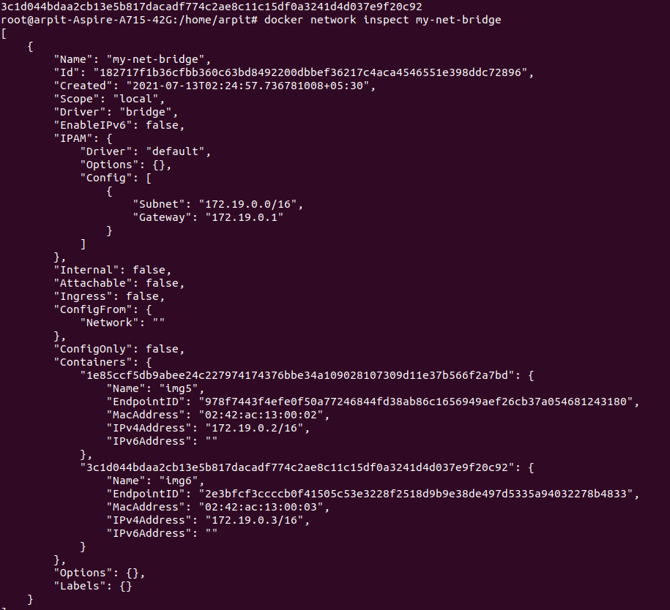

Here in above pic we can see that img5 and img6 have mac and ip address allocated inside my-net-bridge.

Imp:- this img5 and img6 will now behave as hostname (DNS) for there respective IP.

means we do exec in one container (say img5) and do $ ping img6 this should work lets see....

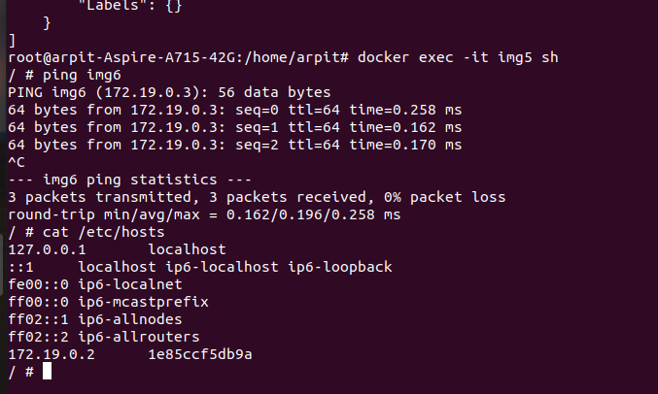

yes its working even we dont have any entry in /etc/hosts.
as this network drive have entries.

Previously there is --link command that will add entry to /etc/hosts but not it is not part of docker, it have many drawback.

SO when we run docker-compose in background it will automatically create a network bridge driver.

