Now full application means Developing, Testing, Deploying a docker application:-

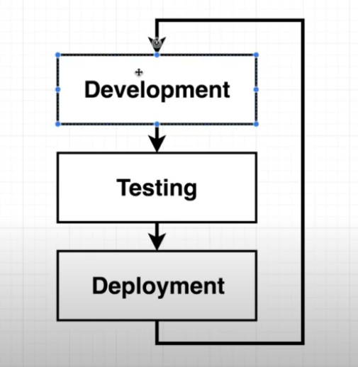
Things required:-

1. Github:-
1.1 Feature branch:- here we are pushing our changes here and create a pull request to be merge in master. Then it will be test and later merge on the master branch to deploy.

1.2 Master Branch:- main code lie here and it will test and then it will be deployed on cloud/anywhere else.

2. Travis CI :- This is continues deployment provider through which we can pull changes and do certain test (we are going to write these test).
Now here in our case we are going to use pre-genetared test.
Travis CI is also responsible to push our code to aws,

3. AWS:- we use Elastic Beanstalk.

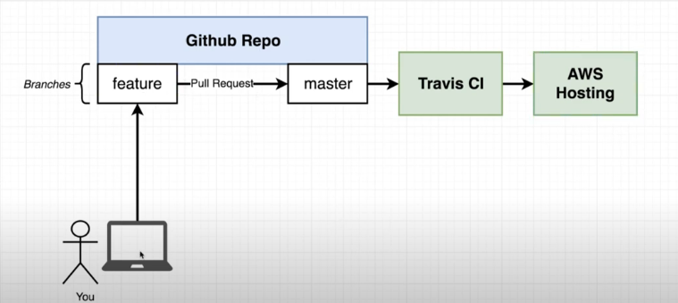
Our work flow will look like this.

Another way to understand the flow like:-

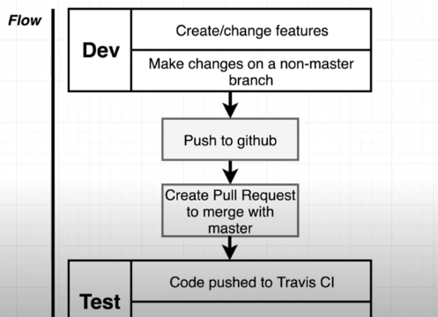

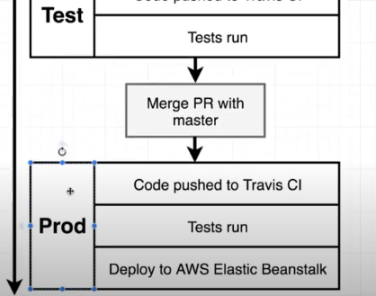
here we can see that we have three phase:-
1. Dev
2. Test
3. Prod

so travis CI is responsible to test freature branch pull request and put that into master.
After merging to Master it will test code again and deploy on AWS Beanstalk.

Here we can notice there is no need for docker:-

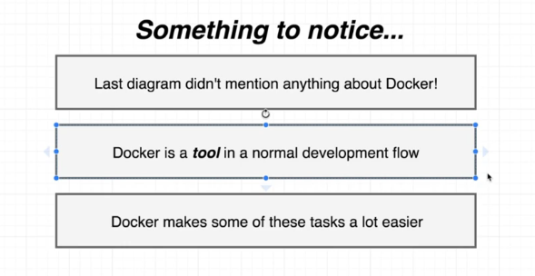
Docker involvement is not mandatory here. But using docker here, make things lot more easier.

Here we are using JS code, but we are not focusing about what code we are using, we need to make focus on how docker is managing all this.

So what we are making is very simple react application.
We will rap it on docker container, and test it on docker container.

Here we are not gonna write anything we are going to use a tiny little project generator.

Now from here we are doing Nodejs stuff, later we will come back to docker.

1. To test nodejs is install or not; $ node -v

we have node js install

2. install a tool :- npm install -g create-react-app
3. run this tool to create a react project name “frontend”:-
$ create-react-app frontend

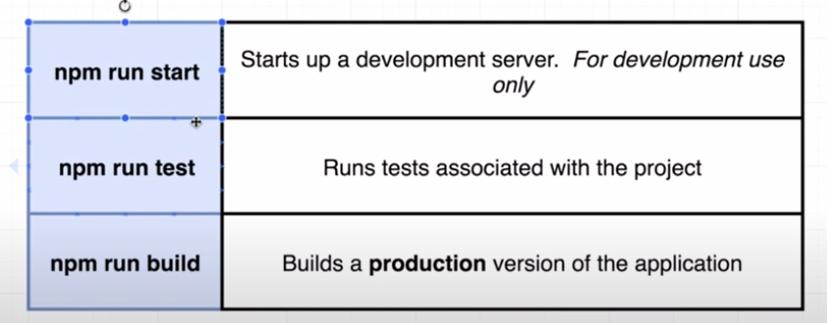
lets talk about some commands:-

1. npm run start => this will start development server, it means all the file scattered and it run server. This is not efficent way and not use in production.

2. npm run test => this will run test

3. npm run build => this will merger all js file into one standalone file and run production server.

Now go to our frontend directory and start to run test.

$ npm run test

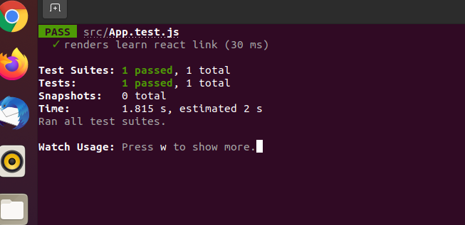

These above test is associated to built-in for our react project.

Press “q” to exit from test runner.

Now build it with :-

$ npm run build => this will concatinate all js file to single file and inside “build” (newly formed) directory.
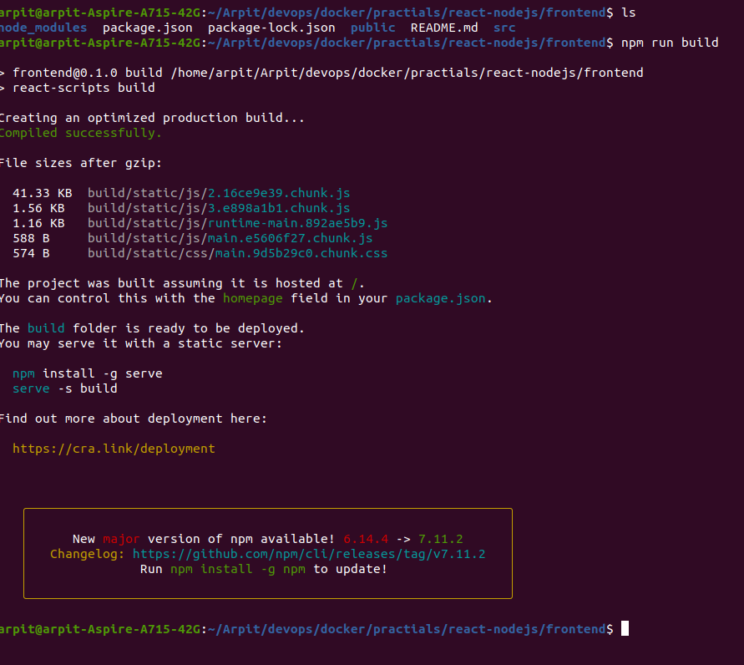
If we look inside “build” directory we can get “index.html” and at “build/static/js/” we have our main js file (this js file is our main application).
In some point of time we will use this file to serve it on aws instnace or aws service.

If we do “npm run start” => it will run development server.

Now lets talk about application as it has development, test, deploy phases.

We will use docker to rap up our application into docker container, so we will react ot development phase.

Later we will create two different container one for “dev” and other for “prod”.
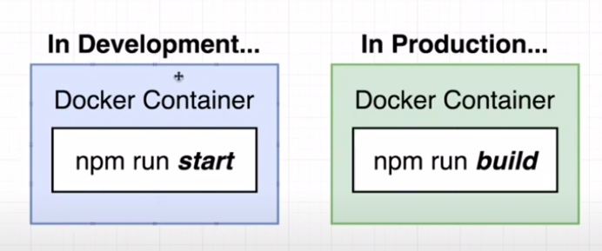
For develpoment we are using a “Dockerfile.dev” (just for understanding)
Later for production we will use simple “Dockerfile”

now create this “Dockerfile.dev” into our react main folder.

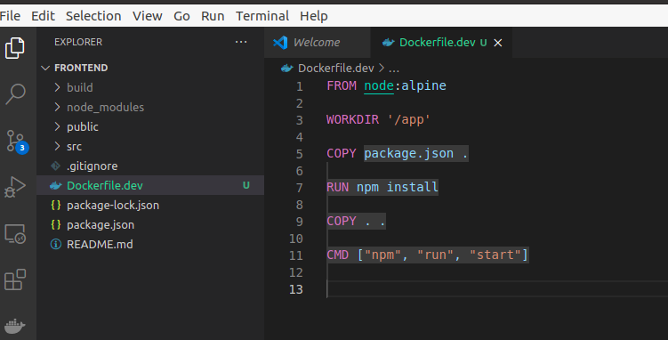
Now our docker file look like this.

Now let see how to run docker file with custom docker name.

$ docker build -f <our custom docker file> .

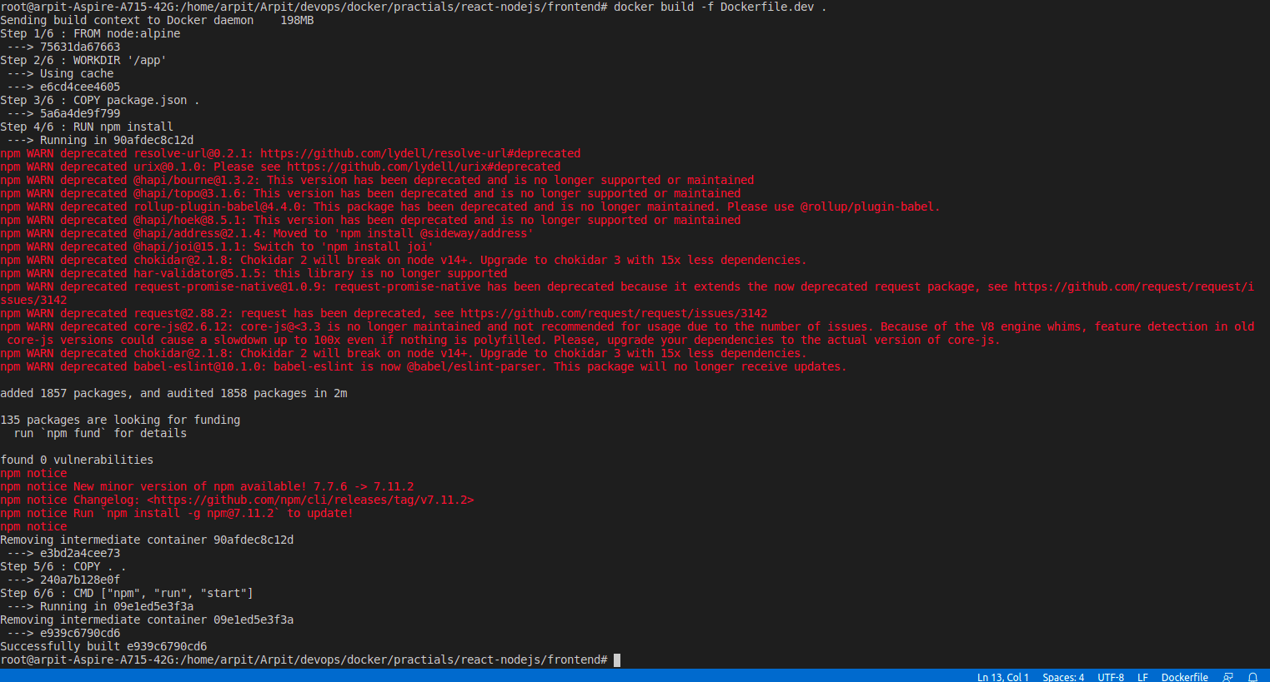
Now here we can see that we have successfully created our image with some warning.

One instreating things to be notice here in very first line it says
“Sending build context to Docker daemon 198MB”

As we are using “create-react-app” tool to create this react app. This tool will automatically install all dependency. Name as “node-modules” which will be equaly to 198MB. But it is create by tool not by docker.

Now As we created an image from our Dockerfile, it also create these dependency install in our image as well.

So we dont need this duplication.we can just delete this “node-modules” from our local machine.
Now run our image :-

docker run -p 3001:3000 c8bf05309b18

now form our local browser are can access our react app on port 3001.

