to install ansible :-
https://www.guru99.com/ansible-tutorial.html

Install ansible and to verify run
$ ansible --version

$ ansible localhost -m shell -a "date" => this will run date command in shell.

This command is to check whether ansible is properly install or not.

Ansible Inventory:-

From ansible inventory all ansible configuration start, it contain all machine configuration for which we need to push configuration (run script) .

- we can run script in many server at a time.
- we can run patch under certain condition like if in some server memory is low then run certain patch.

Also ansible need to connect to the server, it uses "SSH" for linux user and for windows it uses "Power shell routing".

All this configuration store in inventory and default path for inventory is "/etc/ansible/hosts".

we can create our own inventory, while running script we need to pass inventory explicitly other wise default Inventory is used.

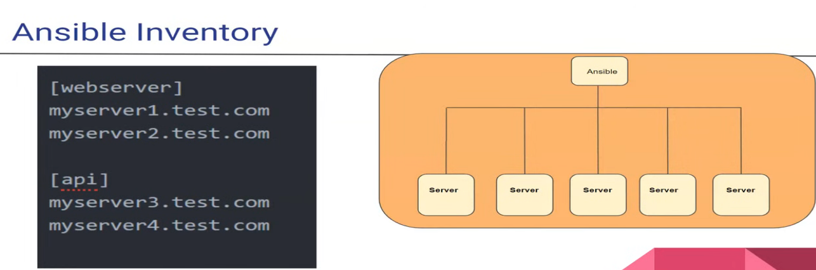

Inside inventory every server has it row entry and we also have to group like [webserver] and [api].
if we want to configure server related to given group then we can do like that.

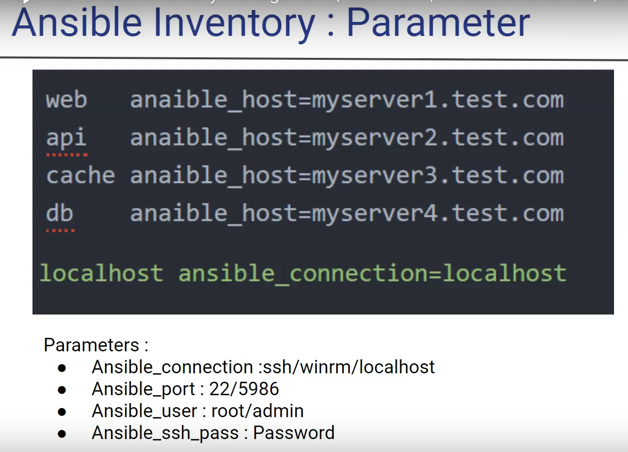
ansible_sudo_pass=yourPassword

or in node $sudo visudo
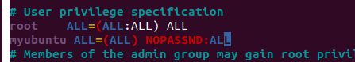

tester ALL=(ALL:ALL) NOPASSWD:ALL # good
The meaning of these additional fields is: First “ALL” indicates that the user can run commands as all users. The second “ALL” indicates that the user can run commands as all groups.

I am using docker for server and use my custom image "arpitguptadockerhub/myubuntu".
Hint :- enable ssh service you can also use sudo /etc/init.d/ssh start

this have some tools pre-install, need to "service ssh start" and also username = myubuntu pass=aa

In this above pic we can see first column as alias name for the server and we can define parameters eg:- ansible_host, ansible_port etc as mention which is used to define servers and its login cred and type.

now it get map with alias we don’t need to mention full configuration every time.

now we will create an inventory => vim inventory.txt
type:-

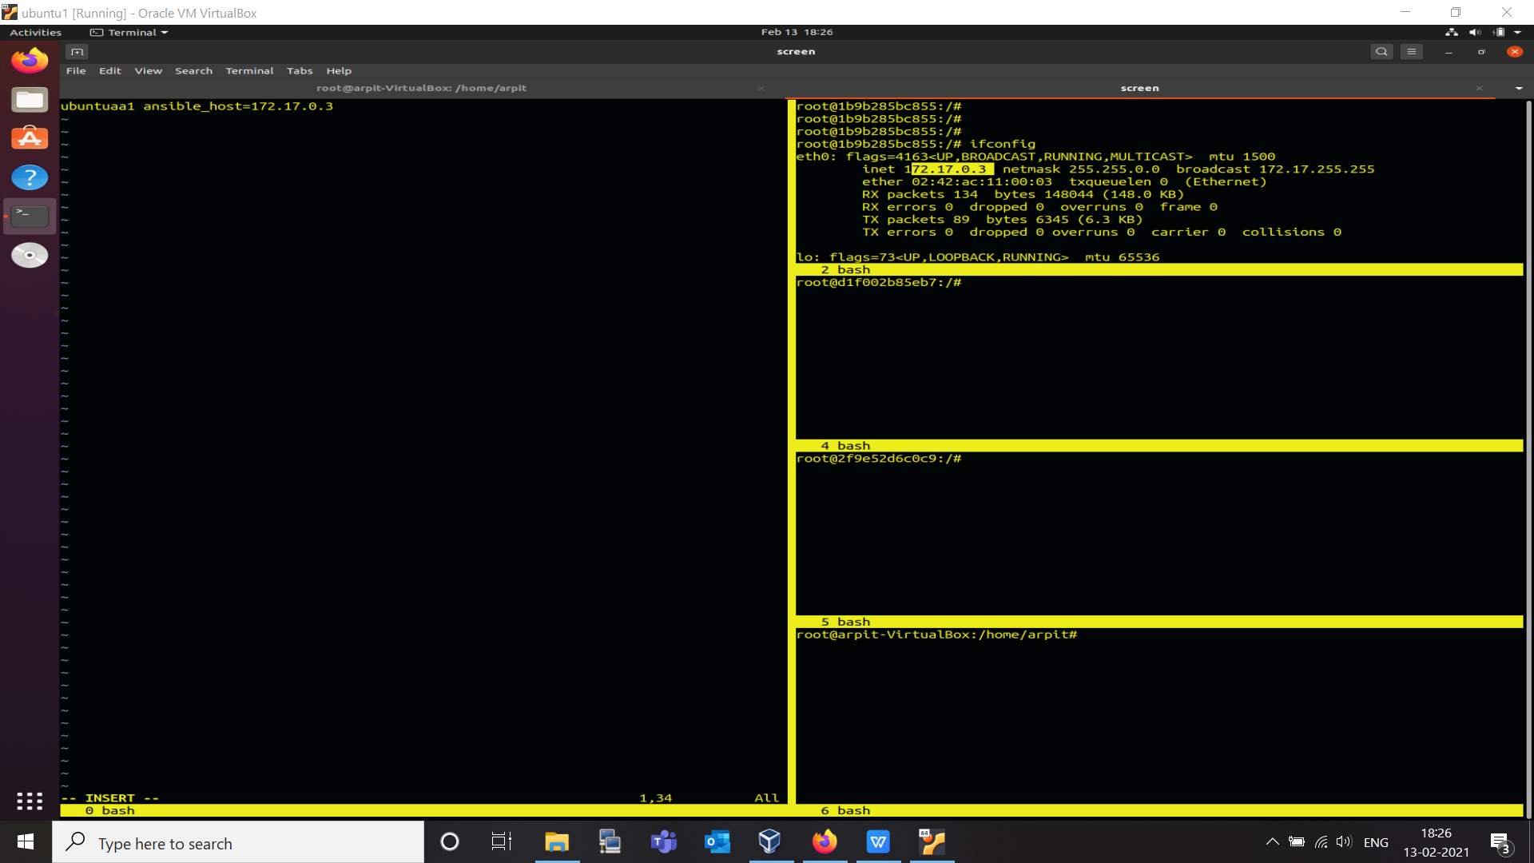

here in right we have docker container running ubuntu server.
$ ansible ubuntua1 -m ping --ask-pass -i inventory.txt
$ ansible -m ping all --ask-pass -i inventory.txt

this will return "pong" on successful ping. if some error try to install "apt-get install sshpass" on Host/node/server.

By default if "--ask-pass" is not given this will search for public key authentication.

By default ansible user is "root" to change it use "ansible_user=myuser".

also before ssh we have to add fingerprint of server. we can remove this setting from /etc/ansible/ansible.cfg => un-comment "host_key_checking = False"

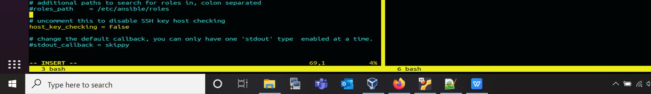

also another solution for above prob is to use "ssh key" not password.
