Version control in S3:-

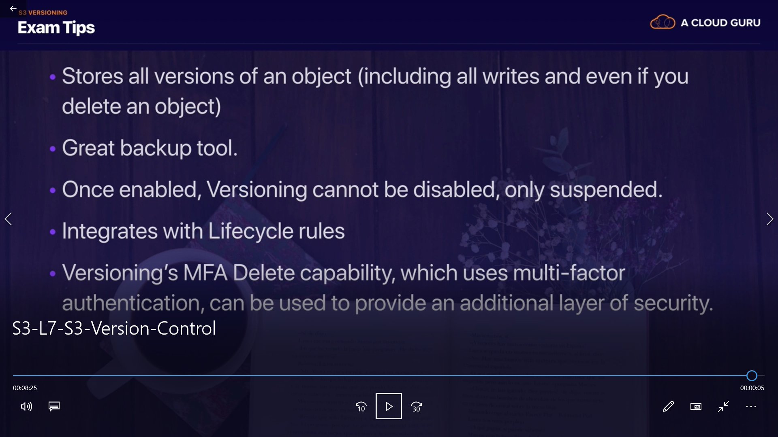

once version control is "enable" for a bucket it can't be disable, it just only be suspended.
now start practical :-

we will make a bucket with "public access" and we enable versioning as well.
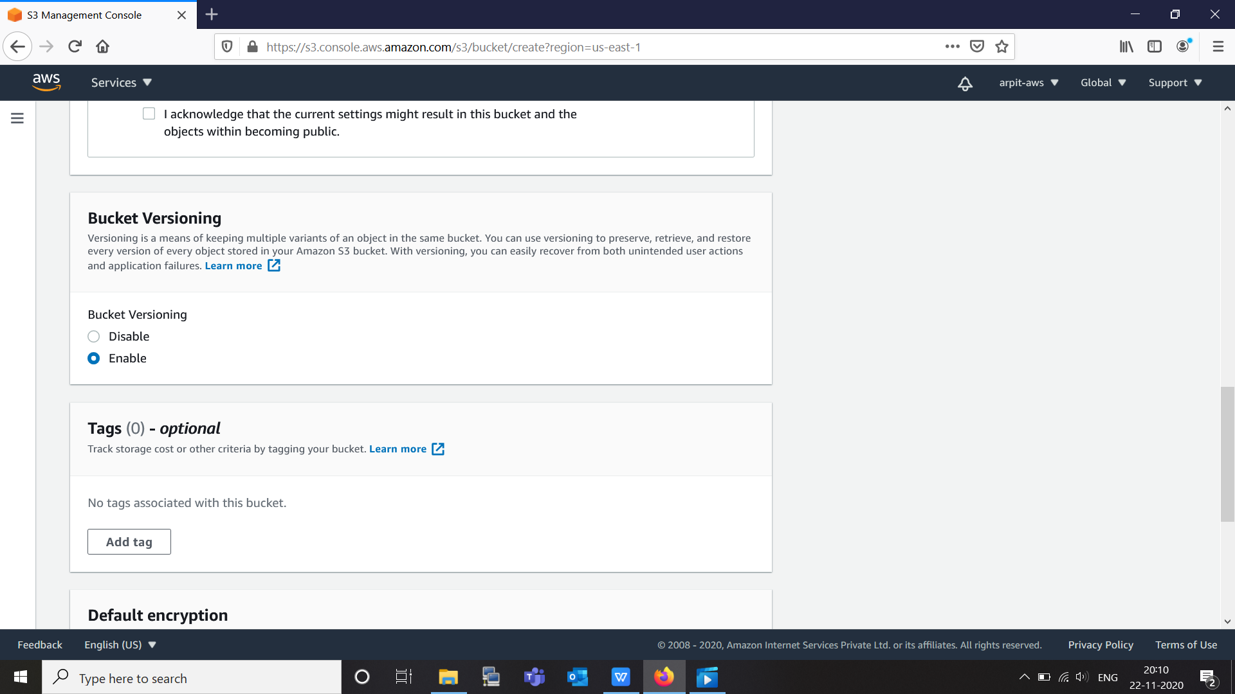

and now we will add item to this bucket to see versioning.

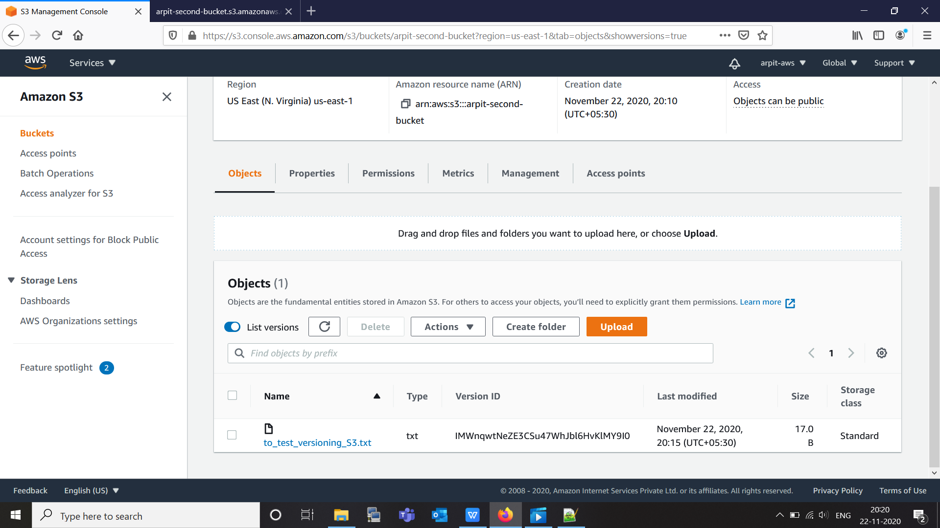

here is option of "list version" just enable it so that we can see all version of same file.

by accessing this bucket file we can see it like:-

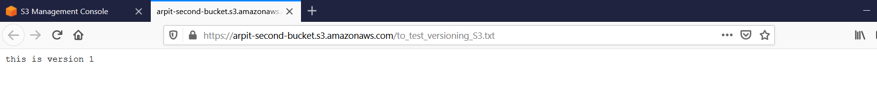
Now edit this file and upload it again to see other version as well.
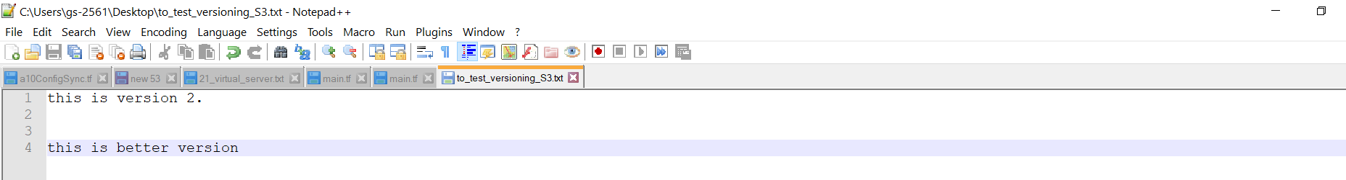

this is our new file and we upload this and lets see console.
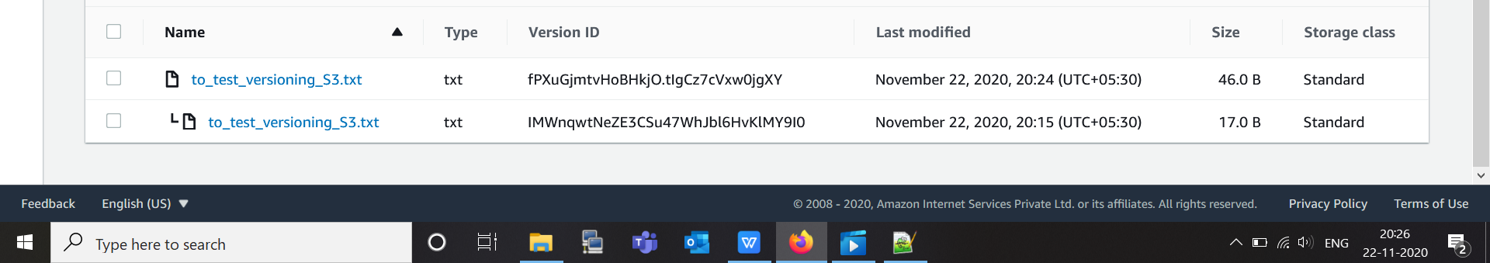
here we can see we have two file.
but latest version file is private , to make public available this file we need to click "action" -> "make public".
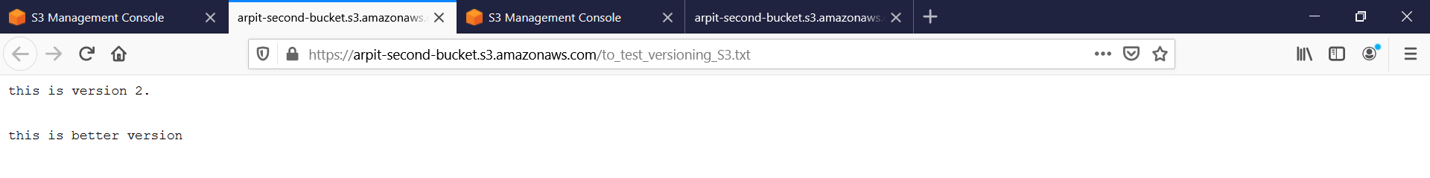
now lets upload version 3 file and try to delete then.

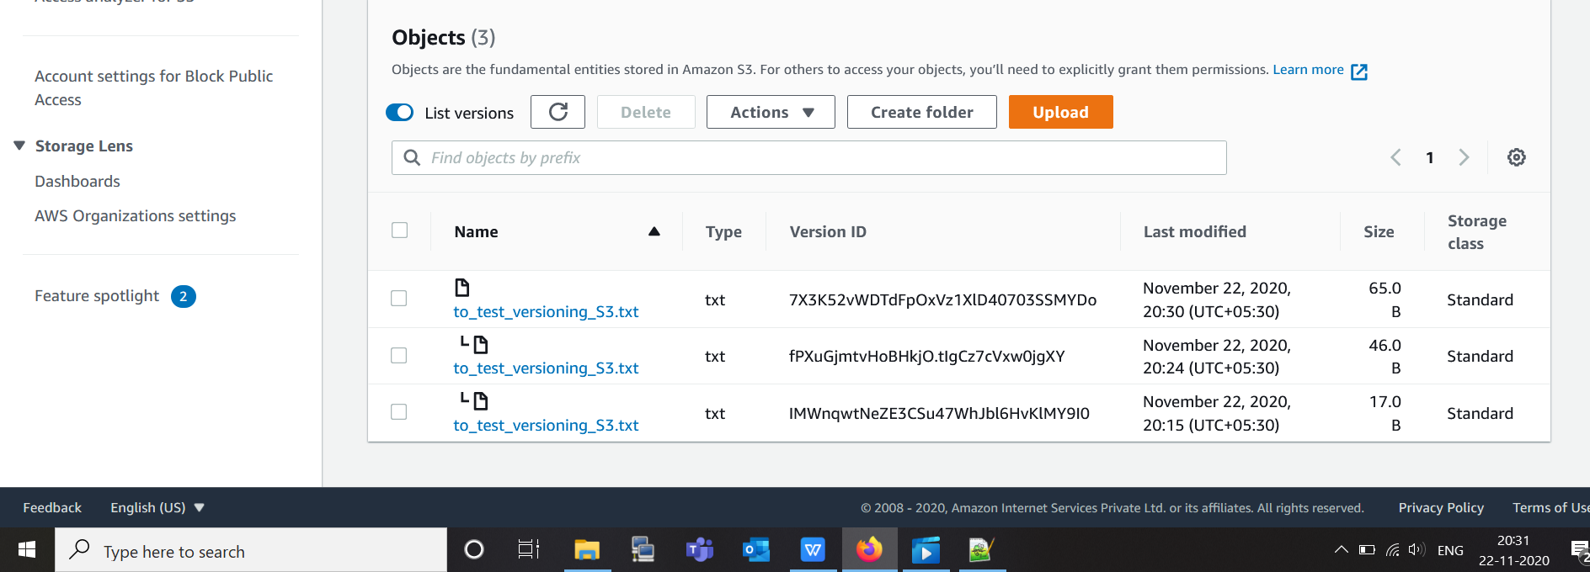

So there are three version of same file.
while deleting we there are two behaviour:-

- List version is off

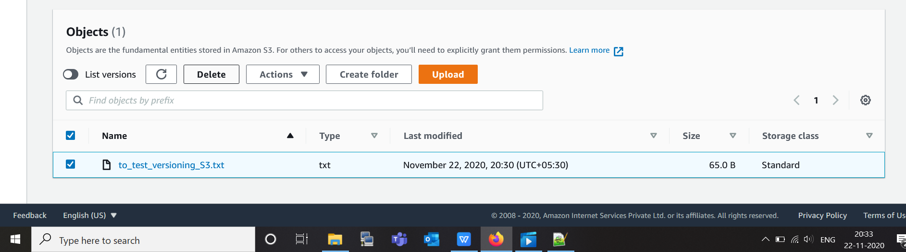

here "list version" is off, we are going to delete this file.
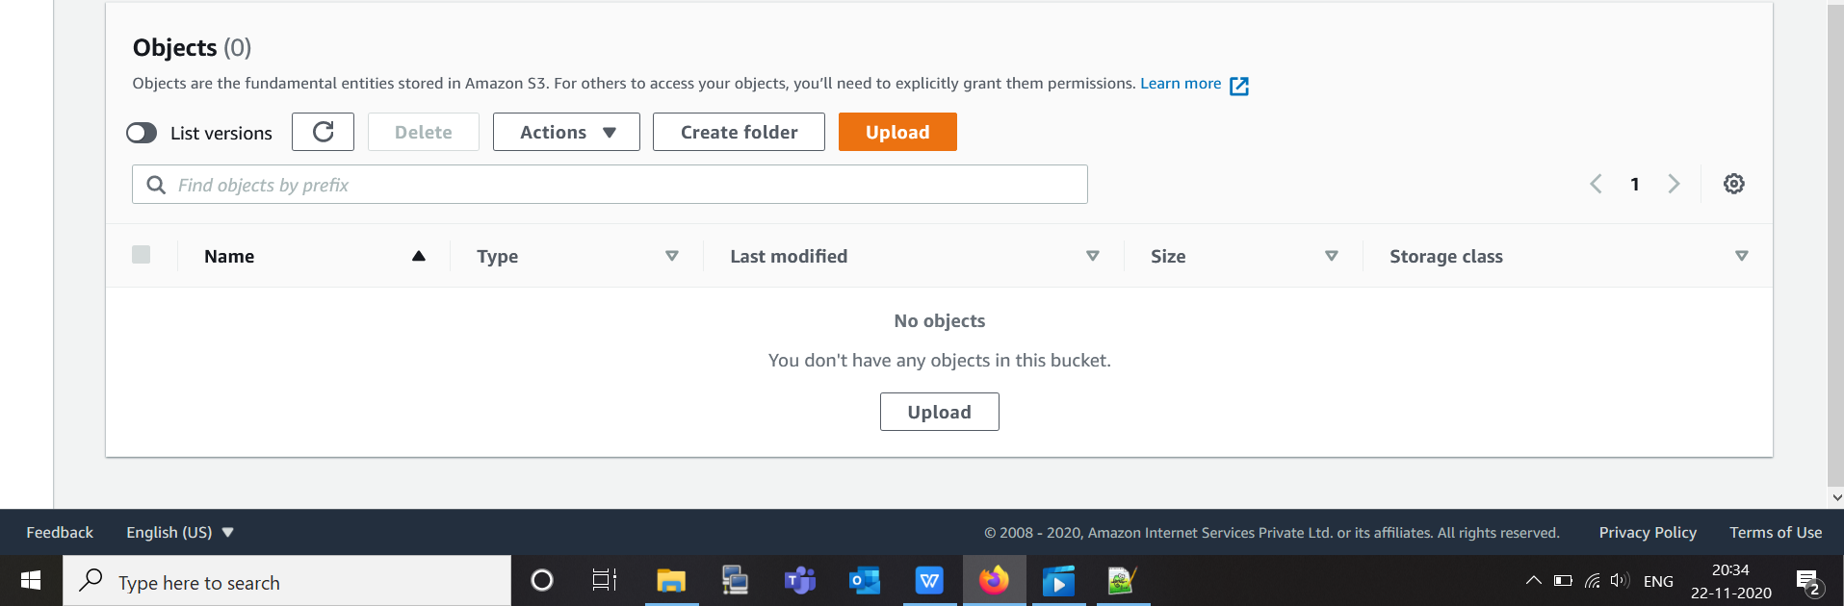

here file seem to be delete but it is not deleted , it is just "marked" as deleted.
when we ON list version we can see our file as marked deleted we can retrive this file a well, by deleting "marked deleted" file.
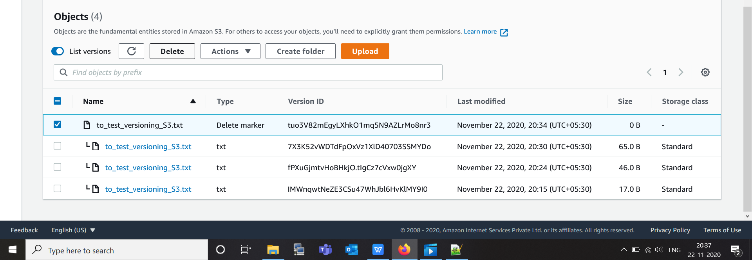
here we can see marked deleted file just delete so that we will get our file back.
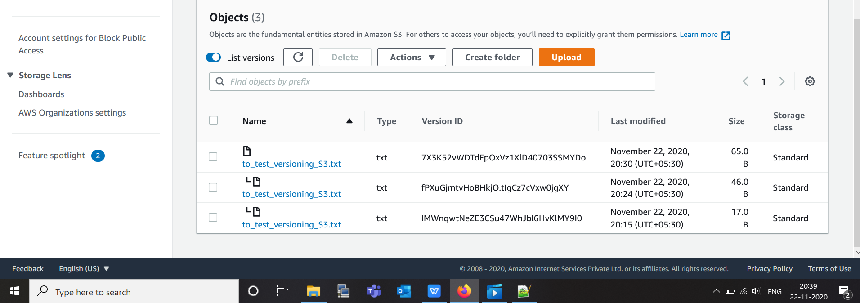

here we can see we get our file back.

now try with second behaviour
2. ON list version and then delete.
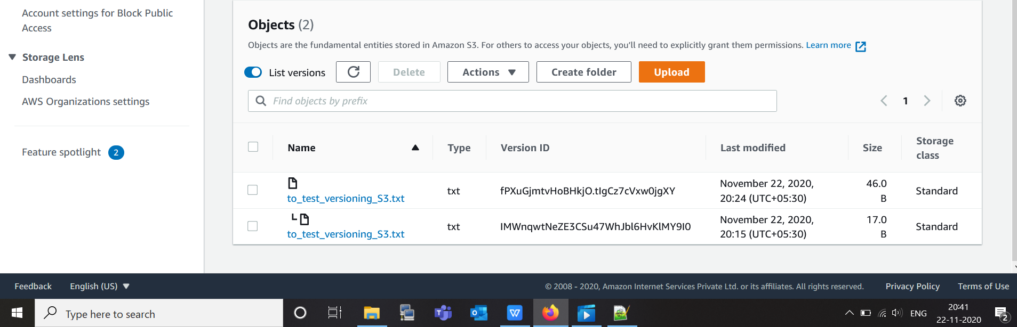

Now here we can see our latest version is deleted permanently. we older version become latest again.

For more security enhancement we can ON MFA on file delete.
By enable versioning, we create multiple copies of these file, so it consume more space in our S3 bucket.
To stop this we can also Integrate lifecycle rules. this we will see in next lecture.

