now we are going to provision our first EC2 instance.

Service -> EC2 -> launch instance.

Step 1: - choose you AMI (amazon machine image) => this is just like template/virtual machine to use.

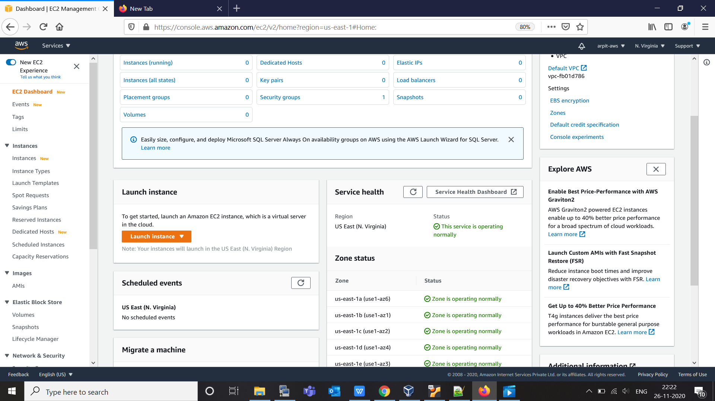

you can see running instance is 0, also we can see all availability zone as well.

After "launch instance" -> we can see OS to choose form -> we will use free tier ubuntu 20.08

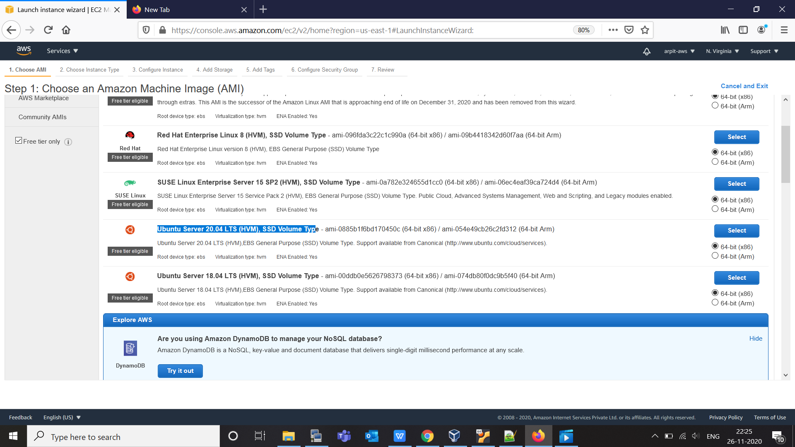

"select"

step-2 :-
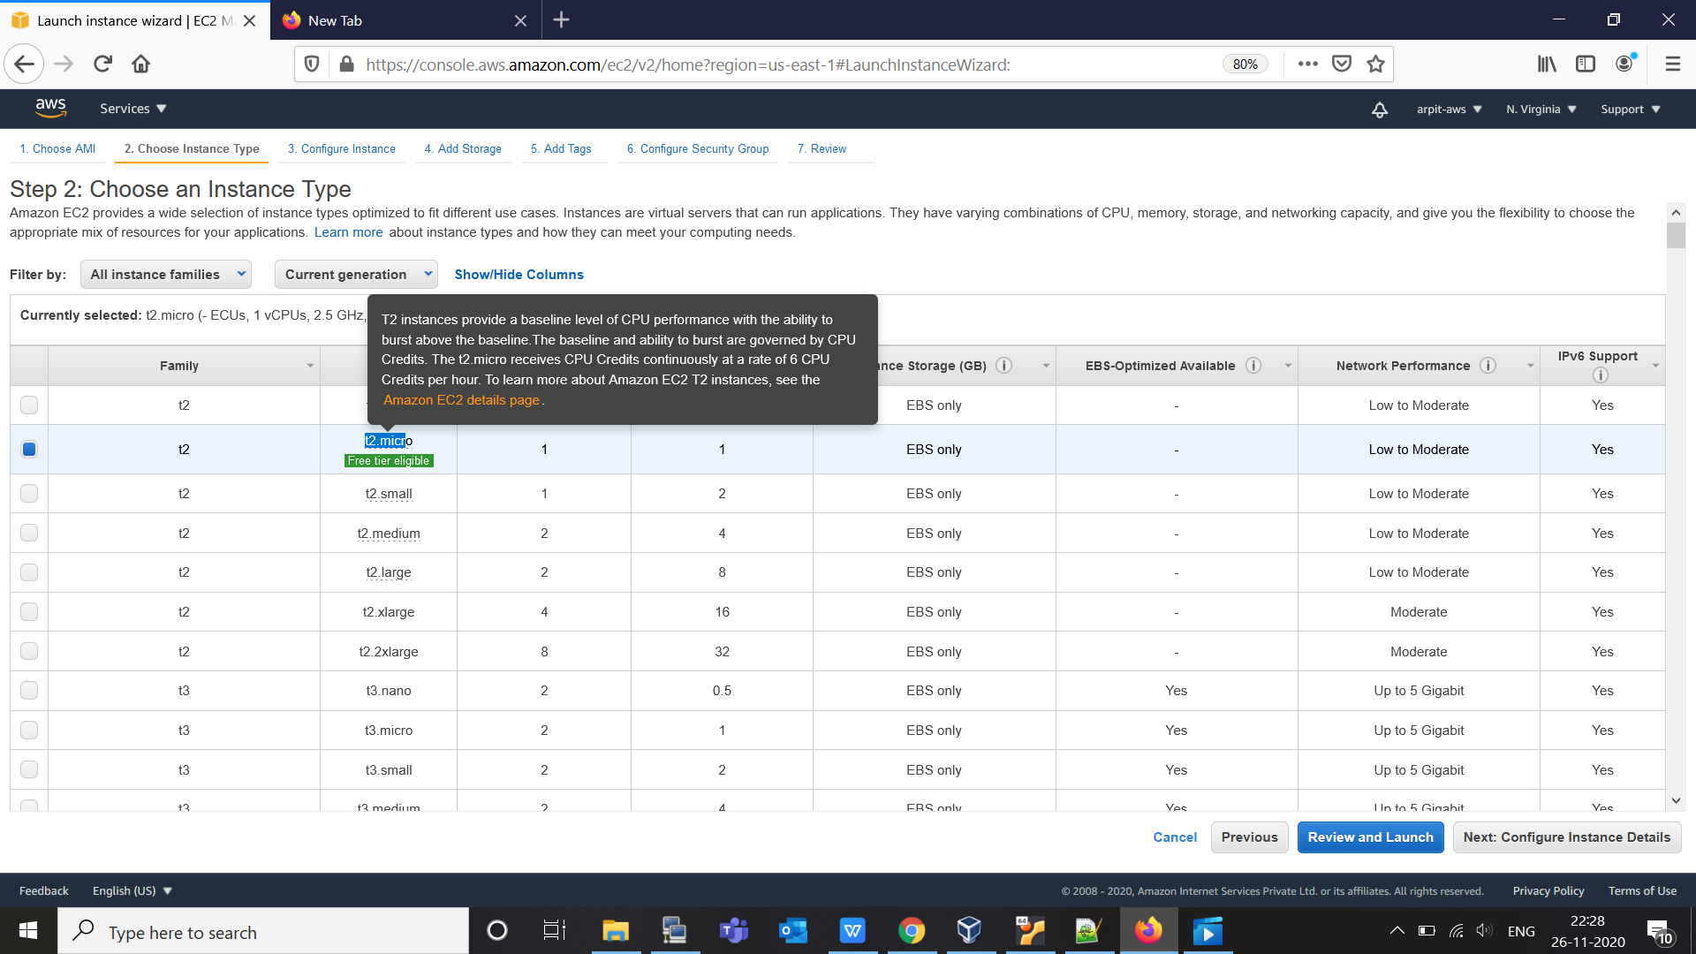

here are list of all instance type as mention in lecture one.

we choose "t2.micro" as it is for free tier.

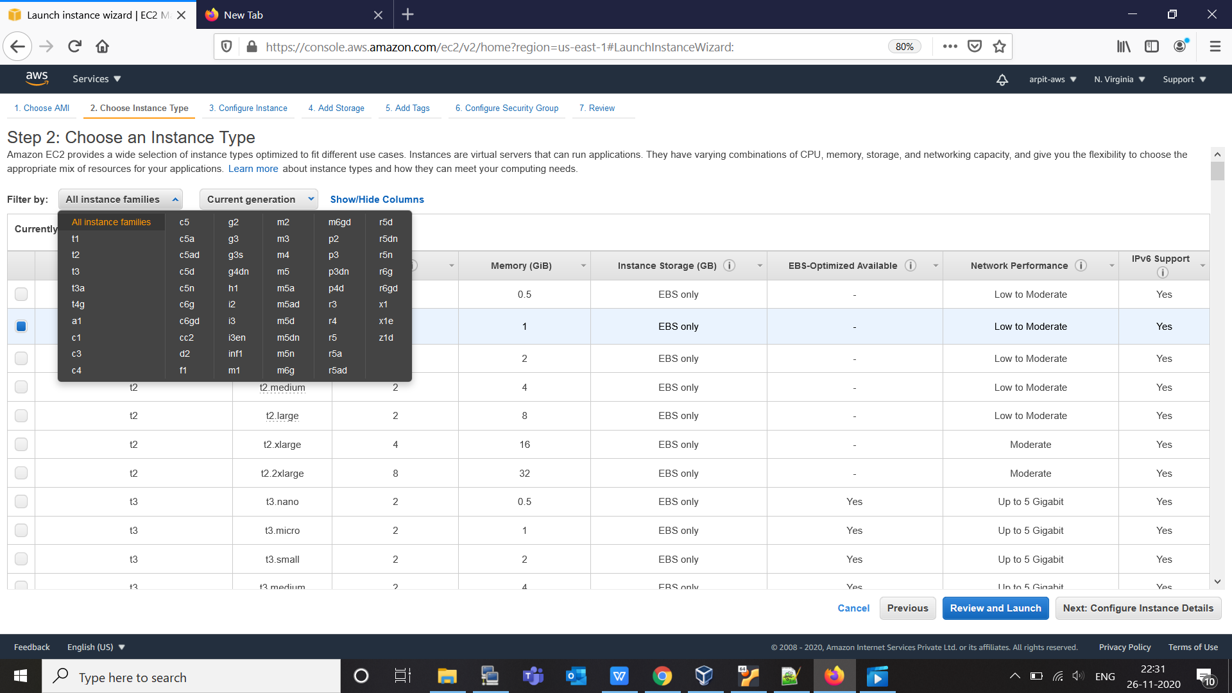

this much of instance we can configure here.

click "next" to configure instance detail.

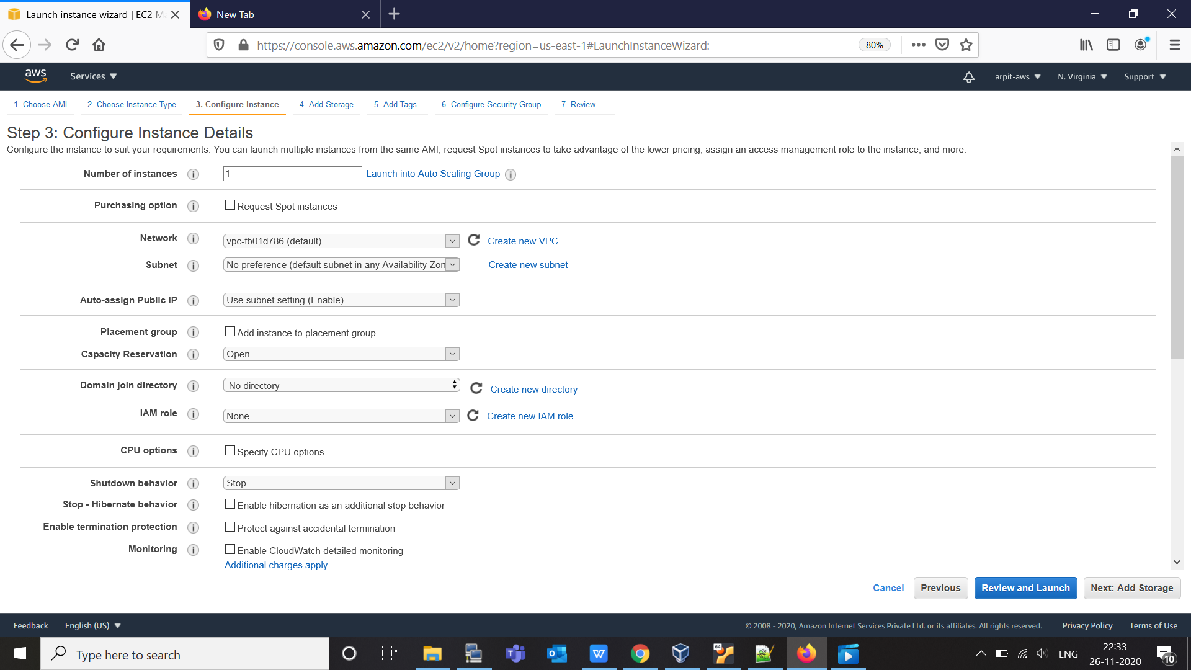

now it time to explain each field here.

- No of instance -> we will put that to one for this example.
Launch info Auto Scaling Group -> we will cover that in next High Availability (HA) lecture.

- Purchasing option -> we will not going into it, lets remain that as it is.
- Network :- here we need to select VPC (virtual private cloud) About VPC we will talk about it later. right now we are using our own default VPC.
- Subnet -> depend upto availability zone in your region.
- Auto-Assign public Ip :- we will make this enable.
- Placement Group -> cover later (basically for high performance computing )
- Capacity Reservation -> this will reverse capacity in your availability zone, stay that as it is.
- IAM -> cover later.
- Shutdown Behaviour -> what is happen when we Shutdown this EC2 instance, is that going to "Stop" or "Terminate".
- Enable termination protection -> protect against accidently termination, we are going to enable that as well.
- remain very thing as by default.
- in Advance option -> there is "userdata" where we can put our BootStrap script, this script run before our instance start working to set initial configuration.

so make every thing as default except check protection against termination.

now click to "next" for storage configuration:-

For storage in EC2 we use EBS (elastic block storage)

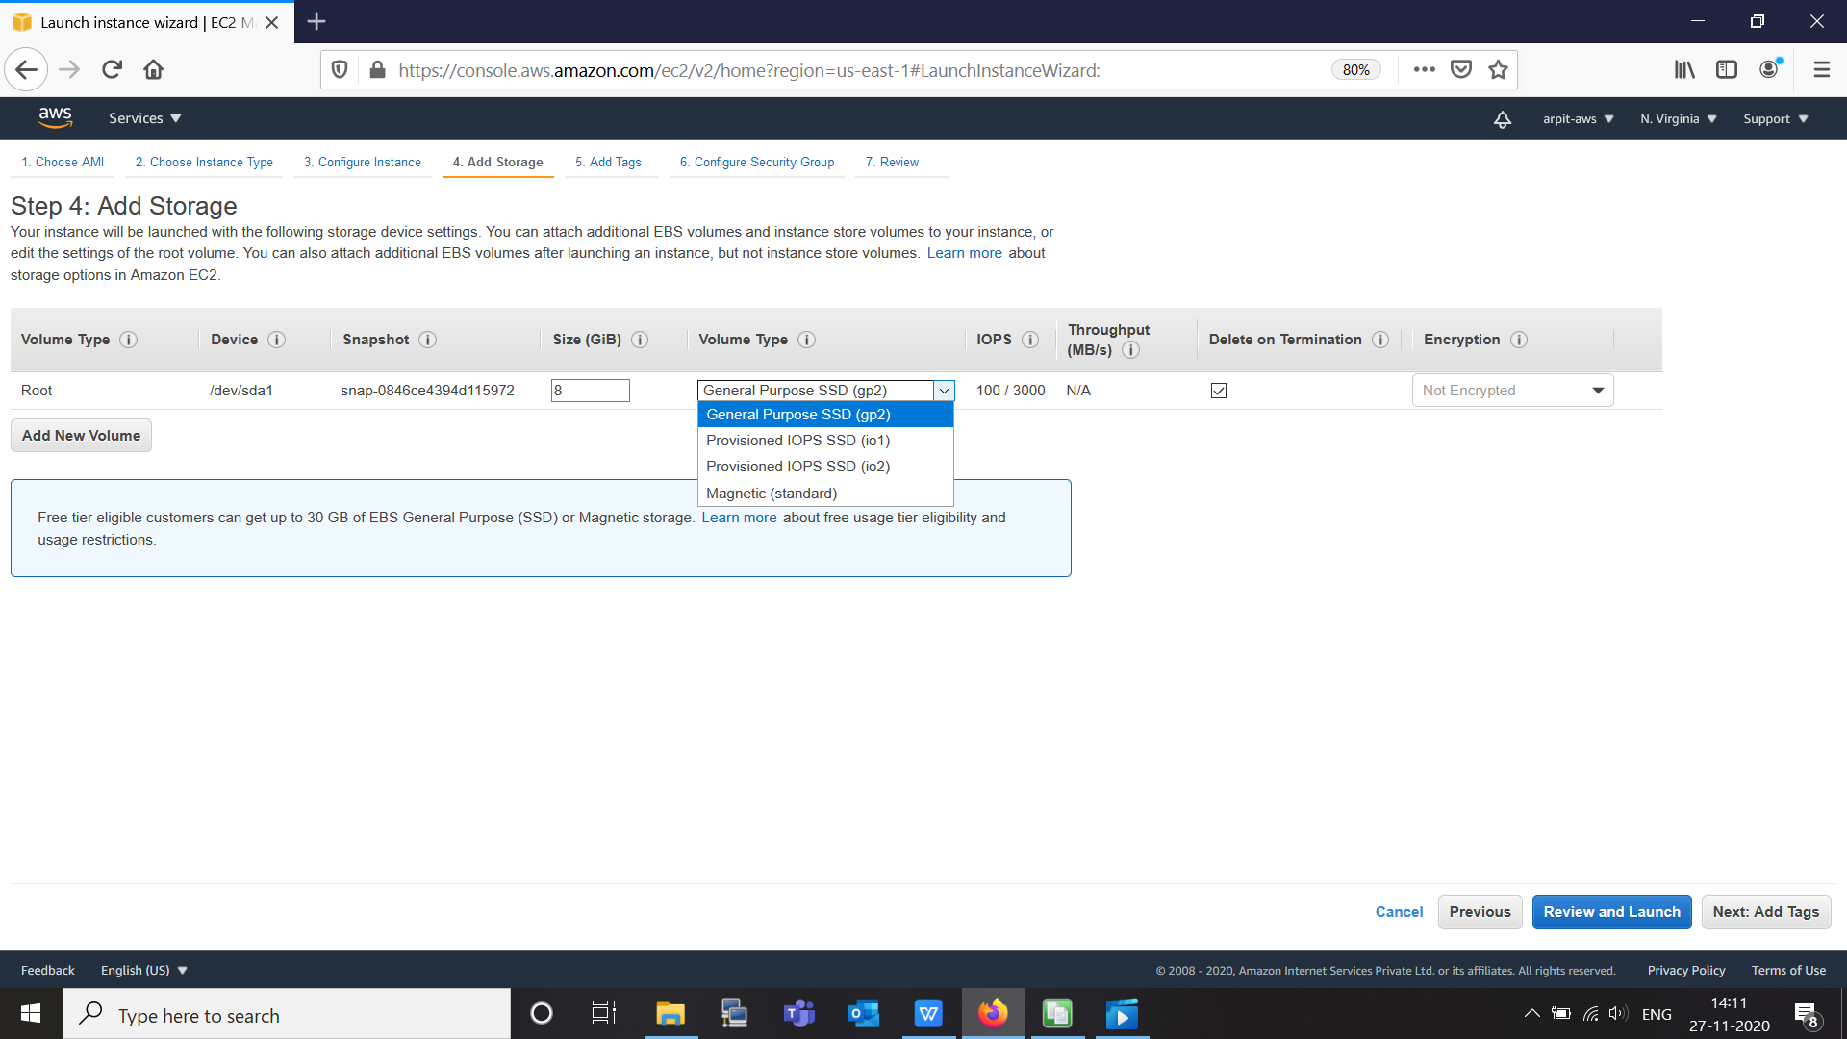

we can see that for "root" our primary harddisk is of type "General purpose SSD" there are other option are available like magnetic as well.

Also we can attach secondary or more harddisk (sdb) as well by clicking on "Add new volume" , here we will get more volume type option.

for current scenario we will use only primary volume which is "root" , with general purpose ssd.

now click "next" to Add Tags.

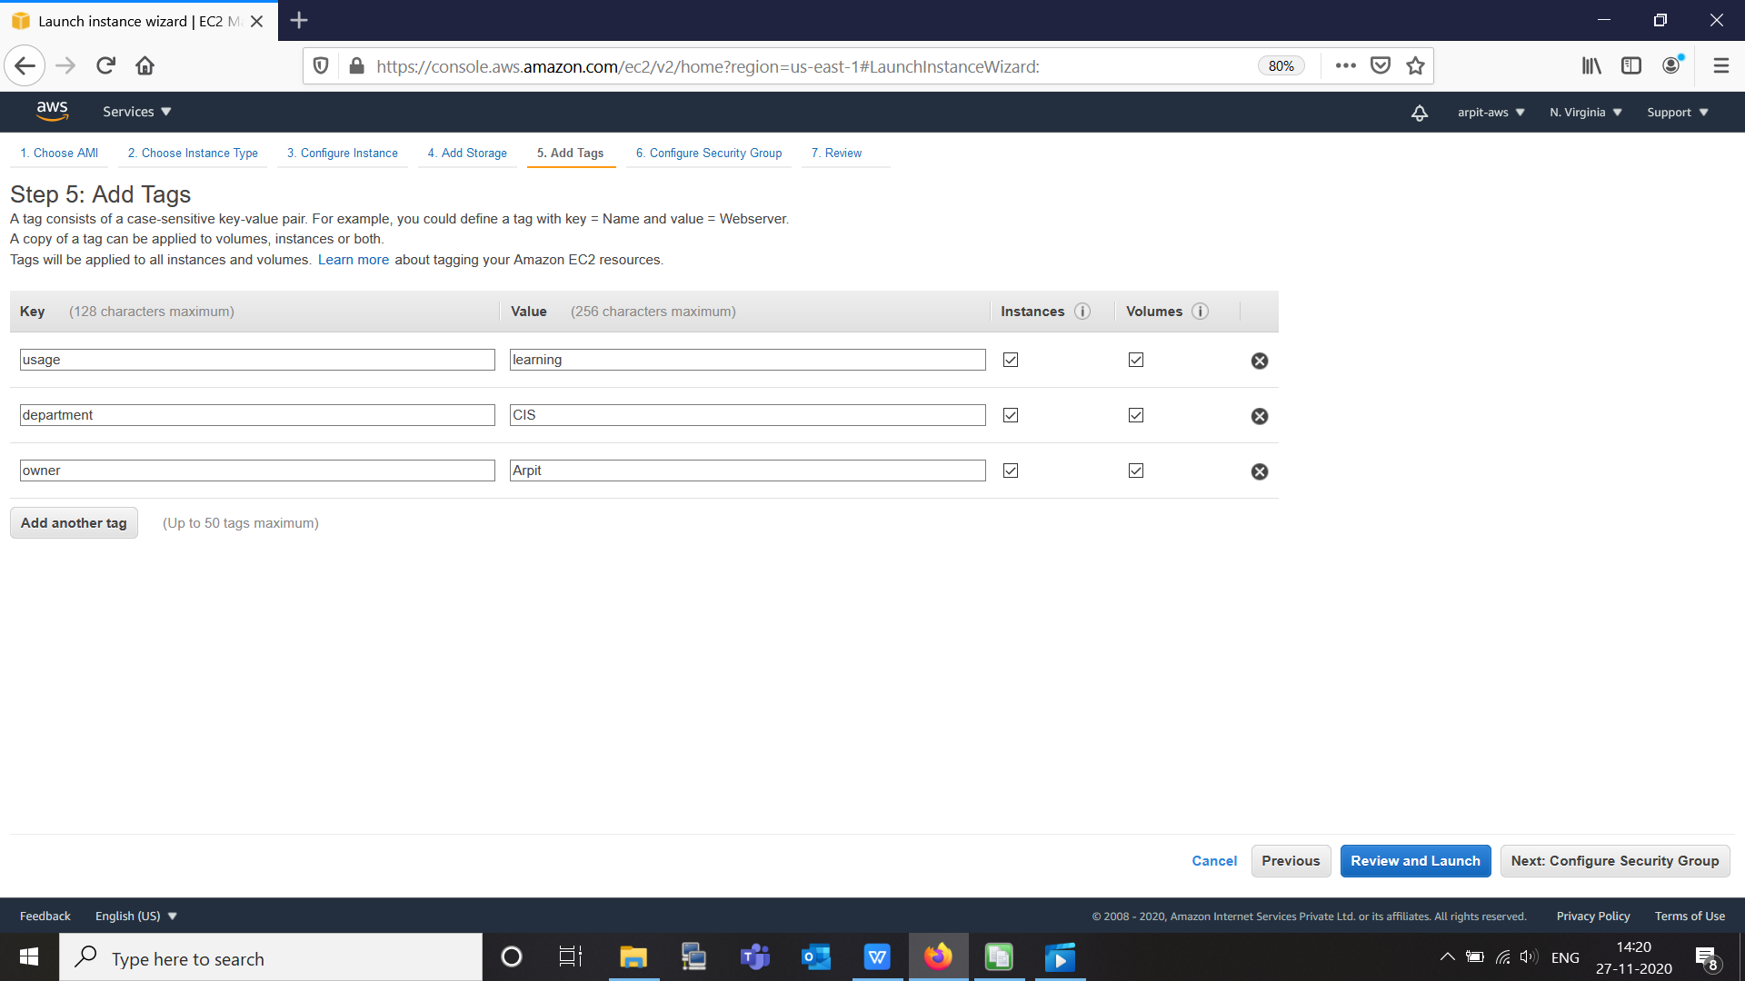

you can add tags to be use that later on to recognize our EC2 instance.

Now click " next" to "configure security group".

Security group is just like a "virtual firewall", which allow certain IP and Port to contact and connect.

We will cover "security group" in lot more detail in VPC section.

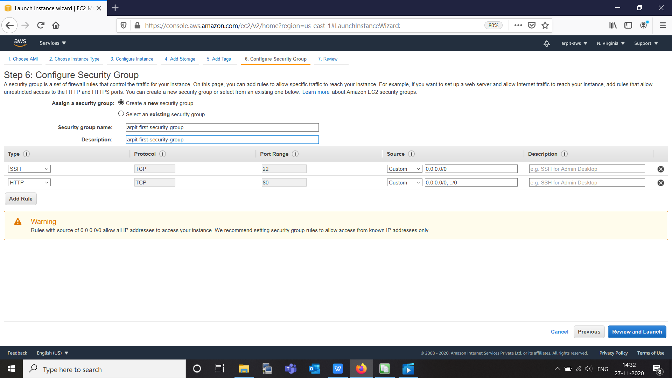

I am creating "new security group", -> arpit-first-security-group
Here we can see I add new rule which is "HTTP" ,

in source we can choose
- custom -> if all zero we anyone from outside world can access this instance. or we can give our custom subnet.
- anywhere
- myIp

click "next" for "review"

then give name to your key pair which is basically key pair and we can download .pem file form here

and launch instance

now goto your terminal use ssh user@publicip -i <pemfile> => to get access.

in our case username is "ubuntu".
