EBS -> Elastic Block Storage

EBS is just like a virtual hard disk in the cloud. it provide persistence storage.

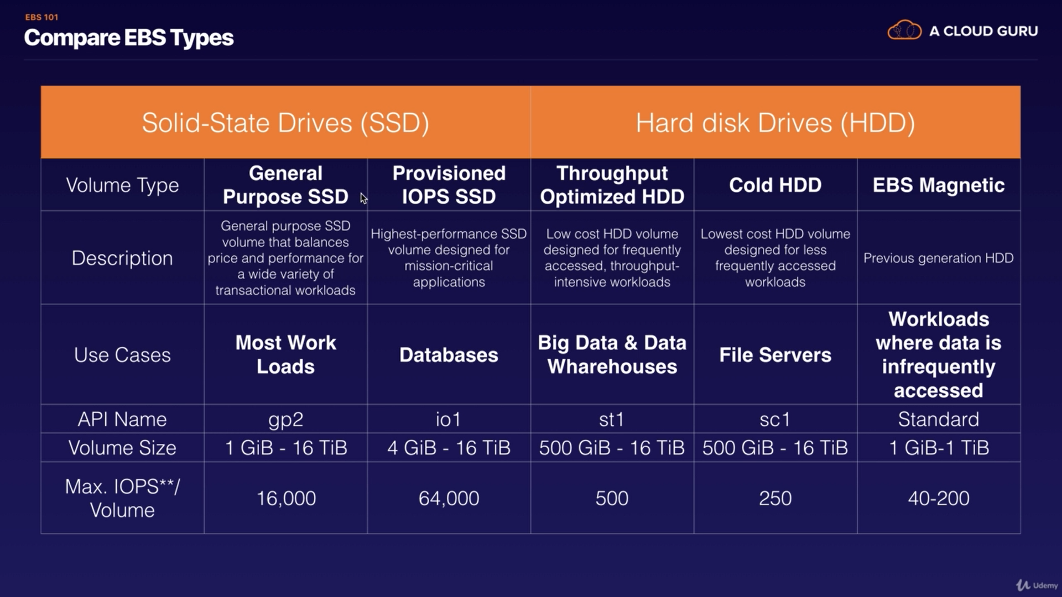

video no -28, name - Volumes and Snapshots

Availability Zone for EC2 and volume will be same. it they are in different availability Zone then you can notice a huge amount of lag.

