There is inbound (like ssh and HTTP) and outbound rule.
so every time any change happen in security group it will take effect immediately.

Outbound is relation to send anything from our instance to outer world.

but suppose you created an inbound rule, an outbound rule will be created automatically,
whether your outbound rule have anything or not.
This is because security group is statefull.

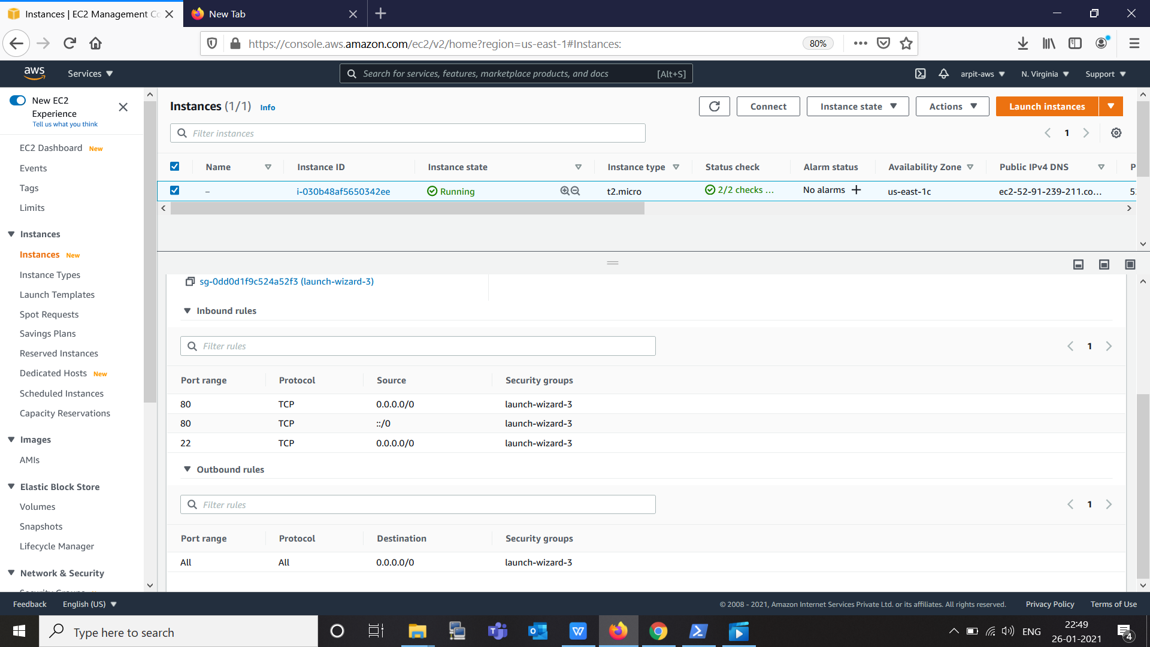

But if we talk about Network access group, we need to specify inbound and outbound both because Network Access Group is stateless.

