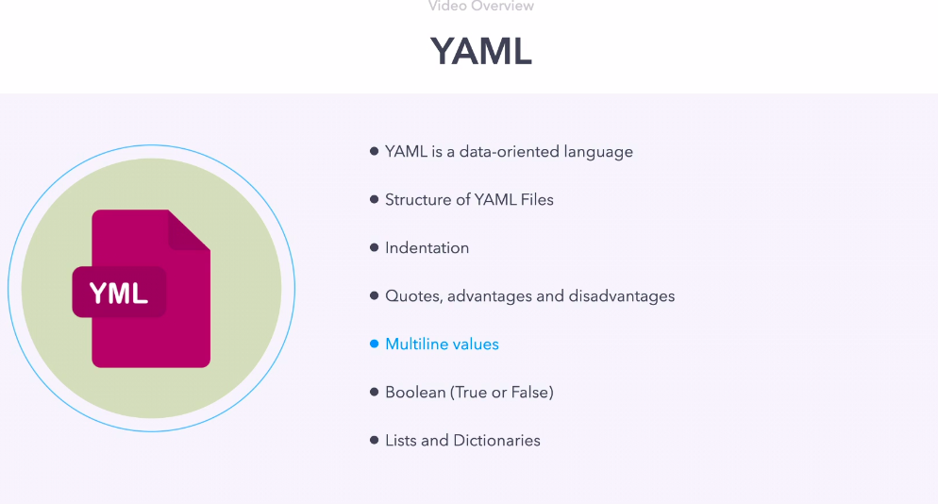

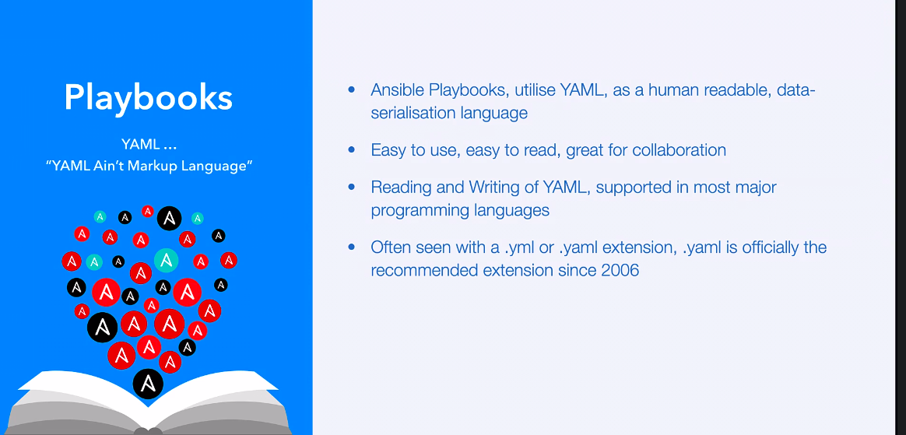

goto this location
/home/ansible/diveintoansible/Ansible Playbooks, Introduction/YAML/01

Revision 1

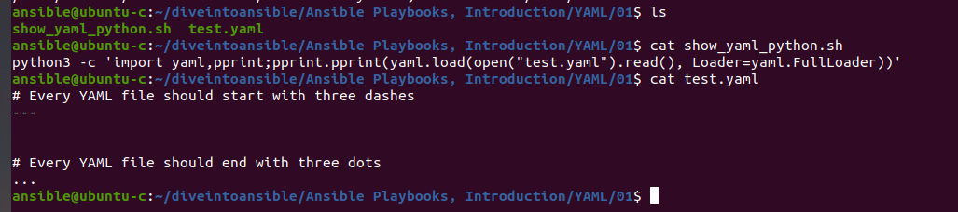

so here in test.yaml file we can see
YAML start with three dash "---"

and end in three dots "..." (this is optional but recommend)
YAML ignore comment. so we can use '#'

file=> cat show_yaml_python.sh
python3 -c 'import yaml,pprint;pprint.pprint(yaml.load(open("test.yaml").read(), Loader=yaml.FullLoader))' and print into json format

this is python utility to show content of YAML in json format. it read test.yaml, currently it say None.

./show_yaml_python.sh
None

Revision 02

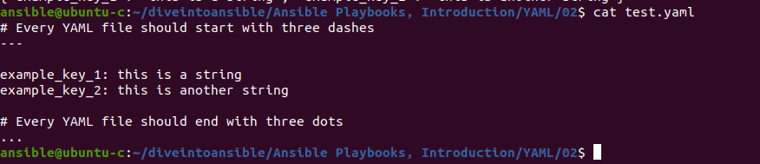

key and values.

now run script

we can see python script, this Yaml is treated as dictionary.

Revision 3

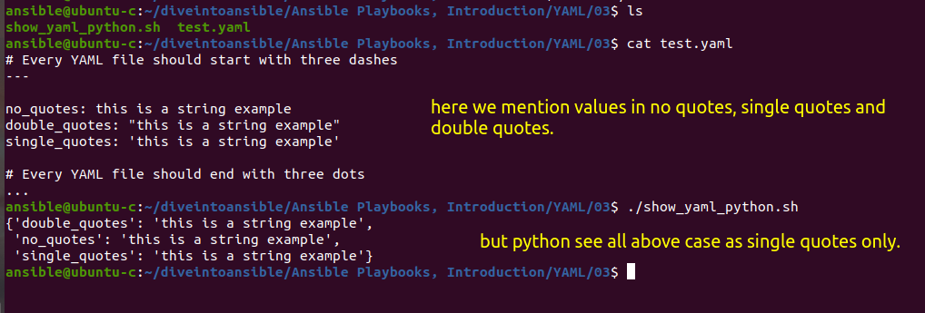

Revision 4

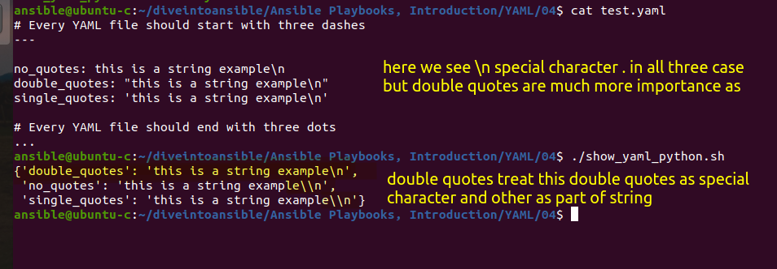

Revision 5

how to multiline value for key using pipe '|' symbol like

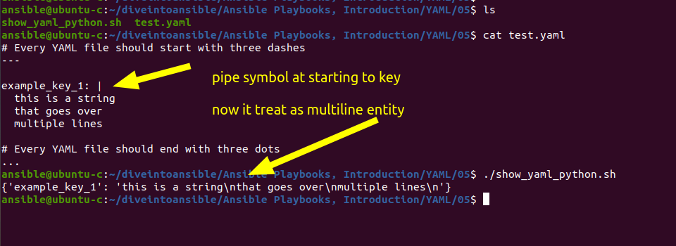

Revision 6

suppose we want single long line as value, but for neatness we want to represent it into multiline. for that we can use '>' symbol

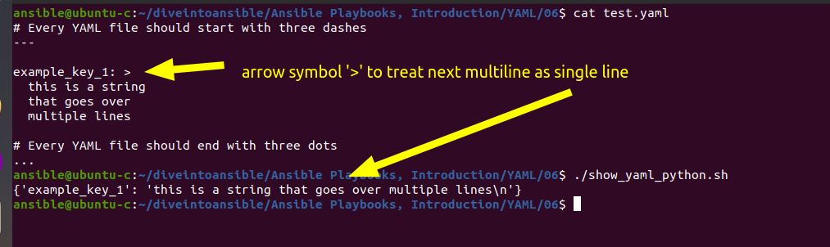

one thing to notice, generally we don't have new line markers in string, but here at last you can see one new line marker '\n'.

this might be required or may, but Yaml have one solution for this, like :-

Revision 7

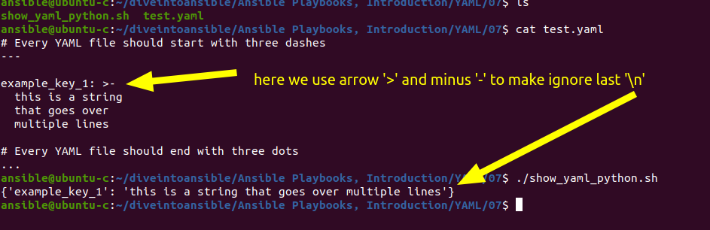

Revision 8

Integer are automatically interpreted

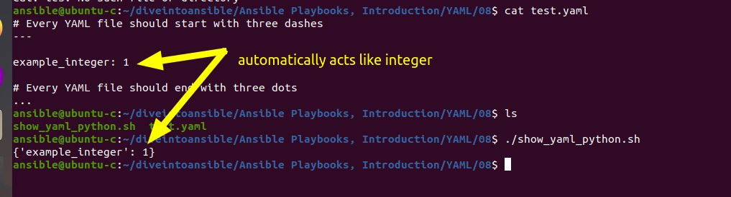

Revision 9

integer in double quotes acts as string

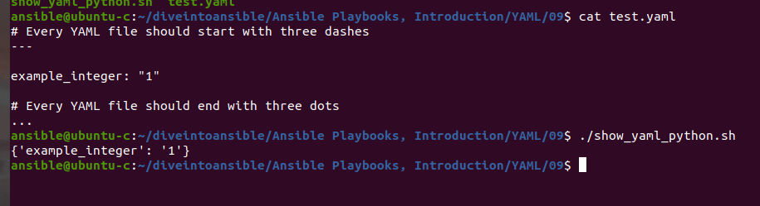

Revision 10

Yaml is very versatile in handling Boolean.

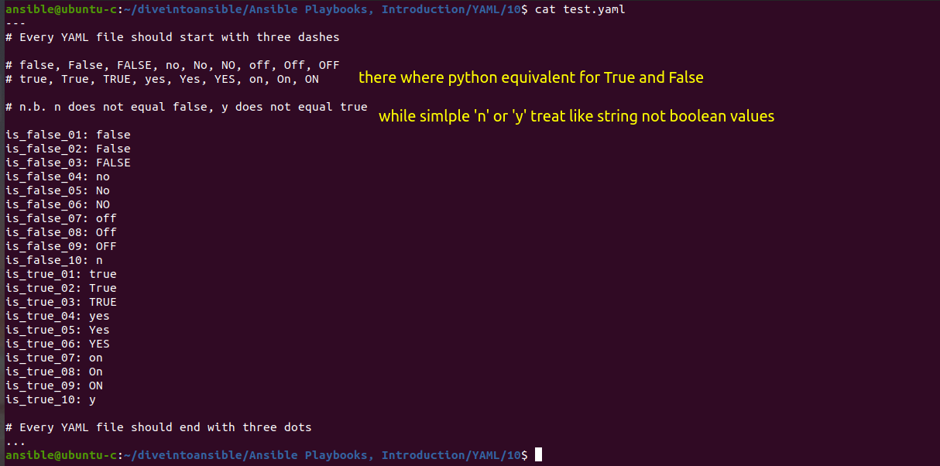

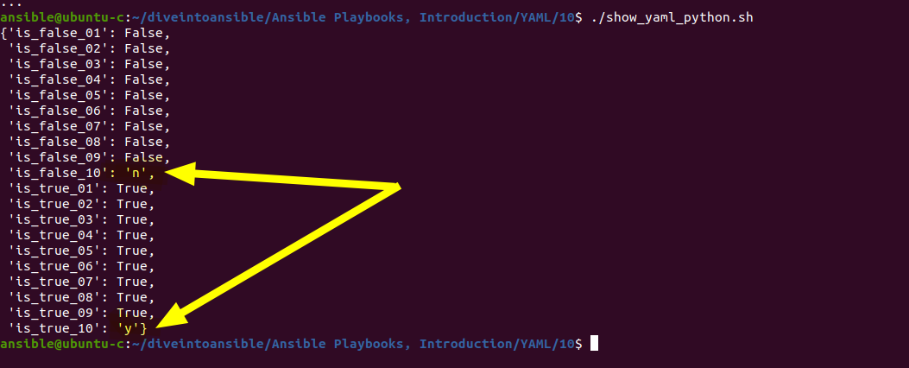

Still it is recommended to use True and False because it is one to one mapping.

Revision 11

All of previous example are related to python dictionary. but lets look for List

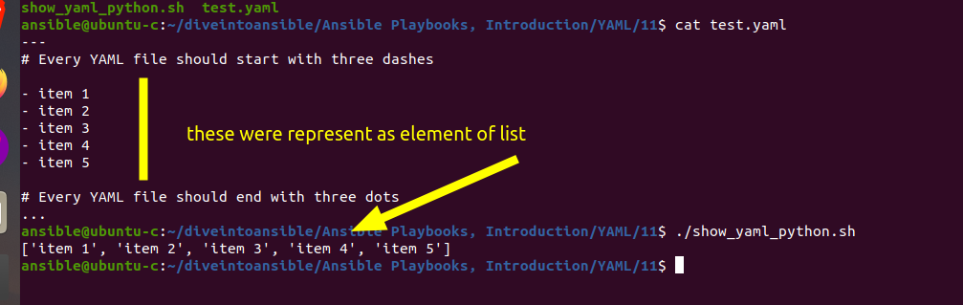

Here we can see, in python equivalent

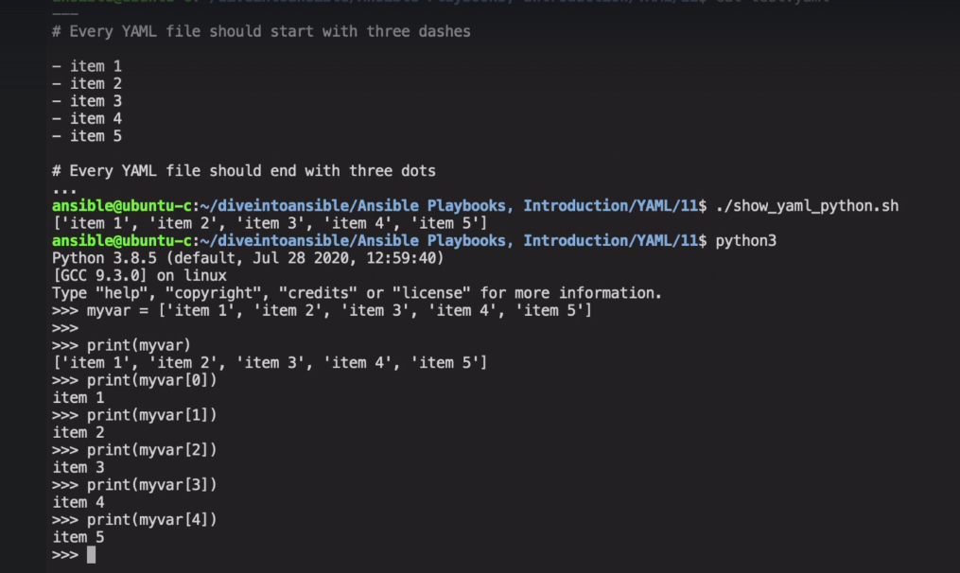

Revision 13

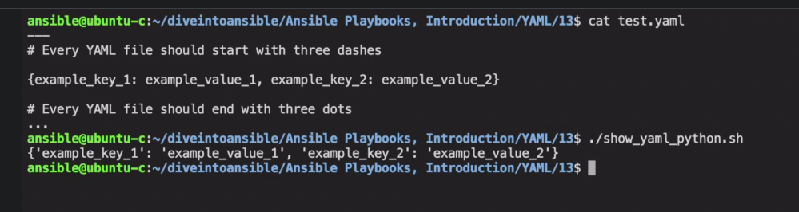

we can also use inline in YAML file similar to dictionary in python.

above pic is equivalent to
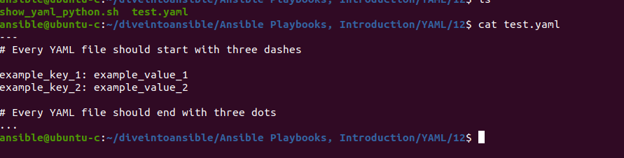

Revision 14

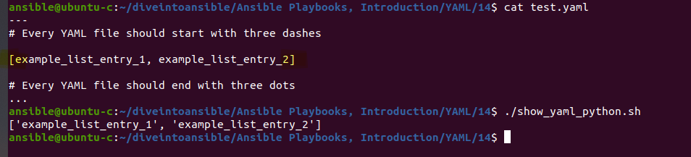

This is Yaml inline equivalent for python list.

Revision 15

you can't have key value and list item in same block

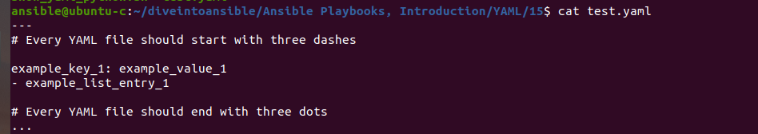
this is invalid

----------

Some dummy case to understand.

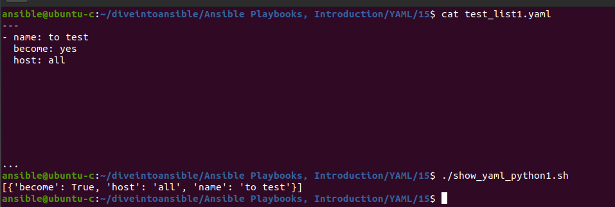

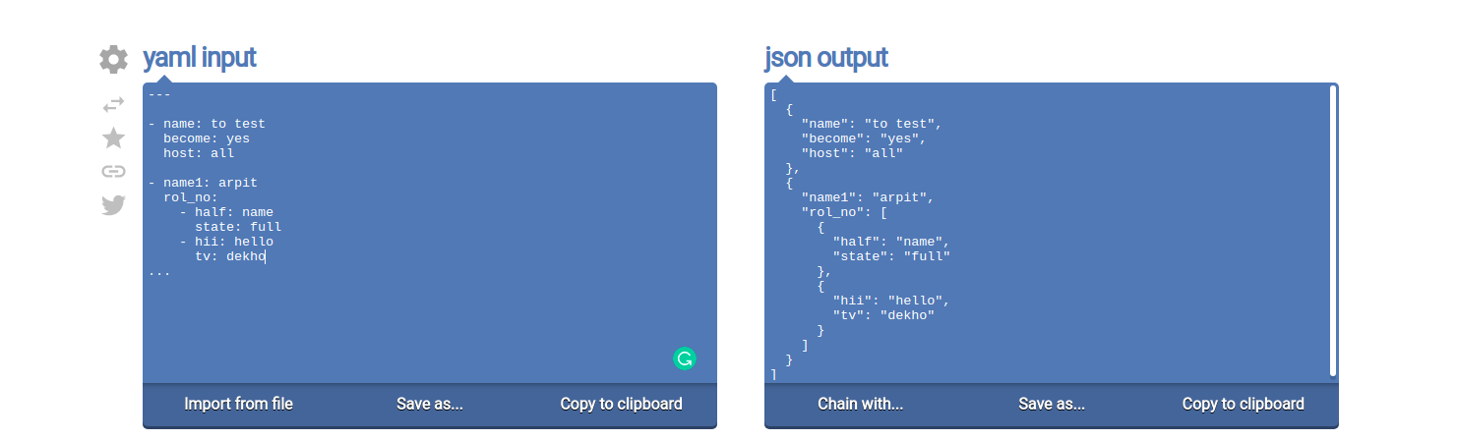

- name: to test
become: yes
host: all

this will create a list having dictionary.

Revision 17

now lets talk about indentation, giving 2 space indentation is common practice.

here can see a dictionary key can be a sub-dictionary

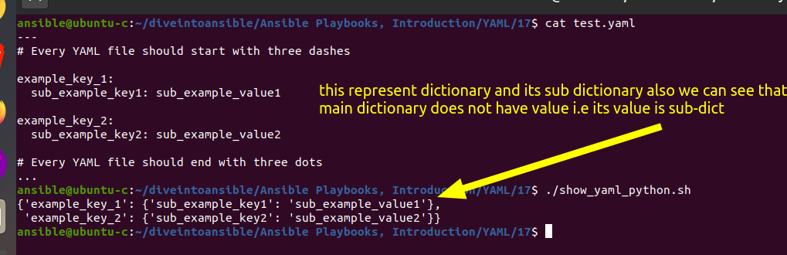

Revision 18

here we can see a dictionary key can be a list of value

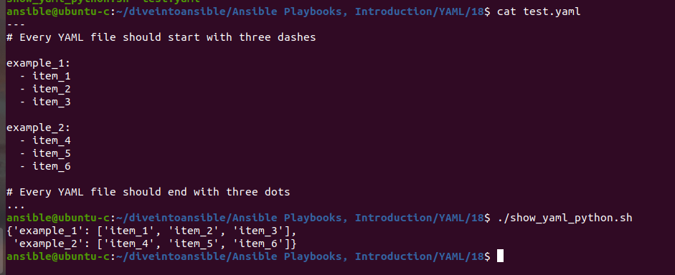

Revision 19

here we can see Dictionary key can be List of element contain Dictionary and its Key can be have list of item.

Dictionary key ---> List of element contain Dictionary --> list

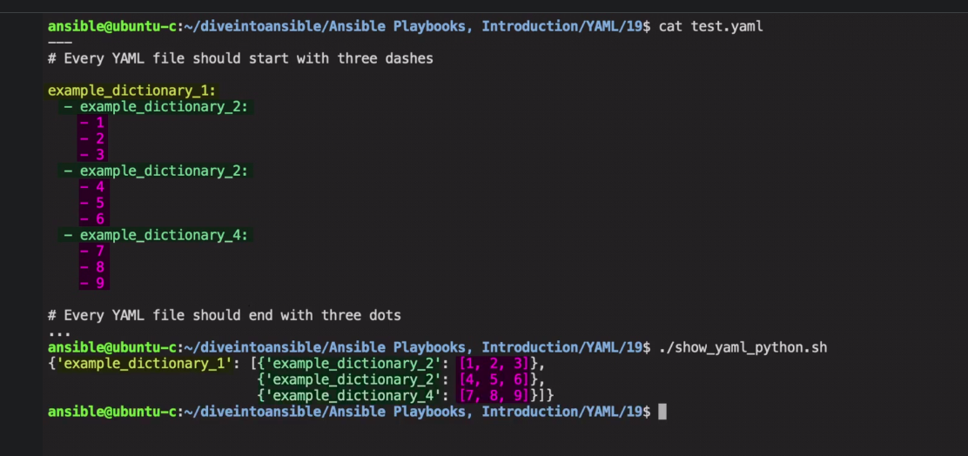

this is beauty of Yaml.

-------------------------------------------
let take a challenge

go to challenge directory

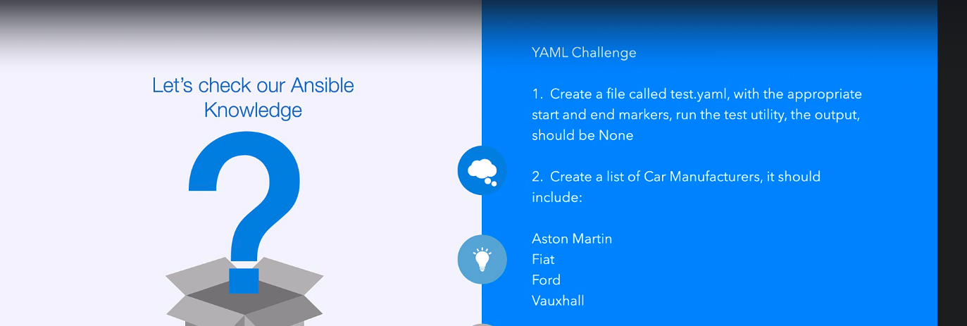

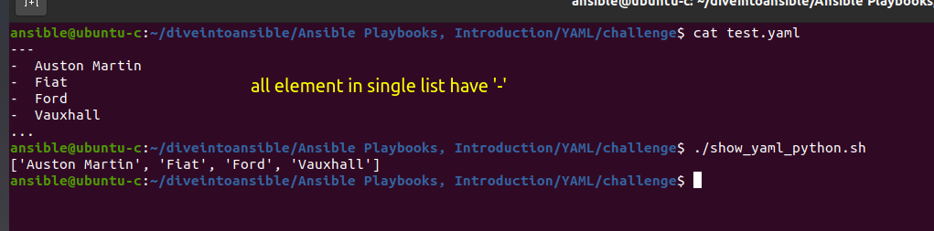

Note:- if you try to create list like

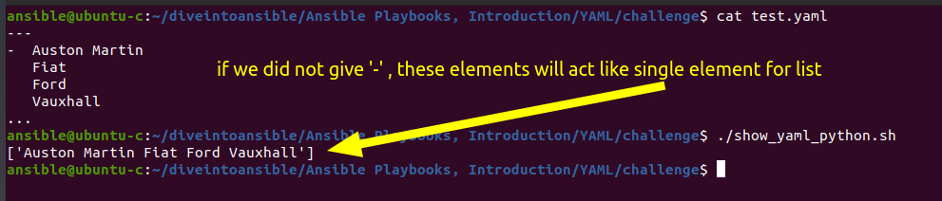
this is wrong.

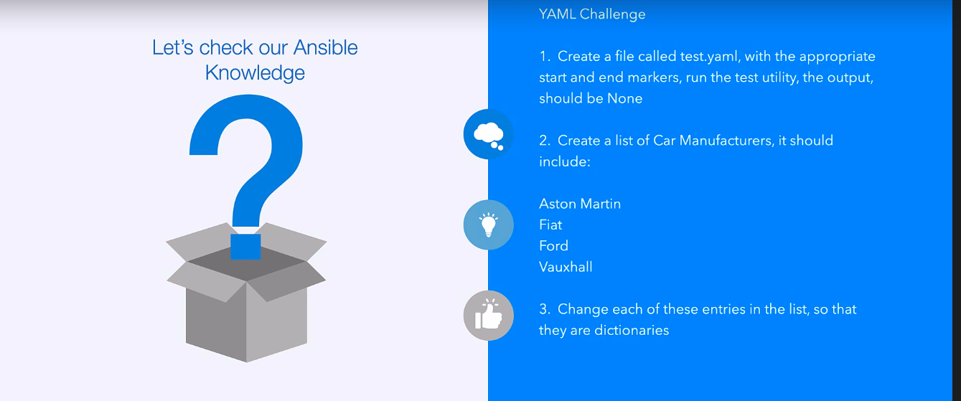

ques 3:-

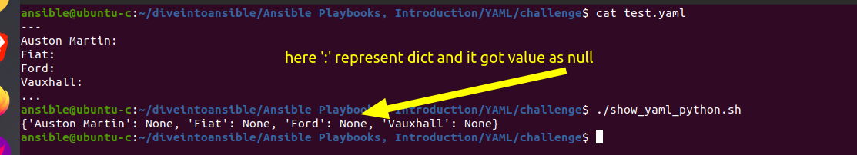

ques4:-
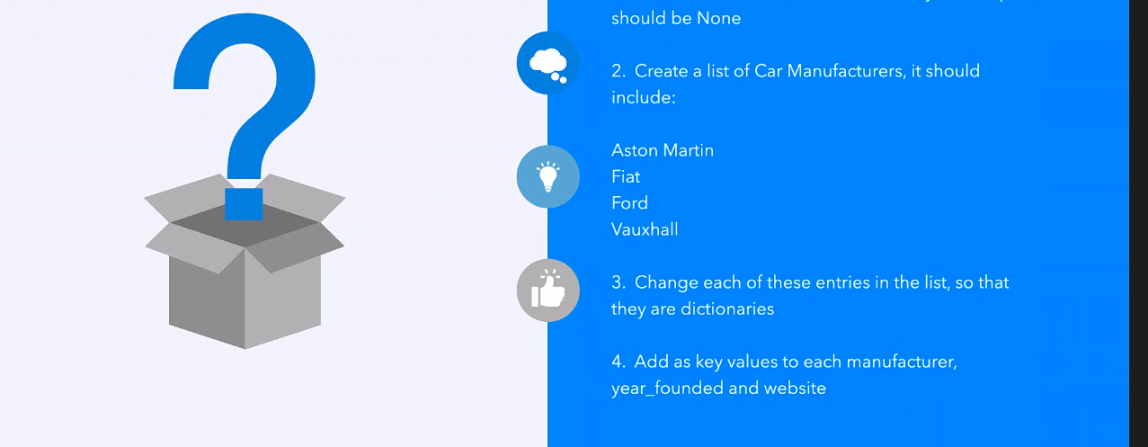

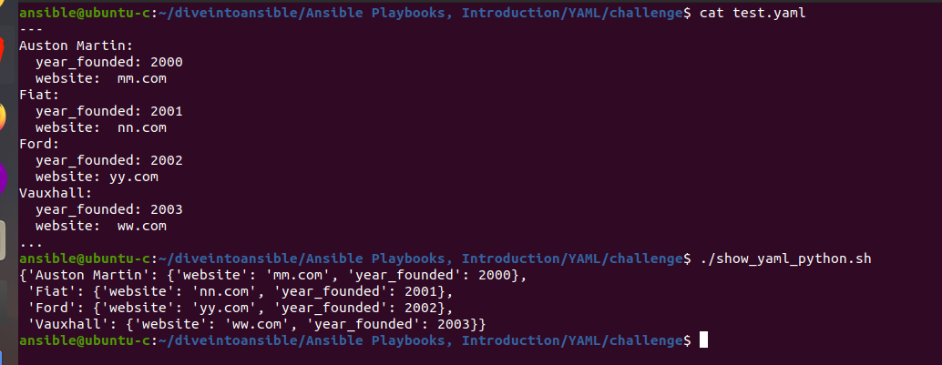

Ques5:-



