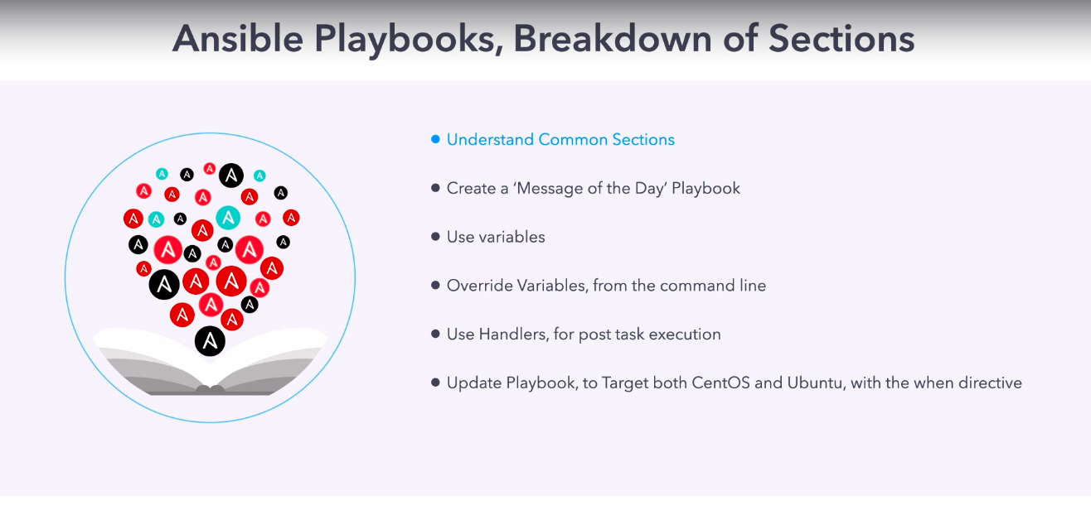

go to /home/ansible/diveintoansible/Ansible Playbooks, Introduction/Ansible Playbooks, Breakdown of Sections/01

Revision 1

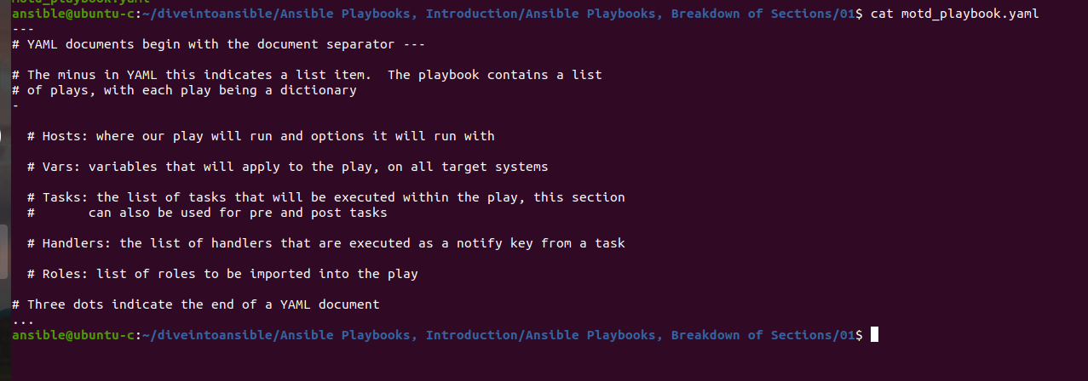

self explanatory about playbook.

Revision 2

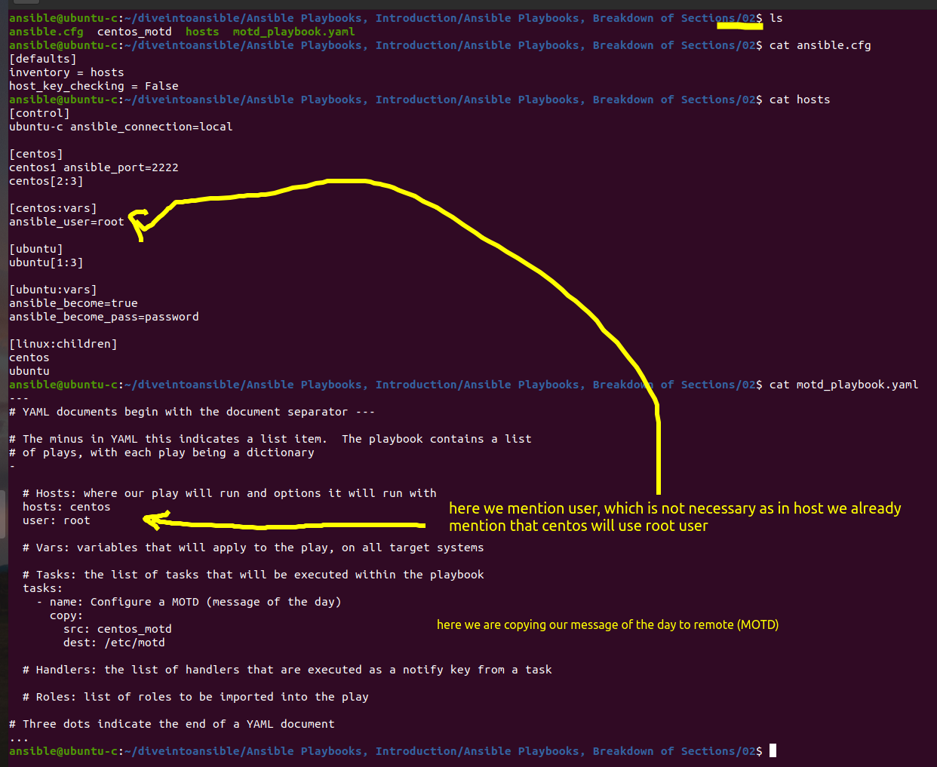

this is message of day

let run this playbook

ansible-playbook motd_playbook.yaml
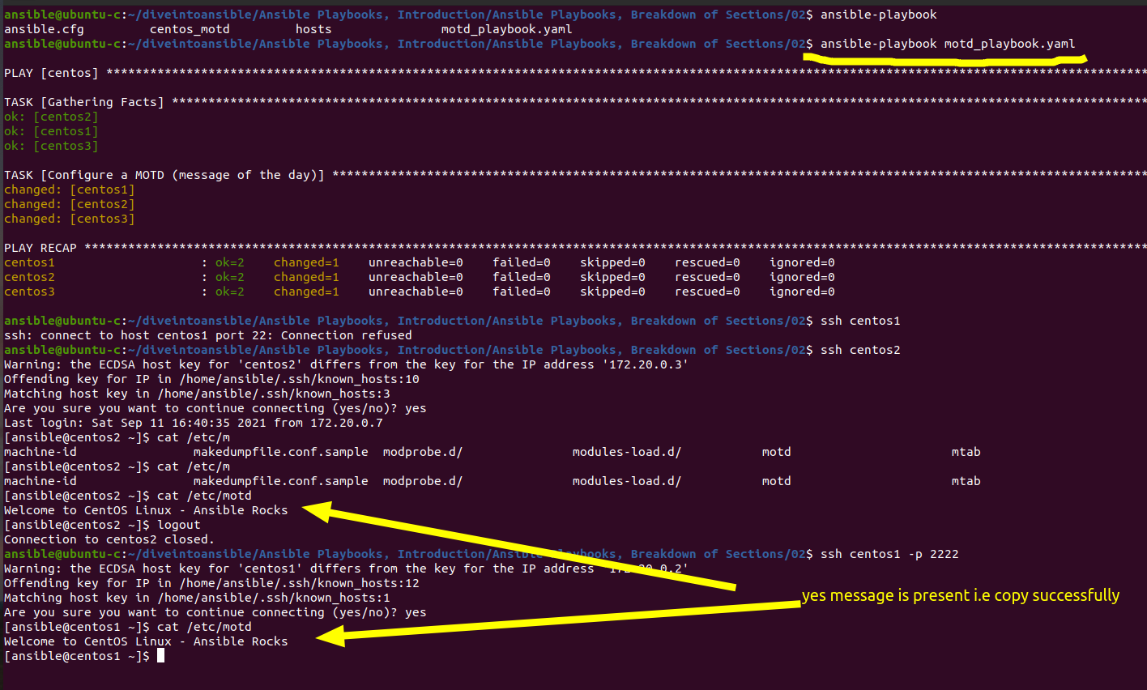

After running playbook we can see we have two task done
- for copy module
- default (setup module) which is gather fact

Explore some Target section option

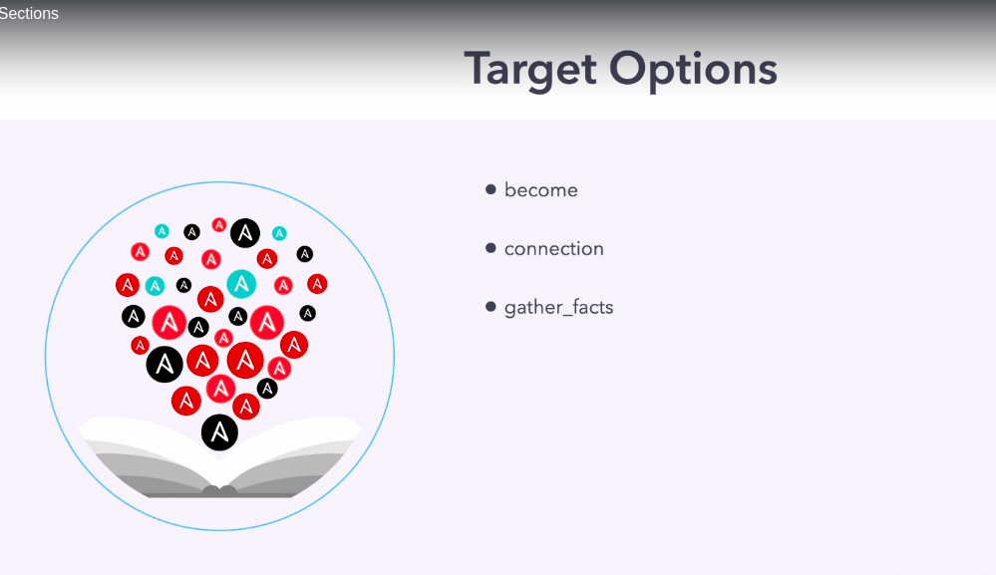

there are few important target option, there are other as well will see that into documentation.

Note :- prefix "time" before any command to see its execution time

$ time ls

$ time anisble-playbook <file.yaml> ==> to check its execution time.

lets observe time if gather_facts is True or False

for gather_facts = True

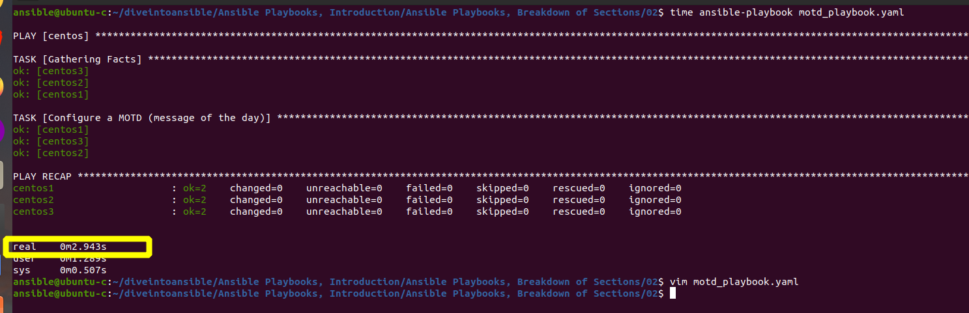

it took 2.943 sec

Revision 3

Now observe time when gather_facts=False

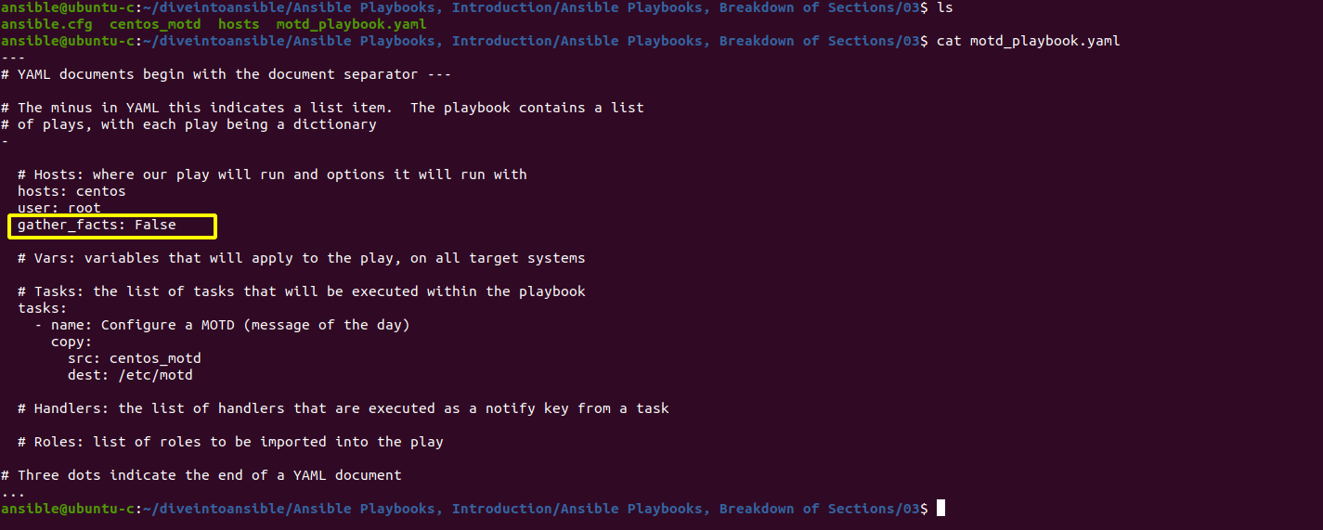

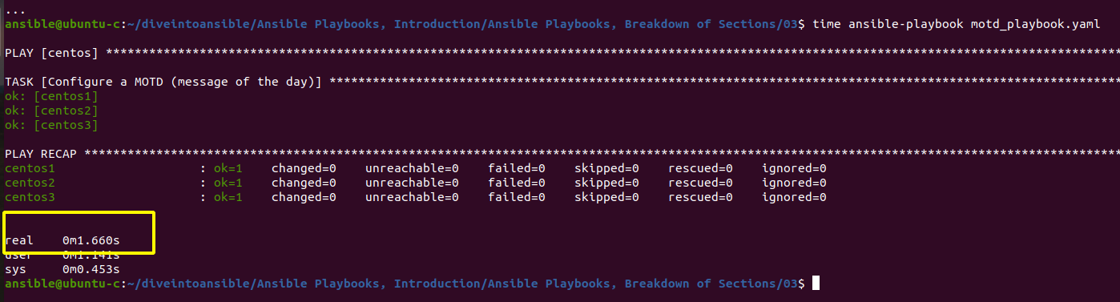

it took nearly half time 1.6 sec, also we can see ok=1 instead ok=2

Revision 4

now Copy module have content option using this option we can directly write file

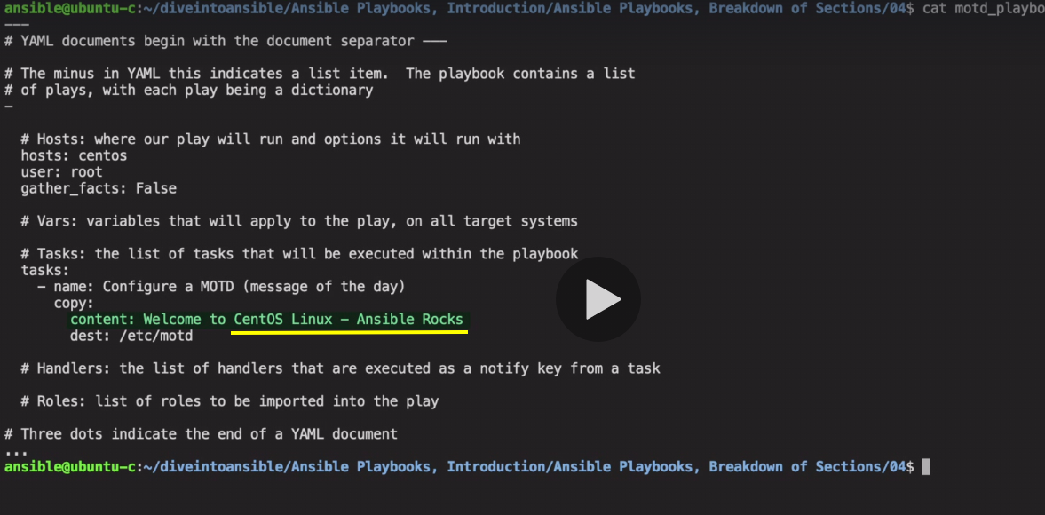

Revision 5

we will look into vars to define variable.

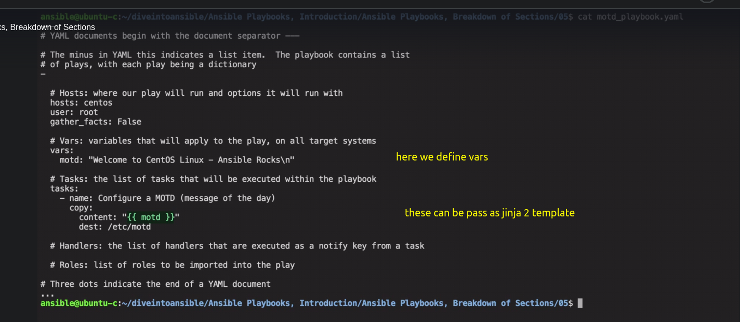

now we will pass the string in jinja 2 template, this is python term and we will look into these template in bit detail later.

The best thing about vars is that these can be pass as command line argument.
this can be achieve by using "-e" option.

$ ansible-playbook motd_playbook.yaml -e "motd='hii there\n'"

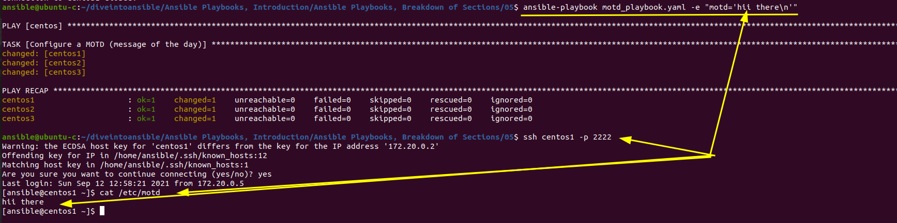

Revision 6

we gonna look into handlers

handlers follow the same syntax as task,
this handler can be called through task by using notify text

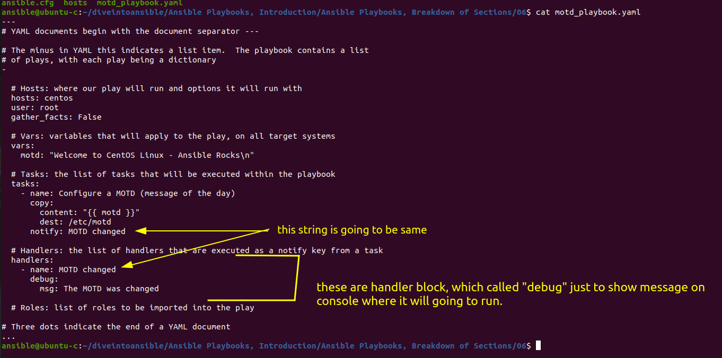

this debug this will add debug content to playbook.

Now run this playbook.

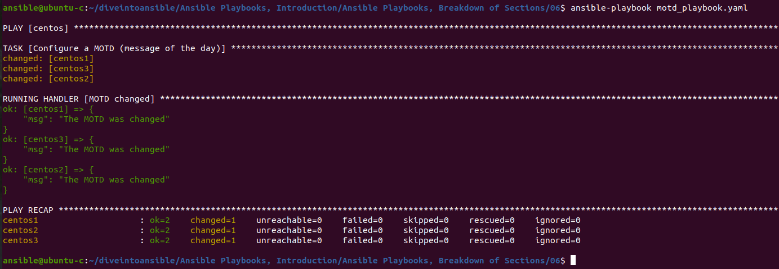

here we can notice, ok=2.

one for change and one for handler

lets re-run this again

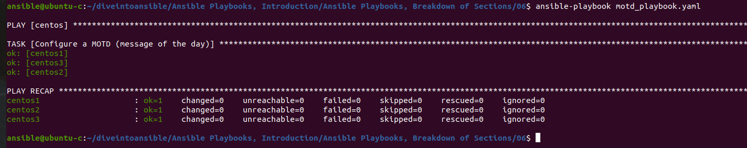

ok=1 as there is no change, just only handler is being notified.

Revision 7

When Directive

here we have to use gather_facts = True , so it will help to decide which is centos and which is ubuntu.

Lets first check all the facts available for all the facts available.

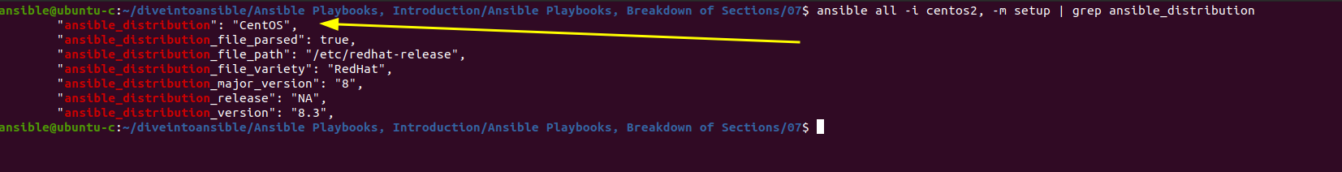

we can see ansible_distribution = centos

we will use this parameter to check whether it is centos or ubuntu.

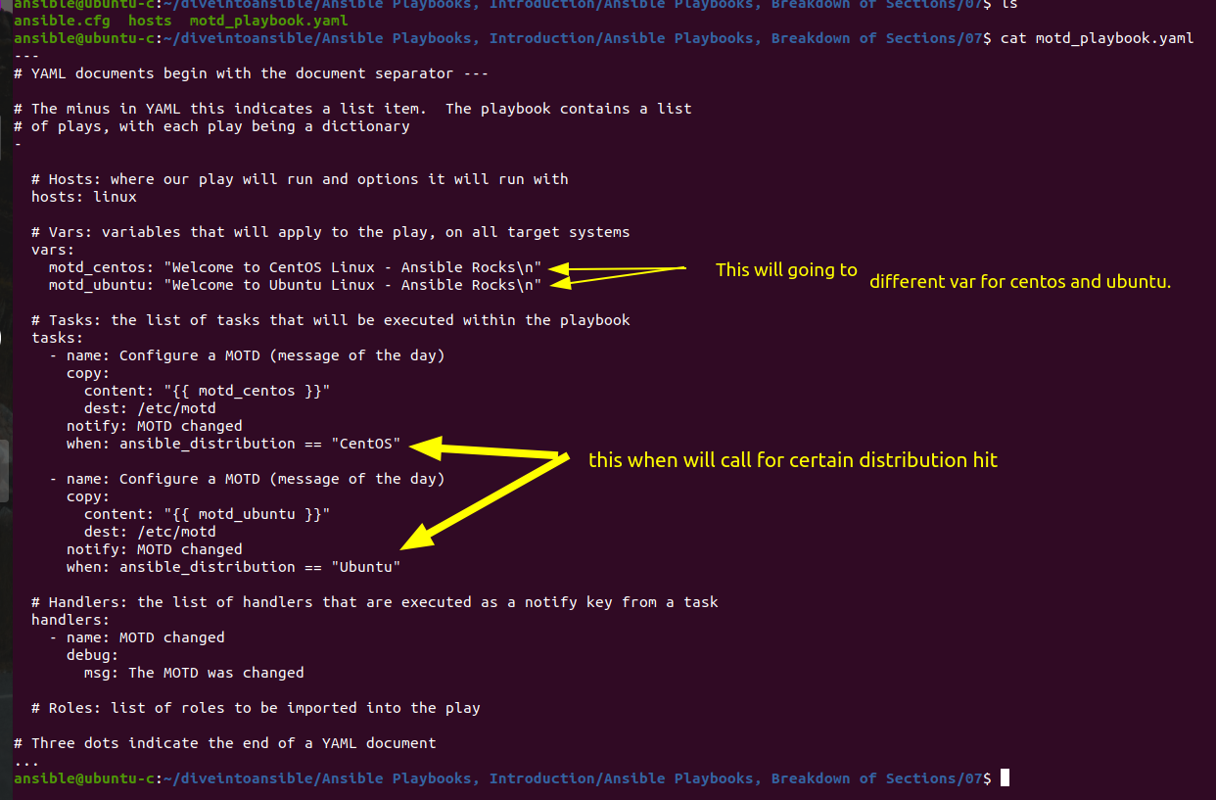

here in above you can see we have custom task for centos and Ubuntu.

----------------

we can also create a executable file like this way.

Challenge Directory

