pwd :- /home/ansible/diveintoansible/Ansible Playbooks, Introduction/Ansible Playbooks, Variables

here we have "show_example.sh" script.
by running this script we can traverse between these revision.

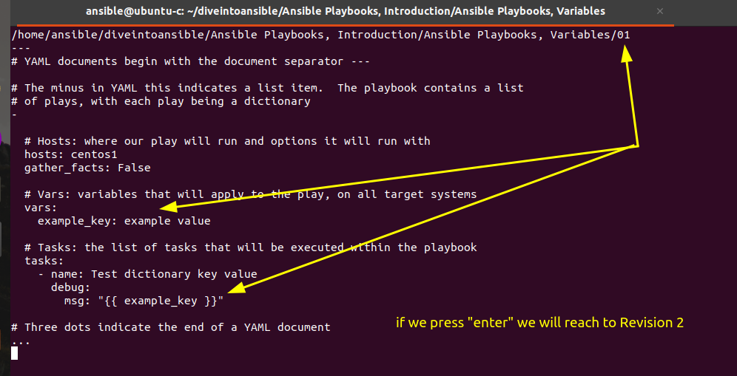

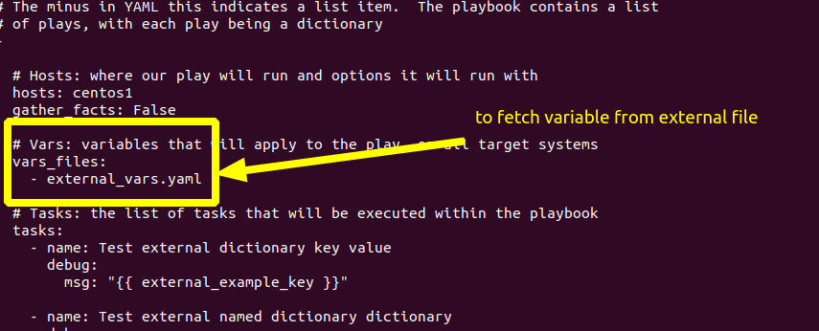

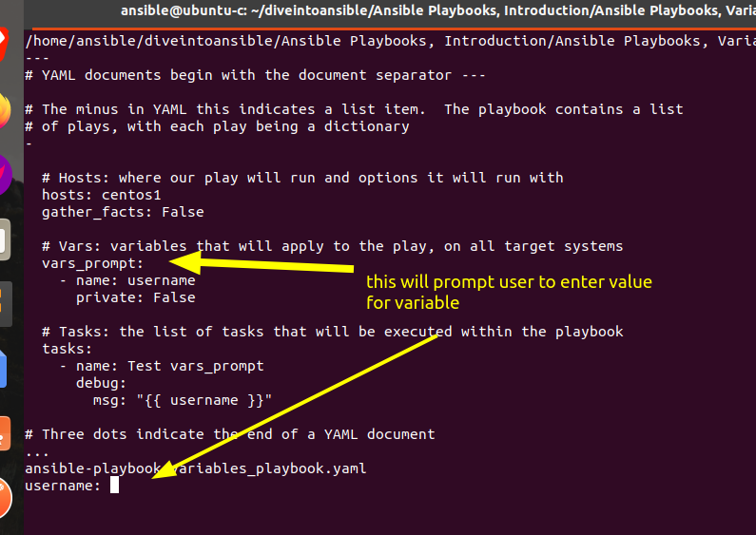

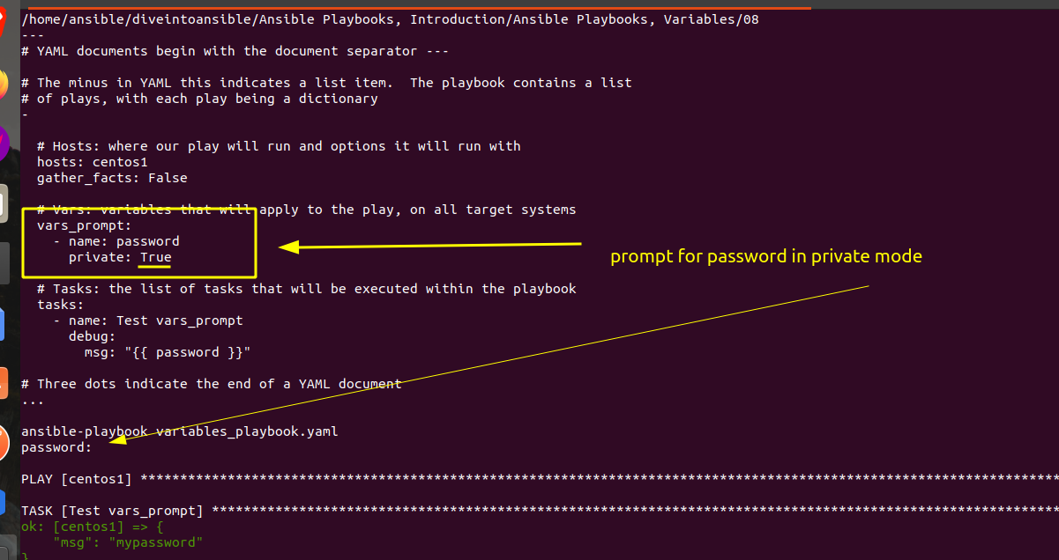

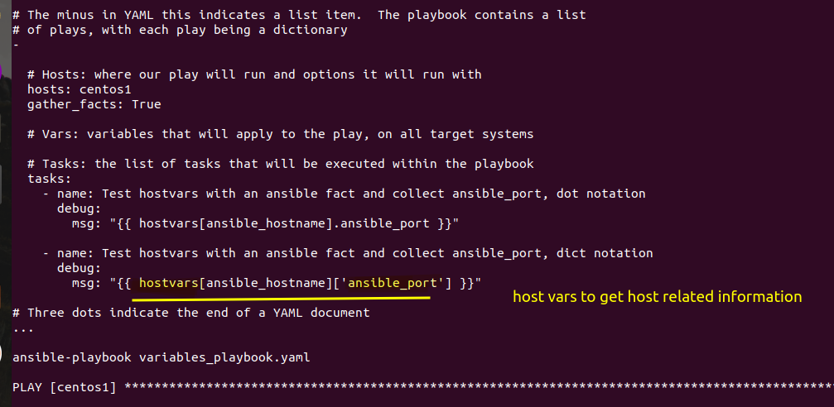

his hostvars we actually define in hosts file.

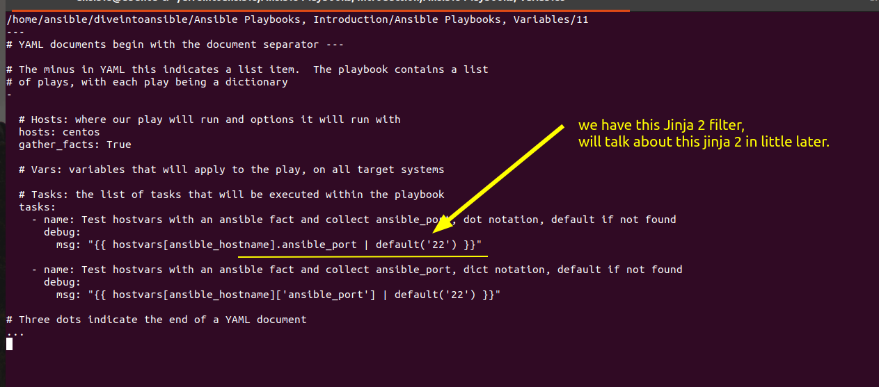
so it means if hostvars doesn't exist in hosts file, this will set default as 22.

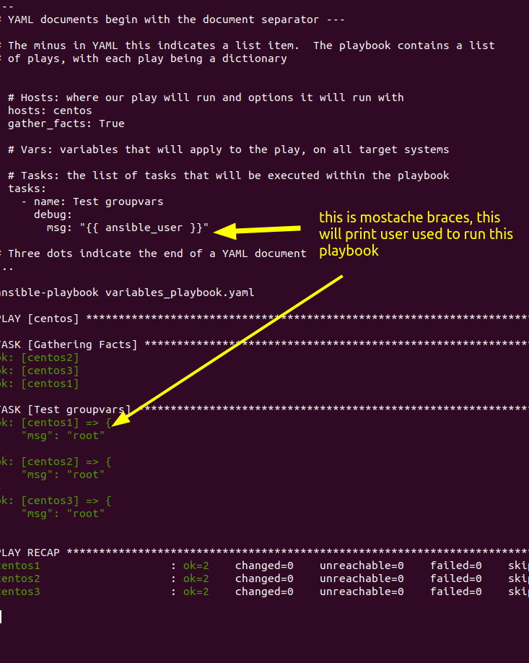

this is way to assign to assign variable using separate yaml, json, ini files.
