- install aws cli
source:- https://docs.aws.amazon.com/cli/latest/userguide/install-linux.html
https://docs.aws.amazon.com/cli/latest/userguide/install-cliv2-linux.html

- To install AWS CLI in ubuntu, you should have python3. as it required pip
- curl "https://awscli.amazonaws.com/awscli-exe-linux-x86_64.zip" -o "awscliv2.zip"
unzip awscliv2.zip
sudo ./aws/install

- aws --version => use this to confirm aws cli
- aws configure => to put cred like access key and secret key

youtube :- https://www.youtube.com/watch?v=sLtf7Sx8lsQ

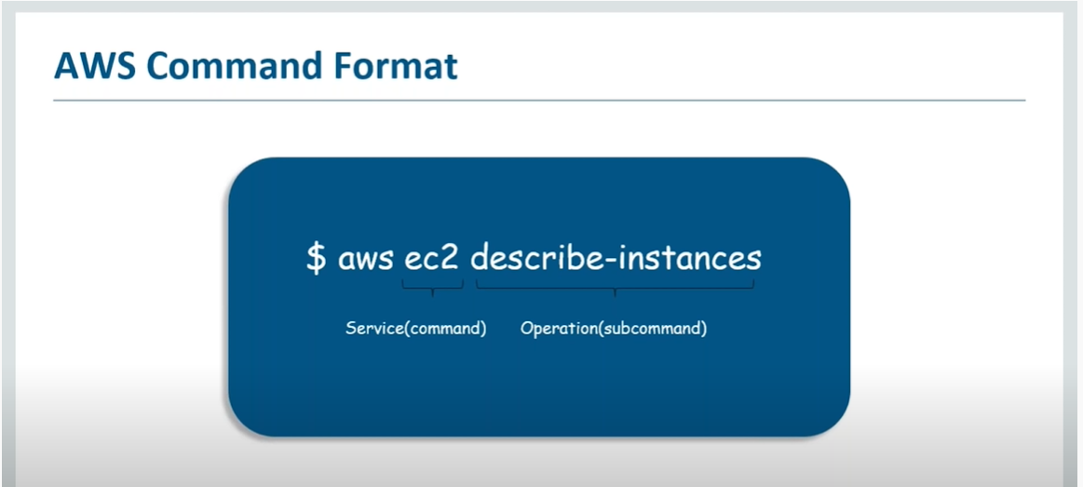

Every command start with "aws", then command and sub-command.
this sub-command is action to that instance.

$ aws ec2 describe-regions --output text => this will give output in text format, the default format is json. there is another format called "table"

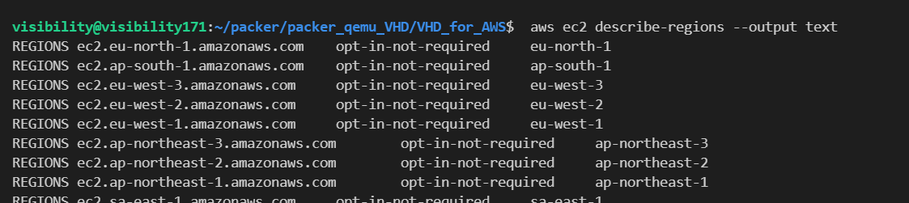

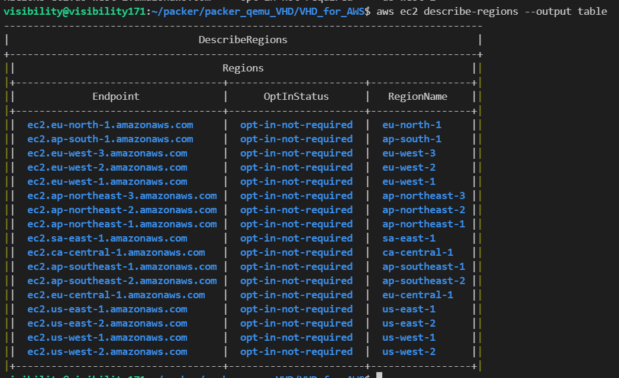

Now to create a "group" :-
$ aws iam create-group --group-name mygroup
so there service is "iam" which has create-group as commad.

Now to create "user":-
$ aws iam create-user --user-name myuser

Now to add user into group, we need to type:-

$ aws iam add-user-to-group --user-name myuser --group-name mygroup

add-user-to-group is command under iam service

To see group information:-

$ aws iam get-group --group-name mygroup

Now we have to create a policy and attach policy to group as an permission.
Now this policy is bigger term in term of explanation and configure. because there might be many policy that can be assign to particular group. so it not good idea to write all those policy into command line. inspite of that what we can do is we can create an file and mention all those policy there.

lets call the file as "mypolicy.json".

vim mypolicy.json

sample policy will be like this:-
{ "Version":"2012-10-17", "Statement":[ { "Effect":"Allow", "Action":[ "s3:PutObject", "s3:GetObject", "s3:GetObjectVersion", "s3:DeleteObject", "s3:DeleteObjectVersion" ], "Resource":"arn:aws:s3:::awsexamplebucket1/Alice/*" } ] }

Now lets attach this policy:-

$ aws iam put-user-policy --user-name myuser --policy-name <your policy name> --policy-document file://mypolicy.json

Now how to list policy:-

$ aws iam list-user-policies --user-name myuser

so we have successfully created a IAM user and attach permission to it.

