HA Architecture



case study of netflix HA planing:- https://netflixtechblog.com/the-netflix-simian-army-16e57fbab116

What is good example of High Availability architecture:-

RDS multi-az deployment :- so database have some kind of synchronization.

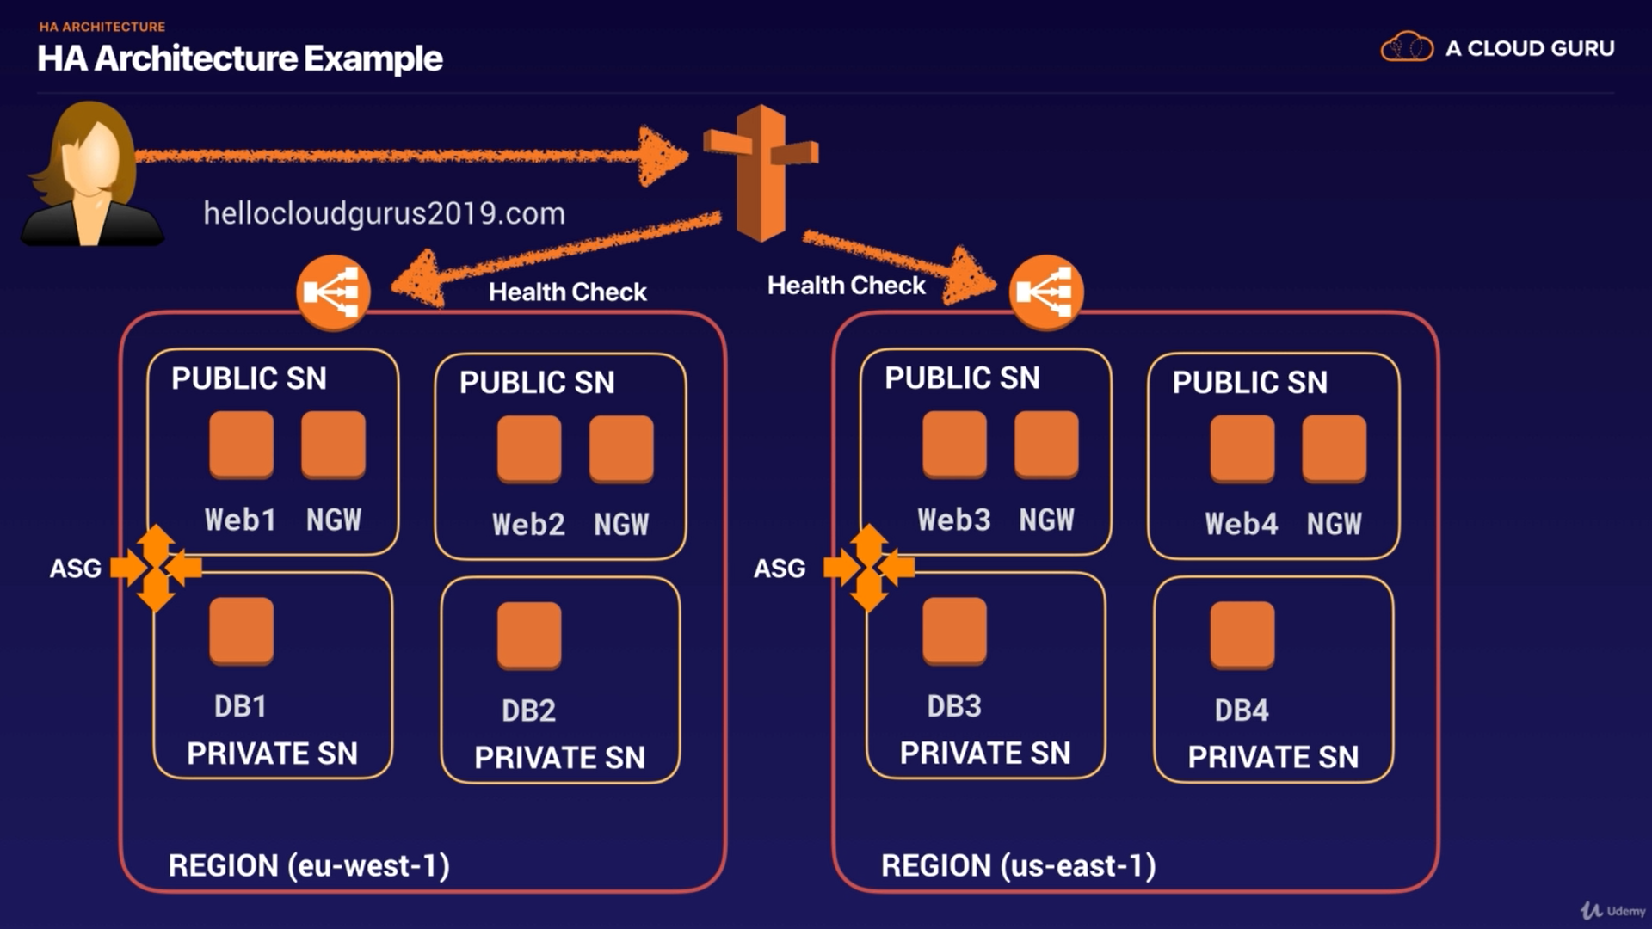

user ---> route53 -------> eu region
|
|
-------> us region

route53 segregate traffic according to region, then in one region we have multi-az deployment with NAT and ASG.

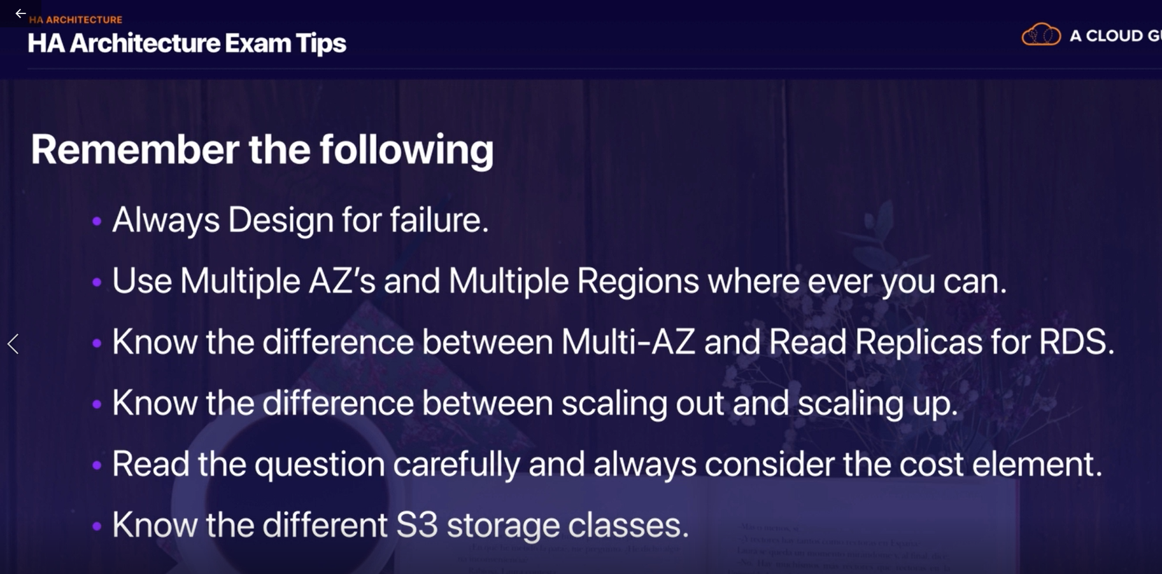

Building a fault tolerant word-press website :-

here is basic architecture what we are going to use:-
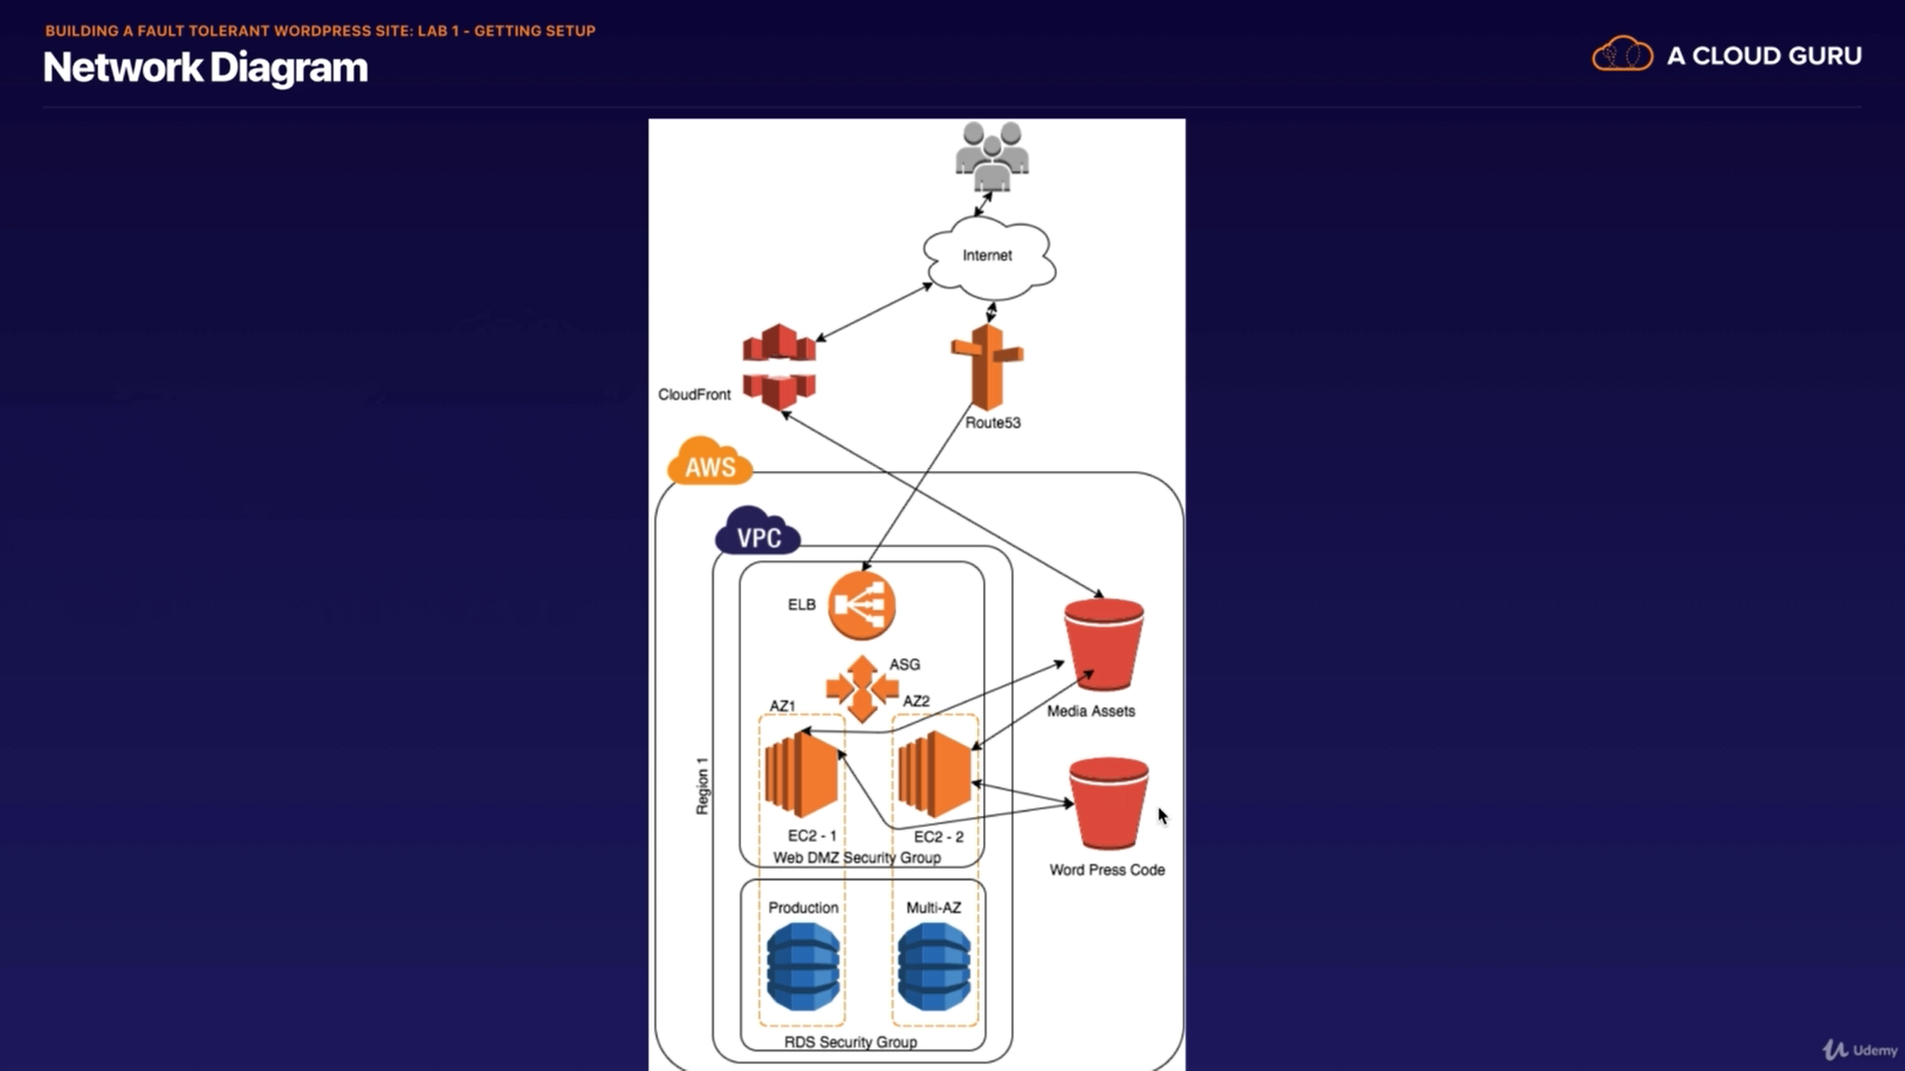

here you can see that we user --->route53 (optional we can directly use application load balancer ) -------> in side region we have ELB, ASG in different AZ and subnet we have EC2 and DB, ----> in global region we have S3 bucket, where we store wordpress code or media asset (picture) link with cloudFront.

Steps:-

- create two S3 bucket ----> wordpress code -----> media (picture)

