Now suppose we have our database server at private subnet, and we want to connect to it.
how to do that.

we have to create a different security group to allow access wrt database port requirement.
assign that security group to database server.

for simplicity we create an EC2 instance as Database server.

these were security rules for our database subnet:-

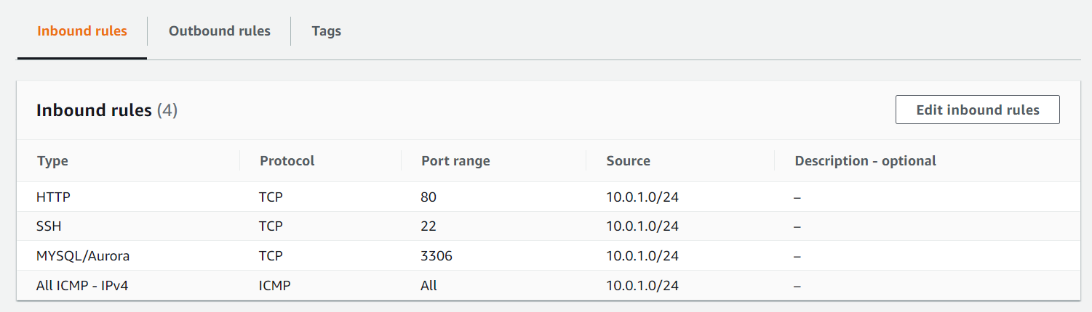

here source is IP address of public subnet.

Now we can copy this db instance(private-subnet, 10.0.2.24/24) private key over webserver instance (public-subnet , 10.0.1.0/24).

and we can ssh from our public subnet to private subnet.ie from our webserver to db server.

Normally we don’t do that instead, we use " bastion host".
we will see "bastion host" later under this course. it is recommended way to do things.

now we know that our bd has private subnet, so how can we update or install mysql into it as it didn't connect to internet.

