This lecture belong to NAT instances ans NAT gateways.

NAT stands for => network address translation.

This is way to enable out instance in private subnet to go to internet to download software.
But what we don’t want to do is make our subnet public.
we want some degree of control.

so to achieve we have to create NAT instances or NAT gateways.

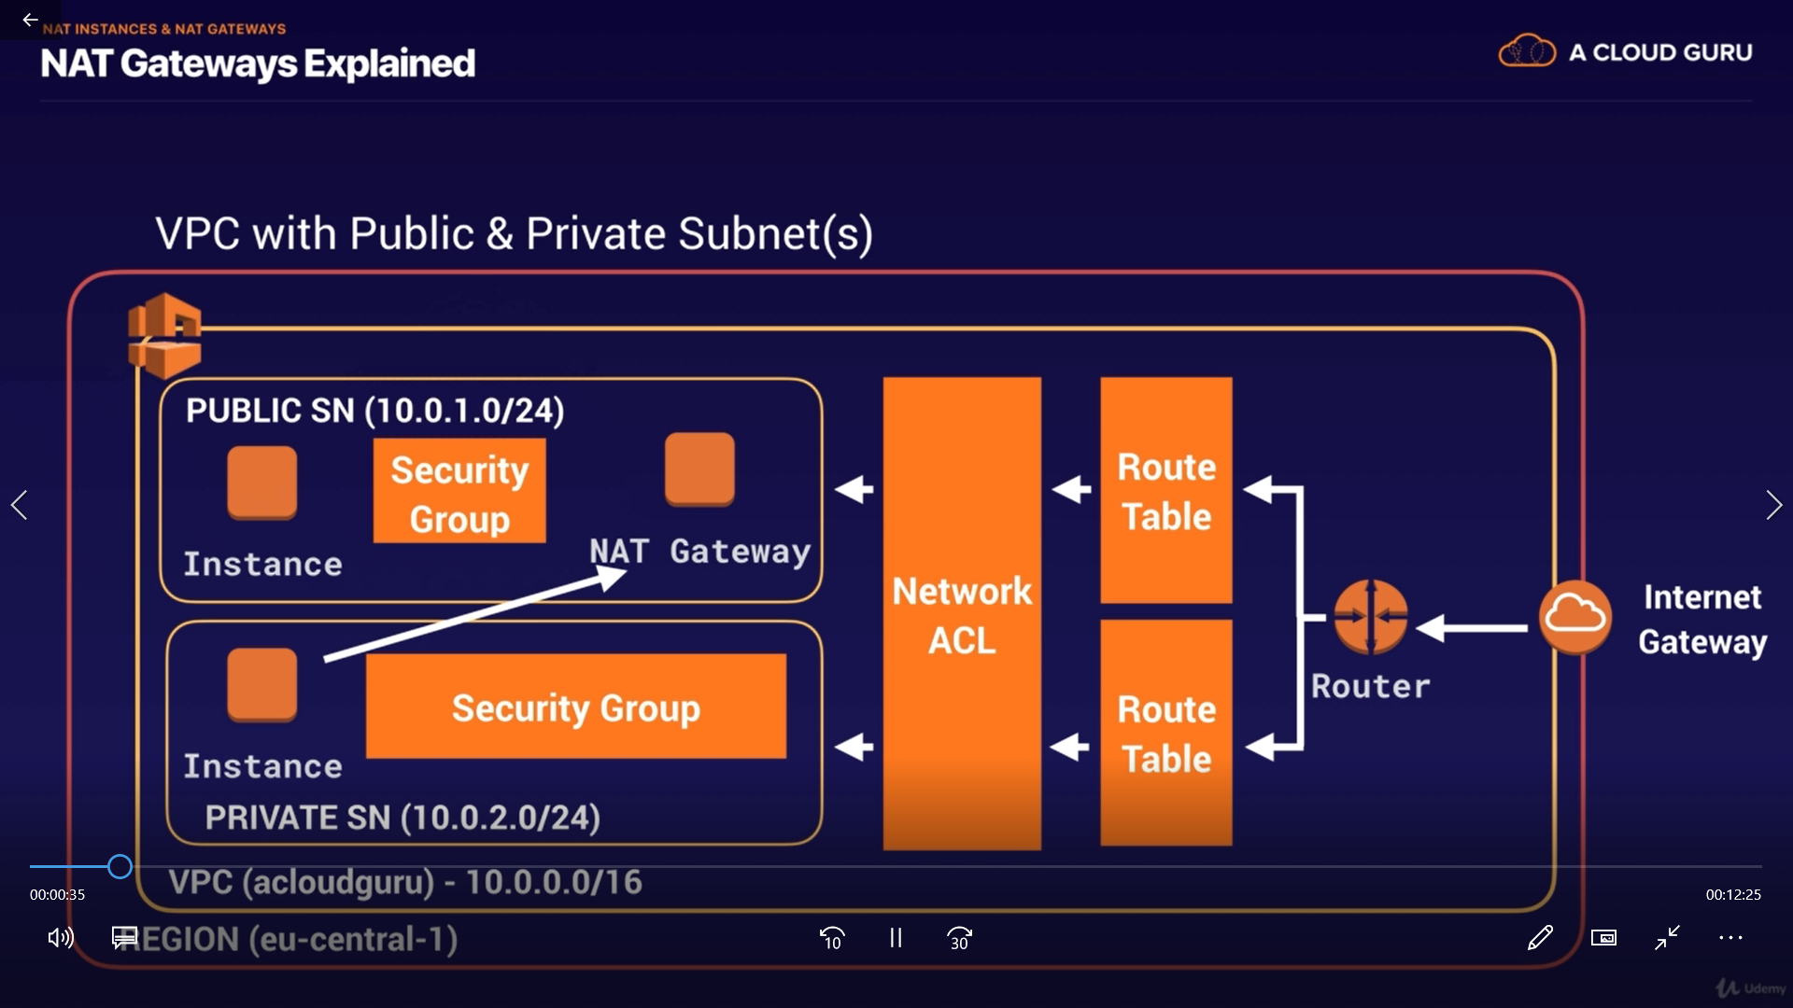

in real world scenario, we always use NAT gateway or NAT instances.

NAT instances are individual EC2 instance.
while NAT gateways is spread across multiple Availability Zone. these are Highly available.
they are not dependent on single EC2 instance.

NAT instances are older technology.

So we will start with NAT instance and then we move to NAT Gateway.

NAT Instance:-

https://docs.aws.amazon.com/vpc/latest/userguide/VPC_NAT_Instance.html

in this document we have session for setting up NAT instance:-

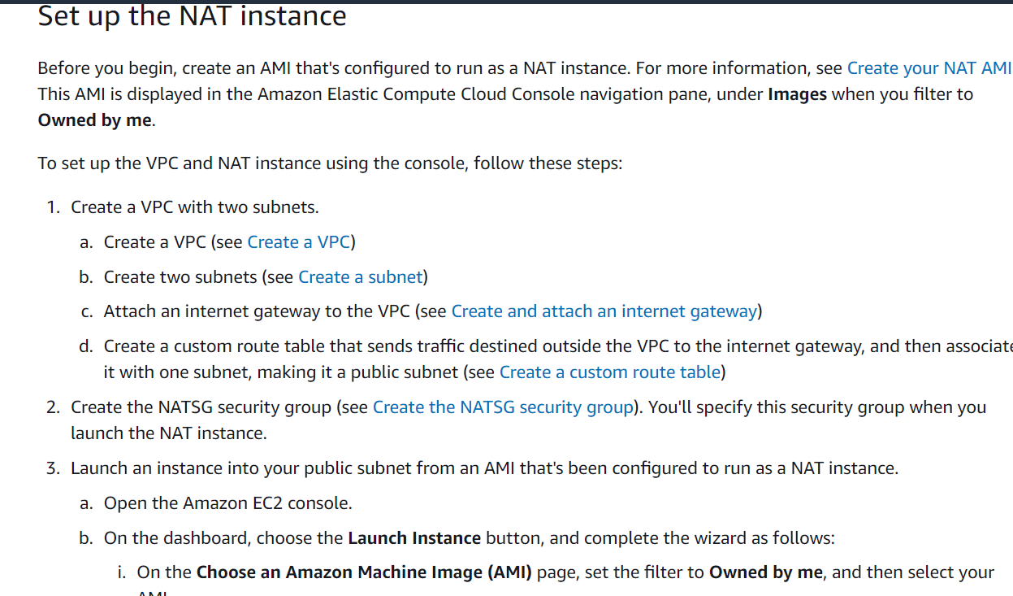

this is more on this document.

- we have to create an EC2 instance from "community AMI" section search "NAT", choose first one which is available by aws linux.

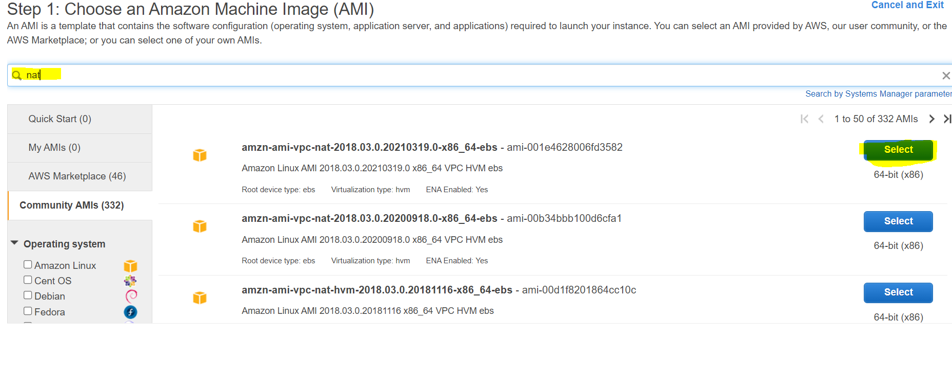

- we have to give public subnet to this instance.

- NAT instance is acting as bridge between private and public subnet. so it is acting like gateway, to enable this so-called gateway we need to disable source or destination check on NAT instance.

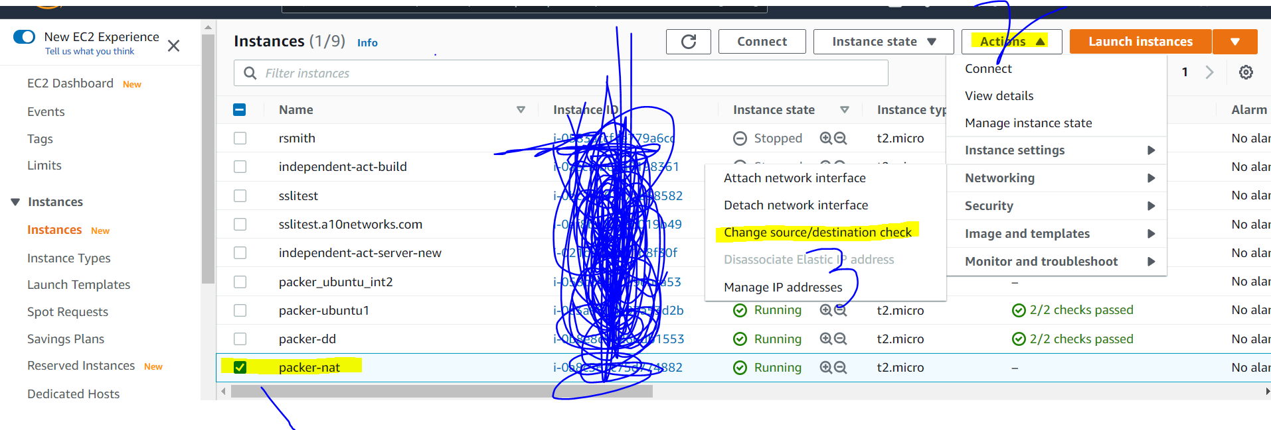

- For our database instance to communicate to NAT instance we need to create route.
this route we need to add in default route table.

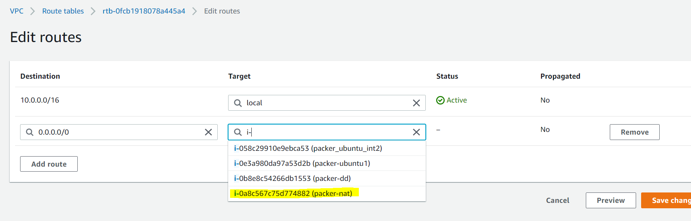

here the route-table associate with private subnet (database-subnet) we add Target as instance ie NAT instance.

now ssh to webserver --> ssh to db --> do update.

Now problem with this Architecture:-

- suppose if we have 100 instance in private subnet, this single NAT instance is bottle-neck and it will slow up to full fill all request.
- suppose if that NAT instance failt it leads to single point failure.

So we need much more highly available and scalable solution

So we will looks to create NAT gateway.

