reference:- https://www.youtube.com/watch?v=gUesnoDzNr4

First we should have some architecture design/plan as per the requirement.
like how many ip we want for our resources, how many subnet we want to create.
in which availablility region and zone we should use our vpc.

lets take example of below architecture and try to build that:-
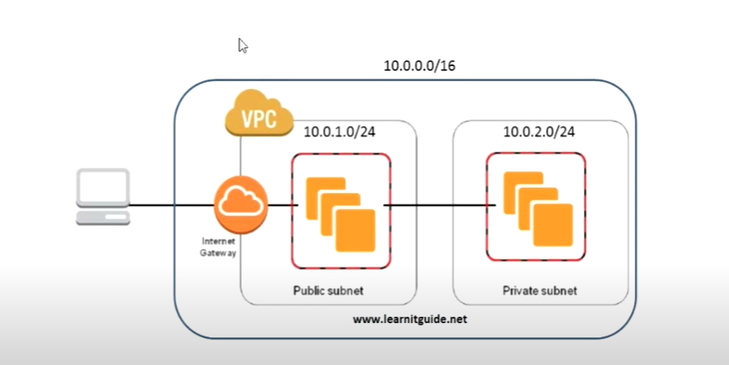

This architecture require one VPC with 10.0.0.0 /16 IP range within that we need to create two subnet:-
- public subnet (10.0.1.0/24)
- private subnet (10.0.2.0/24)

from 10.0.1.0/24 only 251 address are available as other are allocated by aws itself:-
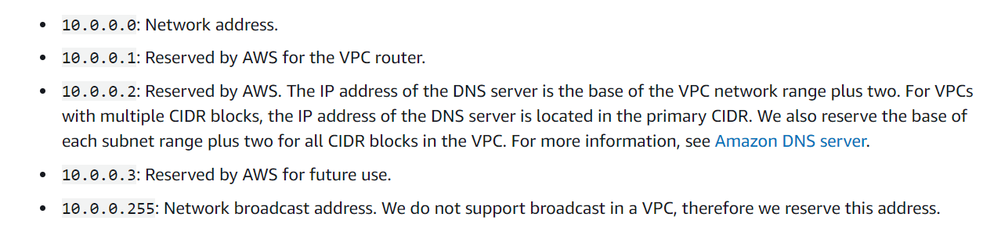

public subnet have internet access.

How can we protect our AWC resource from Internet world
here we have multiple layers of security to avoid these kind of attacks and also to control the
traffic's like security groups and network access control (NAC) list. will explain you all these things while creating the network architecture.

Now come to DEMO:-

- service console ---> VPC -----> VPC dashboard

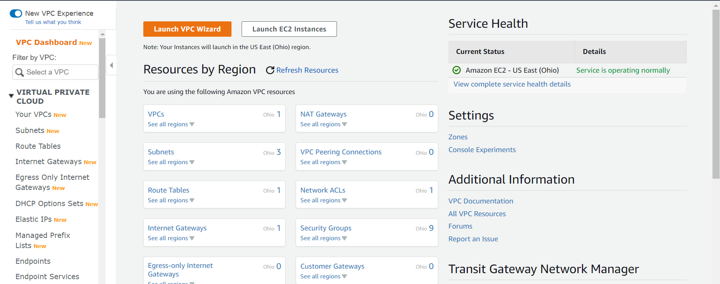

Here click on YOUR VPC
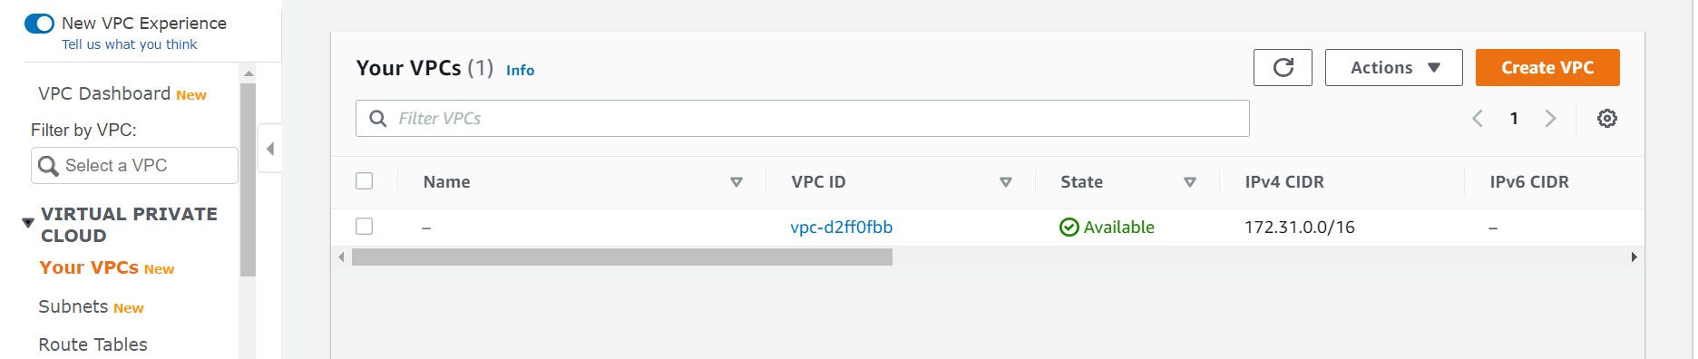
then create vpc

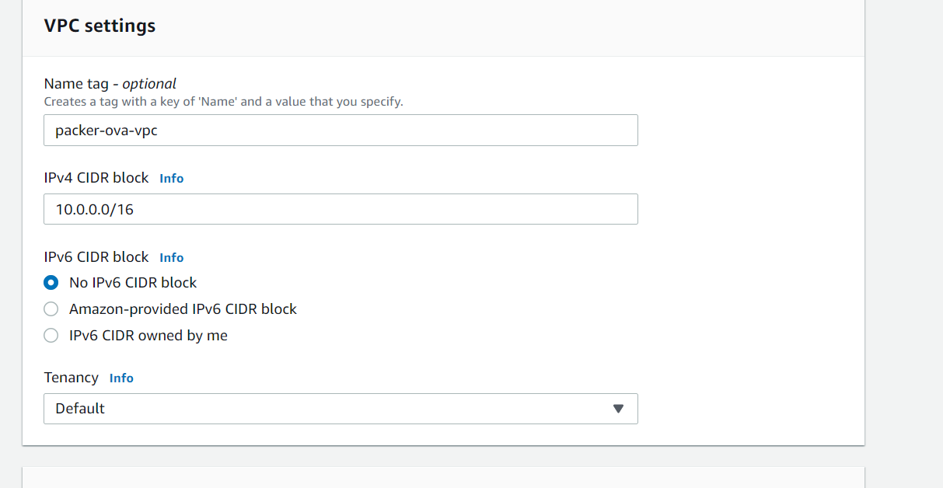
and hit on create

now our VPC is created,
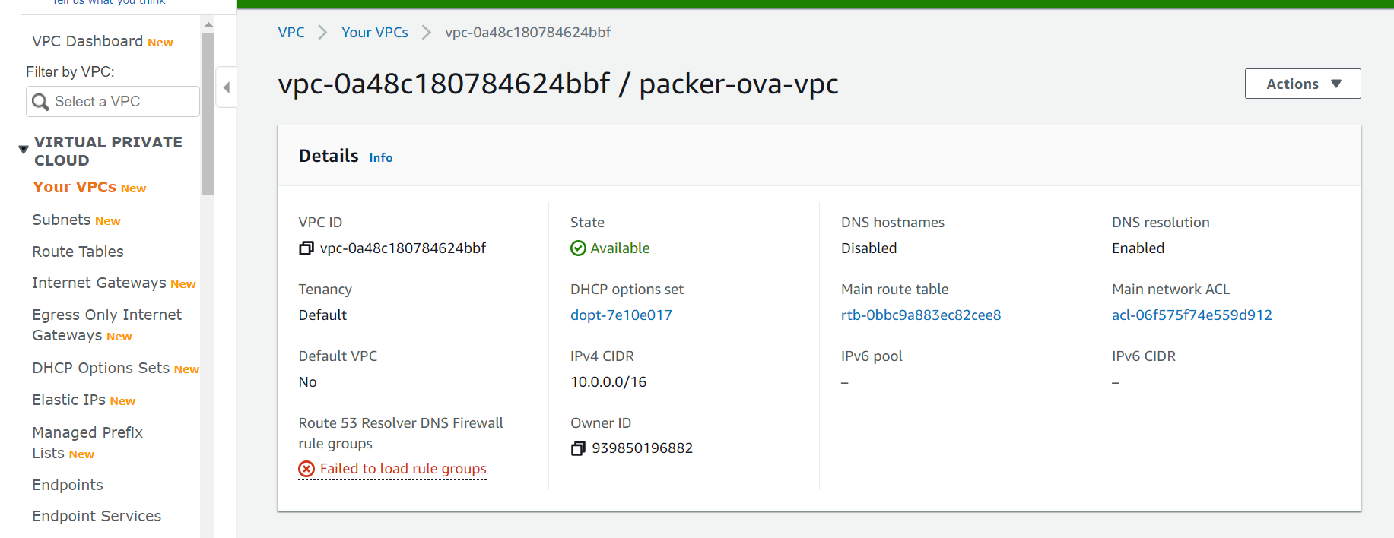

NOW click on internet gateway:-

Internet gateway it enables your instances to connect to the internet through the Amazon network so without this internal gateway you not be able to connect to the external world.

here you have to give name:-
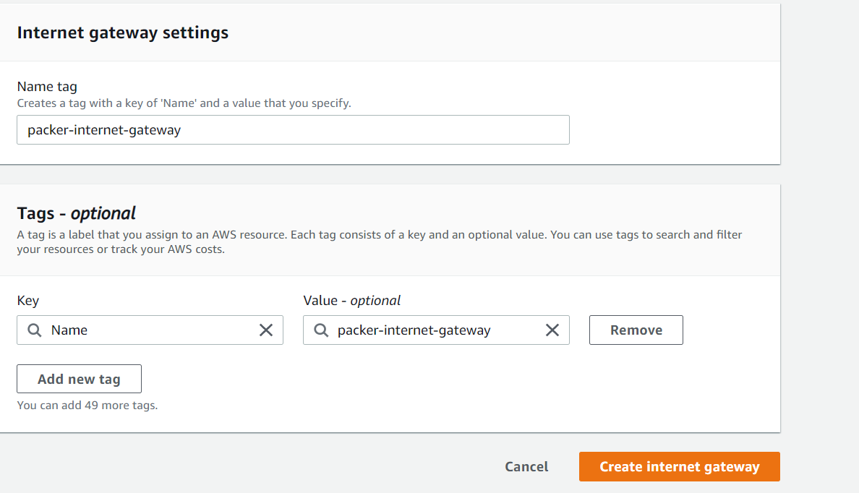

and hit on create internet gateway.

here internet gateway we create it seem detach, we need to attach them to our VPC

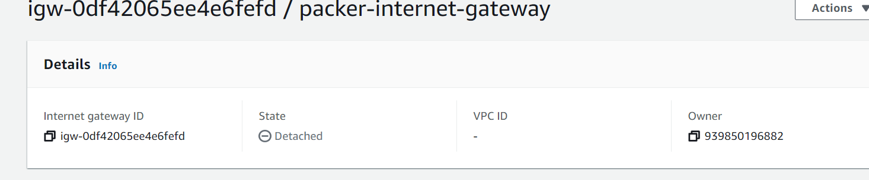

select click on "action" --> "attach vpc" ---> select your VPC and then click attach

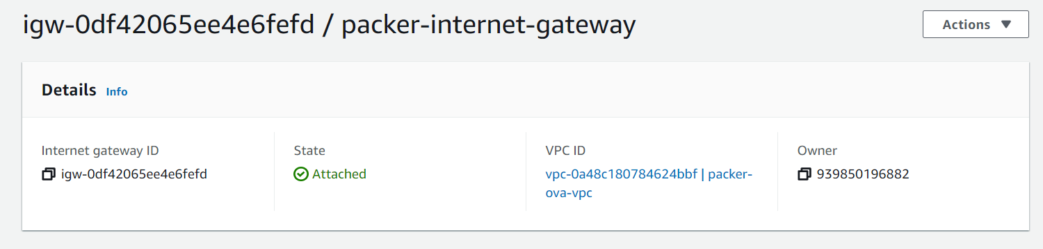

now we can see our vpc is attach to internet gateway.

now create subnet within VPC.

so we need two subnet:-
- public
- private

Subnet is nothing but it is a range of IP address in your VPC so you can launch a your resources into a specified subnet.

click on subnet--> create subnet fill form for two subnet. click on create subnet.

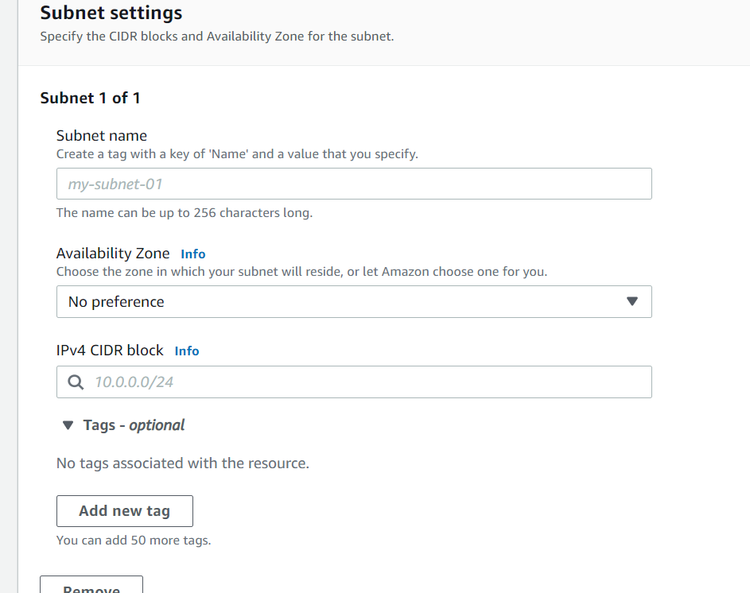

so we have two subnet create
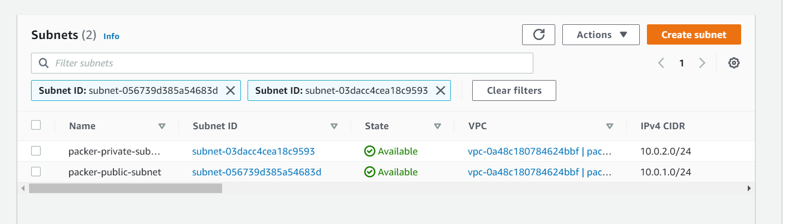

Now lets create route tables:-

By default when you have created a VPC automatically one route table and one network access control list will be get created so you can use this route table itself

this is already created.
so we will use this for private subnet.

you can rename it by ---> (add/edit tags) in action or right click on name.
in key use --> Name ; in value use --> <your name>

lets create a Route table for Public subnet.
create new route table ----> give its name ---> select vpc and then create.

so in public route table you have to add all your public subnet and internet gateway.
so that you public ip will communicate to outer world.

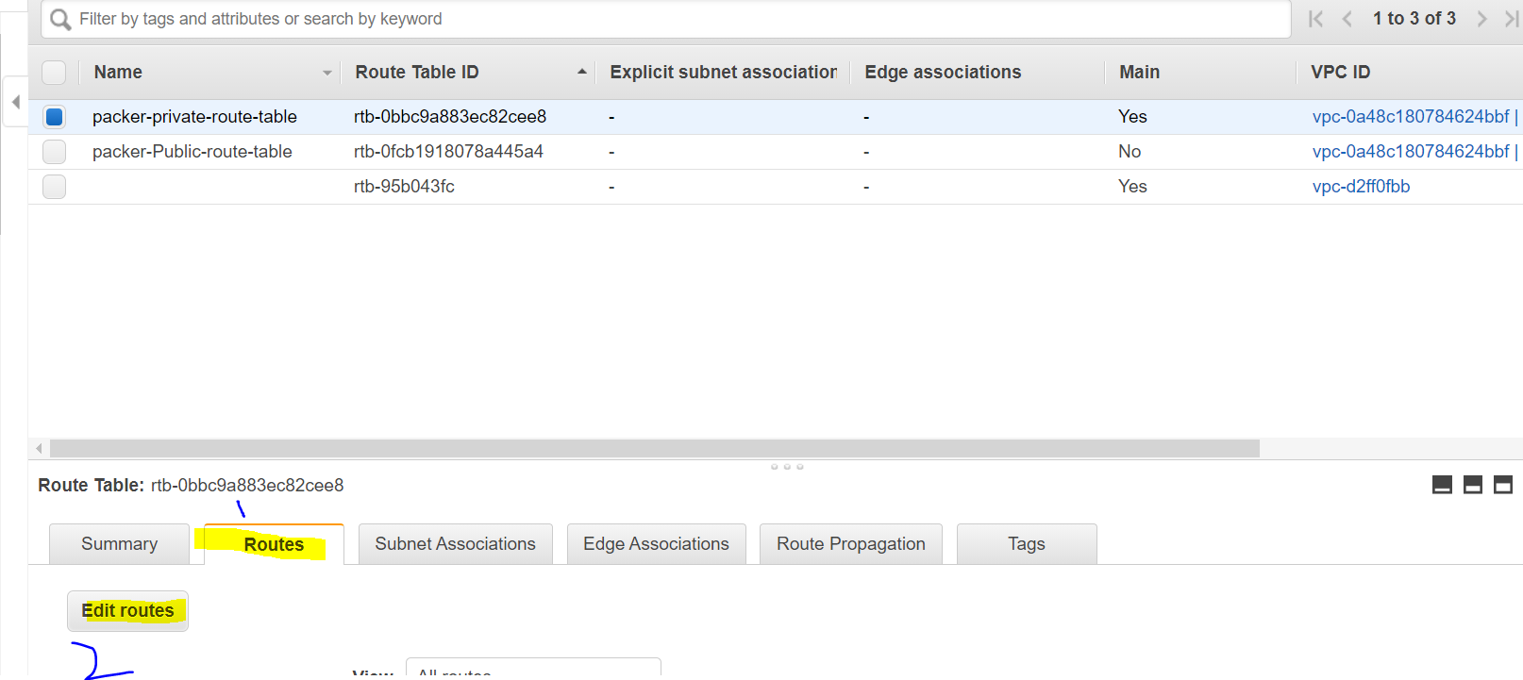

click on edit route:-

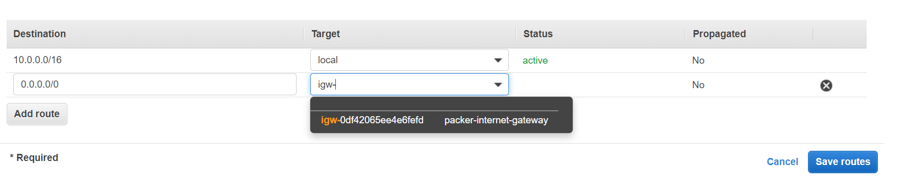
In public subnet anyone can access this from outside throught this internet gateway.
click on save route.

now we will associate subnet to this route table

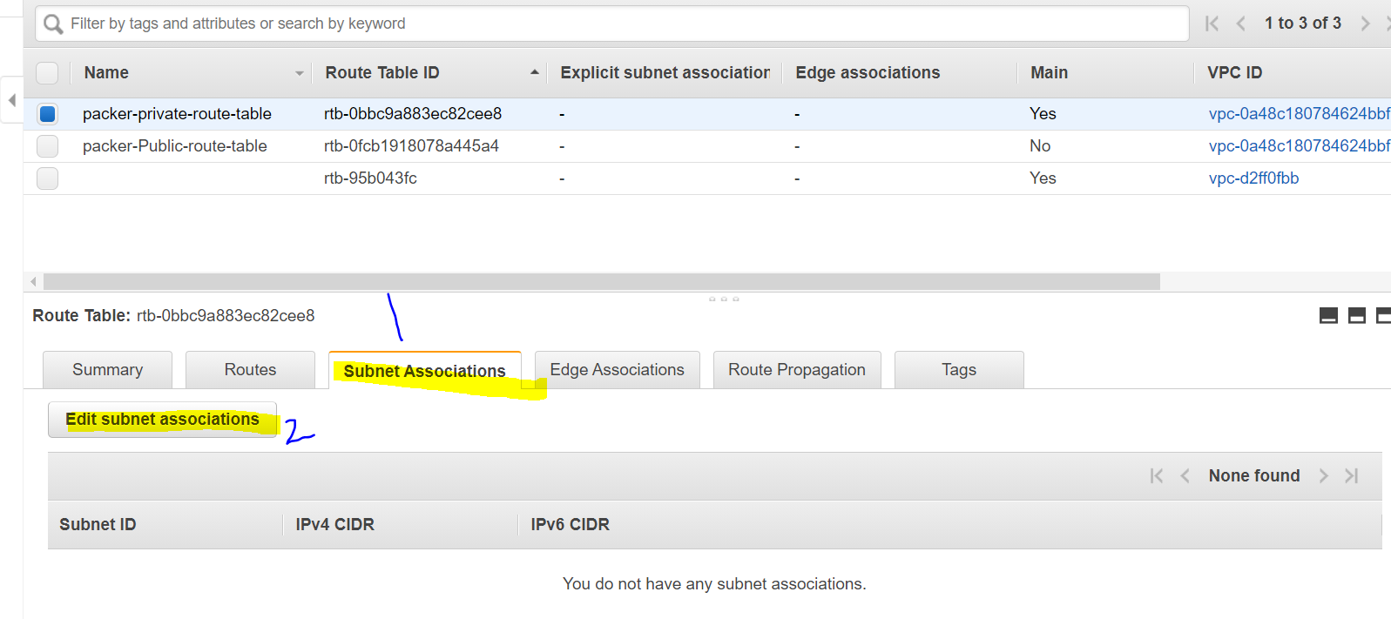
click on Edit subnet associate:-

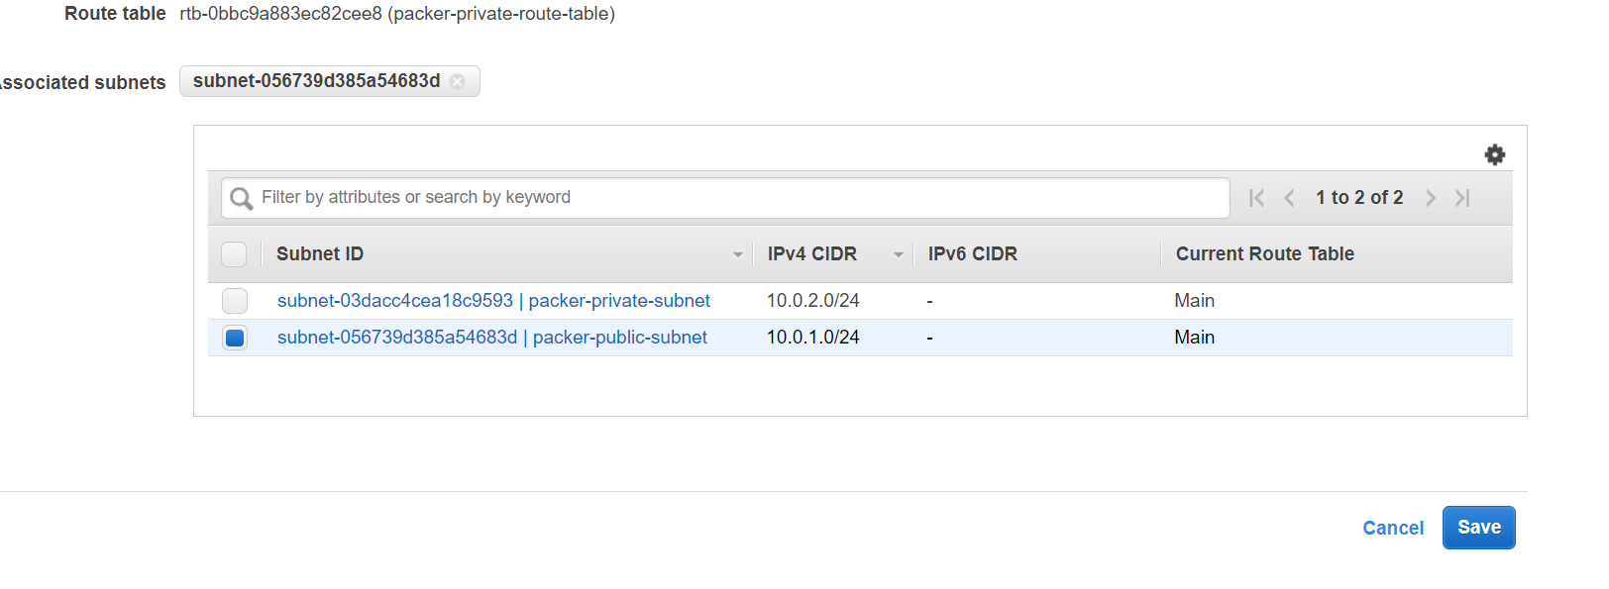
Select public subnet and save it.

now try to assocate private subnet to this in same way. we don’t have to route thought internet gateway.

just go to subnet association and add private subnet.

now we also need to create security groups and ACL to protect our resource from internet.

ACL is a security layer within the network level

Security groups is a security at the instance level
So we have to attach any of the instances to Security Groups.
so already one is create for our VPC
select security group --> you find one default SG belong to your VPC.
just rename it.
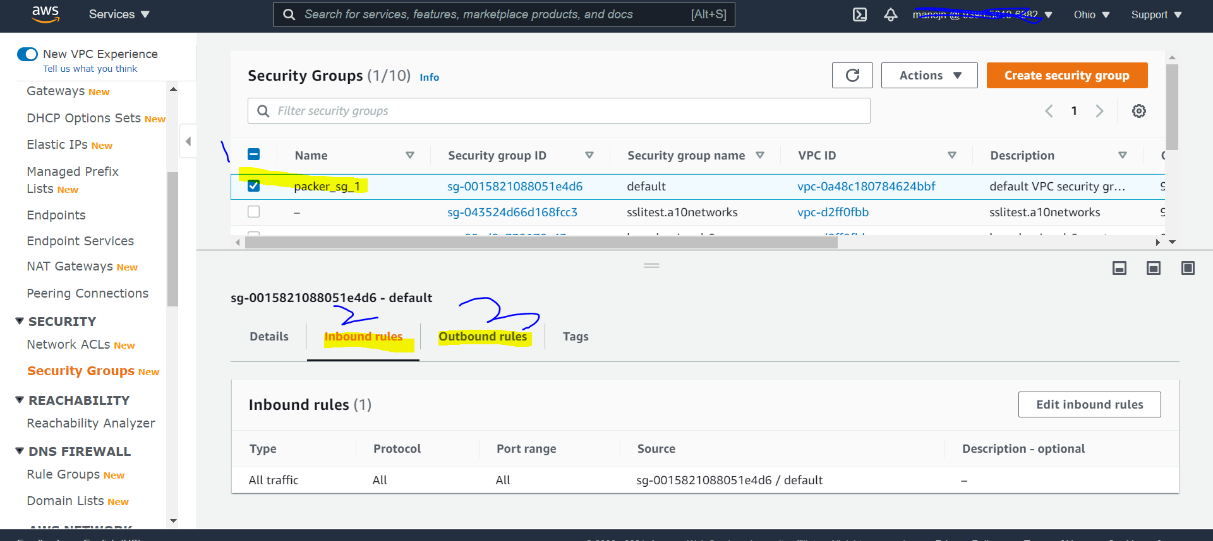

for This SG

Inbound rules and outbound rules

Inbound which means the traffic which is coming to instances from outside network.

Outbound routes from easy to the traffic which is going to outside the network

So we have created required to put some inbound rule, I choose this
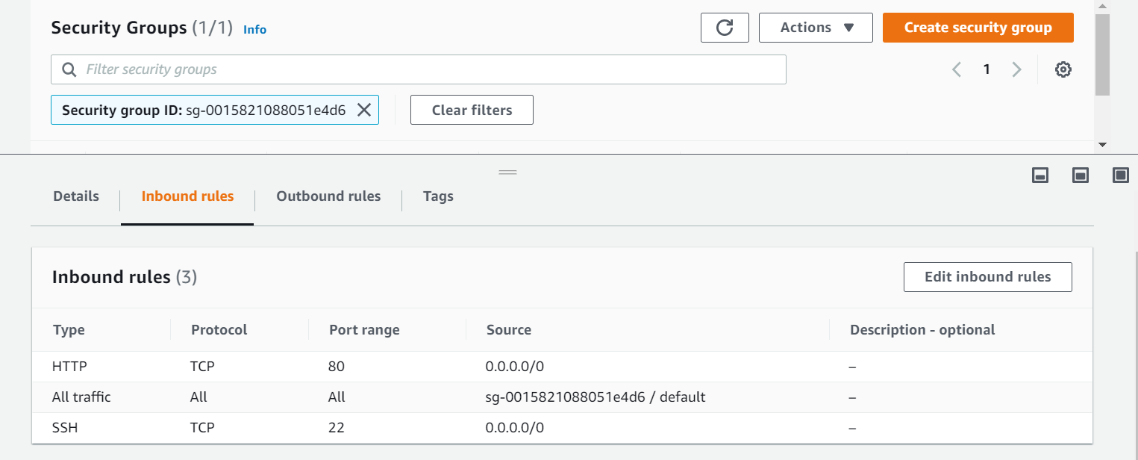

Now we can go to Network ACLs and we can already create NACL
just rename it to pakcer NACL.

so by default any body can access your instance as per NACL in bound rule:-
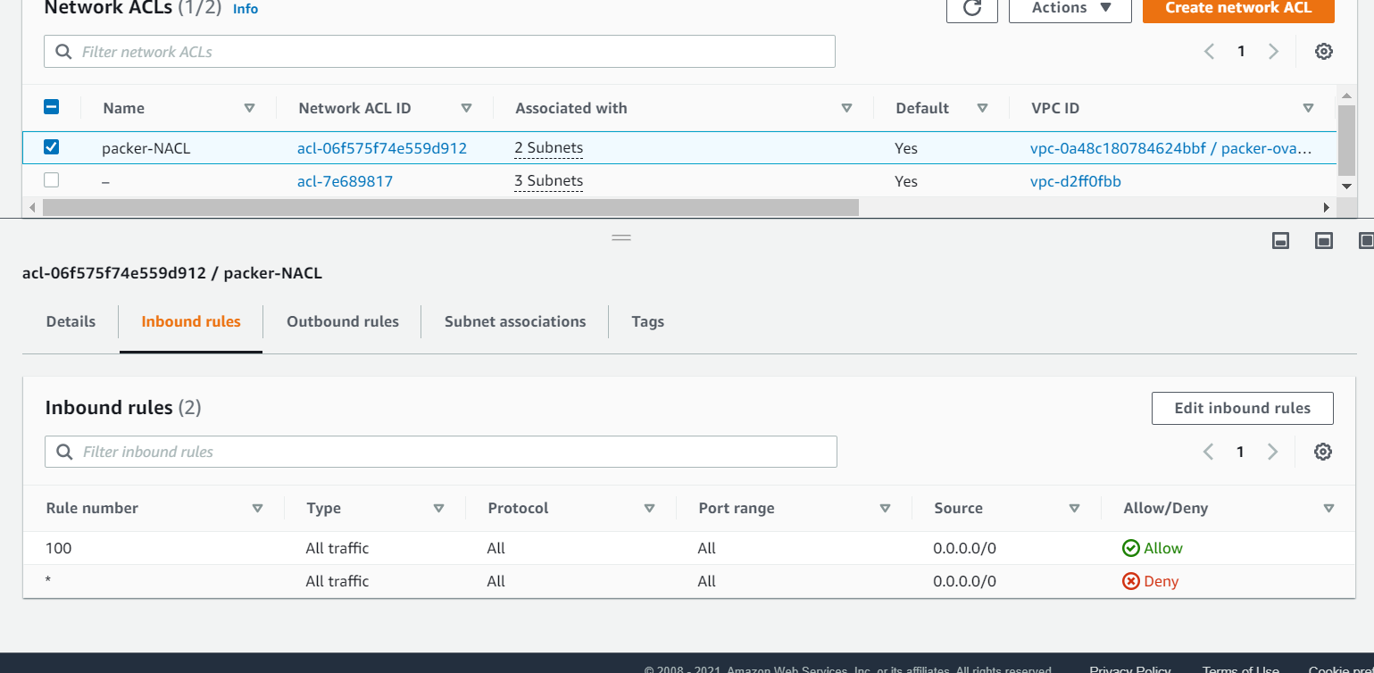

we can modify it for perticular ip as well.

let it be as it for our case.

So based on our diagram we have create our VPC in AWS account.

Now lets create two EC2 instance:-
one in pubic subnet and one in private subnet
lets see what instance we can access.

